|  |  |  |  |  |
| --- | --- | --- | --- | --- |
| ITU Logo | INTERNATIONAL TELECOMMUNICATION UNION  **TELECOMMUNICATION STANDARDIZATION SECTOR**  STUDY PERIOD 2017-2020 | | FG-AI4H-B-028-R1 | |
| **ITU-T Focus Group on AI for Health** | |
| **Original: English** | |
| **WG(s):** | | Plenary | New York City, 15-16 November 2018 | |
| **DOCUMENT** | | | | |
| **Source:** | | Medindia.net | | |
| **Title:** | | Proposal: Using AI for early detection of Diabetic Retinopathy to prevent vision loss | | |
| **Purpose:** | | Discussion | | |
| **Contact:** | | Arun Shroff Medindia.net  United States and India | | Tel: +1 908-208-1100 Fax: N/A  Email: [arunshroff@gmail.com](mailto:arunshroff@gmail.com) |

|  |  |
| --- | --- |
| **Abstract:** | This submission is in response to the ITU-T Focus Group on Artificial Intelligence for Health (AI4H)’s call for proposals on use cases and data. It describes an end-to-end AI based solution for screening, detection and diagnosis of Diabetic Retinopathy using digital images of the retina acquired using either a conventional fundus camera or a smartphone based image capture device. R1 of this document includes answers to the proposal submission questionnaire. |

Project Title

An integrated end-to-end solution for early detection and diagnosis of diabetic retinopathy using Artificial Intelligence

**Overview**

*Please give a general overview of the project, and describe what health problem it is attempting to contribute to solve.*

Diabetic Retinopathy (DR) is a serious eye-disease caused by diabetes that can lead to vision impairment and blindness if it is not detected and treated early enough. Of the estimated 422 million people with diabetes worldwide, over 148 million are estimated to have DR and 48 million have Vision Threating DR (VTDR) that can lead to blindness. Prevention of vision loss requires early detection via regular eye exams and screening for DR by a trained ophthalmologist or eye care professional. However, given the large numbers of people affected worldwide, there are not sufficient specialists globally to screen everyone at risk. The shortfall is particularly acute in developing countries, including India, and many countries in Asia and Africa. In addition, many affected people live in remote areas with little or no access to clinics and screening facilities. This makes Diabetic Retinopathy a global healthcare challenge that needs urgent resolution.

Recent advances in Artificial Intelligence algorithms for image recognition and medical diagnosis have the potential to automate the detection of Diabetic Retinopathy and bridge the gap due to the shortage of specialists and resources. We present a end-to-end approach that combines AI and human expertise with a portable image capture device in an integrated solution that can be deployed in remote areas of the world and address this global healthcare challenge.

The ideal system should combine AI, technology and human expertise in ways that they can complement each other. In order to address the global DR challenge, the system design should satisfy the following objectives:

1. Provide the capability to be deployed in remote and underserved areas.
2. Provide the capability to capture retinal images with a low-cost device.
3. Use AI to automate routine screening of DR for majority of the cases.
4. Allow remote diagnosis by trained professionals when required for cases that are difficult to diagnose with AI, allow experts to validate the AI diagnosis, and allow them to interact and counsel patients.

We present a solution for DR Diagnosis that combines AI and human expertise to achieve these objectives. An overview of the solution and its major components is as follows:

* Patient’s retinal images are captured via Fundus Cameras at local screening centers or clinics, and are uploaded via the web to a cloud-based server for further processing. A low-cost device that can be attached to a mobile phone for image capture of the retina is also being proposed for areas where no clinical facilities exist.
* A cloud-based web application for patient registration and data entry, image capture and uploading, integration with the AI model, remote diagnosis by trained specialists, as well as patient reporting, messaging and notification.
* Automated AI Diagnosis: The AI model runs on a remote server and automatically diagnoses and classifies the image nearly instantly as either normal or showing evidence of DR, the stage of the DR, along with the probability of the model’s predicted diagnosis.
* Remote Human Diagnosis: Eye-care professionals can login remotely to the web application to review and validate the AI diagnosis, add notes, provide referral to a specialist, follow-up and treatment options. The system design will also incorporate the ability to fine-tune the AI algorithm based on corrections of diagnosis errors by the specialists.
* Integrated administrative, reporting, and messaging for patient communication, system performance reports, and overall statistics.

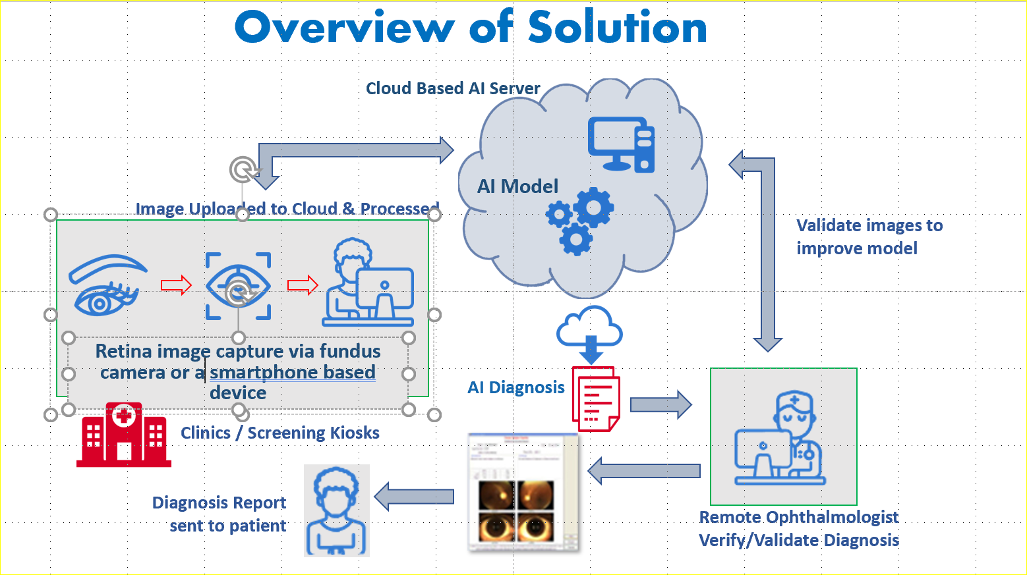

Impact

*Please explain the significance of the problem and describe the potential impact of the project. Please also provide a brief overview of existing work in the area of the project, and describe the current state of the art how the problem is currently addressed.*

As per WHO, the number of people with diabetes worldwide has nearly quadrupled, from 108 million in 1980 to over 422 million people as of 2015, and it is predicted to affect over 640 million people by 2040. Studies suggest that 35% of people with diabetes, or 148 million people globally have some form of DR. And an estimated 11% or 46 million have vision-threatening DR (VTDR), making it one of the leading causes of blindness worldwide.[1]

In India, for example, there are over 72 million people with diabetes and an estimated 25 million are estimated to have some stage of DR and about 7 million have VTDR. However, India only has 15,000 trained ophthalmologists in a nation of 1.3 billion people - or a mere 9 specialists per a million people. Kenya, with a population of 48 million has less than 100 ophthalmologists, and Angola, less than 20 for 29 million people. In addition to the dire shortage of trained professionals, many of the affected people live in remote areas with little or no access to an eye care clinic or a screening center.[2]

Diabetic Retinopathy is clearly a global health care challenge that urgently needs innovative solutions in order to prevent vision loss among millions of people at risk worldwide.

*Current approaches:*

Diabetic Retinopathy detection requires capturing a photograph of the retina using specialized equipment such as a slit-lamp and fundus camera. The image is then examined by an ophthalmologist, optometrist or a trained professional to detect abnormalities such as microaneurysms, exudates, hemorrhages, macular edema, etc. to determine if DR is present and its severity and stage of progression. In general DR can be classified as mild, moderate or vision-threatening, which includes severe non-proliferative DR, proliferative DR (PDR) and diabetic macular edema (DME). Accurate diagnosis of DR from fundus camera images and grading its severity requires professional expertise and training. [3]

In recent years, many AI systems using deep learning have been very successful in image recognition and classification tasks. For example, in the Imagenet challenge, requiring identification of objects in a 1000 categories, the best models achieve a classification error rate of less than 5%. – exceeding the best human accuracy levels.[4]

Many of these models, have now been adapted successfully for use in a variety of medical image diagnosis tasks such as melanoma, breast, lung cancer detection and diabetic retinopathy.

In particular, a team at Google published results in 2016 of a study for detecting DR working with doctors in India and the US. The results show that their AI model’s performance for DR detection and grading its severity was on-par with that of ophthalmologists. Their model had a combined accuracy score of 0.95, which was slightly better than the median of the 8 ophthalmologists consulted (measured at 0.91). [5]

More recently, IDx-DR released software that was FDA approved for detecting Diabetic Retinopathy The software provides the following results: (1) “more than mild diabetic retinopathy detected: refer to an eye care professional” or (2) “negative for more than mild diabetic retinopathy; rescreen in 12 months.” [6]

Data Availability

*Please describe what data sets would be available for the project. In particular, please describe if there are high quality open data sets for training purposes that are available, and / or if you would be able to contribute to an open data set for training purposes. Please also describe what (undisclosed) test data would be available for an evaluation. For any data set, please describe briefly if and how the data have been annotated.*

*[NOTE: This is where a link to the data submission document could be made, but it is suggested that very detailed information about the data is only solicited after the preliminary acceptance of the proposal for further consideration.*

There are a few high-quality open data sets available for training purposes from various sources, including for example Kaggle, EyePACS and Teleoptha (sources listed in the references). [7]

The data-sets vary in terms the number of classification labels, resolution of the images and source of the images. The challenge with getting a good accuracy on detecting DR depends on all of these factors. For the purposes of this project the number of classes we are targeting are normal classification labels are :

* Nongradable (0), No Retinopathy (Normal) (1) , Mild (2), Moderate (3), Severe (4), and Profilerative DR (5).

Of these the Mild, Moderate, Severe and Profilerative DR may be combined into one category – Retinopathy.

Our training dataset contains over 200,000 images and we will be gathering from 25,000 to 100,000 images every month. So we expect the training dataset to grow over time. All of these are classified into the above categories by professional ophthalmologists (in India). This data set may not be available for public use due to our agreement with the service provider. However, we can collect, and provide after informed consent and appropriate agreements, sufficient data for an undisclosed test data-set.

**Benchmarking**

*Please describe what you expect participants in the benchmarking process to submit. Please also describe how the submissions should be evaluated, and why.*

The benchmarking of the algorithms for detecting DR would be done on a sufficiently large undisclosed test data set - representative of number of categories that the algorithm seeks to classify.

For example, the algorithm may classify an image into Binary (Normal vs Retinopathy), three classes (Nongradable, Normal, Retinopathy) or multiple classes (Nongradable, Normal, Mild, Moderate, Severe, Severe PDR) or even more detailed classifications. An appropriate test data-set will need to be used.

In all cases, the following key metrics will be used for benchmarking:

* Accuracy – in all cases,
* Sensitivity and Specificity: for Binary classification.
* For the multi-class cases we will use a Confusion Matrix for comparing performance.
* AUC / ROC Curve will also be used for better visualization.

Organizer Details

*Please describe why your organization is interested in this project, and if you have run similar projects / benchmarks / challenges before.*

The project is being developed by Medindia.net – a leading online publisher of health information, an a developer of health applications and services for consumers, doctors, healthcare professionals globally. Medindia’s website and applications are visited by over 4 million visitors each month from over 230 countries. Medindia offers almost 1 million pages of trusted health and wellness information including news, special reports, articles, animations, slides, infographics, videos, health directories, drug information, calculators, personalized health record, mobile apps, interactive tools, applications and much more. All of Medindia’s content is edited and authenticated by doctors and healthcare professionals. It is certified to comply with the HONCode standard for trustworthy health information. Medindia.net is headquartered in India and owned operated by Medindia4u.com Pvt. Ltd. – a private limited company based in Chennai, India. It has a marketing and support offices in USA.

Medindia is collaborating with a team of AI and technology experts, ophthalmologists, clinicians, and a large tele-ophthalmology group in India working closely together. The Tele-opthalmology group has over 275 screening centers in 22 states in India and is servicing 25,000 patients a month and processing from 50,000 to 100,000 images each month. We have developed a cloud-based AI solution that is fully integrated with a web application to upload images, enter patient information, as well as allow doctors to login and perform diagnosis remotely, verify and validate the data.

Mr. Arun Shroff who is leading the project is co-founder and CTO of Medindia.net, is based in the USA and has extensive background in technology, web applications as well as AI and Deep Learning.

Annex:  
Answers to questionnaire

1. **Relevance** - How relevant is the health problem to be addressed?

**Impact** - What level of impact will a benchmark in the context of the proposed project have?

An accurate way of benchmarking the performance of AI solutions to detect and diagnose Diabetic Retinopathy can have a huge impact on selecting and implementing the best solution to address a global healthcare challenge. This can in turn impact the lives of over the millions of people with diabetic retinopathy who are at risk for vison impairment and blindness globally because they do not have access to human experts and infrastructure to get screened.

1. **Existing work** - Does the project start from scratch, or are there preliminary experiences?

We started the project in the first quarter of 2018 and have trained an AI model starting with a database of over 100,000 images to acceptable levels of accuracy. We have also created a cloud based AI solution integrated with a tele-ophthalmology web application and currently in beta testing the software in clinics in India.

1. **Feasibility** - Is the project feasible, based on the current state of the art?

There are several published algorithms and studies that show that AI can be used to detect and diagnose DR to medically acceptable levels of accuracy including Google. A company called IDx-Care got FDA approved for a DR solution. Our initial trials also show that this is feasible to do.

1. **Data Availability** - Is there sufficient data available? How much of it can be openly available? How much of it as part of the non-disclosed data set?

Kaggle, EyePACS and Teleophtha.fr all have sufficient publicly available datasets that can ne used for training.

We have an initial training dataset of over 100,00 images that have been labeled with a diagnosis code by professional ophthalmologists im India. This data-set is currently private, but we can consider contributing some of it to a public data-set as well as an undisclosed test data-set provided the right agreements are entered into with the partners and consent obtained.

1. **Data Quality** - Is the available data of high quality?

All of the images have been captured with a professional grade fundus camera currently used in diagnosis, and is therefore of the same quality as that used for manually diagnosing diabetic retinopathy.

1. **Annotation / Label Quality** - Are the annotations / labels of the data of high quality?

All of the data is labeled with a diagnosis classification by a professional ophthalmologist in India. We have also created an AI algorithm to eliminate invalid data (for example, images of outside of the eyes), as well as out-of-focus and poor quality images, resulting in a high-quality data set.

1. **Data Provenance** - Has the data been obtained in a professional and ethically correct way?

Yes, all of the data is and will be obtained using informed consent and adhere strictly to the highest professional and ethical standards and best practices.

1. **Benchmarking** - Do the applicants have a clear proposal about what exactly should be evaluated / measured?

We have identified the key benchmarking metrics that can be used to compare performance of the different algorithms and solutions proposed. These include : Accuracy, Sensitivity, Specificity. AUC-ROC, and Confusion Matrix.

1. **Organizers** - Can the Focus Group work with the applicants, and do they have the time / resources to work with the Focus Group on the problem?

Yes, we are fully committed to solving this problem and are willing to devote the required resources and work closely with the Focus Group on all aspects of the proposed solution.

**REFERENCES:**

1. Yau JW, Rogers SL, Kawasaki R, Lamoureux EL, Kowalski JW, Bek T, et al. Global prevalence and major risk factors of diabetic retinopathy. <https://www.ncbi.nlm.nih.gov/pmc/articles/PMC3322721/>
2. International Council of Ophthalmology. Number of Ophthalmologists in Practice and Training Worldwide.

   <http://www.icoph.org/ophthalmologists-worldwide.html>
3. Abdhish R Bhavsar, MD; Chief Editor: Romesh Khardori, MD, PhD, FACP, et al, Diabetic Retinopathy.

   <https://emedicine.medscape.com/article/1225122-overview>
4. IMAGENET. Large Scale Visual Recognition Challenge 2017 (ILSVRC2017).

   <http://image-net.org/challenges/LSVRC/2017/>
5. Varun Gulshan, PhD1; Lily Peng, MD, PhD1; Marc Coram, PhD; et al. Development and Validation of a Deep Learning Algorithm for Detection of Diabetic Retinopathy in Retinal Fundus Photographs.

   <https://jamanetwork.com/journals/jama/fullarticle/2588763>

   Varun Gulshan, PhD1; Lily Peng, MD, PhD1; Marc Coram, PhD; et al. Development and Validation of a Deep Learning Algorithm for Detection of Diabetic Retinopathy in Retinal Fundus Photographs.

   <https://jamanetwork.com/journals/jama/fullarticle/2588763>
6. <https://www.fda.gov/newsevents/newsroom/pressannouncements/ucm604357.htm>
7. Data Set Sources:

   Kaggle: <https://www.kaggle.com/c/diabetic-retinopathy-detection/data>

   EyePACS: <http://www.eyepacs.com/>

   Teleophta: http://www.teleophta.fr/

   _________________