|  |  |  |  |  |
| --- | --- | --- | --- | --- |
| ITU Logo | INTERNATIONAL TELECOMMUNICATION UNION  **TELECOMMUNICATION STANDARDIZATION SECTOR**  STUDY PERIOD 2017-2020 | | FG-AI4H-A-026 | |
| **ITU-T Focus Group on AI for Health** | |
| **Original: English** | |
| **WG(s):** | | N/A | |  | | --- | | Geneva, 26-27 September 2018 | | |
| **DOCUMENT** | | | | |
| **Source:** | | Shabbir Syed Abdul | | |
| **Title:** | | Classification of the healthcare services | | |
| **Purpose:** | | Discussion | | |
| **Contact:** | | Shabbir Syed Abdul Indian association of medical informatic India | | Email: [drshabbir786@gmail.com](mailto:drshabbir786@gmail.com)  Fax: +xx Email: |

|  |  |
| --- | --- |
| **Abstract:** | Objective of this report is to classify healthcare services in a meaningful way, which could guide us to find the challenges and opportunities in the currently practiced healthcare services. This focus group (FG) is keen to emphasize the challenges and opportunities, where Artificial Intelligent models and tools can be applied to its best advantage. Healthcare services are multi-dimensional; hence, classification can be subjective depending on the need, purpose and the stakeholders’ interest. |

**Classification of the healthcare services**

Healthcare services are complex and the outcomes are interdepended on multiple factors, multi-stakeholders and on the timeliness of decisions taken. The most common way is to classify depending on the hierarchical level of the service provided. Most countries follow three-tier healthcare system i.e. primary, secondary and tertiary care. Another way is to classify as preventive, curative and rehabilitative care. Also, if population is target then public health services, if individual patient then clinical care. If disease is focus of interest then it can be classified as communicable, non-communicable, and mental disorders, by duration it can be acute, sub-acute and chronic disease. By etiology it can be bacterial, viral, fungal, trauma, radiation and iatrogenic etc.

Ferlie and Shortell (2001), proposed four levels of healthcare services: (1) the individual (patient/healthy person); (2) the healthcare team, which includes healthcare providers (e.g., clinicians, pharmacists, and care takers) (3) the organization (e.g., hospital, clinic, nursing home, telecommunication service providers etc.) that supports the development and work of care teams by providing infrastructure and complementary resources; and (4) the healthcare authorities (e.g., ministry of health, regulatory, insurance company, CDC, etc.), the conditions under which organizations, care teams, individual patients, and individual care providers operate. See figure 1.

Since this focus group is interested in challenges and opportunities of AI applications to enhance the effectiveness of the healthcare services, let us see how each of the above mentioned level can be benefitted from AI applications.

**(1) The individuals** (patients/healthy persons): In this era of ICT, and emerging wearable technologies, smart mobile phones, huge number of initiatives are in practice to empower the individuals. Technologies are available to monitor the users lifestyle, their physical activities, sleep behavior patterns, to measure blood pressure, vital physiological data real-time and continuously. Enormous data can be collected and analyzed to understand the behavioral patterns of the users. AI can be applicable to motivate the healthy lifestyle by providing timely prompts to the users or to the care providers in case of abnormal physiological parameters. Thousands of mobile applications are available in aiding users for health/disease management. A good number of preventive care or early detection applications can be developed using AI tools for the individuals.

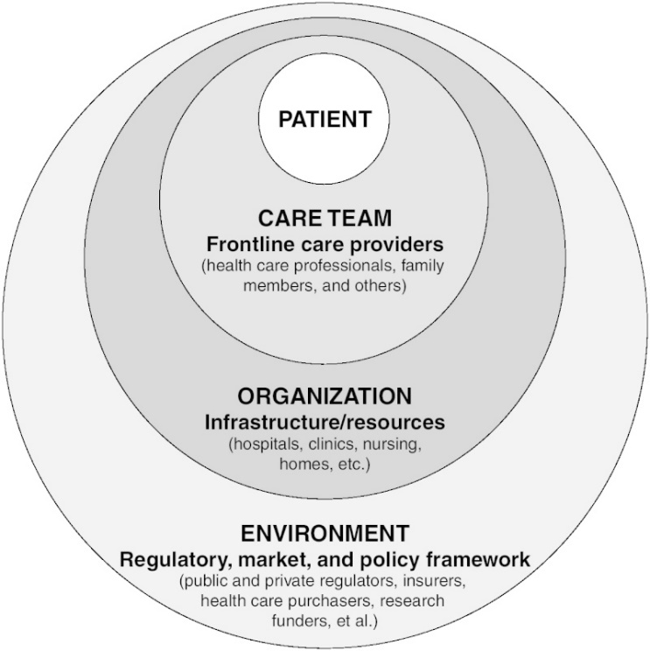

Fig 1. Conceptual drawing of a four-level health care system.

From: [2, A Framework for a Systems Approach to Health Care Delivery](https://www.ncbi.nlm.nih.gov/books/NBK22878/)

**(2)** **the healthcare team** (e.g., clinicians, pharmacists, and care takers)

For this level of stakeholders, there are infinite opportunities of AI applications. Right from the clinical decision support system for diagnosis to suggesting the line of treatment, and also AI systems are available for alerting at the occasions of medication/prescription errors. Disease specific models can be developed for preventing, early detecting and personalized management of the patients.

**(3) the organization** (e.g., hospital, clinic, nursing home, mobile service providers etc.)

Already electronic health records, HIS, LIS RIS are in place since last few decades. Unprecedented amount of data is stored in the database of the organizations. It is a matter of willingness to open or share the data, and then a plethora of opportunities can be applicable for using AI to improve the efficiency of the organizations.

(4) **the healthcare authorities** (e.g., ministry of health, policy makers, regulatory, insurance company, CDC, etc.)

|  |  |  |  |  |  |  |  |  |  |  |  |  |
| --- | --- | --- | --- | --- | --- | --- | --- | --- | --- | --- | --- | --- |
|  | Patients/Care takers | | | Healthcare providers | | | Payers/Insurers | | | Health Authorities | | |
| Home care |  |  |  |  |  |  |  |  |  |  |  |  |
| GP clinic |  |  |  |  |  |  |  |  |  |  |  |  |
| Nursing home |  |  |  |  |  |  |  |  |  |  |  |  |
| Hospital |  |  |  |  |  |  |  |  |  |  |  |  |
| Medical center |  |  |  |  |  |  |  |  |  |  |  |  |

These are top level of stakeholders focused on public health issues and overall management of health services in a given region/state/country. The political will-power has great impact on the healthcare system. Recently, WHO is promoting Universal Health Care (UHC) model of healthcare system. Denmark, Japan and Norway are best examples how ICT aid in achieving UHC. Definitely, AI can play a pivotal role in helping resource distribution and demand prediction.

|  |  |
| --- | --- |
|  | Preventive care |
|  | Curative |
|  | Long-term care |

As you see the healthcare matrix above, ITC has a crucial role to support continuity and care coordination (tools and platforms for the exchange of information through the system).

**WHO 2018 – eight priority practices “Continuity and coordination of care”:**

1. **Continuity with a primary care** professional (continuous contact)
2. **Collaborative planning** of care and shared desicion-making (coaching families and informal caregivers)
3. **Case management** for people with complex needs (care planning and coordination to integrate the services)
4. **Collocated services** or a single point of access (to the local services and community support)
5. **Transitional** or **intermediate care** (from hospital to home)
6. **Comprehensive care** along the entire pathway (anticipates crises and can provide urgent response in the evening and at the weekend)
7. **Technology to support** continuity and care coordination (tools and platforms for the exchange of information)
8. **Building workforce capability** (developing the skills, strengths and confidence of the wider workforce…)





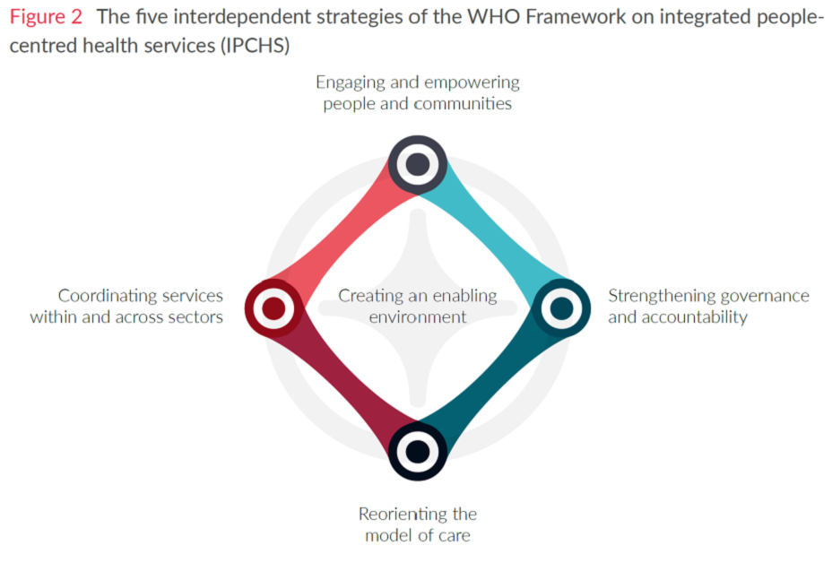

Overview of mental disorder and AI:

Considering projects for early detection of mental disorder such as Defense Advanced Research Projects Agency - teamed up with the US Department of Veterans Affairs to trial veterinary monitors mental health. And IBM also harnesses AI as an early detection mechanism for mental health. In this studies, IBM's Computational Psychiatry and Neuroimaging group, alongside several universities, aimed at predicting the onset of psychosis in patients.

The purpose of this FG is to provide International standards for collecting, aggregating, analyzing, and developing AI models that are needed to each of the above mentioned level of stakeholders in the health systems. Standard provides a common language and common conceptual structures to aid communication within and between communities of practice, and between different components of health and human services systems.

____________________________