|  |  |  |  |  |  |
| --- | --- | --- | --- | --- | --- |
| ITU logo | INTERNATIONAL TELECOMMUNICATION UNION  **TELECOMMUNICATION STANDARDIZATION SECTOR**  STUDY PERIOD 2017-2020 | | | FG-AI4H-A-016 | |
| **ITU-T Focus Group on AI for Health** | |
| **Original: English** | |
| **WG(s):** | | N/A | Geneva, 25-27 September 2018 | | |
| **DOCUMENT** | | | | | |
| **Source:** | | Hankuk University of Foreign Studies | | | |
| **Title:** | | Proposal to work on data availability and benchmarking for AI based Depressive Disorder Assistance Service (AI-DDAS) for teenagers | | | |
| **Purpose:** | | Proposal | | | |
| **Contact:** | | Muhammad Aslam Jarwar  Hankuk University of Foreign Studies Korea (Rep. of) | | | Tel: +82 10 4837 6253  Fax: +82 31 339 5687  Email: [aslam.jarwar@hufs.ac.kr](mailto:aslam.jarwar@hufs.ac.kr) |
| **Contact:** | | Ilyoung Chong Hankuk University of Foreign Studies Korea (Rep. of) | | | Tel: +82 31 330 4229 Fax: +82 31 339 5687 Email: [iychong@hufs.ac.kr](mailto:iychong@hufs.ac.kr) |

|  |  |
| --- | --- |
| **Keywords:** | AI; DD; DDAS; Big Data, |
| **Abstract:** | This contribution proposes the new work to draft document on “Data availability and benchmarking for AI based Depressive Disorder Assistance Service (AI-DDAS) for teenager in the FG-AI4H meeting. The document includes problem statements of depressive disorder, data availability and related benchmarking issues to support AI based DDAS for teenager. In the conclusion, it is proposed to develop a new document on “Data availability and benchmarking for AI based Depressive Disorder Assistance Service (AI-DDAS)”. |

| **Table of Contents**  1. Introduction 3  2. Data monitoring issues for depressive disorder 4  3. Data availability of AI-based DDAS for teenager 4  4. Data availability provision for AI-DDAS 6  4.1 Depressive disorder data analysis and depressive disorder assistance services platform for teenagers 7  5. Results of teenagers depressive disorder monitoring and analysis 8  6. Expected model of AI-DDAS 10  **7.** **Proposal** 10  Bibliography 11 |
| --- |
|  |

Technical Report AI-DDAS

Data availability and benchmarking for AI based Depressive Disorder Assistance Service (AI-DDAS) for teenager

# Introduction

Most of us feel sad, lonely, or depressed at times. It's a normal reaction to loss, life's struggles, or injured self-esteem. But when these feelings become overwhelming, cause physical symptoms, and last for long periods of time, they can keep you from leading a normal, active life. If your depression goes untreated, it may get worse and last for months, even years. It can cause pain and possibly lead to suicide as it does for about 1 of every 10 people with depression. Recognizing the symptoms is key. Unfortunately, about half the people who have depression never get it diagnosed or treated.

* Trouble concentrating, remembering details, and making decisions
* Fatigue
* Feelings of guilt, worthlessness, and helplessness
* Pessimism and hopelessness
* Insomnia, early-morning wakefulness, or sleeping too much
* Irritability
* Restlessness
* Loss of interest in things once pleasurable, including sex
* Overeating, or appetite loss
* Aches, pains, headaches, or cramps that won't go away
* Digestive problems that don't get better, even with treatment
* Persistent sad, anxious, or "empty" feelings
* Suicidal thoughts or attempts

Depressive disorder(DD) is a common disease of illness in emotion. The severity of depression symptoms affects the mood, daily activities and sometime can leads to severe actions: such as suicide. World health organization (WHO) estimated that more than 300 million are suffering from depression illness and an increase of more than 18% between 2005 and 2015 [1]. However, the diagnosis, monitoring, tracking of depression symptoms and therapy still rely mainly on old practices; which are developed approximately more than fifty years ago [2].

Recently **most teenagers** may feel unhappy at times. And when you add hormone havoc to the many other changes happening in a teenager's life, it's easy to see why their moods swing like a pendulum. Yet findings show that one out of every eight adolescents has teenager depression. But depression can be treated as well as the serious problems that come with it. So if your teenager's unhappiness lasts for more than two weeks and he or she displays other symptoms of depression, it may be time to seek help from a health professional.

## Video Transcript

World Health Organization: "Depression."; Mayo Clinic: "Depression."; American Psychiatric Association: "What Is Depression?"; Anxiety and Depression Association of America: "Understand the Facts: Depression."; Getty; Comstock Images;i Stock/Getty Images Plus; Thinkstock; AudioJungle; Rike; Vanessa Clara Ann Vokey; Somos/Veer; KatarzynaBialasiewicz; funduck

[MUSIC PLAYING]

There are multiple reasons why a teenager might become depressed. For example, teenagers can develop feelings of worthlessness and inadequacy over their grades. School performance, social status with peers, sexual orientation, or family life can each have a major effect on how a teenager feels. Sometimes, teenager depression may result from environmental stress. But whatever the cause, when friends or family -- or things that the teenager usually enjoys -- don't help to improve his or her sadness or sense of isolation, there's a good chance that he or she has teenager depression.

# Data monitoring issues for depressive disorder

Currently the psychiatrics are moving from the traditional methods to more autonomic methods by using of information and communication technologies to detect depression symptoms from the emotional behavior of the user. The psychiatrics monitor depression symptoms and also provides cognitive behavioral therapy (CBT) through the information and communication technologies [4]. Currently, the usage of autonomic systems based on internet of things (IoT) notions have been increased in healthcare industry, which are used to track medical devices, remote patient monitoring, telemedicine, and data analytics applications for clinicians and patients .e.g. Kaa,, and HealthSaaS etc.[5], [6]. To detect and depression symptoms from the physiological signals various sensors have been used in many studies. By using the sensors and mobile phone, the electrodermal activity, electroencephalography activity, sleep behavior, location change behavior, SMS, phone calls data, and questionnaire have been used to detect depression symptoms [7]. However, there is dearth of a comprehensive platforms; which detect, monitor, and track depression symptoms and provides recommendation services for the recovery from the depressive disorder in ubiquitous manner.

The questionnaires, face-to-face interviews, and filling-out surveys are the most common methods; and are being in use to diagnose depression symptoms in clinical studies. In clinical diagnosis sometime these methods are applied directly to the depressive victim and sometime the data are collected indirectly from the family member or parent in case of teenager. The diagnosis of depression normally rely that an individual have been experiencing the depression sign and symptoms for at least two weeks [3]. To visit psychiatric clinic after every two weeks for the diagnosis and then for the recovery from the depression symptoms through these methods of face-to-face interviews and filling-out questionnaires are time consuming, costly, unreliable in tracking and provides limited accuracy. Due to unreliable tracking the depression sign and symptoms and limited accuracy, the ratio of recovery from the depression is also less and it takes more time than the expectations.

The diagnosis, monitoring, tracking of depression symptoms and therapy still rely mainly on old practices; which are developed approximately more than fifty years ago. Due to these old methods unreliable tracking the depression sign and symptoms and limited accuracy, the ratio of recovery from the depression is also less and it takes more time than the expectations. For accurate monitoring depressed patient we also have to collect and handle heterogeneous data in a huge quantity. The problem with the current state of the art technologies is the lack of a holistic support to accumulate heterogeneous data from many different sources and convert that data to meaningful information. That meaningful information should support universal meta-data and interoperability, which can be used by others with minimal efforts and can be used for the contextual assistance services

To collect, filter and process depressive disorder data for the monitoring depression situation of patient and provides cognitive behavioural therapy (CBT) and other virtual counselling support by using artificial intelligence and communication technologies. The system will help to psychiatrics in order to provide better consultancy to the DD teenager, and also the psychiatrics will be the moderator of the system.

# Data availability of AI-based DDAS for teenager

Depressive disorder is a mental disorder characterized by at least two weeks of low mood that is present across most situations. It is often accompanied by low self-esteem, loss of interest in normally enjoyable activities, low energy, and pain without a clear cause. People may also occasionally have false beliefs or see or hear things that others cannot. Some people have periods of depression separated by years in which they are normal while others nearly always have symptoms present. Major depressive disorder can negatively affect a person's personal, work, or school life, as well as sleeping, eating habits, and general health. Between 2–7% of adults with major depression die by suicide, and up to 60% of people who die by suicide had depression or another mood disorder.

Teenager can get depressed, and disorders ranging from major depression to bipolar disorder are increasingly diagnosed in children and adolescents. The reason may be the parents work especially hard to get involved in their children’s lives. Psychotherapy is often a highly effective form of treatment, and depending on the severity of the case, medication may also be prescribed. A teenager with major depression may have other mental health problems, such as substance abuse or an anxiety disorder. So early diagnosis and treatment is important to your teenager getting better. A mental health professional often diagnoses major depression after a mental health evaluation. He or she may also evaluate the family and talk with teachers and care providers. Treatment will depend on teenager’s symptoms, age, and general health. It will also depend on how severe the condition is.

Each depression type has some symptom. Some of the symptoms are common in more than one category of depression types. The most common symptoms of depressions are: sadness, insomnia, retardation, hopeless, worthless, elevated feelings, irritation, guilt, loss of interest and weight loss and gain so frequently [8].

**In order to characterize each depression types, some kinds of symptoms are diagnosed to define that what kind of depression type of a teenager. The figure 2 shows the various types of DD symptoms**

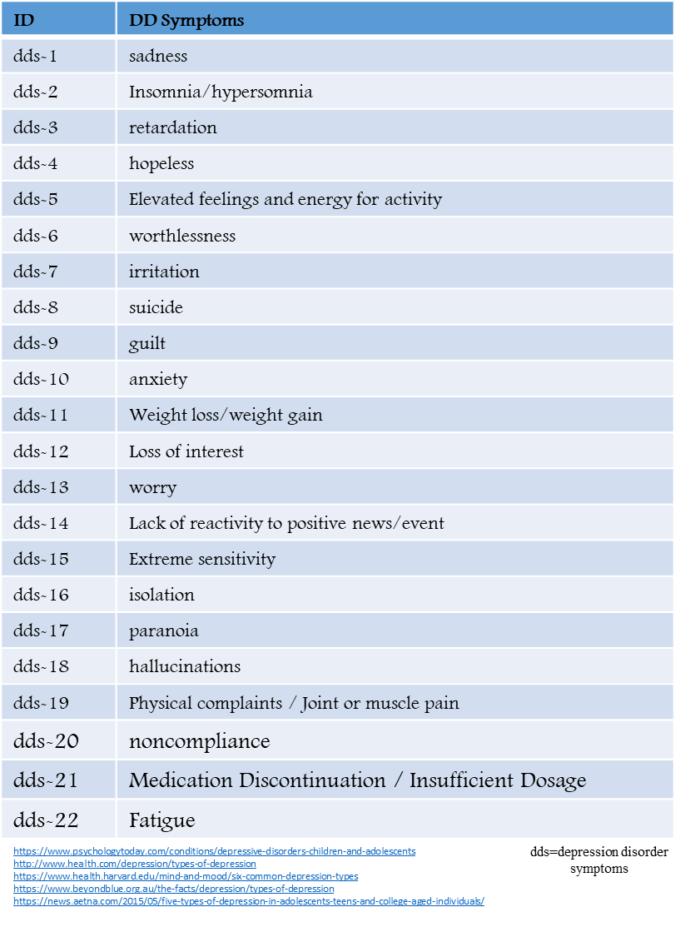

Figure 2. Symptoms of Depression (1st draft version)

Multiple symptoms for a DD teenager will be integrated to expose explicitly, and the integration pattern of multiple DD symptoms according to a personal characteristics. Various depression disorder patterns in teenagers. Among them bipolar, melancholia, cyclothymic disorder, seasonal affective disorder and substance induced mood disorder are the common [8][9].

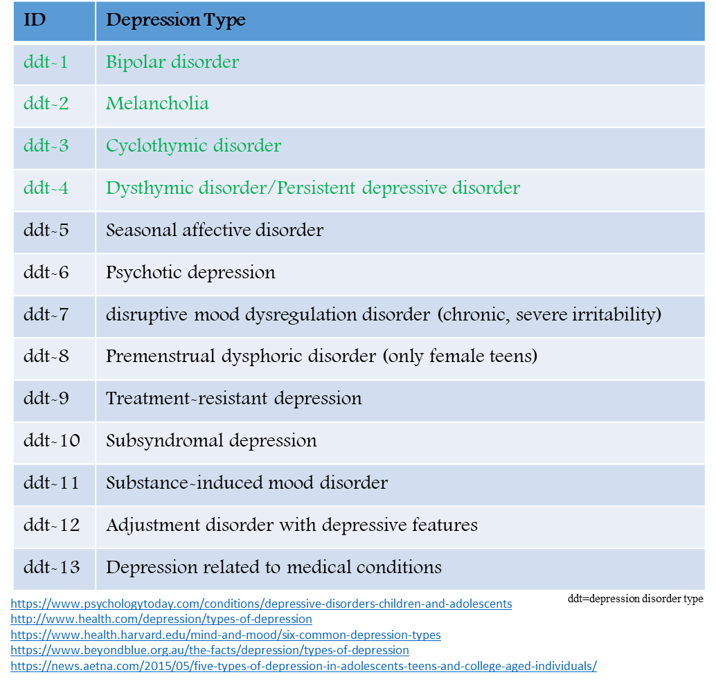

Figure **3**. Types of DD for Teenager (1st draft version)

# Data availability provision for AI-DDAS

We need multiple data in order to monitor the depressive disorder with high accuracy. Initially the primary data is collected and then it will be processed with artificial intelligence (AI) schemes. The primary data includes questionnaire data from teenagers themselves and their parents. The other data like how teenager or parent interact each other and for how much time they interact. Because these interaction is directly proportional with teenager depression. The data from sleeping patterns are also useful in order to detect depression. From SNS posts we can detect user activities, which can be helpful in the detection of teenager’s depression intensity. Indoor and outdoor environment data is also effect on teenager’s depression. The data requirement for monitoring the depressive disorder is illustrated figure 4.

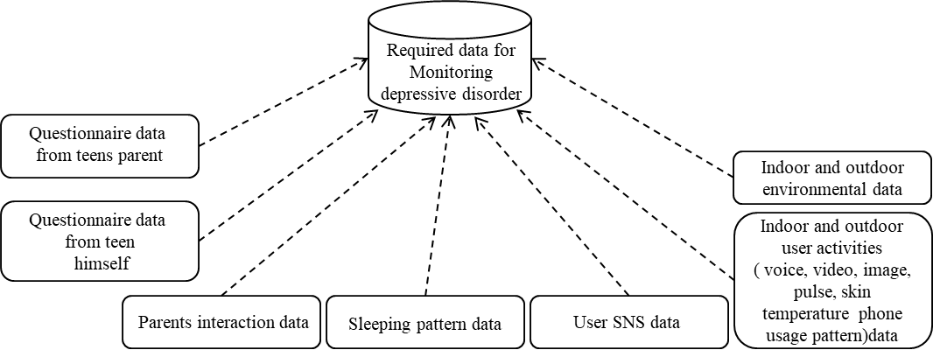

Figure 4. Data requirement for depression disorder

## 4.1 Depressive disorder data analysis and depressive disorder assistance services platform for teenagers

The various types of data would be collected such as data from wearable and non-wearable sensors, questionnaire data, daily activities data, sleep pattern data, and indoor and outdoor environment data. Initially the collected data is preprocessed to clean and fill the missing data, then the machine learning models are applied over the processed data in order to get more acceptable accuracy of the current situation of depressive disorder teenager. Based on the data current situation of the teenager, the recommended services by the psychiatric can be offered to the teenagers. The system can also monitor the severity of the situation in order to facilitate the teenager in emergency situation. The figure 5 illustrate the model of depressive disorder assistance services (DDAS).

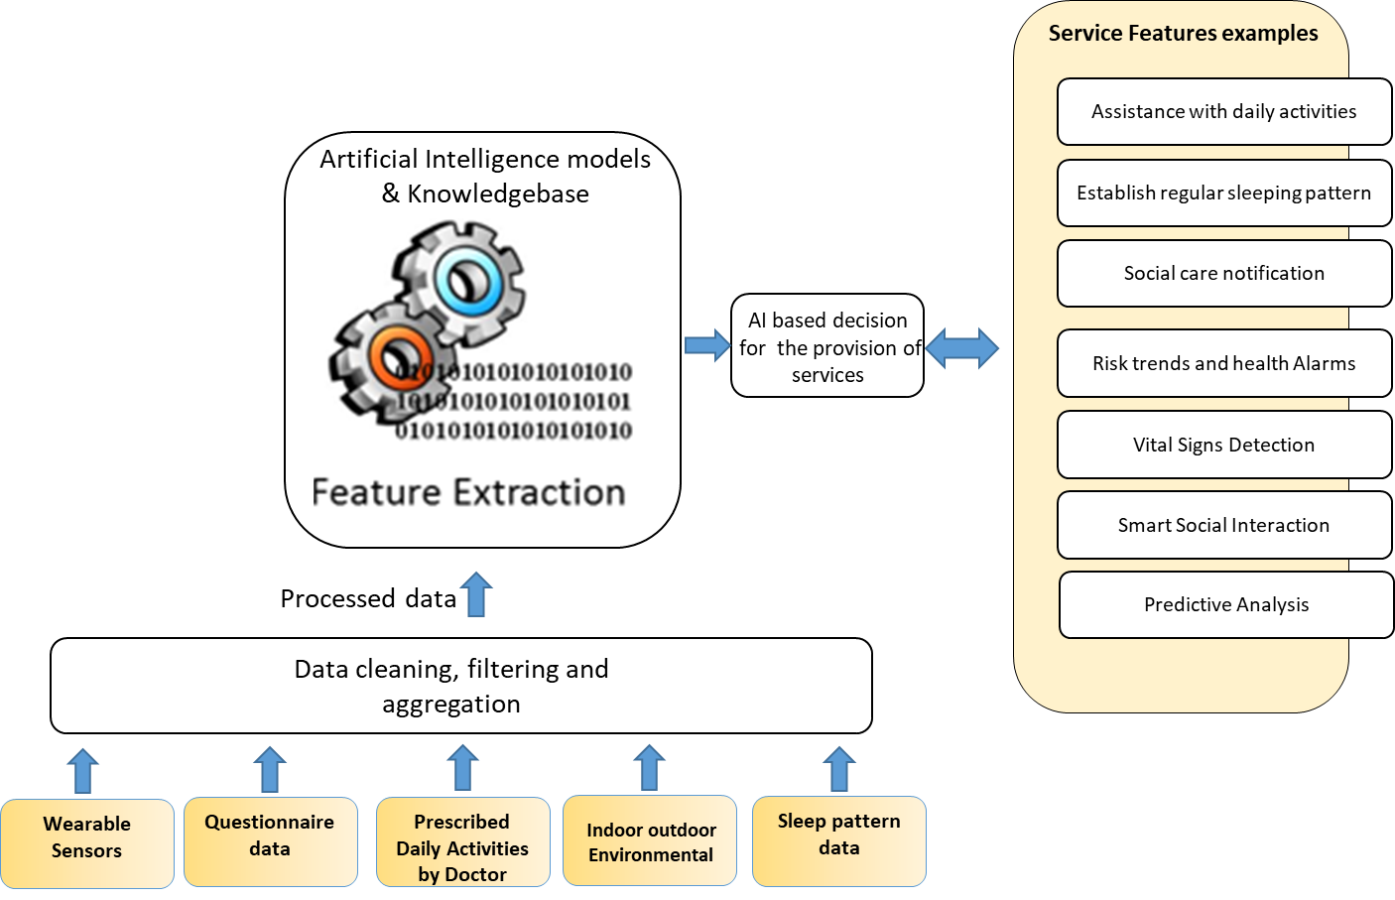

Figure 5. Depressive disorder assistance service (DDAS) provision model.

# Results of teenagers depressive disorder monitoring and analysis

We collected data for bipolar depressive disorder data for nine month and analyze that data. In this data six different symptoms were recorded as shown in the figure 6.

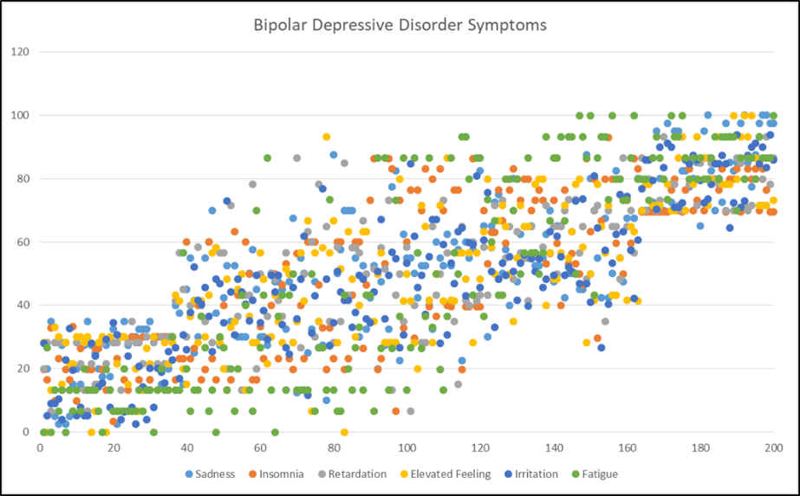

Figure 6. Bipolar depressive disorder symptoms intensity in teenager during a time span of nine month

The environmental factors also effect the depression in teenagers. In the cold weather when the temperature decreased the depression level can also increase in the teens as shown the figure 7.

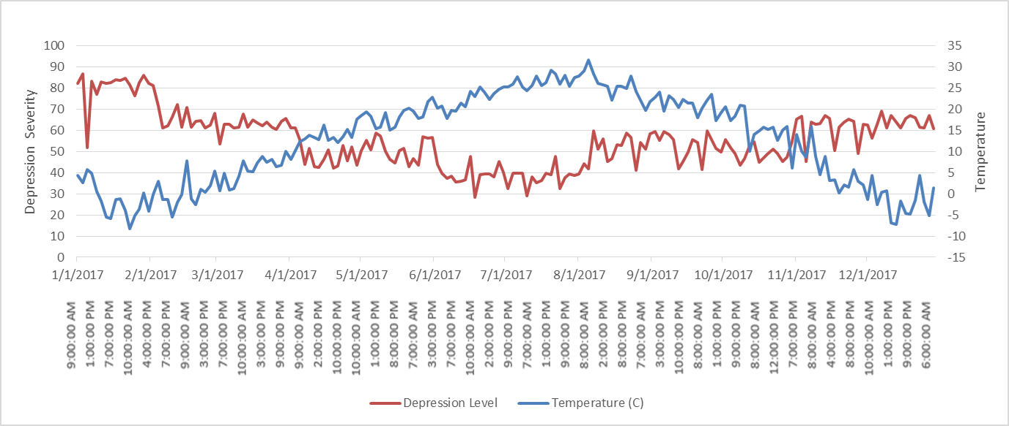

Figure 7. Effect of decrease in temperature on teenager’s depressive disorder

Based on the six months history data, the new two weeks data has been tested. The results show that depression level increased in the noon and remain normal in the morning and night as shown in the figure 8.

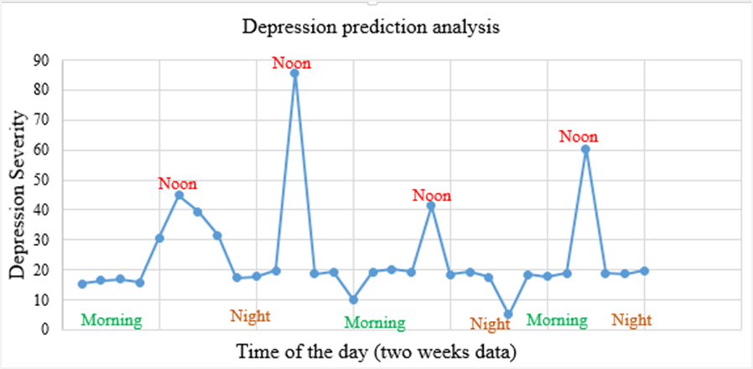

Figure 8. Prediction of depression severity in a time of day

The machine learning model shows the highest accuracy in order to classify the depression types. The machine learning classification model was trained based on nine months history data, which contains two classes (i.e. bipolar and cyclothymic). We have tested the model, we feed two months data to the classifier model and it correctly classified the depression type. The figure 9 shows the correctly and incorrectly classified number of instances for depressive disorder types.

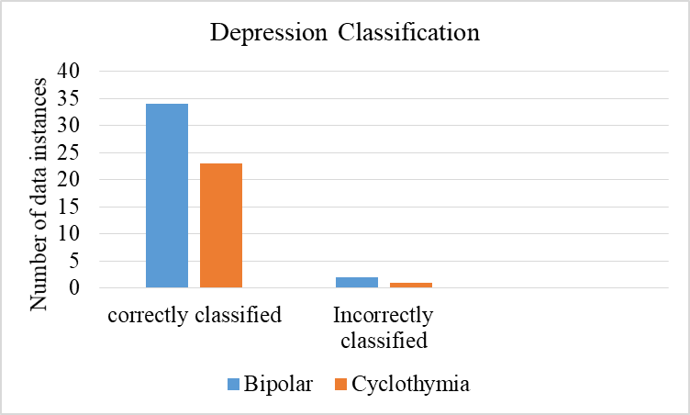

Figure 9. Depression classification model accuracy

We have used regression model to classify the two types of depression including bipolar and cyclothymic. The figure 10 shows that the fitting of regression line in the classification of depression types.

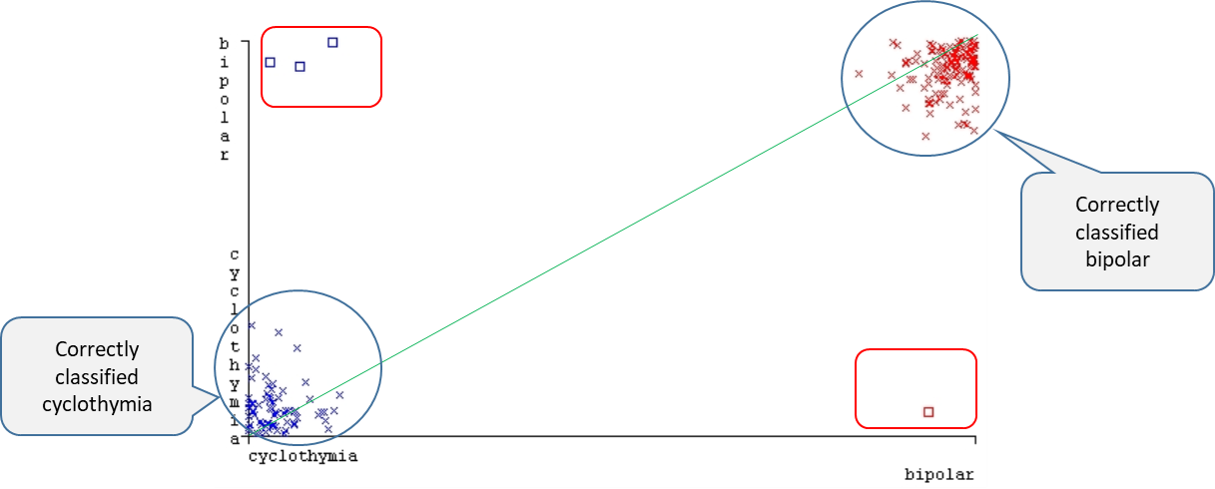

Figure 10. Regression model for the classification of depression types

# Expected model of AI-DDAS

AI-DDAS will help the depressed teenager to recover from the depression situation as shown in figure 11. Due to the continuous monitoring and tracking of teenagers depression symptom the psychiatric will get the status of teenager depression in frequent manner and this will help the psychiatric to recommended better medication and therapy to the depressed teenager. Moreover, the AI-DDAS could significantly reduce the worries of parent’s life.

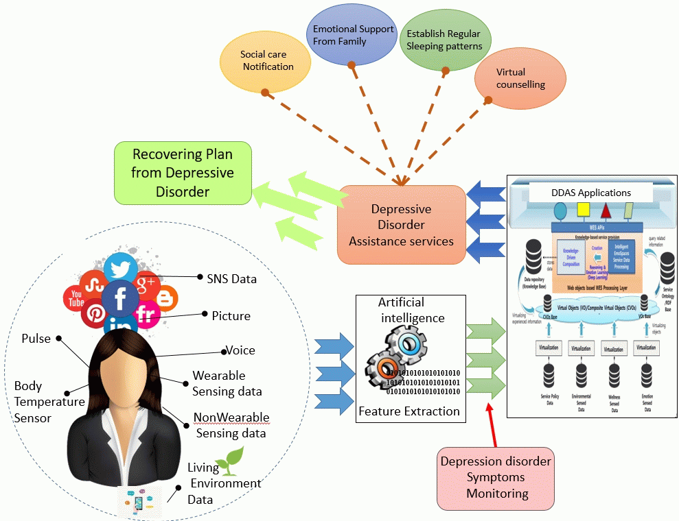

Figure 11. Expected model of AI-DDAS

1. **Proposal**

Based on the above preliminary study of depressive disorder for teenager, it will be proposed to develop the document of the following title in the FG-AI4H:

* Technical Report AI-DDAS:

**“Data availability and benchmarking for AI based Depressive Disorder Assistance Service (AI-DDAS) for teenager”**

Bibliography

[1] World Health Organization, “Depression: let’s talk&quot; says WHO, as depression tops list of causes of ill health,” World Health Organization, 2017.

[2] A. Ghandeharioun *et al.*, “Objective Assessment of Depressive Symptoms with Machine Learning and Wearable Sensors Data,” 2017, pp. 325–332.

[3] The National Institute of Mental Health, “U.S. Department of Health and Human Services, National Institutes of Health, National Institute of Mental Health. (2015). NIMH Strategic Plan for Research (NIH Publication No. 02-2650).,” 2016. [Online]. Available: https://www.nimh.nih.gov/health/topics/depression/index.shtml. [Accessed: 10-Feb-2018].

[4] M. G. Craske *et al.*, “Computer-assisted delivery of cognitive behavioral therapy for anxiety disorders in primary-care settings.,” *Depress. Anxiety*, vol. 26, no. 3, pp. 235–42, 2009.

[5] “IoT Healthcare Solutions - Medical Internet of Things for Healthcare Devices and Hospitals.” [Online]. Available: https://www.kaaproject.org/healthcare/. [Accessed: 11-Feb-2018].

[6] “HealthSaaS | The Internet of Things (IoT) Platform for Healthcare.” [Online]. Available: https://www.healthsaas.net/. [Accessed: 11-Feb-2018].

[7] B. Hosseinifard, M. H. Moradi, and R. Rostami, “Classifying depression patients and normal subjects using machine learning techniques and nonlinear features from EEG signal,” *Comput. Methods Programs Biomed.*, vol. 109, no. 3, pp. 339–345, Mar. 2013.

[8] “Depressive Disorders (Children and Adolescents) | Psychology Today.” [Online]. Available: https://www.psychologytoday.com/intl/conditions/depressive-disorders-children-and-adolescents. [Accessed: 19-Sep-2018].

[9] “Five types of depression in youth.” [Online]. Available: https://news.aetna.com/2015/05/five-types-of-depression-in-adolescents-teens-and-college-aged-individuals/. [Accessed: 19-Sep-2018].

____________________________