|  |  |  |  |  |
| --- | --- | --- | --- | --- |
| ITU Logo | INTERNATIONAL TELECOMMUNICATION UNION  **TELECOMMUNICATION STANDARDIZATION SECTOR**  STUDY PERIOD 2017-2020 | | FG-AI4H-A-014 | |
| **ITU-T Focus Group on AI for Health** | |
| **Original: English** | |
| **WG(s):** | | N/A | Geneva, 25-27 September 2018​ | |
| **DOCUMENT** | | | | |
| **Source:** | | Peking Union Medical College Hospital | | |
| **Title:** | | Effectiveness and experience sharing of AI study on retinal diseases | | |
| **Purpose:** | | Discussion | | |
| **Contact:** | | Weihong Yu Peking Union Medical College Hospital, Chinese Academy of Medical Sciences China | | Tel: + 86-10-69155817 Fax: + 86-10-69155817  Email: [536273640@qq.com](mailto:536273640@qq.com) |
| **Contact:** | | Shan Xu Ministry of Industry and Information Technology (MIIT) China | | Tel: +86-010-62300338 E-mail: [xushan@](mailto:xushan@)caict.ac.cn |
| **Contact:** | | Ziyi Yang Ministry of Industry and Information Technology (MIIT) China | | Tel: +86-010-62300338 Email: yangziyi@caict.ac.cn |
| **Abstract:** | | In this document, we present the background and current work of AI study on retinal diseases in China. The main work includes three aspects: diabetic retinopathy screening, rapid multiple retina disease screening and glaucoma screening based on colour retina photographs. A reference model for diabetic retinopathy screening is being applied for clinical trial validation. We propose to contribute to the establishment of a well-annotated public training dataset for diabetic retinopathy, which may be useful for a variety of eye disease screenings to aid international AI research on retinal diseases. | | |

1. **Background and Effectiveness**

Diabetic retinopathy (DR), as a major complication of diabetes, has become the leading cause of vision loss in China, which has more than 100 million diabetic patients with a DR prevalence rate of around 30%. The Chinese government are doing diabetic retinopathy screening in several areas in China, hopefully to stop blindness at the early stage of diabetic retinopathy and therefore reduce its burden to society and families. Early screening of DR based on color fundus images is well recognized as an effective measure to prevent blindness. Diabetic patients with no retinopathy or mild non-proliferative diabetic retinopathy (NPDR)are recommended to have annual screening, while moderate NPDR, severe NPDR and proliferative diabetic retinopathy (PDR) patients need to be referred to retina specialists for further evaluation, closer follow-up or treatment. Given the high demand for large-scale DR screening, lack of ophthalmologists has become a bottleneck of timely DR screening, especially in developing countries.

In recent years, artificial intelligence technology based on neural network learning theory is booming, and are very likely to be applied to DR screening which is expected to dramatically improve the efficiency of DR screening.

The department of Ophthalmology in Peking Union Medical College Hospital, Chinese Academy of Medical Sciences, in collaboration with technological companies in China, has carried out in-depth preliminary research in the field of AI diabetic retinopathy grading and identifying lesions (microaneurysm, intraretinal hemorrhage, hard exudation, laser spot, etc.). Around 70,000 fundus color photographs were graded for diabetic retinopathy and nearly 1 million lesion data were annotated. The product has entered the clinical trial application stage.

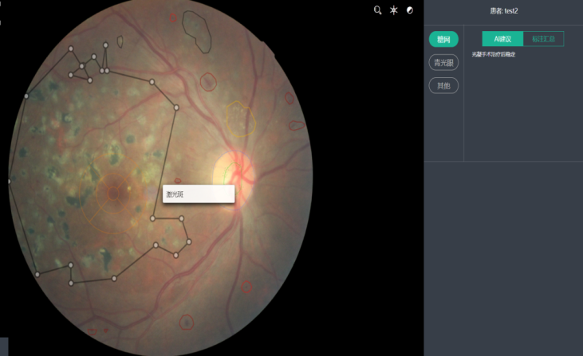

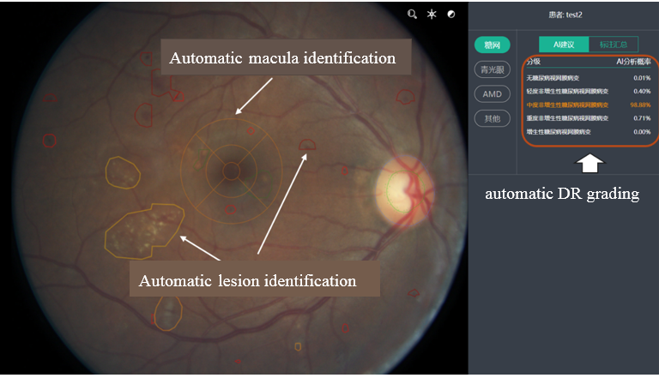

On the basis of automatic DR grading and lesion detection, we further developed a AI system to recognize multiple retina diseases. Through the analysis of digital fundus color photography, more than 30 kinds of fundus diseases can be detected automatically. On a test set of more than 10,000 digital fundus color photographs, the specificity and sensitivity of the automatic detection of more than 10 kinds of fundus diseases exceed 85%. The specificity and sensitivity of automatic detection of pathological myopia has exceeded 95%.

Research on glaucoma is also under way, focusing on in-depth learning techniques for automatic cup/disc segmentation (as shown below), followed by automatic segmentation of nerve fiber layer defects.

1. **Relevant experience and key points for further work**

After nearly 2 years of AI study of retina diseases, our team realized that:

1. AI research emphasizes the collaboration between doctors and engineers. It is important to train a high-quality doctor team to perform high-quality dataset labelling in order to train a good AI model.
2. In the later stage of product verification, clinical trials should also be conducted under the guidance of hospital experts.
3. AI is a brand-new field, which needs supervision by regulatory departments, health commissions, in order to form a high quality AI market and system in China.
4. Further work will focus on the establishment of a standard test set for retina diseases AI, and will focus on further development of AI research based on more precise examination such as OCT, fluorescence angiography, to improve the accuracy of AI.
5. **Our submission:**

We propose to work out and submit a well-labelled public training dataset and test dataset of diabetic retinopathy color photographs. The composition of the submitted color photographs will take into account several main factors: the type and model of camera equipment used, the width of the photography field, and the proportion of the each stage pictures according to different application scenarios (such as primary screening or diagnosis in a tertiary hospital).

_____________________