ANNEX A

How Communications Will Change Vehicles
  - Workshop on Vehicle Communications and Automated Driving; and
Meeting of the Collaboration on ITS Communication Standards
  - 28-29 July 2015, Beijing, China

Practical Information for Participants

1 Event venue
Beijing International Convention Centre (Beijing Continental Grand Hotel)
Address: No.8 Beichen Dong Road, Chaoyang District, Beijing P. R. China
Tel.: +86 10 84980105
Fax: +86 10 84970106
E-mail: yuding@bcghotel.com
Website：www.bcghotel.com
www.bicc.com.cn

2 Hotels
The list of proposed hotels may be found in Annex B.
Preferential rates have been obtained with Beijing Continental Grand Hotel.

3 Arrival and transportation
Arrival

Local airport: Beijing Capital International Airport (http://en.bcia.com.cn/)

Transportation to/from the airport
- Taxi

It is about a 35-minute drive from Beijing Capital International Airport to Beijing Continental Grand Hotel depending on traffic conditions. Taxis are always available. The fare will be around 90 CNY.

Please Note:

Taxi drivers may not speak English, so make sure you have the name of your hotel or address written in Chinese. The following is the name and address of the Beijing Continental Grand Hotel in Chinese; please print it for your convenience:

北京国际会议中心（北辰五洲大酒店）

地址：朝阳区北辰东路8号

电话：+86 10 84980105

- Shuttle Buses
Take Shuttle Bus Line 5 at Beijing Capital International Airport and get off at Asian Games Village (Anhui Bridge) [fare: 21 CNY]
The Bus runs every 30 minutes between: 5:10～22:00. Buses depart when fully seated.

- Subway (Not Recommended)
Take the Airport Express at Beijing Capital International Airport and transfer to line 10 at Sanyuanqiao Station and then transfer to line 8 at Beitucheng Station. Please stop at the Olympic Sports Center Station, and find Exit B2.

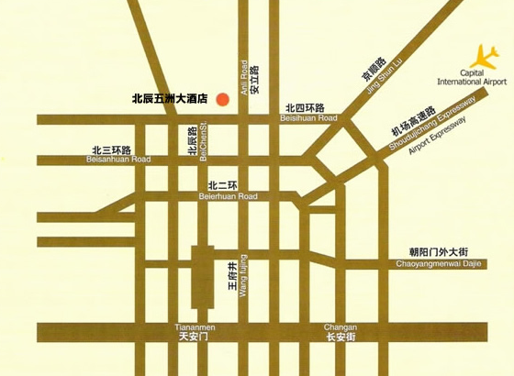

4 Visa – Formalities for entering China

For entering China, it is required to hold either a tourist or business visa. Should you require a personal letter of invitation for your business visa application, please contact Mr. Xu Qi. Your email should attach the Invitation Letter Request Form (Annex C) filled with all the necessary information and be sent out before 1 July 2015.

Mr. Xu QI
Tel: +86 10 62304200
Mobile: +86 13466724696
Email: qixu@ccsa.org.cn
Fax: +86 10 62301849-4200

For Chinese Embassy or Consulate information, please visit website http://www.fmprc.gov.cn/eng/.

5 Currency exchange
The currency in China is the CNY or RMB. Businesses accept most major credit cards. Only Chinese Yuan (CNY) is accepted at stores and restaurants. Major foreign currencies may be exchanged to CNY at the hotel and foreign exchange banks in Beijing and at the airport. Regular banking hours are from 9 am – 5 pm, Monday - Friday and 10 am – 4 pm during weekends.

6 Language
The meeting official working language will be in English.

7 Climate
http://www.weather.com.cn/english/

8 Local time
Standard time zone: UTC/GMT +8.

9 Telecommunications

The country code for China is +86. There are cdma2000 1x/1xEVDO, GSM, TD-SCDMA, WCDMA, FDD-LTE and TDD-LTE coverage in Beijing.

10 Electricity
The Standard electrical current/outlet in China is 50Hz, 220V, AC. The standard outlet and plugs are shown below:

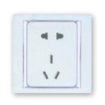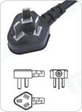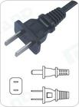
Please be sure you have the right adapter.

11 Health
For medical emergencies, there is a major hospital named Beijing Anzhen Hospital near the Beijing Continental Grand Hotel. If you have any emergency, please contact Mr. Xu QI at +86 13466724696.

12 Internet connectivity
Free WLAN will be available at the meeting venue. Payment may be required at certain hotels.

13 Contact
For any questions, please contact:
Mr. Xu QI
Tel: +86 10 62304200
Mobile: +86 13466724696
Email: qixu@ccsa.org.cn
Fax: +86 10 62301849-4200

Note:
General information about Beijing: http://www.ebeijing.gov.cn/

Annex B: List of hotels

NAME OF HOTEL | TYPE OF ROOM | PRICE including tax and breakfast | CONTACT
Beijing Continental Grand Hotel  （4 stars）  （Recommended） | See reservation form in Annex D |  | http://www.bcghotel.com/English/
V-Continent Beijing Parkview Wuzhou Hotel  （5 stars） | Delegates have to make their bookings by themselves |  | http://v-continent.com/en/
InterContinental Beijing Beichen  （5 stars） | Delegates have to make their bookings by themselves |  | http://www.ihg.com/intercontinental/hotels/gb/en/beijing/peghc/hoteldetail

Annex C: INVITATION LETTER REQUEST FORM

To enter China for the meetings indicated above, you may need a letter of invitation from the Chinese host, which you will need to present to the Chinese Embassy/Consulate in your area in order to obtain your visa. In order to obtain the invitation letter, please:

- Fill out the form below
- Send it to (please reference “Invitation letter request for ITS meeting” as the subject):

Mr. Xu QI
China Communications Standards Association (CCSA)
qixu@ccsa.org.cn
(It’s recommended to scan your passport page and email to us so that it’s discernible and can be used.)
Fax number: +86-10-62301849-4200 (if your passport page is photocopied and enlarged)

Company
Applicant  Information |  |  |  | Mr Ms Mrs
 | Date of birth :
 | Is this your first visit to China? |  |  | __ Yes ___ No
 | If the country in which you'll obtain your visa is different from your nationality, please indicate it here:
Address
Place to visit after entry | In this case, it is Beijing by default.
Date of arrival in China |  |  | Date of departure from China
Time restriction |  | According to the policy of MIIT of China, in this case, we can provide a five-day invitation letter (at most, covering the meeting time) to the delegates.
(Please do not forget to attach a copy of your passport photograph page before sending.)
Your information should be sent out before 1 July 2015.

End of form

Annex D: Beijing Continental Grand Hotel
Reservation Form

Please complete this form and send it to the hotel manager at yanruowei@bicc.com.cn by
20 July 2015.

Name | First : |  | Sex | Male □ Female □
 | Last : |  | Title | Mr.□ Ms. □ Dr. □ Prof. □
Company:
Mailing address:
Tel : |  |  | Passport No. :
E-mail : |  |  | Credit Card type:
Card Number: |  |  | Expiration Date:
Check-in Date |  |  | Check-out Date
Room Type |  | Deluxe Room （single） □ CNY 640 per night
 |  | Deluxe Room （Double） □ CNY 640 per night
 |  | (Service fee and breakfast are included, internet access will be charged CNY 90 per day.

♠ NOTE
Reservations after 20 July 2015 will be accepted only upon room availability.

_______________________

