 | INTERNATIONAL TELECOMMUNICATION UNION  TELECOMMUNICATION  STANDARDIZATION SECTOR  STUDY PERIOD 2017-2020 |  | DOC 1
 |  |  | Collaboration on Intelligent Transport Systems Communication Standards
 |  |  | Original: English
Question(s): |  |  | Arlington, USA, 6 December 2017
DOCUMENT
Source: |  | Chairman, Collaboration on ITS Communication Standards
Title: |  | Draft agenda (CITS meeting, 6 December 2017, Arlington, USA)
Purpose: |  | Information
Contact: |  | T.Russell Shields  Ygomi LLC  United States |  | Tel:  Fax:  Email: trs@ygomi.com
Please don’t change the structure of this table, just insert the necessary information.
Draft agenda
Meeting of Collaboration on ITS Communication Standards
6 December 2017, Arlington, USA
http://itu.int/go/ITScomms

Time | Agenda item
8:30 | Registration
9:00-9:15 | 1 Opening  – Welcome, opening of the meeting  – Introduction of meeting participants  – Approval of draft agenda [Doc 1]
9:15-9:30 | 2 Wrap-up of ITU/TIA Workshop on "Autonomous Transportation" – How communications will change vehicles & transport – 5 December 2017
9:30-10:30 | 3 Status of ITS communications work in various SDOs  – SAE International [Doc 16] (S. William Gouse, SAE International – remote presentation)  – TTC WG on Connected Car [Doc 11] (Yushi Naito, Mitsubishi Electric, Japan)  – WWRF VIP WG The Connected Car [Doc 17] (Seshadri Mohan)  – ISO TC 204 [Doc 18] (Adrian Guan, TC 204 Secretariat)  – IEEE VTS Standards [Doc 09] (Tom Kurihara, IEEE VTS)  – UNECE WP.29: Vehicle Regulations (T. Russell Shields, Chair CITS)  – Intelligent Transport Systems and Automated Driving (ITS/AD)  – UN Task Force on Cyber security and OTA issues (CS/OTA)  – OTHER?
10:30-11:00 | Coffee break
11:00-12:30 | 4 Status of ITS communications work items in ITU  – Overview of all ITS work items (maintained by Secretariat)  – ITU-T (Q4/12) work items on objective methods for vehicles speech & audio evaluation [Doc 08]  – ITU-T (Q27/16) work items on vehicle gateway platform [Docs 4, 5, 6, 7 and 10]  (Yushi Naito, Mitsubishi Electric, Japan, SG16)  – ITU-T (Q13/17) work items on ITS communications security [Docs 2, 3 and 15]  (Koji Nakao, NICT, SG17)  – ITU-T (Q2/20, Q4/20) work items related to IoT to support ITS [Doc 14]  (Marco Carugi, NEC, SG20 – remote presentation)  – ITU-R work items related to radio ITS [Doc 13]  (Tom Schaffnit, USA, ITU-R WP5A)
12:30-12:45 | 6 Next meetings  – Symposium on the Future Networked Car (FNC-2018) – 8 March 2018, @ Geneva Motor Show, Switzerland  – CITS meeting – 9 March 2018, ITU premises, Geneva, Switzerland  – CITS meeting plus workshop – 6-7 Sept 2018, Nanjing, China (TBC) | 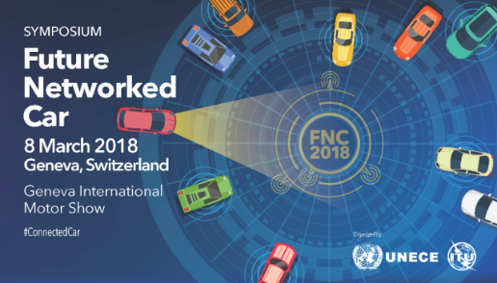
12:45-13:00 | 7 Any other business
13:00 | 8 Closure of the meeting

____________________

