 | INTERNATIONAL TELECOMMUNICATION UNION  TELECOMMUNICATION  STANDARDIZATION SECTOR  STUDY PERIOD 2022-2024 |  |  |  |  | SCV-TD16
 |  |  |  |  |  | SCV
 |  |  |  |  |  | Original: English
 |  | 8, All/5 |  |  |  | Virtual, 10 November 2022
TD
(Ref.: SG5-LS14)
Source: |  | ITU-T Study Group 5
Title: |  | LS/r on SG5 comments on SCV activity in SG2 (reply to SG2-LS2)
LIAISON STATEMENT
For action to: |  |  |  | SG2
For information to: |  |  |  | SCV, SG3, SG9, SG12, SG13, SG15, SG16, SG17, SG20.
Approval: |  |  |  | ITU-T Study Group 5 meeting, (Geneva, 1 July 2022)
Deadline: |  |  |  | N/A
Contact: |  |  | Michael Maytum  Rapporteur Q8/5 |  | Tel: +44 1234838589  E-mail: maytummichael3@gmail.com

Abstract: | This Liaison responds to the liaison topics of distributed ledger technology, SG2 definitions and ISO/IEC definition format.
This LS replies SG2-LS2.
ITU-T Study Group 5 (SG5) thanks ITU-T Study Group 2 for keeping ITU-T SG5 informed on the alignment terms and definitions work.
This reply covers the ITU-T SG2 liaison topics of distributed ledger technology, ITU-T SG2 definitions and ISO/IEC definition format.
Distributed Ledger Technology (DLT)
The ITU Terms and Definitions database lists:
distributed ledger technology
Recommendation ITU-T F.747.10 (01/2022)] Technology that enables the operation and use of distributed ledgers.
[ITU-T F.751.1 (08/2020)] Technology enabling large groups of nodes in distributed ledger networks to reach agreement and record information without the need for a central authority.
[Recommendation ITU-T X.1404 (10/2020)] Technology that enables the operation and use of distributed ledgers.
[Recommendation ITU-T X.1400 (10/2020)] Technology that enables the operation and use of distributed ledgers.
On Recommendation ITU-T L.1317, the definition entry now reads
3.1.6 distributed ledger technology (DLT) [ITU-T X.1400]: Technology that enables the operation and use of distributed ledgers.
This is in line with the SG2 request.
SG2 definitions
The SG2 definitions for the terms; Communication network health, Communication network health index and Network toughness, all pass the SG5 Author’s guide crib sheet criteria.
SG5 Author’s guide crib sheet
1. Clause number followed by tab to term
Example 3.1.1 (Bold 12 pt, Times New Roman)
2. Term followed by space
Example amendment (Bold 12 pt, Times New Roman)
Q8/5 Note – Terms list must be in alphabetical order.
3 [Class of object] followed by space
Example [b-ITU-T A.1]: (12 pt, Times New Roman)
Q8/5 Note – The Authors guide is fuzzy on this, only source document reference is shown, whereas it could apply to a usage domain.
4 definition
Example Changes or additions to an already published ITU-T Recommendation. (12 pt, Times New Roman)
Q8/5 Note – There is a shopping list of requirements here
A. Must be concise and the Vocabulary committees look for a single sentence ending with a period.
B. Definitions must be able to stand alone.
C. Figures or equations can assist with the understanding of the meaning of a term, but they should not form the essence of the definition.
D. Definitions where abbreviations are used must include an explanation of the abbreviation.
Q8/5 Note – Definitions should not reference other parts of the standard or other references (standalone). Figures or equations with a definition must be informative and not form the definition. Abbreviations must be explained.
5 NOTE –
Example NOTE – If an amendment forms an integral part of the Recommendation, approval of the amendment follows the same approval procedure as the Recommendation; otherwise (e.g., when all changes are in appendices), it is agreed by the study group. (11 pt, Times New Roman).
Q8/5 Note – Notes are informative only and are not part of the definition.
ISO/IEC
The SG5 vocabulary rapporteur has worked with ISO/IEC terms and definitions and has created the following overview of the terminological elements.
ISO/IEC Directives Part 2
In ISO/IEC Directives Part 2 (Edition 9. 02021-05) Principles and rules for the structure and drafting of ISO and IEC documents, clause 16 covers Terms and definitions. In that clause Figure 1 gives an overview of the main elements of a terminological entry.
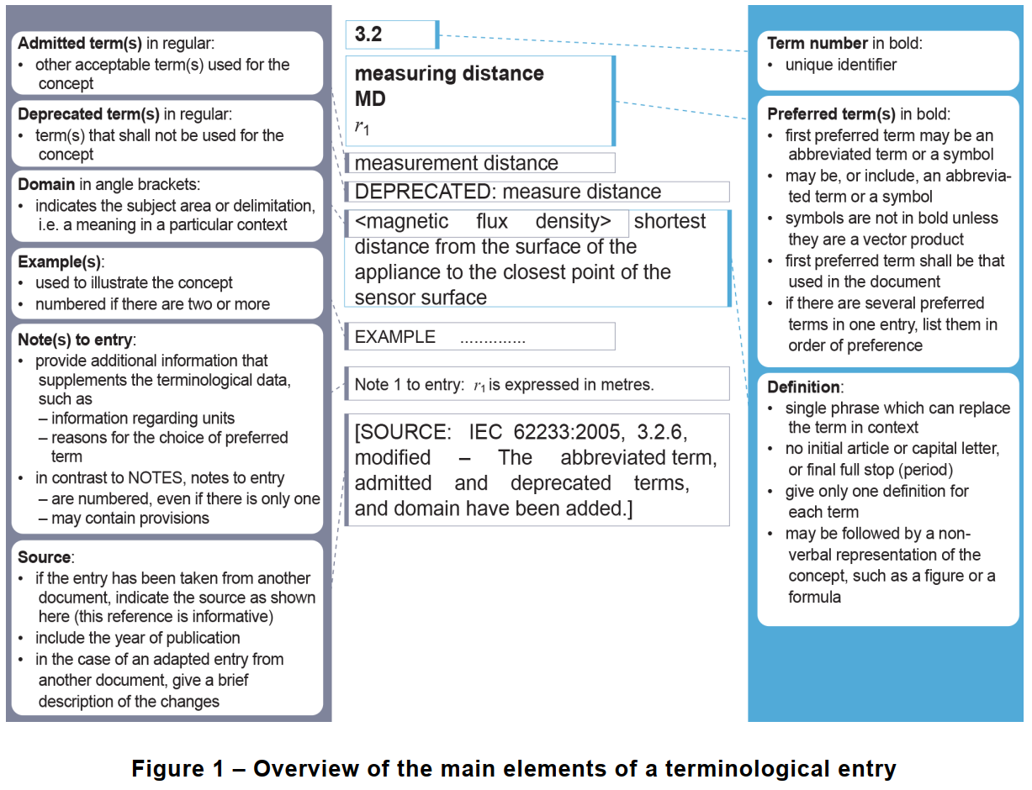
In Figure 1, the right-hand item lists the mandatory elements with the left-hand item listing optional elements. The central list of Figure 1 shows examples of item entry.
The clause 16 text expands on the element details.
Terms
• Preferred terms are the primary terms for a given concept. Preferred terms are written in bold type (with the exception of symbols, which shall be presented as used in running text).
• Admitted terms are accepted synonyms for the preferred term. They are written in regular type.
• Deprecated terms are synonyms of the preferred term, which are no longer in use or whose use is discouraged. They are written in regular type.
Definition
The definition shall be written in such a form that it can replace the term in its context. It shall not start with an article (“the”, “a”) or end with a full stop. A definition shall not take the form of, or contain, a requirement. Circular definitions, which repeat the term being defined, are not allowed.
Example
Examples provide information that illustrates the concept. Examples shall not contain requirements (use of “shall”) or any information considered indispensable for the use of the document, for example instructions (imperative mood), recommendations (use of “should”) or permission (use of “may”). Examples should be written as a statement of fact.
Non-verbal representations
Figures and formulae may be included within a terminological entry. The definition may take the form of a formula.
Notes to entry
A note to a terminological entry (referred to as “Note # to entry”) follows different rules from a
note (referred to as "NOTE #") integrated in the text. It restricts the note to specifically apply only to the definition and not the whole document. It provides additional information that supplements the terminological data, for example:
• provisions (statements, instructions, recommendations or requirements) relating to the use of a term;
• information regarding the units applicable to a quantity; or
• an explanation of the reasons for selecting an abbreviated form as the preferred term.
Source
If a terminological entry is reproduced from another document, the source shall be given at the end of the entry. If any changes are made to the original terminological entry, this shall be indicated, along with a description of what has been modified. A document given as a source of a terminological entry is informative.
Footnotes
Footnotes to any part of a terminological entry are not allowed.

ITU-T SG5 looks forward to collaborating closely with all the relevant parties.

_______________________

