INTERNATIONAL TELECOMMUNICATION UNION |  | SCV
TELECOMMUNICATION STANDARDIZATION SECTOR  Standardization Committee for Vocabulary |  | TD 175
 |  | English only
 |  | Virtual meeting, 8 February 2022
TD
Source: | SCV/Secretariat/CCV Secretariat/ C&P STRAIT
Title: | Process for validating and translating terms

The graphic on the next page describes the procedure followed to validate and translate the terms approved by ITU-R and ITU-T. The figure updates the one that had been presented in the 18 May 2017 meeting (SCV TD 55).

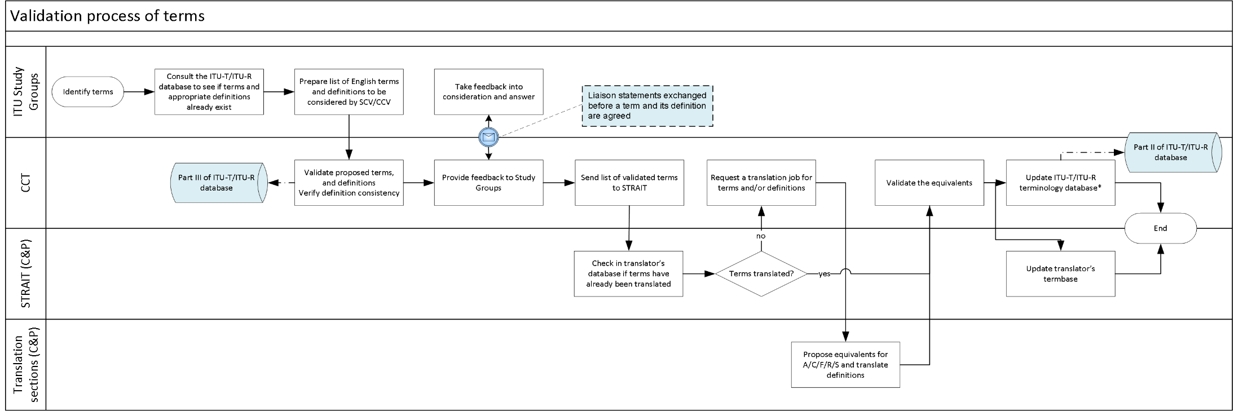
STRAIT : C&P' s Terminology, references and computer aids to translation section.
*The ITU-T /ITU-R terminology database is divided into the following four parts:
- Part I: Terminology issued from the Constitution, Convention and Radio Regulations, as we11 as those terms included in the V-Series Recommendations
- Part II: Terminology related to approved ITU-T/ITU-R texts (Recommendations, Reports, Handbooks, etc.)
- Part III: Temporary terminology issued from the Radiocommunication Study Groups under consideration by the CCT (as well as draft definitions) (restricted access).
- Part IV: A general list of abbreviations and acronyms.
The terms and definitions in English newly proposed or revised during the study period are provided by the ITU-T/ITU-R Study Groups to be included in the database. The translations into Arabic, Chinese, Spanish, French and Russian are provided by the ITU General Secretariat’s Conferences and Publications Department (C&P), and are ultimately approved by the CCT.
_______________

