 |  | INTERNATIONAL TELECOMMUNICATION UNION  TELECOMMUNICATION  STANDARDIZATION SECTOR  STUDY PERIOD 2017-2020 |  |  | SCV-TD137
 |  |  |  |  | SCV
 |  |  |  |  | Original: English
Question(s): |  |  |  |  | Virtual, 7 December 2020
TD
(Ref.: Documents 3J/56 (3/8, 3M/22) and 3J/TEMP/19)
Source: | ITU-R SG 3 Rapporteur for Vocabulary
Title: | Revision of terms used in the transmission loss concept
Purpose:
LIAISON STATEMENT
For action to: |  |  | CCT
For comment to: |  |  | -
For information to: |  |  | -
Approval: |  |  | N/A
Deadline: |  |  | N/A
Contact: |  |  | Ms Clare Allen | E-mail: clare.allen@ofcom.org.uk
Working Party 3J would like to thank the Coordination Committee for Terminology (CCT) for its liaison statement regarding the clarification of the terms highlighted in Document CCV/1 (CCV/62). Recommendation ITU-R P.341-7 revises the definitions for five terms used in relation to the transmission loss concept.
The revised definitions are provided in the Annex for:
– Free-space basic transmission loss
– Basic transmission loss
– Transmission loss
– System loss
– Total loss.
Working Party 3J requests that the CCT revise the definitions for these terms in the ITU terminology database using the text contained in the Annex.
Annex: 1

ANNEX
Figure 1 provides a graphical depiction of the terms used in the transmission loss concept and is relevant to all definitions.
figure 1
Graphical depiction of terms used in the transmission loss concept
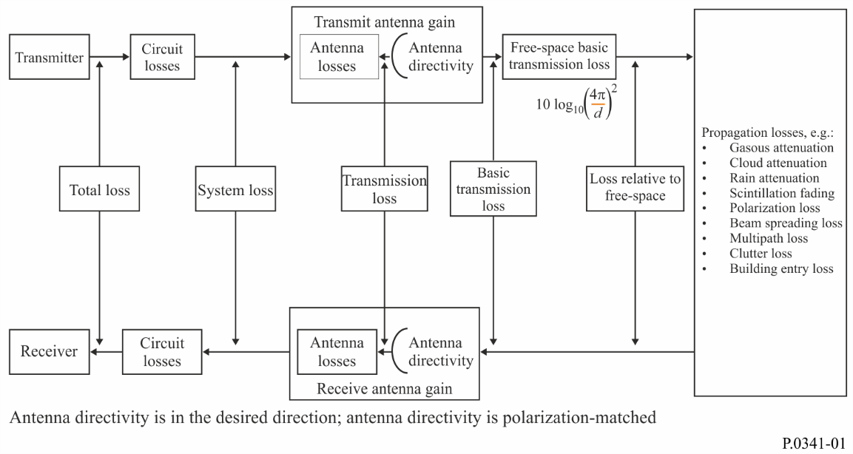
Free-space basic transmission loss (symbols: L_{bf} or A_{bf})
The ratio, usually expressed in decibels, for a radio link between the power radiated by the transmitting antenna and the power that would be available at a conjugately matched receiver antenna input if the actual antennas were replaced by loss free isotropic antennas located in a perfectly dielectric, homogeneous, isotropic and unlimited environment, the distance between the antennas being retained (see Recommendation ITU-R P.525).
NOTE – If the distance d between the antennas is much greater than the wavelength λ, the free-space attenuation in decibels will be:
Lbf = 20 log $\left(\frac{4p d}{l}\right)$ dB (1)
Basic transmission loss (of a radio link) (symbols: L_{b} or A_{b})
The ratio, usually expressed in decibels, for a radio link between the power radiated by the transmitting antenna and the power that would be available at a conjugately matched receiver antenna input if the antennas were replaced by isotropic antennas with the same polarization as the real antennas, including the attenuation effects on the propagation path, but with the effects of obstacles close to the antennas being disregarded.
𝐿_{𝑏}=𝐿_{𝑏𝑓} + 𝐿_{𝑚} dB (2)
where L_{m} is the loss relative to free space (symbols: L_{m} or A_{m}).
NOTE – The loss relative to free space, L_{m}, may be divided into losses of different types, such as:
– absorption loss (ionospheric or atmospheric gases, precipitation, clouds, etc.);
– diffraction loss as for ground waves;
– effective reflection or scattering loss as in the ionospheric case including the results of any focusing or defocusing due to curvature of a reflecting layer;
– polarization coupling loss; this can arise from any polarization mismatch between the antennas for the particular ray path considered;
– aperture-to-medium coupling loss or antenna gain degradation, which may be due to the presence of substantial scatter phenomena on the path;
– beam spreading loss;
– effect of wave interference between the direct ray and rays reflected from the ground, other obstacles or atmospheric layers;
– clutter loss;
– building entry loss.
Transmission loss (of a radio link) (symbols: L or A)
The ratio, usually expressed in decibels, for a radio link between the power radiated by the transmitting antenna and the power that would be available at a conjugately matched receiver antenna input if actual antenna radiation patterns are substituted with no losses in the radiofrequency circuits.
NOTE 1 – The transmission loss may be expressed by:
$L=L_{b}- G_{t}-G_{r}$ dB (3)
where Gt and Gr are the directivity gains (see Annex 1) of the transmitting and receiving antennas, respectively, in the direction of propagation.
NOTE 2 – The effect of the local ground close to the antenna is included in computing the antenna gain, but not in the basic transmission loss.
System loss (symbols: Ls or As)
The ratio, usually expressed in decibels, for a radio link of the radio-frequency power input to the terminals of the transmitting antenna and the resultant radio-frequency signal power available at the terminals of the receiving antenna.
$L_{s}=L+L_{tc}+ L_{rc}$ dB (4)
where Ltc and Lrc are the losses, expressed in decibels, in the transmitting and receiving antennas circuits respectively, excluding the dissipation associated with the antennas radiation, i.e. the definitions of Ltc and Lrc are 10 log (r'/r), where r' is the resistive component of the antenna circuit and r is the radiation resistance.
NOTE 1 – The available power is the maximum real power which a source can deliver to a load, i.e. the power which would be delivered to the load if the impedances were conjugately matched.
NOTE 2 – The system loss may be also expressed by:
Ls = 10 log ( pt /pa) = Pt – Pa dB (5)
where:
where:
pt : radio-frequency power input to the terminals of the transmitting antenna;
pa : resultant radio-frequency signal power available at the terminals of the receiving antenna.
NOTE 3 – The system loss excludes losses in feeder lines but includes all losses in radio-frequency circuits associated with the antenna, such as ground losses, dielectric losses, antenna loading coil losses, and terminating resistor losses.
Total loss (of a radio link) (symbols: Ll or Al)
The ratio, usually expressed in decibels, between the power supplied by the transmitter of a radio link and the power supplied to the corresponding receiver in real installation, propagation and operational conditions. This is determined at the input or at the output of the transmitting and receiving antenna feed lines. The feed lines may include radio-frequency filters or multiplexers.
______________

