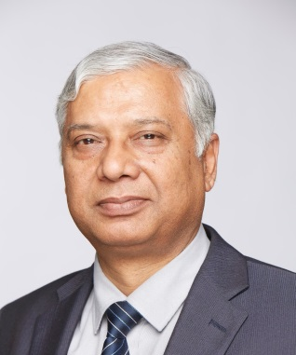Profile

RAKESH GARG

Chairman, Telecom Commission & Secretary, Department of Telecommunications, Ministry of Communications & Information Technology, Government of India

Did B.E. from prestigious University of Roorkee & now IIT, Roorkee & M.Tech from IIT, Delhi. Supplemented it with MBA from University of Ljubljana (pronounced as Lubliana) in Slovenia. Has done many short-term executive refresher / training courses from many prestigious institutions. Is an Alumnus of Harvard Kennedy School (John F. Kennedy School of Government, Harvard University).

As an IAS officer, served in many important places – both in the Centre and the State. Before joining the IAS, worked for 2 years in Indian Railways. In the IAS, got an opportunity to run an Industrial PSU for about 4 years. Worked as Secretary (Industries), Director (Udyog Bandhu – single window clearance & grievance redressal organization for Industries) and as Commissioner, Sales Tax. Also worked in the field of Non-Conventional Energy, Agricultural Marketing and Urban Development. Also held important positions, in the State Government, such as Principal Secretary to Chief Minister and Secretary / Special Secretary to Governor. In Govt. of India, was entrusted with huge logistical challenge of handling FCI operations of food grain movement and storage. Spearheaded the successful Private Sector Participation Scheme for go-down construction which led to creation of storage capacity of more than 150 lakh tonnes across the country including in remote & backward areas.

Has been awarded by Govt. of Uttar Pradesh for outstanding work as District Magistrate, Banda, as also received Presidential Silver Medal in 1991 for exemplary work in the field of census operations.

Has joined as Secretary, Department of Telecommunications on 17th July 2014.

-----------------------------------------------------------------------------------------------------------

Tel: +91 11 23719898 ; email: secy-dot@nic.in