Title of talk | Radiocommunications and climate change
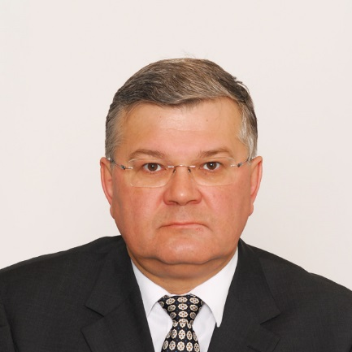 | Vadim Nozdrin
Since 2010 Vadim Nozdrin is BR Counselor of ITU-R Study Groups, in particularly dealing with operational and technical aspects of systems for remote sensing and space research, operating on both ground-based and space-based platforms, as well as airborne and maritime communications. Before Vadim Nozdrin has been working on technical and regulatory aspects of satellite coordination at ITU’s Radiocommunication Bureau since 2000.
Since 1992 he had technical and executive responsibilities at the Moscow Radio Research and Development Institute. He has been involved in studies of technical, regulatory and economical aspects of spectrum management.
He has a degree in telecommunication engineering (1988), and a PhD in spectrum management (1998) from the Moscow University of Telecommunication and Information.

