Title of talk | Information & Communication Technologies (ICTs): Enabler of Green Smart Cities
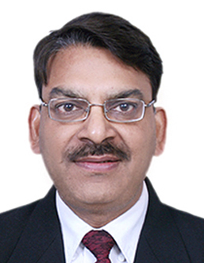 | R. M. Agarwal, DDG(Networks and Technologies), Department of Telecommunications, Ministry of Communications & Information Technology, Government of India
Shri R. M. Agarwal, DDG(NT) is an Indian Telecommunication Services officer and is presently working as Deputy Director General (Networks and Technologies) in the Department of Telecommunications, Government of India. He is having more than 27 years experience in telecom policies, planning, operations and financial management of telecom services. He is designated as the Central Coordinating Officer to coordinate with Government and Industry for IPV6 transition in the country.

While functioning as DDG(Services & Applications) in the Telecommunication Engineering Centre, a standardization body of Department of Telecom , he has brought out IPv6 standard and policy document “National IPv6 Deployment Roadmap” for India in July 2010. He had been editor in ITU (T) in the recommendations related to IPTV services. He has also brought out ‘National IPv6 Deployment Roadmap v2’ in March, 2013 for the time bound IPv6 implementation by all stakeholders in the country. Currently he is responsible for M2M and Cloud service policy formulation as per national telecom Policy 2012. He has delivered number of talks and chaired various sessions at national and international forum on various important subjects.

For examples, see: http://itu.int/ITU-T/worksem/cce/bios.html

