Title of presentation | Evaluating Sustainability of ICT solutions in Cities
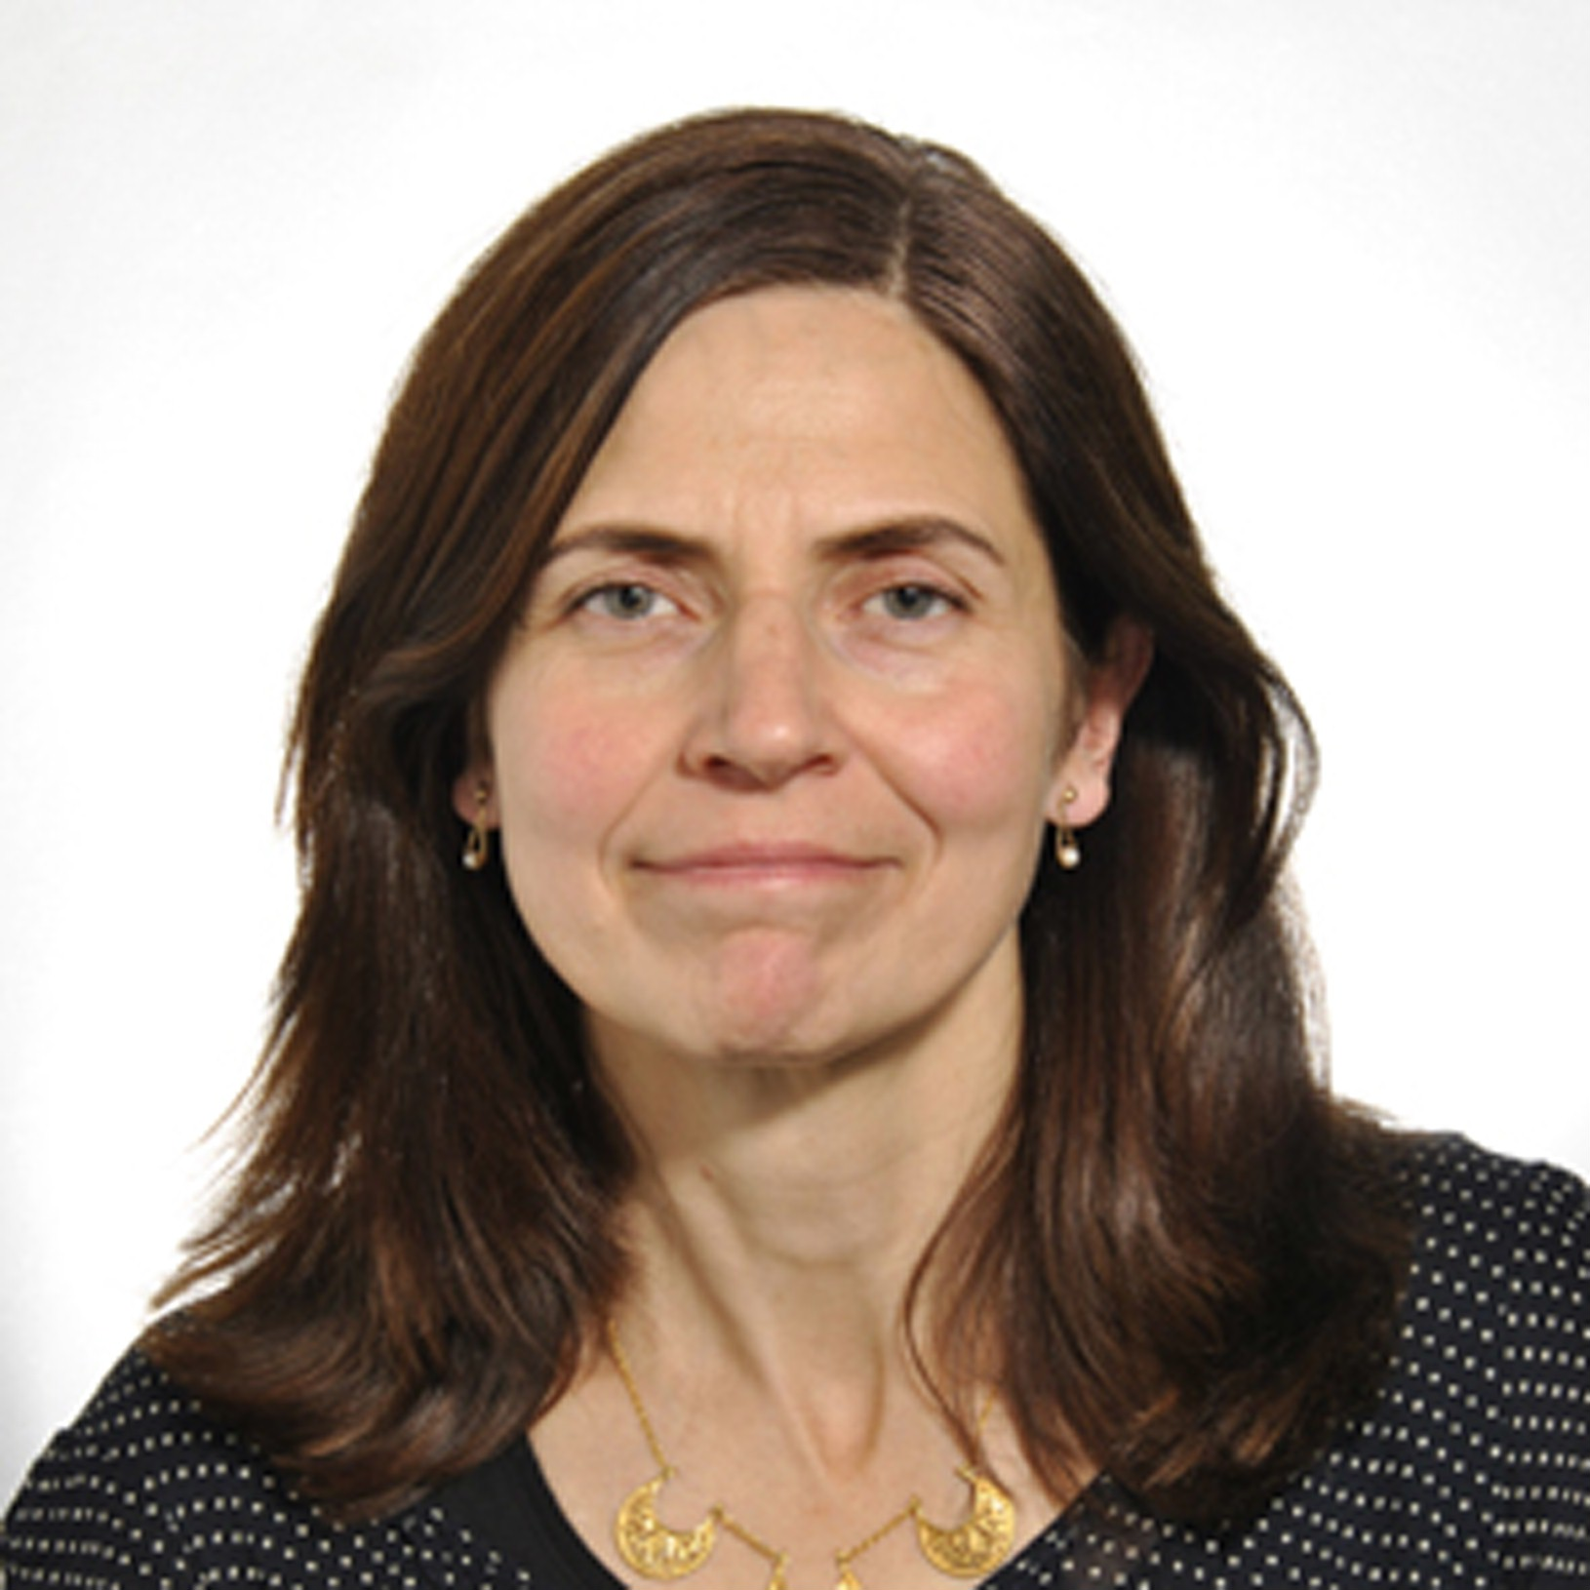 | Pernilla Bergmark, Master Researcher Sustainability Assessments,  Telefon AB L M Ericsson
Pernilla Bergmark started in telecom sector and joined Ericsson in 1994 and worked for several years with system management in various positions, focusing on radio performance and hardware architecture. Over the years she has specialized on energy efficiency and sustainability, particularly focusing on life cycle assessments, and since 2011 she holds a master researcher position in sustainability assessment at Ericsson Research.
Pernilla Bergmark has been an active member of many of the recent standardization initiatives related to life cycle assessments and organizational inventory, including ETSI EE, ITU-T and GHGP ICT supplement. In ITU-T she is currently an editor of the environmental assessment methodology for cities and an associate rapporteur of ITU-T SG5 Q18. She is also active in the ITU Focus Group for Smart Sustainable Cities.
Pernilla Bergmark is a Master of Science in Electrical Engineering from the Royal Institute of technology and graduated 1991.

