Title of talk | Green Communication
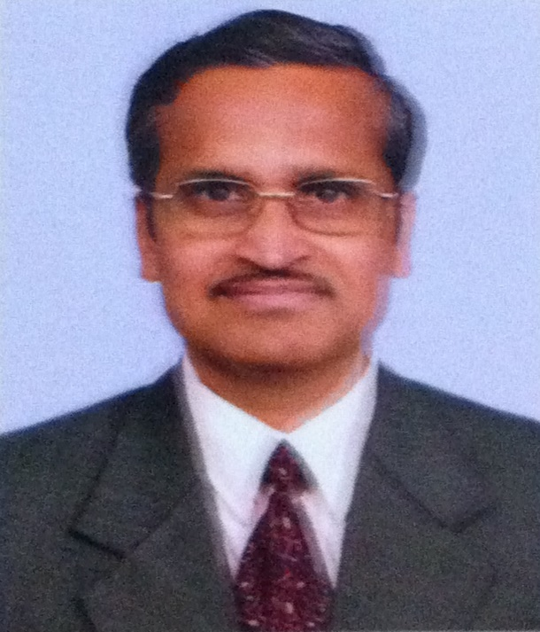 | P.K.Panigrahi
 | Shri. P.K.Panigrahi is an Electrical Engineer from National Institute of Technology, Rourkela, India. Worked in Government of India, Department of Telecom in various capacities in planning, design, installation of telecom infrastructure and is responsible for standardization of electromechanical products, introduction of energy conservation/efﬁciency and renewable energy Technology in telecom sector which has resulted in substantial energy savings. Shri. Panigrahi is a recipient of an Award from Hon’ble President of India in appreciation of the achievements in the ﬁeld of energy conservation. Written papers on standardization, climatic change, energy efﬁciency & conservation, effects of EMF radiation on health from mobile towers/hand-sets, e-waste management, innovative institutions.

