Title of talk | Smart City platforms, methodologies and indicators: the European Commission perspective.
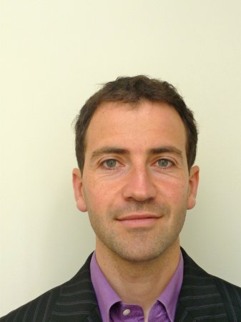 | Cristobal Irazoqui  (European Commission)
Cristobal Irazoqui is working at the European Commission in the unit Smart Cities and Sustainability in the role of "Policy Officer ICT Environmental Sustainability". He is been following the activities of the ITU-T SG5 Environment and Climate Change for the last years and currently is the Chief Editor for the methodology L.ICT in Cities.

Prior to the European Commission he has worked for Ebone, BT, Cisco and Mobistar in a variety of roles. He holds an MSc in Telecommunication Engineering together with an MBA and studies on Energy Sustainability.

