ITU Kaleidoscope Academic Conference 2014
3-5 June 2014, St. Petersburg Russia
GENERAL INFORMATION
(as of 26 March 2014)
ITU Kaleidoscope 2014 (K-2014 “Living in a converged world – impossible without standards?”) will be held at The Bonch-Bruevich St. Petersburg State University of Telecommunications (SPbSUT), Russian Federation, 3-5 June 2014, organized by the ITU Telecommunication Standardization Sector (ITU-T) with the support of the K-2014 Steering and Host Committees.
Participants are requested to take note of the following practical information:
- VENUE
1st floor of the Bonch-Bruevich St. Petersburg State University of Telecommunications (SPbSUT),
Address: 22, Prospekt Bolshevikov, St. Petersburg, 193232 Russia
Website: http://www.sut.ru

- CONFERENCE FACILITIES AND REGISTRATION
Registration will start from 08:30 on Tuesday, 3 June 2014, on the ground floor of the Bonch-Bruevich St. Petersburg State University of Telecommunications (SPbSUT).
The opening session will commence at 09:30. All sessions scheduled will be indicated in the lobby on the ground floor.

- ACCESS TO THE BONCH-BRUEVICH ST. PETERSBURG STATE UNIVERSITY OF TELECOMMUNICATIONS (SPbSUT)
The majority of the event’s international participants will enter Russia, St. Petersburg through Pulkovo Airport - http://www.pulkovoairport.ru/eng/
Participants entering Russia trough other airports (from Moscow) will find more information here:
- Domodedovo Airport - http://www.domodedovo.ru/en/
- Sheremetevo Airport - http://www.svo.aero/en/
- Vnukovo Airport - http://www.vnukovo.ru/rus/index.wbp
The route between Moscow and St. Petersburg is serviced by the high-speed electric train Sapsan. There are currently seven trains per day between the two cities. It will take you between 3 hours and 45 minutes and 4 hours and 45 minutes, depending on the departure time. We advise you to purchase your tickets in advance. Click here for a detailed timetable and ticket prices for Sapsan trains.
St. Petersburg is also reachable from Finland, Helsinki by train within 3 hours 36 minutes. This route is served by the Allegro, a high-speed train which also offers a high level of comfort. Passport control takes place on the train itself. Four Allegro trains travel between the two cities. Click here for a detailed timetable and ticket prices.

From Pulkovo Airport to prospect Bolshevikov, 22, build.1 (route by car)
You can take a city taxi (travel time: 30 minutes) +7 (812) 912 12 12; +7 (812) 960 0 068.
There are also centres of “Pulkovo Taxi” situated in the centre of the Terminal in the baggage claim area and at the exit of customs control area where you can pay by credit card or in cash according to a fixed rate.
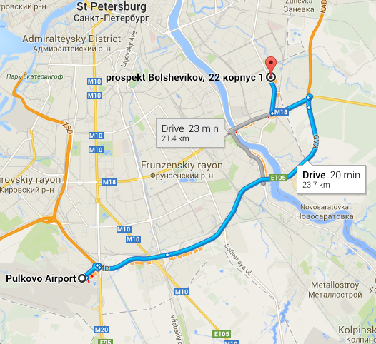
The nearest metro station to Pulkovo Airport is Moskovskaya station (line 2).
The nearest metro station if you travel by train is Ploschad Vosstania (Moscow Railway Station) – line 1
Ulitsa Dybenko (line 4) is the nearest metro station to The Bonch-Bruevich St. Petersburg State University of Telecommunications (SPbSUT).
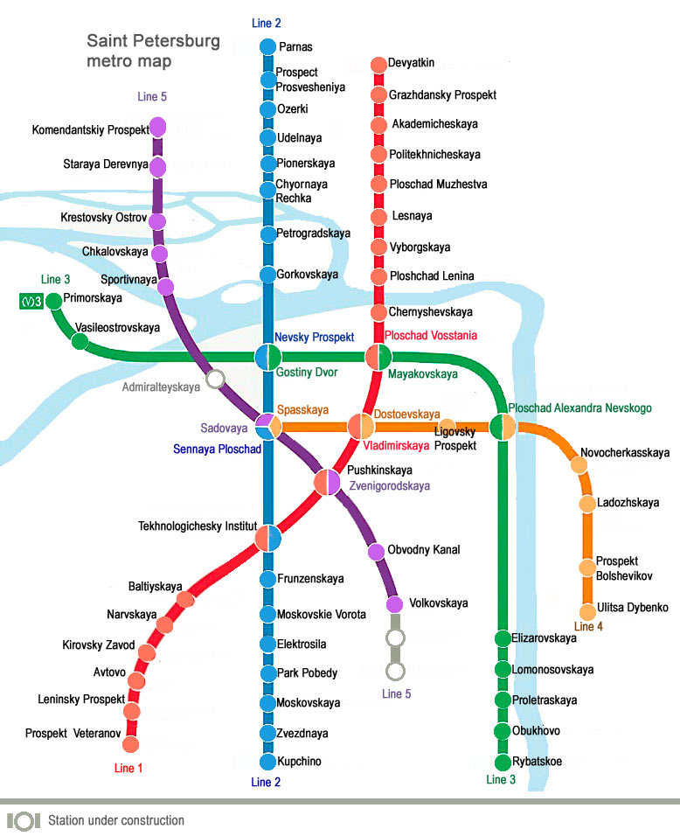
How to get to Moskovskaya metro station (opened from 05:35 till 00:41)
- From Pulkovo-1:
- Bus № 39: the bus station can be reached on foot from the airport land side by the exit from the Arrival Hall 1. Hours of transport service: from 05:30 till 01:30, every 12–20 min.
- Shuttle Bus № К39: the bus station can be reached on foot from the airport land side by the exit from the Arrival Hall 1. Hours of transport service: from 07:00 till 23:30, every 12–20 min.
- Taxi
- From Pulkovo-2:
- Bus № 13. Hours of transport service on weekends: from 06:07 till 00:47, on workdays — from 05:33 till 01:03, every 13–20 min.
- Shuttle Bus К3, К213, К13А: the bus stop is in front of the Arrival Hall. Hours of transport service: from 06:30 till 23:30, every 12–20 min.
- Shuttle bus К3 route:
- Airport Pulkovo-2;
- Pulkovskoe Highway;
- Moskovskiy prospect;
    - metro station «Moskovskaya»;
    - metro station «Park Pobedy»;
    - metro station «Elektrosila»;
    - metro station «Moskovskie vorota»;
    - metro station «Frunzenskaya»;
    - metro station «Tekhnologichesky institut»;
    - metro station «Sennaya».
Ticket cost: 25 rubles, for shuttle bus - 35 rubles per person.
- From Pulkovo-3:
- Bus № 39. The bus stop is in front of the exit from Arrival Hall (New terminal Pulkovo). Hours of transport service: from 5:30 till 01:30, every 12-20 min. Ticket cost: 25 rubles. Travel time: 30-35 min.
- Shuttle Bus К 39. The bus stop is in front of the exit from Arrival Hall (New terminal Pulkovo). Hours of transport service: from 7:00 till 23:30, every 12-20 min. Ticket cost: 35 rubles. Travel time: 30-35 min.

How to get to The Bonch-Bruevich St.Petersburg State University (SPbSUT), Prospekt Bolshevikov, 22 from the metro station Ulitsa Dybenko (line 4):

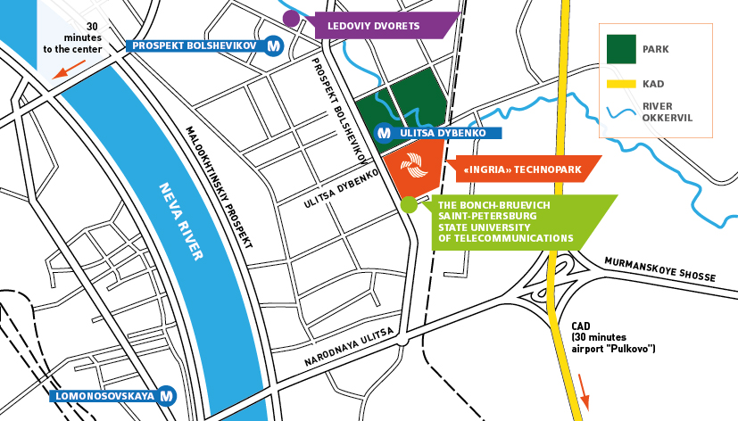

- HOTELS
We recommend the attendees to book the following hotels:
Hotel "Baltiya" - (a number of rooms are preliminary blocked for participants)
Address: 5/1 Smolyachkova street
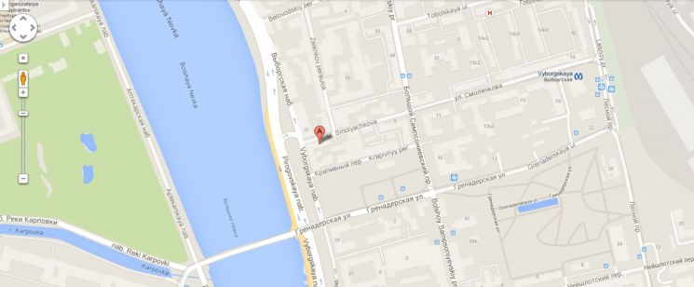
Baltiya hotel is located in 5 minutes walking distance from Vyborgskaya metro station and near a variety of transport options and attractions. Since it’s opening in March 2012, Baltiya hotel has thrived on becoming a quiet haven in the middle of the bustling city due to it’s location and accessibility. Baltiya hotel has enjoyed remarkable success and popularity among the travellers it has accommodated.
Convenient location near the metro station Vyborgskaya (5 minute walk from the subway). The business part of the Vyborg district. Baltiya hotel is situated in 10 minutes driving distance from Finland railway station. "Directions from". In 20 minutes driving distance from Moskovsky railway station. "Directions from". In 1 hour driving distance from Pulkovo 1 airport (Terminal 1). "Directions from". In 1 hour driving distance from Pulkovo 2 airport (terminal 2). "Directions from". In 30 minutes driving distance from Vitebsky railway station. "Directions from”.
Participants are requested to book their room filling out the following form
The “Okhtinskaya Hotel” - (a number of rooms are preliminary blocked for participants)
Address: 4, Bolsheokhtinsky Avenue, Saint-Petersburg
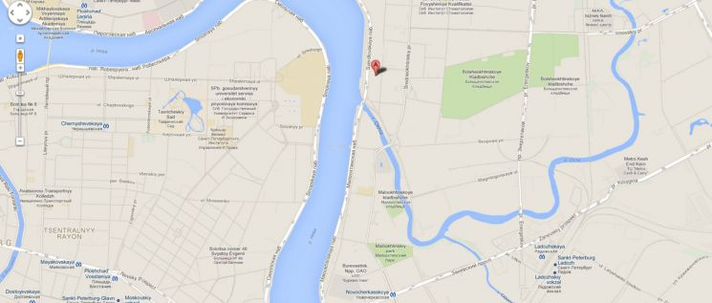
The Okhtinskaya Hotel is situated in a quiet residential area on the northern bank of the Neva River. Excellent bus links to the city centre are easily accessed from the hotel, with major attractions such as the Hermitage and Nevsky Prospekt easily reachable in around twenty minutes.

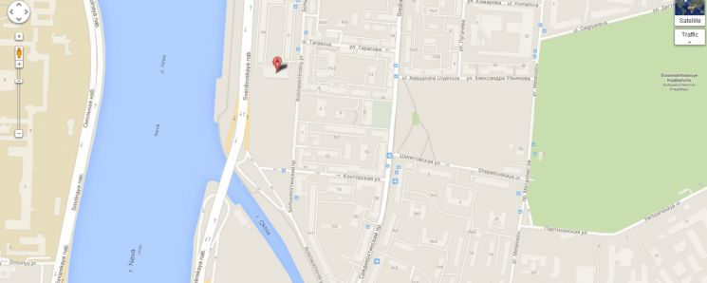
Novocherkasskaya metro station:
The nearest metro station, Novocherkasskaya, is around 2km from the Okhtinskaya Hotel. Bus Nr. 46, trams Nr 10, 23, 7 and mini-buses K6, K83, K289, K95, K274, K156, K254 drive to the hotel. The nearest stop is called Bolsheokhtinsky Avenue, the Tarasova street corner.
From Airport (LED):
It is approximately 20km from Pulkovo International Airport to the Okhtinskaya Hotel. As the only public transport option is by bus, metro, and bus again, guests are strongly recommended to book a transfer or take a taxi. The journey will take 40-60 minutes.
Participants are requested to book their room filling out the following form
AZIMUT Hotel - (a number of rooms are preliminary blocked for participants)
Address: 43/1, Lermontovsky prospect, Saint Petersburg
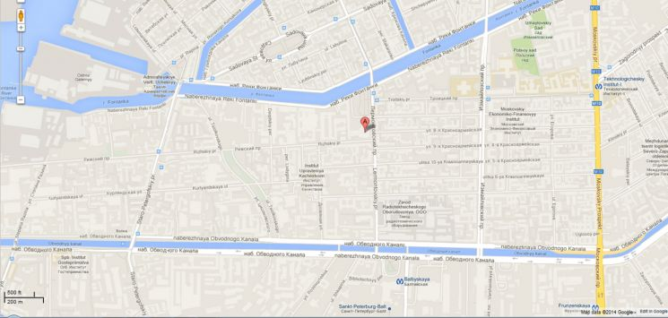
The route to the hotel from Moskovskaya metro station:
- From Moskovskaya metro station to Technologichesky institute-2, then transfer to the station Technologichesky institut-1. Then go one station to Baltiyskaya metro station. From Baltiyskaya metro station it is 900-meter walk to AZIMUT Hotel Saint Petersburg, which is located at Lermontovsky prospect, 43/1.
- From Moskovskaya metro station to Technologichesky institute-2, then transfer to the station Technologichesky institute-1 and go out. Take tram No. 16 and get off at the bus stop Lermontovsky prospect. It is 150 meters from the bus stop to AZIMIT Hotel.
- From Moskovsky railway station: Go down to the underground and go from the station Ploshchad Vosstaniya (Vosstaniya square) to Baltiyskaya station. It is 900-meter walk from Baltiyskaya metro station to Hotel AZIMUT, located at Lermontovsky prospect, 43/1.
- From Vitebsky Railway Station: Take tram No.16 from the railway station to stop Lermontovsky prospect. It is 150-meter walk from the stop to AZIMUT Hotel.
- From Ladozhsky Railway Station: Take subway train from metro station Ladozhskaya to Dostoyevskaya station. Then transfer to Vladimirskaya and follow to Baltiyskaya Station. It is 900-meter walk from Baltiyskaya metro station to our Hotel, located at Lermontovsky prospect, 43/1.
- From Finland Railway Station: Take subway train from Ploshchad Lenina (Lenin Square) metro station to Baltiyskaya station. It is 900-meter walk from Baltiyskaya metro station to Lermontovsky prospect and Hotel AZIMUT.
Participants are requested to book their room filling out the following form
Ambassador Hotel - (a number of rooms are preliminary blocked for participants)
Address: 5-7, Rimsky-Korsakov Avenue, Saint Petersburg
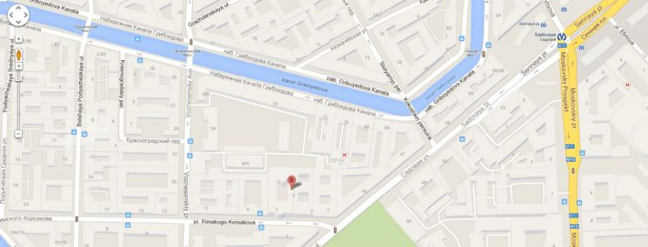
- From Moskovskaya metro station (line 2) to Sennaya Ploschad metro station (direct line), then it will take you 7 min. on foot to get to the Hotel
- Shuttle Bus №3 from the Terminal Pulkovo-2 straight to Sennaya Ploschad metro station, and then 7 min. on foot
Participants are requested to book their room filling out the following form
Hotel “Na Krestovskom” - (a number of rooms are preliminary blocked for participants)
Address: 11 A, Konstantinovsky Avenue, Saint Petersburg
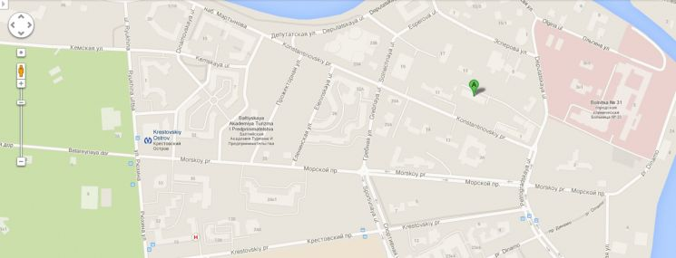
How to reach the hotel:
- From “Moskovskaya” metro station (line 2) to Sennaya ploshad metro station (line 2), change to “Sadovaya” (line 5) and go straightly to “Krestovsky Ostrov” (line 5).
- From metro station “Krestovsky Ostrov” - 10 minutes on foot.
Room price
Rooms | Price
Single | 1600 - 1800 rubles
Double | 1900 - 2100 rubles

Participants are requested to book their room
+7 (812) 235-31-13; +7 (812) 235-68-53. E-mail: hotel-locniis@yandex.ru

- VISA AND IMMIGRATION INFORMATION:
Participants requiring a visa should apply at a Russian consulate or a diplomatic mission in their respective country, well in advance of their departure.
Participants are also advised to contact their local travel agents or carriers. Visa processing by the Embassy may take two weeks or more.
Participants requiring supporting documents to their visa should fill out all items in the Application Form of ANNEX 1, and then email or fax the form to one of the following contact points together with a copy of the photograph page of their passport, no later than April, 1st, 2014.
The person responsible for visa support is Sergey Kislyakov. Please send him the following documents by e-mail s.kislyakov@sut.ru :
1) passport details form. It can be downloaded (ANNEX 1)
2) copy of valid passport.
The applications must be submitted by April, 1st, 2014

- SOCIAL EVENT
Details will be provided in due course.
- USEFUL INFORMATION
  - About St. Petersburg
The city is located in the north-west of the Russian Federation. Saint-Petersburg is called the Northern capital of Russia with a population of over 5 million people. The Historic Centre of Saint-Petersburg and Related Groups of Monuments constitute a UNESCO World Heritage. The city is one of the most important tourist centers.
City travel website: http://visit-petersburg.ru/
Saint-Petersburg Tourist Information Bureau website: http://eng.ispb.info/
7.2. Weather
The average temperature in St. Petersburg in June ranges from 12C to 22C. Average rainfall of this period is 71 mm. In June daylight lasts very long, and this period is called the "White Nights".
7.3. Time zone
St. Petersburg is located in Moscow time zone, UTC / GMT +4
7.4. International code of St. Petersburg: +7 812
  - Electricity
Electrical network in the city: AC voltage 220V, frequency 50Hz.
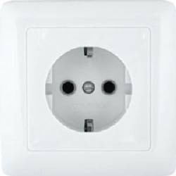
7.6. Currency Exchange
The ruble is the official currency of Russia. Currency exchanges are made in exchange offices of banks. Exchange points are located throughout and work, as a rule, from 10.00 to 20.00 hours. Exchange currencies on January, 18 are 1 ruble = U$ 33.43, 1 ruble = 45,51 €. The most profitable exchange rate is in large banks.
Caution: Do not change money from private individuals.
7.7. Tip
In Russia it is customary to leave a tip for service in cafes and restaurants if they are not included in a bill. Recommended tip size is 10% of the total order.
NB! In summer in St. Petersburg bridges are raised for navigating on Neva river according to a specific schedule, starting from 1:05 till 5:45.

- LOCAL CONTACT POINT:
For any additional information, please contact:
Nina Zhuravleva, Head of International Cooperation Department
pr_nina@mail.ru, international@sut.ru
Tel: +7 (812) 305-12-24
ANNEX 1

Application Form for Visa Supporting Documents

Name (as in passport) (□Mr. □Ms. □Dr.):

Family Name Middle Name Given Name
(*):
*If you are a Chinese participant, please write your full name in Chinese characters.

Official Title

Department:

Institution/university/company name and its exact address
(**):
**If you are a Chinese participant, please write your organization in Chinese characters as well.

Phone No. Fax No. E-mail

PASSPORT INFORMATION:

Passport No. : Date of Issue: / / (DD/MM/YYYY)

Expiry Date : / / (DD/MM/YYYY)

Place of Birth (town/city – state): Date of Birth: / / (DD/MM/YYYY)

Nationality:

Country (where you live)

Residence Address (*1):
(*1) VISA supporting documents will be sent to the address above by courier service ___________________________________________
Russian embassy (consulate) location (city) to apply for visa to ____________________________________________________
FLIGHT INFORMATION(*2) :
Arrival in St.Petersburg from city Date__________ Flight No. Time
Departure from St.Petersburg to city Date__________ Flight No. Time
(*2) For VISA supporting documents, a planned flight schedule is available as well.
HOTEL ACCOMMODATION
This information is NOT for hotel reservation (you can find the relevant forms above by the name of each recommended hotel), but NEEDED for staying schedule for visa supporting documents.

Hotel name :
Check in date: (DD/MM/YY) Check out date: (DD/MM/YY)

If making your own accommodation arrangement other than recommended hotels in St.Petersburg, please indicate your contact address and phone number:

Hotel Address_______________________________________________________
Hotel phone No.
Date: Signature:
Deadline of Submission: 1 April 2014 for all visa related documents
Please Return this form to:
Mr. Sergey Kislyakov (Chief Specialist of International Cooperation Department, SPbSUT) s.kislyakov@sut.ru

