**Practical information for participants**

**1. Event venue**

**Zambezi Sun Hotel**

Mosi-oa-Tunya Road

Livingstone, Zambia

Tel: +260 21 261550

Mob: +260 977652866/977824236

E-mail: [sinani.sinyangwe@suninternational.com](mailto:sinani.sinyangwe@suninternational.com)

S 17° 55' 28.8804" E 25° 51' 57.2142"

**2. Contact persons**

**Mr Mwenya Mutale**

Zambia Information & Communications Technology Authority (ZICTA)

Fax: +260 211 244424

Email: [mmwenya@zicta.zm](mailto:mmwenya@zicta.zm)

**Mrs Nawiti Kangwa**

Zambia Information & Communications Technology Authority (ZICTA)

Tel: +260 21 1 244431

Mobile: +260 966847077

Fax: +260 21 1 246701

Email: [nkangwa@zicta.zm](mailto:nkangwa@zicta.zm)

**Ms Patricia Maluti**

Zambia Information & Communications Technology Authority (ZICTA)

Tel: +260 21 1 244431

Mobile: +260 962519242

Fax: +260 21 1 246701

Email: [pmaluti@zicta.zm](mailto:pmaluti@zicta.zm)

**3. Contact person for visa support and hotel booking**

**Mrs Nawiti Kangwa**

Zambia Information & Communications Technology Authority (ZICTA)

Tel: +260 21 1 244431

Mobile: +260 966847077

Fax: +260 21 1 246701

Email: [nkangwa@zicta.zm](mailto:nkangwa@zicta.zm) and [SG13@zicta.zm](mailto:SG13@zicta.zm)

**4. Visa Formalities**

Delegates requiring visas are requested to obtain them from the Zambian Embassy in their respective countries.   
**Referred Visas**

Countries whose nationals do require a visa to enter Zambia are as follows:

Angola, Benin, Burkina Faso, Cameroon, Chad, Cote d’Ivoire, Gabon, Gambia, Ghana, Guinea Bissau, Guinea Conakry, Liberia, Mali, Niger, Nigeria, Papua New Guinea, Saudi Arabia, Senegal, Sierra Leone.

Nationals of all Commonwealth countries do not require a visa to enter Zambia except for the following countries on reciprocal basis:

Gambia, Ghana, Nigeria, Mozambique, Sierra Leone, Papua New Guinea

Single Entry US$ 50.00

Multiple Entry US$ 80.00

Delegates should apply 7-14 days prior to departure. You can down load the visa forms from the website, [www.zambiaimmigration.gov.zm](http://www.zambiaimmigration.gov.zm).

Visa requirements change fairly regularly so it is advisable to check with your Consulate or Embassy.

Every foreign national travelling to Zambia must be in possession of a valid passport.

**5. Hotel Accommodation**

A list of suggested hotels in Livingstone, Zambia can be found in Appendix I of this document. The hosting organization has negotiated special rates, as specified in the table of Appendix I. Delegates are strongly advised to make all reservations by signing the form (Appendix II) indicating their choice of hotel as well as their flight details and sending it back to the host contact point (see clause 3) who will make the reservations on their behalf and arrange for airport pick up as well as hotel to meeting venue transfers.

**6. Travel, airport transfer and vaccination**

All delegates travelling through and from the Republic of South Africa are required to get yellow fever vaccination at least ten days prior to travelling and carry yellow fever booklets with them. Those without yellow fever cards/booklets will not be checked in at the airport.  
Delegates are responsible for making their own travel arrangements to Livingstone. All travel information, including flight numbers, arrival and departure dates should be communicated to the host contact point via a form found in Appendix II for facilitation of airport transfers. The airport transfers will be provided by the host. Flight schedules are as follows:

Connection in South Africa, Johannesburg to Livingstone:

Daily Flights

Connection in Zambia, Lusaka to Livingstone:

Flights twice daily on Proflight at either 08:00 h and 15:00 h, or 12:00 h and 15:00 h.

Arrival at the Harry Nkumbula International Airport in Livingstone:

Livingstone has one of the major airports in Zambia named Harry Nkumbula Airport. It is a 24 hour open airport with full amenities of an international airport.

**7. Climate**

Livingstone has a hot climate, with extreme temperatures of 40.6 degrees Celsius and 3 degrees Celsius and an annual rainfall of almost 30 inches. Average temperature at the end of February varies around 24 degrees Celsius. The rainy season occurs from November through April.

**8. Medicine issues**

Delegates are advised to consult their medical doctors to find out if they need to take malaria tablets. There is a hospital in Livingstone which operates 24 hours.

**9. Time Zone**

Zambia is two hours ahead of GMT.

**10. Currency and Banking Facilities**

Zambia’s unit of currency is the Kwacha (K), sometimes listed as ‘ZMW’ (Zambia Kwacha). In cities and larger towns, you can change cash and travellers cheques at branches of Barclays Bank and Standard Chartered Bank. Larger branches have ATMs that accept Visa. Foreign exchange offices called Bureau de change are easy to find in Livingstone and other larger towns. The major credit cards are widely accepted. Travellers’ cheques are best taken in Pounds Sterling or US Dollars. Many Lodges and businesses prefer payment in hard currency.

The Zambia currency consists of:

Banknotes: K100, K 50, K20, K10, K5, and K2

Coins: K1, 50ngwee, 10ngwee and 5ngwee

Exchange Rates

• 1 GBP = 9.9 ZMW

• 1 USD ($) = 6.4 ZMW

• 1 South African Rand = 0.566 ZMW

There are numerous forex bureaux in the main towns. The exchange rate varies from time to time, but it currently ranges from Kwacha 6,000 to 6,400 per US $1.00.

Note: For an accurate exchange rate, it is advisable to check just before departure as it fluctuates.

Banking: Monday to Friday 08.15 – 14.30

Shops: Monday to Friday 08.00 – 17.00 Saturday 08.00 – 13.00

Bureaus are usually open up to 17.00 hours

**11. Electricity**

Zambia uses 230 Volts AC (50Hz). The plug type used is G - the three-pin square plug below

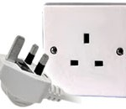

**12. Communication**

Zambia has three main mobile network providers, these being Airtel, MTN and ZAMTEL. To get connected, all visitors can visit any of the mobile phone service outlets which are mainly located at shopping malls. Please note that you will need a passport for you to acquire a SIM card. This is due to the ongoing SIM card registration in Zambia. A SIM card is not more than US$1 dollar; the maximum price is K5.

International calls cost about K2 (US 40 cents) per minute. The country code is + 260 and for international access, please dial 00.

For internet access, the country has multiple internet service providers, internet cafes, as well as mobile network providers through the use of modems. Television and radio broadcast is available including international channels courtesy of DSTV.

**13. Insurance and Security**

It is strongly advisable that all delegates travel with full cover insurance.

Zambians are known for their hospitality and friendliness towards each other and visitors alike. Although all Zambians are very helpful it is always advisable to be cautious when dealing with strangers. Police officers are very helpful and are easily identified by their uniforms although some may be plain-clothed, like everywhere in the world valuables should always be safeguarded or left in the hotel safe box. If you do not know where to obtain a certain service or you are not sure always contact the Hotel Information Desk.

Emergency Numbers:

• 993 – Fire Brigade

• 999 – Police

• 991 – Ambulance

Other Important Numbers:

• National Telephone Operator – 100

• National Directory – 102

• International Operator – 00

**14. Information about the country**Information about the country can be found in Appendix III.

**APPENDIX I**

**LIST OF HOTELS**

|  |  |  |  |
| --- | --- | --- | --- |
|  | **Hotel** | **Room Type** | **Amount** |
| 1. | **Zambezi Sun Hotel** (event venue)  Mosi-oa-Tunya Road, Livingstone  Tel: +260 21 261550  Mob: +260 977652866/ 977824236  E-mail: [sinani.sinyangwe@suninternational.com](mailto:sinani.sinyangwe@suninternational.com) | Standard | $160.50 |
| 2. | **Protea Hotel**  Plot No 2110 Mosi-oa-Tunya Road  Tel:+260 213 324630  Email: [reservations@phlivingstone.co.zm](mailto:reservations@phlivingstone.co.zm) | Single  double | $183  $193 |
| 3. | **Courtyard Hotel Victoria Falls**  Corner Mosi-oa-Tunya and Sichango Roads  Tel: +260 213 320884/85, +260 213 320806/807  Email: [resvictoriafalls@courtyardhotel.co.zm](mailto:resvictoriafalls@courtyardhotel.co.zm) | Standard  Double | $125  $150 |
| 4. | **Road Lodge**  1892, Mosi O Tunya Road, Livingstone  +260 213 324 848  +260 977324646  Email: [fallswaylodge@microlink.zm](mailto:fallswaylodge@microlink.zm)  [www.fallswaylodge.co.zm](http://www.fallswaylodge.co.zm) | Small double  Big double | $110  &130 |
| 5. | **New Fairmount Hotel**  Plot 441/2 Mosi-oa-Tunya Road  Tel: +260 213 320723, +260 21 0977777014  E-mail: [nfhc@zamnet.zm](mailto:nfhc@zamnet.zm) | Standard  Twin double | $70  $90 |
| 6. | **Cross roads Lodge**  Plot 2644/66 Ellen Britell Area, Lusaka Road  +260 966783838  +260 213 322474/5  E-mail: [crossroads@crossroadslodges.com](mailto:crossroads@crossroadslodges.com)  ww.crossroadslodges.com | Standard | $80 |
| 7. | **Chapa Classic Guest House**  66 Neru Way 4th Plot off Airport Road  Tel: +260 977796710  Email: [chapaclassiclodge@zamnet.zm](mailto:chapaclassiclodge@zamnet.zm) | Double  standard | $70  $60 |

Note: Free Wi-Fi available in all hotels on this list

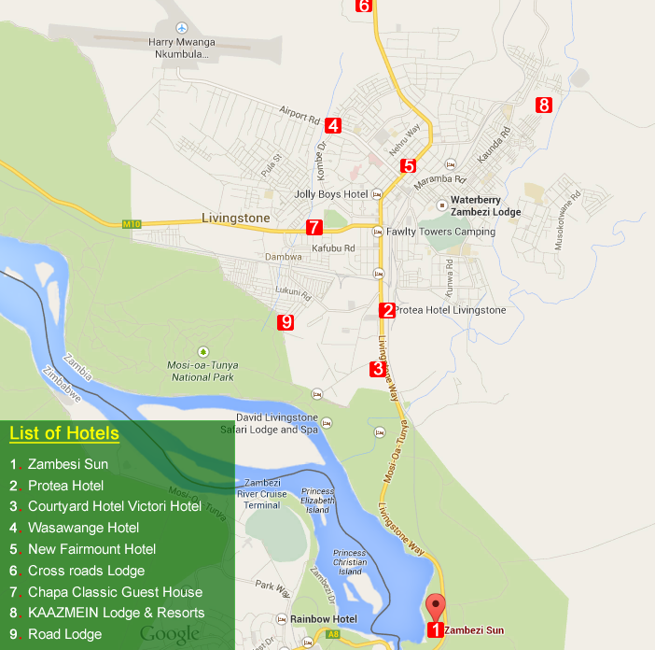

The meeting will be held at the **Zambezi Sun Hotel** (1) in Livingstone which is a historic colonial city situated in the Southern Province of Zambia:

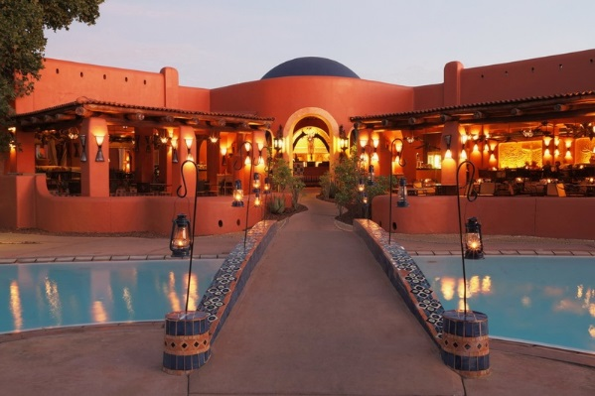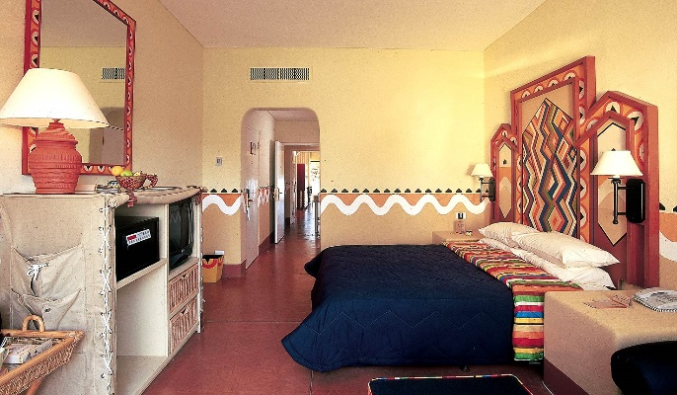

**APPENDIX II  
HOTEL RESERVATION AND AIRPORT TRANSFER FORM**

**ITU-T STUDY GROUP 13 REGIONAL GROUP FOR AFRICA MEETING and WORKSHOP**

**LIVINGSTONE, ZAMBIA**

**23 - 26 FEBRUARY 2015**

1. Name of Hotel: …………………………………………………………………………….…….………………………………

2. Type of Room: …………………………………………………………………………….…………………………………….

3. Arrival Date: ………………………………………………………………………………….……………………………………

4. Departure Date: …………………………………………………………………………….……………………………………

5. Number of Nights: ……………………………………………………………………….…………………………………….

**Personal Details**

6. Name of participant: …………………………………...……………………………….…………………………………….

7. Organisation: ………………………………………………………………………………………………………………………

8. Country: …………………………………………………………………………………………………………...……………

**Flight Information:**

Date of Arrival: …………………………………………………………………………………………………………….……..

Time of Arrival: …………………………………………………. Flight No:…………………………….………….……..

Date of Departure: …………………………………………………………………………………………………….……….

Time of Departure: …………………………………………... Flight No: ……………………………………..………..

9. **Signature:** ………………………………………………………………………………………………………………….…………

*Once the form has been completed, please email it to* [*nkangwa@zicta.zm*](mailto:nkangwa@zicta.zm) *and* [*SG13@zicta.zm*](mailto:SG13@zicta.zm) *or fax to +260 21 1 246701*

**APPENDIX III**

**GENERAL INFORMATION about the country**

**About Zambia**



The Republic of Zambia is landlocked and bordered by Mozambique, Tanzania, Malawi, Zimbabwe, Namibia, Angola, Democratic Republic of Congo and Botswana. The country has a surface area of 752,614 square kilometres and divided into 72 districts.

**About Livingstone**

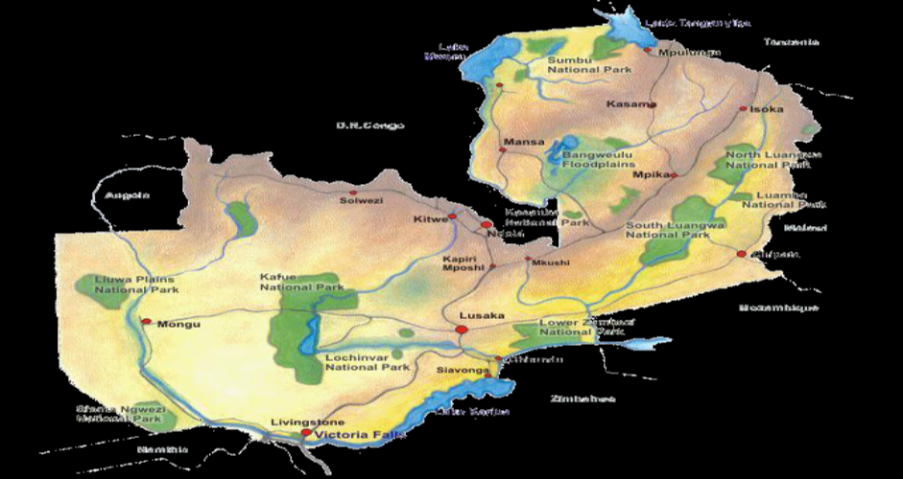

Livingstone is a Tourism Centre lying 10 km North of the Zambezi River, and a border town with road and rail connections to Zimbabwe on the other side of the Victoria Falls, one of the seven Natural Wonders of the World and 60 km by road to the border with Botswana.

Livingstone acts as a gateway to the magnificent attraction of the Victoria Falls and the Mosi-o-Tunya National Park. For those interested in local culture and history, the Livingstone Museum which is the oldest Museum in Zambia, has interesting displays of David Livingstone memorabilia and the Maramba Market which sells an assortment of handcrafts and colourful fabric.

**PEOPLE AND LANGUAGES**

Zambia has seventy three (73) ethic groups and seven main languages. English is the official language. Tonga and Lozi are other common languages spoken in Livingstone.

**TOURISM, CULTURE AND ART**

The Victoria Falls area is rapidly becoming known as the “Adventure Centre’ of Southern Africa, with various adrenaline sports, unmatched scenery of breath-taking proportions, and many other leisure options for outdoor lovers.

**CULTURAL PLACES**

1. Livingstone Museum

2. Maramba Cultural Village

3. Railway Museum

**SHOPPING CENTRES**

1. Shoprite

2. Spar

**RESTAURANT GUIDE**

**Kubu Crafts –** found at the main shopping mall next to Shoprite.

**Utsav Indian Restaurant** - found in the main Mosi-o-tunya Rd. They also have a takeaway section called Exciting Biting.

**The Laughing Dragon - Chinese** - just off the main road near the **Hungry Lion** – a fast food outlet**.**

**Hippo's** pub behind Fawlty Towers serves great meals and has a pool table and darts.

**Zigzag** also doubles as a booking office for various adventures as well as a small shop which serves lunches and cakes on the pavement.

The **Pigs Head**, Kabompo Road is one of the local pubs, also serving food.

**Eatrite Fast Foods**, in the main road.

For excellent lunches and steaks try **Mr. Pete’s just** on the outskirts of Town on the way to the Falls.

**Chanters** is a good restaurant in Lukulu Rd with accommodation as well.

**Flying Pizza** on the main road near the Adventure Centre serves great pizzas, Shawarmas, burritos, and soft drinks.

**The water front** always has meals available on their terrace on the river's edge.

Both of **Sun International Hotels** have several good restaurants.

__________________