

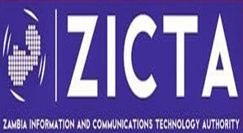

**3rdSG13 Regional Workshop for Africa on**

“**ITU-T Standardization challenges for Developing Countries working for a connected Africa”**

**(Livingstone, Zambia, 23-24 February 2015)**

**Session 4: Experiences& Successful Stories from Africa**

This session presents some experiences and successful stories of different African telecommunication stakeholders in one of the workshop topics and/or other related topics.

***Abstract on the presentation “Homologation of Telecom Equipment in Zambia – Procedure and Experience”***

**The process of Homologation of ICT equipment in Zambia started in 2006 concentrating on PSTN and Radio terminal equipment. After enactment of the ICT Act No. 15 of 2009, the net was cast wider to include all ICT equipment and a related Statutory Instrument (SI) was released in 2011.**

**ZICTA is mandated by the SI to come up with guidelines concerning type approval where the international standards are cited and are enforceable. On the other hand the Zambia Bureau of Standards (ZABS) is the mother body which oversees development and enforcement of all the standards in Zambia. Therefore, a Memorandum of Understanding was signed between ZICTA and ZABS to collaborate on the issue of development of ICT standards.**

**The presentation will look at the history of homologation in Zambia, past and current challenges, and how some challenges have been overcome. It describes in detail the procedure for homologation of equipment in Zambia and the vision for the future such as construction of a type approval lab in Zambia.**

In the light of the SG13 hot topics, Zambia is anxiously following discussion and is ready to use recommendations that will be developed in ensuring compliance of systems and equipment to be used in Zambia.