**MEETING OF STUDY GROUP 5**

**(Lima, 2-13 December 2013)**

**A INFORMATION CONCERNING THE MEETING**

# 1 VENUE

The meeting of Study Group 5 will be held in the Hotel Meliá Lima at the following address:

Av. Salaverry 2599, San Isidro, Lima   
Tel (511) 411 9057   
Fax (511) 411 9029  
Website: [http://es.melia.com/hoteles/peru/lima/melia-lima/home.htm](http://www.sbs.gob.pe/app/stats/tc-cv.asp).

# 2 NATIONAL COORDINATOR

Dr Fiorella Moschella Vidal  
Tel (511) 615 7800 / Extension 1807  
E-mail: [fmoschella@mtc.gob.pe](mailto:ccarrasco@mtc.gob.pe)

# 3 ACCOMODATION AND HOTEL BOOKINGS

The Administration of Peru has obtained special rates in a number of hotels situated close to the event venue ‑ details are given in the table below. The following page also includes a map indicating the distance of each hotel from the meeting venue. Bookings should be made directly via the designated contact persons in each hotel.

| **HOTEL** | **CONTACT** | **PREFERENTIAL RATES\*** |  |
| --- | --- | --- | --- |
| **Hotel Meliá Lima**  Av. Salaverry 2599 San Isidro, Lima  Tel (511) 411 9057  Fax(511) 411 9029  [http://es.melia.com/hoteles/peru/lima/melia-lima/home.htm](mailto:reservas@hotelbasadre.com) | **Ms Valeria Noriega**  Tel (511) 411 9057  Complete and send the attached form to the following addresses:  [reservas4@melialima.com.pe](http://www.sonesta.com/lima/)  [valeria.noriega@melialima.com.pe](http://www.casabellaperu.net/es/san-isidro/) | **Short stay: from 1 to 8 days**  **Single room:** S/.398.75 / US$ 137.50  **Double room:** S/.462.55 / US$ 159.50  **Longer stay: from 8 days to one month**  **Single room:** S/.396.85 / US$ 126.50  **Double room:** S/.430.65 / US$ 148.50  Buffet breakfast and free Internet connection are included. |  |
| **Hotel Los Delfines**  Los Eucaliptos 555 San Isidro  Tel (511) 215 7000  [http://www.losdelfineshotel.com/default-es.html](http://www.senamhi.gob.pe/) | **Ms Nathalie Loayza**  Tel (511) 215 7000  E-mail:  [nloayza@losdelfineshotel.com.pe](http://www.peruserviciosturisticos.com/lima.php) | **Single room:** S/.576.30 / US$ 185.90  **Double room:** S/.576.30 / US$ 185.90  Breakfast is included. | Delfines Hotel & Casino |
| **Hotel Libertador Lima**  Los Eucaliptos N° 550, San Isidro  Tel (511) 518 6300  [http://www.libertador.com.pe/libertador/lima/informacion-general/](mailto:valeria.noriega@melialima.com.pe) | **Ms Nathalie Rodríguez**  Tel (511) 712 7000  E-mail: [info@libertador.com.pe](mailto:fmoschella@mtc.gob.pe) | **Single room:** S/.363.00 / US$ 121.00  **Double room:** S/.393.80 / US$ 130.00  Buffet breakfast is included. | Libertador |
| **Hotel Atton**  **San Isidro**  Av. Jorge Basadre 595, San Isidro  Tel (511) 208 1200  (511) 208 1220  [http://sanisidro.atton.com/default-es.html](http://www.google.com.pe/url) | **Ms Sandra Pinglo**  Tel (511) 208 1225  E-mail: [spinglo@atton.pe](mailto:spinglo@atton.pe) | **Single room:** S/.408.24 / US$ 145.80  **Double room:** S/.453.60 / US$ 162.00  Breakfast is included. | Atton San Isidro |
| **Novotel Hotel**  Av. Victor Andrés Belaunde N° 198, San Isidro  Tel (511) 315 9999  Fax (511) 315 9900  [http://www.novotel.com/es/hotel-6339-novotel-lima/index.shtml](mailto:nloayza@losdelfineshotel.com.pe) | **Ms Karla Bichara**  Tel (511) 441 4171  E-mail: [Karla.bichara@accor.com](mailto:reservas4@melialima.com.pe) | **Single room:** S/.428.00 / US$ 143.00  **Double room:** S/.499.40 / US$ 166.46  Rates include buffet breakfast, free Wi-Fi and cable Internet connection, Business Center with unlimited use of Internet free of charge, heated swimming pool, gym and steam sauna, 24-hour room service, parking places subject to availability.  Check in after 14:00, check out before 12:00. | Novotel |
| **Los Tallanes Hotel &Suites**  Av. Jorge Basadre N° 325, San Isidro.  Tel (511) 221 0001 Fax (511) 222 5030  <http://www.hoteltallanes.com.pe/esp/index.html> | **Ms Janeth Vega**  Tel (511) 221 0001  Extension 187 - 168  E-mail: [reservas@hoteltallanes.com.pe](http://www.losdelfineshotel.com/default-es.html) | **Single room:** S/.341.22 / US$ 121.00  **Double room:** S/.403.26 / US$ 143.00  Rates include à la carte breakfast, Internet, gym, 24-hour room service. | http://www.hoteltallanes.com.pe/img/header_logo.png |
| **Sonesta Hotel El Olivar**  Jr. Pancho Fierro 194, San Isidro  Tel (511) 712 6050  Extension 1029  Fax(511) 712 6099  [http://www.sonesta.com/lima/](http://www.hotelbasadre.com/) | **Ms Daniela Pérez Olazo**  Tel (511) 712 6059  712-6099  E-mail: [dperez@sonestaperu.com](mailto:reservas@hoteltallanes.com.pe) | **Single room:** S/.399.00/ US$ 133.00  **Double room:** S/.462.00/ US$ 154.00  Rates include buffet breakfast, complimentary fruit punch on arrival, access to gym and swimming pool, Wi-Fi in rooms and public areas, 30 minutes of free Internet access in the Business Center. | [http://cdn.sonesta.com/images/sonestaLogoNew/lima/sonestaLogo.png?t=201208211558](http://es.melia.com/hoteles/peru/lima/melia-lima/home.htm) |
| **Hotel Plaza del Bosque**  Av. Paz Soldán 190 San Isidro  Tel (551) 616 1818  Fax (511) 221 3010  [http://www.plazadelbosque.com/](http://www.libertador.com.pe/libertador/lima/informacion-general/) | **Ms Liliana Nakasato**  Tel (551) 616 1818  E-mail: [reservas@plazadelbosque.com](mailto:info@libertador.com.pe) | **Single room:** S/.499.20/ US$ 166.40  **Double room:** S/.537.60/ US$ 179.20  Rates include buffet breakfast. | [logoplazadelbosque](mailto:dperez@sonestaperu.com?sa=i&rct=j&q=&esrc=s&frm=1&source=images&cd=&cad=rja&docid=E6c_9z6xUcVCJM&tbnid=P58WFw3p7mnLCM:&ved=0CAUQjRw&url=http://www.hotelperu.info/hoteles/lima/hoteleslima.asp&ei=HS1YUqrLIPK84AOL74Aw&bvm=bv.53899372,d.dmg&psig=AFQjCNG8YoyV5LpQTD8JxqgG5h52E7BOEQ&ust=1381596825852634) |
| **Peru Star Boutique Apartments Hotel**  Calle Burgos N° 266-276, San Isidro  Tel (511) 442 7376  (511)2218481 Fax(511) 221 8482  [http://perustar.com/index.php](mailto:Karla.bichara@accor.com) | **Ms Lesly Valenzuela**  Tel (511) 221 8481  E-mail: [recepcion@perustar.com](http://www.plazadelbosque.com/) | **Single room:**  S/.249.20 / US$ 89  **Small single room:**  S/.277.20 / US$ 99  **Small double room:**  S/.333.20 / US$ 119 |  |
| **Hotel San Isidro Inn**  Av. Gral. Juan Antonio Pezet Nº 1765, Urb. Orrantia del Mar, San Isidro  Tel (511) 264 2019  (511) 264 3370 Fax (511)264 3434  [http://www.sanisidroinn.com.pe/](http://perustar.com/index.php) | **Ms Marina Briones**  Tel (511) 264 2019  E-mail: [informes@sanisidroinn.com.pe](http://sanisidro.atton.com/default-es.html)  [reservas@sanisidroinn.com.pe](mailto:reservas@sanisidroinn.com.pe) | **Single room:** S/.205.00 / US$ 75.00  **Double room:** S/.235.00 / US$ 85.00  Rates include buffet breakfast. | logo de San Isisidro  inn |
| **Suites Antique Apart Hotel**  Av. 2 de Mayo N° 954, San Isidro  Tel (511) 222 1094  [http://www.suites-antique.com/](http://www.sanisidroinn.com.pe/) | **Ms Angela Padilla**  Tel (511) 264 2019  Email: [sales@suites-antique.com](mailto:recepcion@perustar.com)  [administrador@suites-antique.com](mailto:administrador@suites-antique.com) | **Single room:** S/.237.60 / US$ 79.20  **Double room:** S/.270.60 / US$ 90.20  Rates include buffet breakfast, Wi-Fi. | [http://www.perutourservice.com/images/antique.jpg](http://www.google.com.pe/url?sa=i&rct=j&q=&esrc=s&frm=1&source=images&cd=&cad=rja&docid=Cin6yfI8S2VIuM&tbnid=hBrdSOCIh54_RM:&ved=0CAUQjRw&url=http://www.perutourservice.com/hoteles.php&ei=0BVcUra4NYWu9ASd2oDACw&bvm=bv.53899372,d.eWU&psig=AFQjCNE8KltQeaqsiNp28X4WCSC_u4XRow&ust=1381853000591739) |
| **Casa Bella**  **Boutique Hotels**  Calle Las Flores N° 459, San Isidro  Tel (511) 421 7354  (511) 421 1033  [http://www.casabellaperu.net/es/san-isidro/](http://es.melia.com/hoteles/peru/lima/melia-lima/home.htm) | **Ms Lucy Sánchez**  Tel (511) 421 7354  E-mail:  [casabellaperu@msn.com](http://www.aa2000.com.ar/) | **Single room:** S/.202.50 / US$ 67.50  **Double room:** S/.213.30 / US$ 71.10  Rates include buffet breakfast. | lima peru hotels |
| **Basadre Suites Boutique Hotel**  Av. Jorge Basadre N° 1310, San Isidro  Tel (511) 615 3939  [http://www.hotelbasadre.com/](mailto:reservas@plazadelbosque.com) | **Ms Patricia González**  Tel (511) 615 3939  E-mail: [ventas@hotelbasadre.com](http://www.google.com.pe/url) [reservas@hotelbasadre.com](http://www.novotel.com/es/hotel-6339-novotel-lima/index.shtml) | **Single room:** S/.224.00 / US$ 80.00  **Double room:** S/.274.00 / US$ 98.00  Rates include buffet breakfast, swimming pool, Internet. | [http://cdn.dbapp.netdna-cdn.com/438x244basadresuit9a50e720cd.jpg](http://www.suites-antique.com/?sa=i&rct=j&q=&esrc=s&frm=1&source=images&cd=&cad=rja&docid=acdqRxychwaZGM&tbnid=MeF1Kb7xIVLaaM:&ved=0CAUQjRw&url=http://ofertop.pe/Ofertas-y-Descuentos/Ofertas-en-Lima/Hoteleria-y-Turismo/Noche-romantica-S-209-en-vez-de-S-433-por-1-Noche-para-2-en-habitacion-matrimonial-plus-Desayunos-buffet-plus-Welcome-drinks-plus-Chocolates-en-BASADRE-SUITES-Boutique-Hotel-40201&ei=yhRcUvWhIYzQ8wTUmoHQCA&bvm=bv.53899372,d.eWU&psig=AFQjCNFRJXG3Y2hLDxLUUqOxufOD43Dmyg&ust=1381852736381640) |

* Subject to availability.

Rates include 10 per cent service charge

In order to take advantage of these rates, meeting participants should refer to the meeting and the Ministry of Transport and Communications when booking.

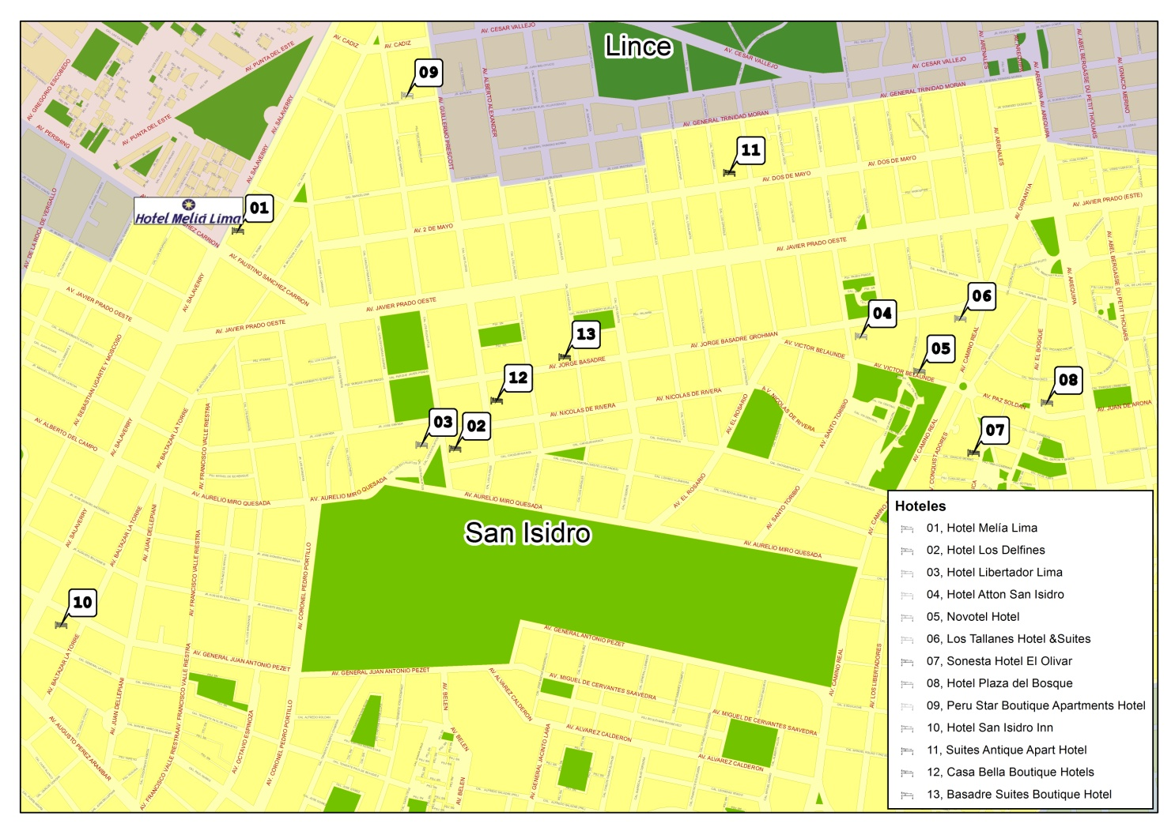

# 4 FLIGHTS AND TRANSPORT

Jorge Chávez International Airport is situated 30 minutes from the city and is used for international arrivals and departures. Delegates have a number of options for getting from the airport to their hotels in Lima.

**Private chauffeur-driven cars and taxis:** The airport has many taxi and private car hire companies, which can be found at the arriving passengers’ exit from the disembarkation area.

Approximate fare for the transfer from the airport to San Isidro: S/. 60.00 (about US$ 25.00).

**Minibuses:** Larger groups may also hire minibuses (maximum capacity: seven passengers) at the airport. Reservations: [http://www.taxigreen.com.pe](mailto:informes@sanisidroinn.com.pe).

Approximate fare from the airport to San Isidro: S/. 85.00 (about US$ 33.00).

For more information, consult the Jorge Chávez International Airport web site at <http://www.lap.com.pe/lap_portal/index.asp>.

For other transfers we recommend using the taxi services offered by the hotels or contacting the following companies:

Taxi Satelital: (511) 355-5555 (waiting time: about 15 minutes).

Taxi Seguro: (511) 241-9292 (waiting time: 20 to 25 minutes, depending on the time of day).

Taxi San Borja: (511) 225-8600 (waiting time: 20 to 25 minutes, depending on the time of day).

**B GENERAL INFORMATION**

# Introduction

Lima is situated on the Pacific coast and is a perfect blend of tradition and modernity. As the capital of Peru, the city is a wonderful melting pot of customs and cultures, reflecting the diverse mixture of Peruvians from the country’s various regions and foreign nationals who love living in Peru.

Lima is home to more than 8.5 million people and accounts for almost two thirds of the country’s total economic and industrial activity. It provides what is undoubtedly a perfect climate for business people who come from all parts of the world to do business.

# 1 The city of Lima

Also known as the “City of Kings”, Lima was built over the traces of an existing prehispanic metropolis that was home to the first civilizations of the Americas. As a result of its historical legacy, it has been declared a World Heritage Site by UNESCO.

The city is known for its magnificent archaeological, historical and artistic remains. It has maintained the riches of its historical centre over the years and is endowed with important examples of architecture from the colonial and post-colonial eras. Visitors can find pre-Columbian tombs, ancient buildings put up by the first Limans that still survive between modern office blocks and crowded dwellings, as well as more than 50 museums scattered around the city. They contain exhibits in the fields of art, archaeology, nature, science and technology, and preserve the city’s collective memory and culture.

Lastly, no visit to Lima is complete without an opportunity to enjoy Peru’s cuisine. Lima takes pride in its status as Peru’s gastronomic capital and is striving to become the gastronomic capital of the Americas by 2021.

# 2 Formalities for visitors to Peru

Most delegates do not require a visa to enter Peru. You can check whether or not you require a visa by consulting the web site [http://www.rree.gob.pe/servicioalciudadano/Documents/VisasxExtran_Agosto_2013.pdf](mailto:ventas@hotelbasadre.com). Information on precise requirements for obtaining a visa may be obtained from the embassy or consulate in your country.

Persons requiring a visa to enter Peru should apply to Ms Claudia Carrasco at [ccarrasco@mtc.gob.pe](mailto:casabellaperu@msn.com) for a personalized letter of invitation which will be sent to the applicant by e-mail. The letter should then be submitted to the Peruvian embassy or consulate in the applicant’s country in order to obtain the visa.

Peru does not require any type of vaccination certificate, although anyone intending to travel to areas outside Lima, including the rain forest region, will need to be vaccinated against yellow fever at least ten days in advance of travel.

# 3 Time zone

Local time throughout Peru is GMT (UTC) −5.

# 4 Language

The official language is Spanish.

# 5 Mains electricity

The mains voltage in Peru is 220V / 60 Hz. Most 4 and 5 star hotels also have 110V outlets.

# 6 Climate

Average temperature in Lima in December is between 17° C and 25º C (spring season, some fine sunny days). Average humidity is 80 per cent.

More information on climate conditions in the city of Lima and other areas of the country is available from the web site of the National Meteorological and Hydrological Service (SENAMHI) at [http://www.senamhi.gob.pe/?p=0100](http://www.google.com.pe/url?p=0100).

# 7 Currency and exchange rates

The national currency of Peru is the nuevo sol (S/.). Coins of 10, 20 and 50 cents and 1, 2 and 5 nuevo sol are in circulation, as well as 10, 20, 50, 100 and 200 nuevo sol notes.

[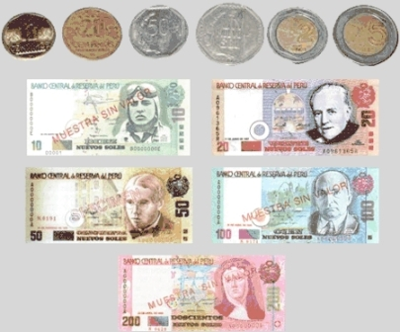](mailto:sales@suites-antique.com?sa=i&rct=j&q=&esrc=s&frm=1&source=images&cd=&cad=rja&docid=uLyObAs9tDmI1M&tbnid=KH5fcrXGJlzllM:&ved=0CAUQjRw&url=http://peru.travelguia.net/el-nuevo-sol-moneda-del-peru.html&ei=tyZYUqfsLa6p4APh1YCoDA&bvm=bv.53899372,d.dmg&psig=AFQjCNE3TDIGrRDuhcsaPrm_YWf8SDurBw&ust=1381595188067164)

The exchange rate fluctuates freely according to market conditions. Information on the prevailing exchange rate is available at [http://www.sbs.gob.pe/app/stats/tc-cv.asp](http://www.rree.gob.pe/servicioalciudadano/Documents/VisasxExtran_Agosto_2013.pdf).

Visitors are advised to exchange money through banks or currency exchanges. Local banks operate from Monday to Friday between 09.00 and 18.00.

Most commercial establishments accept credit cards (American Express, Diners Club, Mastercard and Visa).

# 8 Opening hours

Banks and currency exchanges: 09.00 to 18.00, Monday to Friday,

Offices: usually 10.00 to 19.00, Monday to Friday.

Shops: 10.00 to 20.00, Monday to Friday; Saturday 10.00 to 21.00.

Cafés: 09:00 to 21.00 Monday to Sunday.

Restaurants: lunch is served from 12.30 and dinner between 19:00 and 23:00. Fast food of various types is available in many places at all hours.

# 9 Tips

It is customary to leave 10 per cent of the bill in cafés and restaurants, and to give a tip to service staff such as doormen, porters and ushers.

# 10 Emergency numbers

National Police: 105

Fire Service: 116

Medical emergencies and serious accidents

(SAMU Hospital Casimiro Ulloa): 106

# 11 Useful information

More information on Lima can be obtained from: [http://www.peruserviciosturisticos.com/lima.php](http://www.taxigreen.com.pe)

# 12 Clothing

Participants in the meeting of Study Group 5 are advised to adopt formal work dress.