GENERAL INFORMATION FOR PARTICIPANTS
ITU Workshop on "Human Exposure to Electromagnetic Fields (EMFs) in Latin America"
14 August 2013, Quito, Ecuador

1 Venue for the meeting
Swissotel Quito
Address: Ave. 12 de Octubre 1820 y Luis Cordero, Quito – Ecuador
Telephone: +593 2 256 7600
2 Arrival, departure and transportation
Transport will NOT be available for International delegates from the airport to the respective hotels and/or the conference venue. However, delegates should note that it costs 25 US dollars for a taxi from the airport.
Please find below useful numbers to request for taxi services.
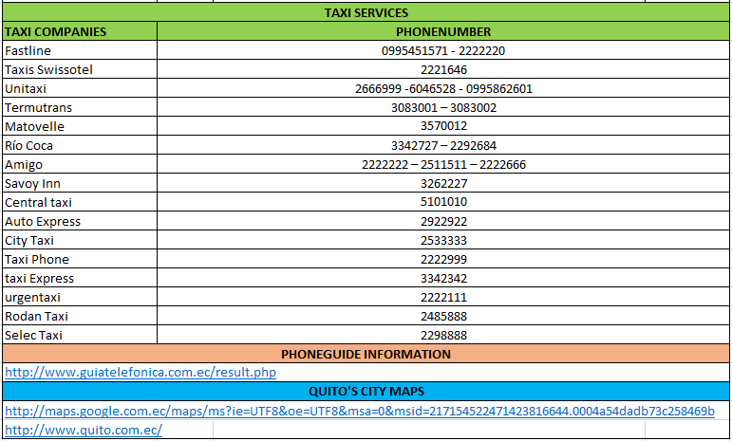
3 Delegate registration
Delegates are requested to pre-register using the online registration form provided at the
ITU-T website: http://www.itu.int/en/ITU-T/Workshops-and-Seminars/emf/201307/Pages/default.aspx as soon as possible, but not later than 7 August 2013. Please note that pre-registration of participants to workshops is carried out exclusively online. Participants will be able to register onsite after 7 August 2013. On-site registration will take place on 14 August between 08:00 and 09:00 a.m.
4 Accommodation / hotels
All costs shall be borne by the participant, including extension beyond the duration of the meeting dates.
Delegates are requested to book their hotel accommodation directly with the hotel of their choice (see list of hotels in Annex 1). The recommended hotel is the Swissotel which is also the meeting place.
5 Vaccination Requirements
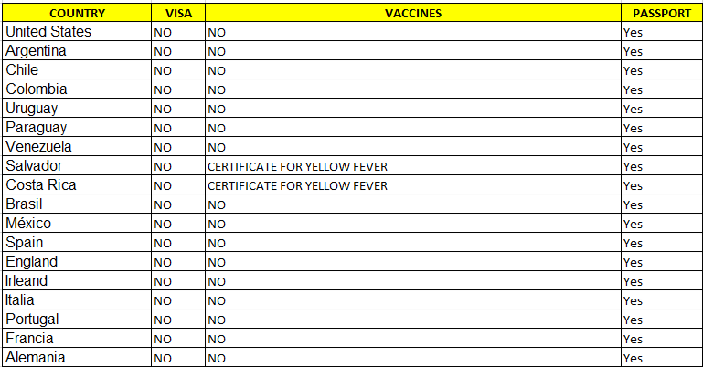

6 Below are some useful numbers

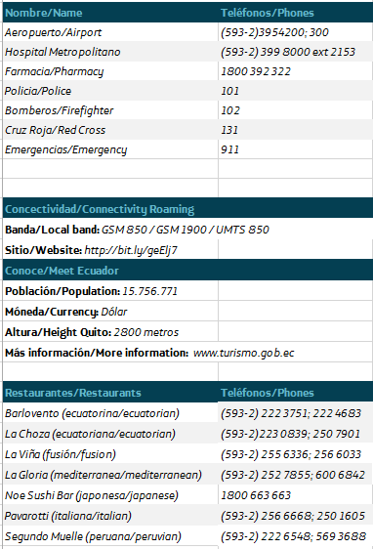

7 Weather

Quito is an ageless city, warm and friendly, with generous hosts always willing to showcase its beauty and magnificence to their every guest. Options as diverse as the stunning geography of the Andes, from volcanic paramo to lush subtropical cloud forests, provide ever-changing opportunities for visitors and residents to discover nature and take advantage of outdoor life. A deep-rooted culture, artful crafstmanship and beautiful colonial architecture are the not-so-hidden treasures one admires all across the landmark-ridden Historic Center, one of the largest and best preserved in all of the Americas. It comes as no surprise UNESCO declared Quito its first World Cultural Heritage Site in 1978. A modern yet traditional, cosmpolitan yet ancient mountain niche, whose variety in cultural venues and exquisite gastronomy make it a tourist’s delight.
In this section you will be able to visit our city virtually, its climate, geography, history, language, cultural activities and fascinating local celebrations filled with color and personality… Welcome to Quito!
San Francisco of Quito, it is the cardinal city of Ecuador [1] and also of the province of Bargain, [2] it is the second city biggest and filled with the Ecuador. In addition it is a head-board cantonal or distrital of the Metropolitan District of Quito. [3] Bargain Is located on Guayllabamba's pit in the oriental hillsides of the active estratovolcán, in the western part of the Andes. One finds approximately in the coordinates 0°13 ' 23? S 78°30 ' 45? Or?/?-0.22306,-78.5125 and his average altitude is of 2800 msnm The city is divided in 32 parishes, which subdivide in neighborhoods.
Quito is the political center of the Republic, shelters the principal governmental, cultural, financial organisms - to the being the home of the majority of banks of the Nation-, administrative and commercial of the country - the majority of transnational companies that are employed at Ecuador have his counterfoil in the city-. The city, to more of being the administrative capital of the Ecuador, is the new economic capital of the country, according to the economic census of 2010. [7] It is the first declared city, close to Cracow in Poland, as Cultural Heritage of the Humanity for the UNESCO, on September 18, 1978. [8] Quito possesses the biggest historical, less upset center and the best preserved one from America.
8 Time Zone
Quito is in the GMT - 5 time zone
9 Electricity
The power supply is 110volts.
10 Contacts
Host country contacts for all official enquiries:

Cristina Larrea
Email: Cristina.larreapena@telefonica.com
Telephone: +593 9 984081668

Diana Baquero
Email: Diana.baquerochambers@telefonica.com
Telephone: +593 9 998974614

Nancy Paladines
Email: nancy.paladines@telefonica.com
Telephone: +593 9 987377686

Annex 1
RECOMMENDED HOTELS
For recommended hotels, click here: http://www.itu.int/en/ITU-T/Workshops-and-Seminars/emf/201307/Pages/default.aspx

