BSG Interactive Workshop on Effectiveness in Standardization

Tunis, Tunisia 24 April 2018

Practical Information
- About the City
Tunis is both the capital and the largest city of Tunisia. The greater metropolitan area of Tunis, often referred to as Grand Tunis, holds some 2,700,000 inhabitants.
Situated on a large Mediterranean Sea gulf (the Gulf of Tunis), behind the Lake of Tunis and the port of La Goulette(Ḥalq il-Wād), the city extends along the coastal plain and the hills that surround it. At its core lies its antic medina, a world heritage site. Beyond this district lie the suburbs of Carthage, La Marsa, and Sidi Bou Said.

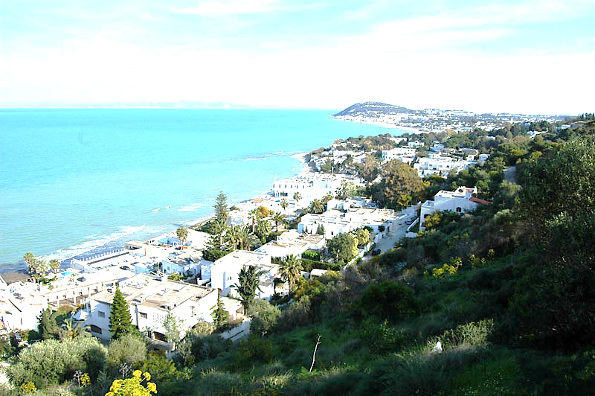
- Event Venue
Hotel Ramada Plaza
Les côtes de Carthages Gammarth, Tunisia
Telephone: (+216) 71 911 100
Fax: (+216) 71 910 041
Website: http://www.ramadaplaza-tunis.com/anglais/index.html

This 5-star hotel is Beautifully positioned on sandy beach on the Côtes de Carthage. Located on a beautiful private beach, few minutes from downtown Tunis, the hotel is also near Tunis-Carthage International Airport. Ramada Plaza hotel offers beautiful views and comforting amenities.
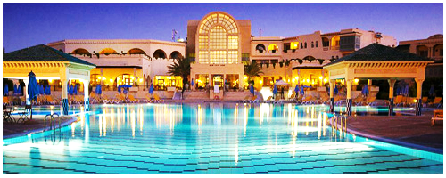

- Reservation in Recommended Hotel
Special rates have been negotiated for participants in the hotel Ramada Plaza, venue of the event. Participants are kindly requested to fill out the Hotel Reservation Form (see page 7) and email it directly to the contact person of the selected hotel before 12 April 2018 in order to guarantee preferential rates. The account of the hotel will be paid directly by each participant at the end of the stay.

Special Rate | Contact
Single LPD :72.11 USD  Single DP: 90.240 USD | reservations@ramadaplazatunis.com
Other Hotels:
Hotel | Star Rating | Facilities Included | Distance to Venue | Daily Rate (USD)  LPD/DP | Contact
Maison Blanche | 5 | Wifi/breakfast/dinner/  parking | 30 min | Single : 92 / 92+dinner on the card | maison.blanche@planet.tn
Belvedere Fourati | 4 | Wifi/breakfast/dinner | 28 min | Single : 98 / 116.5 | reservation@hotelbelvederetunis.com
Hotel Le Consul | 4 | Wifi/breakfast/dinner | 30 min | Single : 75 / 75+dinner on the card | contact@hotelleconsul.com
Hotel El Becha | 3 | Wifi/breakfast/dinner | 26 min | Single : 62 / 76 | contact@le pacha.com.tn.

- Visa Information
A valid passport and visa are required to enter Tunisia except for nationalities from the following list of countries that DO NOT REQUIRE A VISA: http://www.tunisia.org.ua/fr/travelling/visa/
Holders of ordinary passport of countries NOT included in the abovementioned list will need a visa to enter into Tunisia. Participants are strongly advised to seek information on requirements applicable in their case from Tunisian diplomatic or consular missions in their home countries at least 15 days prior to the trip.
In order to facilitate the visa process, please send the following documents to the hosts before applying for the visa.

Documents | Contact
- Copy of your passport  - Detailed itinerary  - Invitation letter for event attendance | Eng. Sami Trimech  Director of Strategic Planning and Development  AICTO  Address : 16, rue du Brésil, 1002 Tunis, Tunisia  Email : s.trimech@aicto.org  Phone : + 216 71 284 187  Fax : + 216 71 846 865  www.aicto.org

Apply at nearest Tunisian diplomatic or consular mission by providing the following documents:
- Visa application form duly filled and signed
- Valid passport (at least 06 months valid)
- Two recent passport sized photos
- A roundtrip airline ticket.
- Hotel booking in your name or in the name of the person with address/phone number of the place where you will stay.
- Copy of the confirmation of registration to the event

Eventually, the Consular Mission may ask for additional information. Please find the nearest Consular mission: http://www.diplomatie.gov.tn/fileadmin/user1/reseau_diplomatique_03.pdf .

Those participants, whose flights make a stop in other countries, must pay special attention to the requirements of these countries, since they may need an entry or transit Visa to the country or change of airport.

- Climate

Tunis has a hot-summer Mediterranean climate (characterized by a hot and dry season and mild winters with moderate rainfall. The local climate is also affected somewhat by the latitude of the city, the moderating influence of the Mediterranean Sea and the terrain of the hills. The average temperatures in the summer months of June, July, August, and September are very high. Sea breezes may mitigate the heat. The temperature in July varies during daytime from 34 to 42ºC and in the evening time around 25ºC.

- Arrival at airport

In order to secure reception at the airport and transportation to hotel, participants are requested to request complimentary pick-up from the airport the Hotel when sending the Reservation Form (see page 7).
Otherwise, the airport has all necessary amenities to welcome participants. It is located 10 mn by car from Gammarth and the venue of the meeting. At the airport, taxi service is available at the Arrivals and the fees are reasonable.

- Services available for participants during meetings
Information display:
It will be located outside the main meeting room and will provide information on many issues of interest of the participants and will forward to other services, such as city tour and transfers, mail, medical care, communications, etc. It will also be the place where you should deliver or collect lost items.

Security:
For security reasons, all participants should be permanently using their badges during the meeting and in all social activities.

Medical Assistance: Emergency and urgency medical assistance will be provided charge within the premises where the meeting will take place. Nevertheless, it is advised to take out international travel insurance to cover any medical expenses in case of medical treatment.

- Currency

The official currency of Tunisia is the “Tunisian Dinar (TND)”. Foreign currencies may be changed into Tunisian Dinar at the airport or banks or hotel. Banks are open from 8 am to 5 pm.
The exchange rate in Tunisia is available at http://www.bct.gov.tn/bct/siteprod/cours.jsp or http://www.oanda.com/ .

- Time Zone:

Tunisia is GMT + 1 hour.

- Electricity:

AC power voltage in Tunisia is 220V/50 Hz :
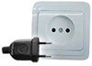 Type C
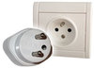 Type E
- Telecommunication
The country code for Tunisia is +216.
Foreign visitors to Tunisia can utilize mobile telephony services in two ways:
- International Roaming, which is provided with nationwide coverage.
- Prepaid Sim Cards, which can be purchased from any mobile operator.
Visitors need a valid passport in order to purchase Sim Cards. Credit recharge can be done through several channels such as supermarkets, operators point-of-sale and newspaper kiosks.

- Internet
Internet connection will be available at the meeting venue and the Hotel free of charge.

- Coordinators

AICTO
Eng. Sami Trimech
Director of Strategic Planning and Development
AICTO
Address : 16, rue du Brésil, 1002 Tunis, Tunisia
Email : s.trimech@aicto.org
Phone : + 216 71 284 187
Fax : + 216 71 846 865
www.aicto.org

HOTEL RESERVATION FORM
(to be submitted before 12 April 2018)

ITU-T SG2RG-AFR and SG2RG-ARB meetings
Tunis, Tunisia, 26-27 April 2018
(USE CAPITAL LETTERS)
1. Mr. / Mrs.
(Family name) (First name)
2. Country : _____________________________________________________________________________
3. Address : _____________________________________________________________________________
____________________________________________________________________________________
4. Tel.:__________________ Fax: __________________ E-mail : _______________________________
Check-in (dd/mm/yy): ____________________ Check-out (dd/mm/yy): _______________________
Total of nights ________________
Pick-up from Airport :
Yes
No

5. Credit Card Information:
Number: _______________________________________
Type of card: ___________________________________
Expiration date: ________________________________
Name of cardholder (as written on the card): _______________________________________
6. Arrival Date : ____ /_____ /2018
Flight No. : ______________ Time : _____________ Flight coming from (city): _____________________
7. Departure date : ____ /_____ /2018
Flight No. : _______________ Time : _________________

Date : Signature : _______________________________________

