# 

Dear Delegate,

Welcome to Uganda otherwise known as ***The Pearl of Africa***. The Uganda Communications Commission (UCC) warmly welcomes you to Uganda. We hope you will have a memorable visit. In this manual we have endeavoured to give you as much information as possible for a non-Ugandan on a visit.

## IMPORTANT INFORMATION

[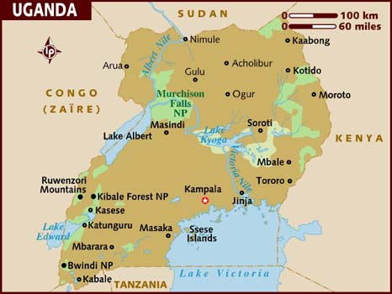](http://www.lonelyplanet.com/destinationRedirector?openMap=true&ethylCobjId=3613)

## The Republic of Uganda is located in East Africa and lies astride the equator. It is land-locked and bordered by Kenya in the East, Tanzania in the South, Rwanda in the Southwest, Democratic Republic of Congo in the West and Sudan in the North. The country has a surface area of 241,039 square kilometres and divided administratively into decentralised districts. The Time Zone is: Greenwich Meridian Time (GMT) + 3. Uganda’s population is 35 million (2013 estimates), with the youth being the majority. The country is governed under a multiparty system of governance.

## CLIMATE AND VEGETATION

Uganda enjoys a tropical climate, with abundant sunshine all year round. Uganda's temperatures are moderate throughout the year. In Kampala, near Lake Victoria, average daily temperatures range from 18° to 28° C (65° to 83° F) in January and from 17° to 25° C (62° to 77° F) in July. The rainy seasons occur from March through May and from October through November.

**TOURIST ATTRACTIONS**

**Wildlife:** Uganda's beauty, wildlife diversity, and friendly people justify its reputation as ***"The Pearl of Africa"****.* The habitats are immensely varied and Uganda is one of the most biologically diverse nations on the Continent: primeval forest, rain forest, snow-capped mountains, savannah, crater lakes and volcanoes.

Uganda is home to the source of the Nile. It is also home to more than 1,000 species of birds, and there are more species of primates than you will see anywhere else in the world. It is in Uganda that the greatest percentage of Mountain Gorillas and Chimpanzees remain, with many other mammal species representative of both East and Central Africa.

**Gorilla Tracking:** [[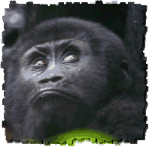](http://www.churchillsafaris.com/gorilla-safaris-uganda/uganda-gorilla-safaris.html)](http://www.churchillsafaris.com/gorilla-safaris-uganda/uganda-gorilla-safaris.html)Uganda is the only country where the endangered Mountain Gorilla can be seen in its natural habitat and expeditions through the Bwindi Impenetrable Forest in the South of the country can be organised to search for this magnificent species and Parc de Nationale in the Virungas

**Bird Watching:** 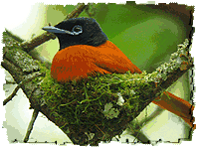Uganda is one of the best bird watching destinations with an excellent Tropical climate and lies in the Albertine Rift region. A tiny landlocked country supporting more than 1000 species, Uganda deserves its reputation as “birders Eden”. A short trip here to soak up the birrarre and mind blowing shoebills at Mabamba, Murchison falls or Albertine Rift endemics at Bwindi Natioal Park is incredibly rewarding. Uganda is a superb destination for rainforest fanatics and those in search of rare elusive species.

**Cultural and Eco Tourism:** 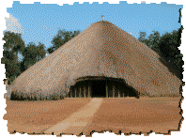Uganda has a very strong culture heritage. Many regions in Uganda have kingdoms including Buganda, Busoga, Bunyoro, Ankole, Toro, etc.

**Kasubi Royal Tombs** – The Kasubi tombs, traditionally known as Muzibu-Azaala-Mpanga, are a burial place for the four previous Kings of Buganda known traditionally as Kabakas, and are situated five km away from [Kampala](http://www.guideforafrica.com/uganda/kampala-travel.html) **city** centre on Kasubi hill. The cultures of the Baganda lie in the Magnificent Tombs. Other cultural places worth visiting are:

* **Karambi Tombs**, Fort Portal
* **Nyero Rock Paintings**
* **Baker’s Fort**, Patiko
* **Bigo bya Mugenyi**, Ntusi
* **Mparo Tombs**, Hoima
* The **Nommo Gallery** in Kampala
* The **Namugongo Martyrs Shrine** near Kampala
* Entebbe Wildlife Education Centre
* The Equator Line mark along Masaka road
* **National Museum** – This is a display of Uganda’s cultural heritage including ethnological and natural-historical exhibitions. It is a reminder of wonderful past of the country with a collection of musical instruments, photos, pictures, materials of the past. A visit to the museum will give you the country’s flash back.

**Forest Guided Walks:** 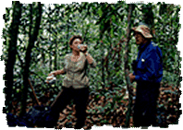These can be done in most of the National Parks in Uganda, Kenya , Tanzania, Rwanda and South Africa to look for various types of wildlife species.

**Fishing****:** Come to Uganda to fish one of the largest water predators on this earth; the Nile Perch on Lake Victoria and the Nile. On World records, the largest freshwater fish have been obtained in Ugandan waters.

**Mountaineering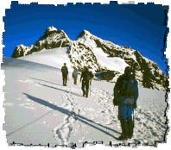:** Uganda’s evident extraordinary scenic diversity and richness of landscape compares favourably with everywhere on the African continent.

* **Mount Rwenzori** in the West
* **Mount Elgon** in the East
* **Virunga Volcanoes** in the south west
* There are also several hills around the country

**Spectacular Water Falls**

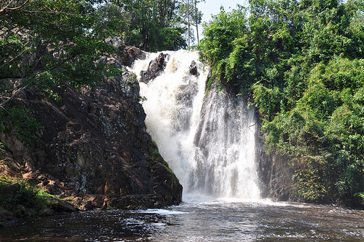

*Spectacular Ssezibwa Falls*

**Ssezibwa falls** – The falls are located about 20 miles along **Jinja Road** from Kampala; is a Buganda Heritage site, with an out span of sharp edged rocks and a magnificent sound of soothing waters flowing down the steep ridged stones. Local people attach cultural and traditional significance as well as spiritual beliefs onto the site.

* **Murchison Falls** in the Northwest
* **Source of the River Nile** – The Nile is more than the longest river in the world. The Nile is enthralling, with its majestic beauty and brutal power.
* **Sipi Falls** in Kapchorwa, East
* **Semliki Falls** in the west
* **Bujagali Falls** in Jinja
* **Lake Victoria** near Kampala

**Cycling:** 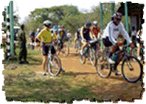Your challenge is to cycle 300km in one of the most spectacularly beautiful countries of East Africa, through Lake Mburo National park which features some of the rare animals in Uganda including the Impalas, eland, antelopes as well as zebras, buffalo and hippos.

**White Water Rafting:** 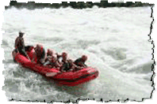The thrill of churning rapids is one of the newest adventures in Uganda. As the Nile River flows through on its 6600km journey to the Mediterranean it alternates between a placid course and the swirling white water rapids. Rafting is available on Bujagali falls, more than 4000miles in length, the mighty Nile is the longest river on earth.

**Balloon safaris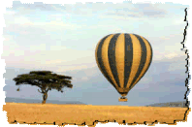:** This is an elegant and memorable form of air travel as an option in the many parks/game reserves. This is available in Kenya and Tanzania. Day and night game drives where possible.

**ISLANDS**

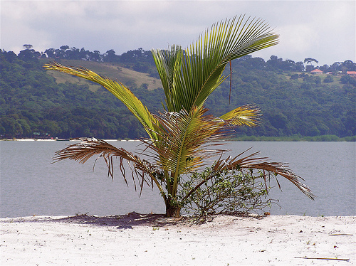

*Ssese Islands*

**Ssese Islands** – Ssese islands are a collection of 84 attractive Islands situated in the northwestern part of **Lake Victoria.** They are also amazingly a popular tourist destination in the country. They offer captivating scenic views, plenty of activities like nature walks, fishing volley ball and other games. Spending a weekend on this island can fun and an adventurous moment.

[**UGANDA NATIONAL PARKS**](http://www.guideforafrica.com/uganda/uganda-national-parks.html)

Uganda is not your ordinary safari destination; it is a country very rich in fauna and flora which are seen in the 10 national parks in the country .Come and explore a rich biodiversity in a single destination. Uganda is more importantly famous for the endangered mountain gorillas. Perhaps the most interesting park you can track the gorillas is the thick Bwindi impenetrable forests.

**Uganda National Parks** are:

* [Semliki National Park](http://www.guideforafrica.com/uganda/semliki.html)
* [Lake Mburo National Park](http://www.guideforafrica.com/uganda/lake-mburo-park.html)
* [Mgahinga Gorilla National Park](http://www.guideforafrica.com/uganda/mgahinga.html)
* [Bwindi Impenetrable National Park](http://www.guideforafrica.com/uganda/bwindi-park.html)
* [Queen Elizabeth National Park](http://www.guideforafrica.com/uganda/queen-elizabeth.html)
* [Murchison Falls National Park](http://www.guideforafrica.com/uganda/murchison-falls.html)
* [Kibale Forest National Park](http://www.guideforafrica.com/uganda/kibale-park.html)
* [Mount Elgon National Park](http://www.guideforafrica.com/uganda/elgon-park.html)
* [Rwenzori Mountains National Park](http://www.guideforafrica.com/uganda/rwenzori-park.html)
* [Kidepo Valley National Park](http://www.guideforafrica.com/uganda/kidepo.html)

## [Entebbe Wildlife Education Centre](http://www.igougo.com/b387570-attraction-reviews-entebbe-wildlife-education-centre-entebbe--uganda.html) (UWEC): Set on the shores of Lake Victoria, Uganda Wildlife Education Centre is a must visit for anyone coming to Uganda for a leisure or educational tour. The centre which sits on 72 hectares, boasts of a wide variety of indigenous wildlife numbering well into thousands, and housed in natural settings which depict three of Uganda’s ecosystems: The Wetland, The Savannah and The Forest.

With all these **tourist attractions** that **Uganda** has at hand, it just confirms that the country is truly the *Pearl of Africa*.

**OTHER INFORMATION**

# AIR TrAvEl

Entebbe International Airport, Uganda’s man international airport is located on the shore of Lake Victoria, about 32km (20 miles) south of Kampala, the capital city of Uganda. The Airport is open 24 hours with full amenities of an international airport. Some of the international and regional flights that ply the Entebbe route are KLM, Emirates, Kenya Airlines, British Airways, South African Airways, SN Brussels, Egypt Air and Ethiopian Airlines.

**TRAVELLERS REQUIREMENTS**

All travellers to Uganda must be in possession of a valid passport issued and recognised by their government. Visas are issued at Ugandan Missions abroad and also at entry/exit points. The duration for the visitor’s visa varies, with a maximum of three months. Here below are the various visa fees:

* Single Entry-US$30;
* Multiple-entry 6-month visa - US$80,
* Multiple-entry 1-year visa - US$160.

It is possible to obtain your visitor’s visa on arrival at Entebbe airport. Multi-entry visas are not available at the airport, but can be obtained from Ugandan embassies in foreign countries. You should present your application and US$50 in cash to the immigration officer. The airline will normally have distributed the visa application form prior to landing in Entebbe. Delegates are able to obtain foreign exchange at the forex bureaux inside the arrival terminal.

Nationals from the COMESA (Common Market for Eastern and Southern Africa) member countries are exempt from visa requirement into Uganda. COMESA countries are Angola, Burundi, Comoros, Eritrea, Kenya, Malawi, Mauritius, Madagascar, Rwanda, Seychelles, Swaziland, Tanzania, Zambia, Zimbabwe.

Others countries exempt from visa requirements to Uganda are Antigua, Bahamas, Barbados, Belize, Fiji, Gambia, Grenada, Jamaica, Lesotho, Malta, Sierra Leone, Singapore, Solomon Islands, St Vincent & The Grenadines, Tonga, Vanuatu, Italy (Only Diplomatic Passports), Cyprus. Please note that American nationals, British, and just about all Commonwealth nationals and European nationals that make up the vast majority of visitors to Uganda do need a visa to travel to Uganda.

**TRANSPORTATION**

Travellers to Uganda can get airport taxi or hotel courtesy buses on arrival and departure to Entebbe Airport. Commuter omni buses and taxis (special hire) are the main means of public transport in Kampala. There are both buses and mini buses for inter-city services. Distances are relatively short and road surfaces good.

**HEALTH REQUIREMENTS**

There are not any health requirements for temporary entry to Uganda. However, travellers to Uganda must have an international Inoculation Certificate against Yellow Fever (although a strict requirement being requested to present it for inspection at any entry point into the country would be rare)

**ELECTRICITY**

The electricity supply in Uganda is 240 Volts ac 50 Hz. Sockets are usually 13 Amp, square pin in most buildings.

# Accommodation

There are international-standard hotels in Kampala City and the major urban areas in Uganda. Kampala is rich in hotel and accommodation facilities, ranging from three-star to five-star hotels. There are also a lot cheaper and more pocket-friendly but convenient hotels as indicated below. Information can be obtained from the Uganda Tourist Board. Note that most places will add 18 per cent VAT to any bill. However, we encourage delegates to reside at or near the venue at the negotiated rates.

**INSURANCE**

It is strongly advisable that all delegates travel with full cover Travel Insurance.

**SECURITY**

Ugandans are known for their hospitality and friendliness towards each other and visitors alike. Although all Ugandans are very helpful it is always advisable to be cautious when dealing with strangers. Police officers are very helpful and are easily identified by their uniforms and although some may be plain-clothes police. Like everywhere in the world valuables should always be safeguarded or left in the hotel safe box. If you do not know where to obtain a certain service or you are not sure always contact the Hotel Information Desk.

# CURRENCY

# The currency of Uganda is the Uganda Shillings (/-).

The notes and coins that are currently in circulation are:

Bank notes UGX 50,000/=, UGX 20,000/- UGX 10,000/- UGX 5,000/- UGX 1,000/-

Coins 500 shillings, 200 shillings, 100 shillings, 50 shillings

## FOREX BUREAUS AND BANKING

Uganda has a liberalised economy. Hence, there are numerous forex bureaux in Kampala and the main towns across the country. A number of international and regional banks exist. These include Bank of Africa, Barclays Bank, Standard Chartered, Stanbic, Tropical African Bank, and Cairo bank – just to mention a few. We also have money transfer services from Western Union and Money Gram in most of our local and international banks.

Mobile money transfer (e-banking) by major telecommunications operators, such as MTN Uganda, Uganda Telecom Limited and Airtel, is also a booming business. Almost all credit cards (Visa, Barclays, American Express, Master card, etc) are accepted in a few restaurants, hotels and shopping centres.

# Shopping Centres

1. **The Shoprite** - Commercial Centre
2. **The Game** – Commercial Centre + Supermarket
3. **Garden City -** CBD
4. **Nakumatt Oasis** – CBD (24-hour shopping)

# GENERAL ENTERTAINMENT

1. National Theatre - **Tel:** +256-41 4225506

Parliament Avenue

Kampala

1. Cineplex Garden City, Yusuf Lule Road **Tel:** +256-31-2261 416 [www.cineplex.co.ug](http://www.cineplex.co.ug)
2. Ndere Troupe **Tel**: +256-41-4288123; +256- 41-488222. Mobile: +256-77-2200104
3. Ndere Centre for Development Theatre  
   Kigoowa (Take the Kisaasi road from Ntinda Trading Centre)  
   Kampala, Uganda, P.O. Box 11353, Kampala

# Restaurant Guide

In Kampala, you can find a wide range of different restaurants:

***French***

* Café de Paris, Plot 7 Yusuf Lule Road, Tel: +256-41-4344240; +256-71-2344240
* Le Petiti Bistro, Ggaba Road Kansanga, Tel: +256-77-2403080

***Italian***

* Mamba Point Restaurant, 22 Akii Bua Rd, Nakasero Tel: +256-77-2243225
* Pizzeria Mammamia, Speke Hotel, Nile Avenue Tel: +256-41-4346340; +256-77-2630211
* Villa Flora, 62 Lumumba Avenue, Tel: +256-41-4347273 (open daily)

***Chinese***

* Fang Fang Restaurant, Roof Terrace Communication House, Plot 1 Colville Street

Tel: +256-41- 4344806, +256-31-2 260681

* China Plate, 11 Cooper Road, Kisementi, Tel: +256-41-4233888
* Chopsticks, Equatorial Hotel, William Street, Tel: +256-41-4250781/5

***Ethiopian***

* Fasika Restaurant, Kabalagala Gaba Road Tel: +256-41-4510441; +256-77-2303716

***Indian:***

* Khana Khazana, 20 Acacia Avenue, Kololo Tel: +256-41-4233049; +256-41-4347346
* Sam’s Restaurant, 78 Kampala Road, Tel: +256-41-4251694
* Restaurant Misono (Japanese), Lenana Road, Tel: +256-41 4568959

**Fast Food:**

* Dominos Pizza, Plot 14 Kampala Road, +256-41-4251513
* Steers Food Court, Kampala Road, Tel: +256-41-4231623; +256-77-2770011
* Krua Thai, Windsor Crescent (off Acacia Avenue) Kitante, Tel: +256-41-4234852; +256-71-2777433
* Food court, 2nd Floor Garden City, Yusuf Lule Road

**Lebanese:**

* Al-Fiesta, 12 Lumumba Avenue, Nakasero Kampala. Tel: +256-71-2664488; +256-75-2617772

MEETING costs

Where participation to the meeting is free, no charges are levied. However, participants are advised to settle their accommodation and related bills during their stay Kampala. Included in this pack is more elaborate information concerning Uganda. Please read carefully and if there are any queries, do not hesitate to ask any of the staff of the Commission using the contact numbers indicated below:

**How to Contact Us**

**Uganda Communications Commission (UCC)**

**UCC House**

**Plot 42-44 Spring Road, Bugolobi**

**P. O. Box 7376, KAMPALA**

**Tel: +256-41-4339000 or** **Tel: +256-31-2339000**

**Toll Free Line: 0800133911**

**Twitter: UCCUg**

**Email:** [**ucc@ucc.co.ug**](mailto:ucc@ucc.co.ug)

**Facebook: Uganda Communications Commission**

## Website: www.ucc.co.ug

## Contact persons:

**Ms Helena Mayanja**

Public Relations Specialist

E-mail: [hmayanja@ucc.co.ug](mailto:hmayanja@ucc.co.ug)

Tel: +256-41-4339171

Mobile Phone: +256-77-2406464

**Ms Nakiguli Helen Cynthia**

Environment Management Specialist

E-mail: [hnakiguli@ucc.co.ug](mailto:hnakiguli@ucc.co.ug) or hecyna@gmail.com

Tel: +256-41-4339000

Mobile Phone: +256-772-433448; +256-70-2139887

**Ms Immaculate Kyomuhendo**

Communications Officer

E-mail: [ikyomuhendo@ucc.co.ug](mailto:ikyomuhendo@ucc.co.ug)

Tel: +256-41-4339000

Mobile Phone: +256-77-3120596; 079-44120596

Enjoy your stay in Uganda.