Events of ITU and UNESCO in Uruguay

From 11 to 14 March, 2014
Montevideo - Uruguay

Website: http://www.itu.int/en/ITU-T/Workshops-and-Seminars/Pages/URY-2014.aspx

- DATES AND VENUE OF THE MEETING

1.1 Date: 11 to 14 March, 2014.

1.2 Venue: Sede del Mercosur
Address: Dr. Luis Piera 1992 Piso 1 (ex Parque Hotel)
Montevideo - Uruguay
Fax: 00 598 2410 0958 / 2418 0557
Telephone: 00 598 2412 9024
Website: http://www.mercosur.int/

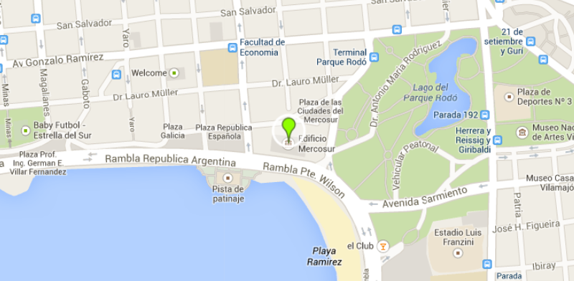
1.3 National Coordinator
Ministry of Industry, Energy and Mining (MIEM)
National Direction of Telecommunications (DINATEL)

Mr. Juan Piaggio
Tel.: 00 598 2915 0856
Fax: 00 598 2916 7923 int. 210
Correo Electrónico: juan.piaggio@dinatel.miem.gub.uy

Mrs. Virginia Alonso
Tel.: 00 598 2915 0856
Fax: 00 598 2916 7923 int. 218
Correo Electrónico: virginia.alonso@dinatel.miem.gub.uy

- VISA REQUIREMENTS

A list of countries that DO NOT REQUIRE VISA for entry into Uruguay can be obtained at: Visas para ingresar a Uruguay . Holders of ordinary passport of countries NOT included in the previous list will need an entry visa into Uruguay. In this case, participants are strongly advised to seek information on requirements applicable in their case from Uruguayan diplomatic or consular missions in their home countries at least 15 days prior to the trip. The following documents are required:

- Valid passaport.
- A round-trip airline or bus ticket. If travelling with a vehicle, title of the car or documentation that proves you are able to drive it.
- Hotel booking in your name or in the name of the person with address/phone number of the place where you will stay.
- If applicable, invitation letter received from Uruguay.

Eventually, the Consulate may ask for additional information. Please see Oficina Consular for the nearest Consulates.
Diplomatic or Official passport holders are requested to contact the nearest Uruguayan Embassy or
Consulate in order to get additional information on visa requirements.

Participants on transit flights in other countries must pay special attention to the requirements of these countries, since they may need an entry or transit Visa to the country or change of Airport (the latter can occur on flights making a stop in Buenos Aires).

Participants who require an entry visa into Uruguay, are requested to contact Mrs. Madelón Musse at the Ministry of Industry, Energy and Mining (see contact details below) for a personalized invitation letter addressed to the participant. The letter will be sent by e-mail and should be delivered afterwards to the Uruguayan Embassy Consulate in order to obtain the visa.

Mrs. Madelón Musse
Tel.: 00 598 2915 0856
Fax: 00 598 2916 7923 int. 200
E-mail: secretaria@dinatel.miem.gub.uy

- ARRIVAL AT AIRPORT

The airport Aeropuerto Internacional de Carrasco has all necessary amenities to welcome participants properly. It is located 40 minutes from the city and the official hotels of the meeting and the airport is used for arrival and departure of international flights.

Participants should make their own transportation arrangements from and to the Aeropuerto Internacional de Carrasco.

Airport practical information:
At the airport you can find taxi Service and Exchange.

International Arrivals | Ground Floor  Oficina zona Carruseles  Oficina Hall Público / Costums
International Departures | Upper Level  Oficina zona Hall Público  Check in area
Taxi Aeropuerto | Taxi Service  Tel: 00 598 2604 0323  www.taxisaeropuerto.com  Rate to “Parque Rodó”: 1.100 pesos uruguayos  About USD 55,00
Exchange | Global Exchange Uruguay  Tel: 00 598 2600 7397  Working hours: 24 hours.  http://www.globalexchange.com.uy/

- TRANSPORTATION
Hotels officially recommended are located close to the event. For those who wish to take taxi, it is strongly recommended that you only use black taxis with yellow stripes or white taxi with yellow stripes. The cost of a journey of 3 kilometers is $ 82 uruguayos (About USD 4,00).
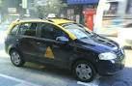
Local Taxi Telephone nº:
Radio Taxi Patronal 141
Radio Taxi Celeritas 1919
Radio Taxi Punta Gorda 1771

The event organizers will not provide transport to participants from the recommended hotels or meeting venue to the location of the social events scheduled on the agenda of activities.

- HOTEL RESERVATION

Special rates have been negotiated for participants in the hotels close to the venue of the event.
Participants who choose hotels that are shown in the table below are kindly requested to fill out the attached form and email it directly to the selected hotel copying the following email: secretaria@dinatel.miem.gub.uy.

However, it is required to send the reservation form (Annex I) no later than 25 February 2014 in order to guarantee preferential rates. Delegates are responsible for settling their hotel bill at the end of their stay.

A credit card is required to guarantee the reservation. Participants who cannot attend the event are requested to contact the selected hotel since each one has its own cancellation policy.

IT IS STRONGLY ADVISED TO MAKE HOTEL RESERVATIONS THROUGH THE FORM ATTACHED AND NOT THROUGH INTERNET BOOOKING IN ORDER TO BENEFIT FROM THE NEGOTIATED RATE AND TO AVOID PROBLEMS IN CASE OF CANCELLATION.

Recommended hotels location map:
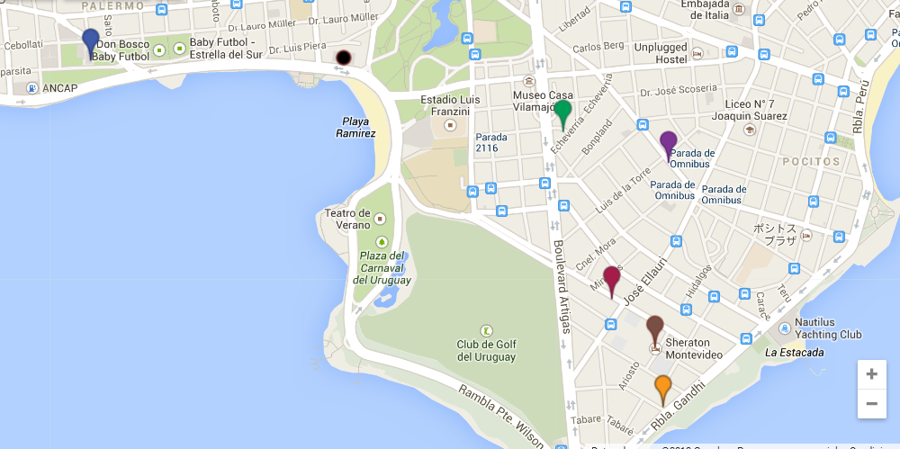
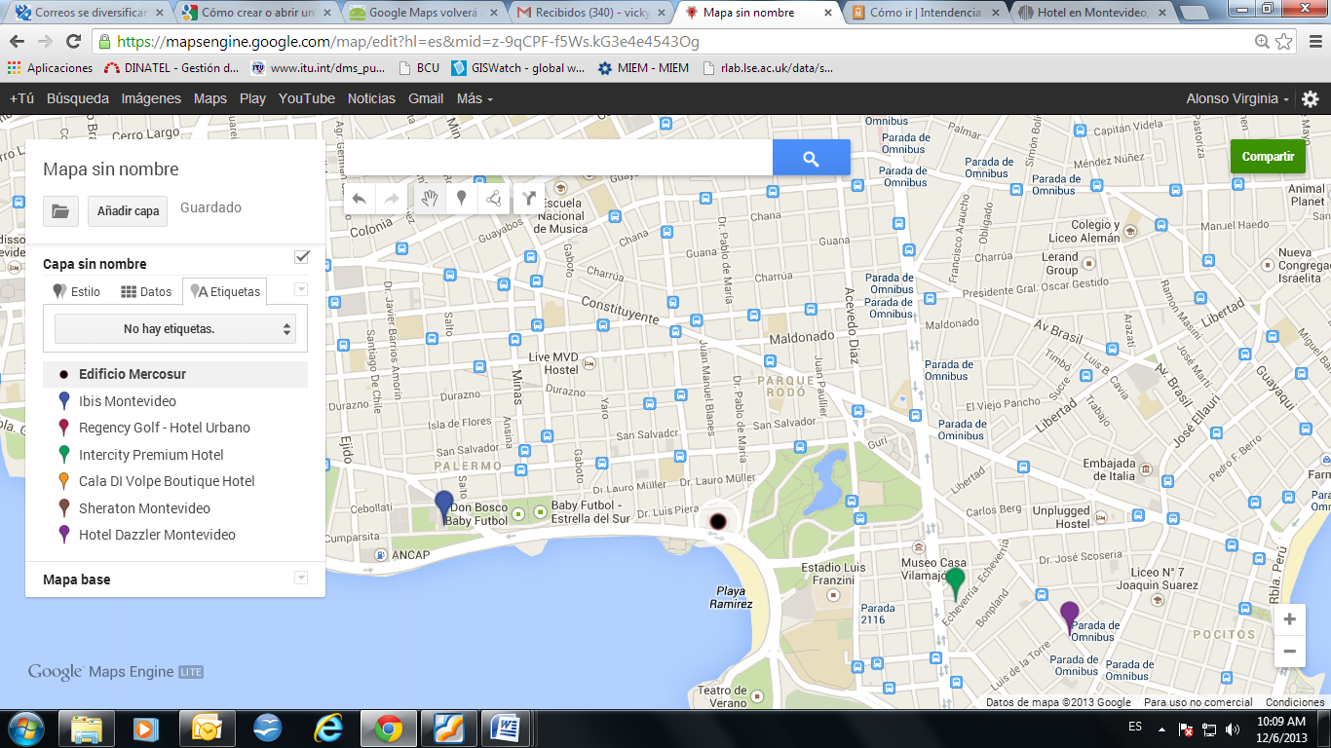

RECOMMENDED HOTELS FOR WHICH SPECIAL RATES HAVE BEEN NEGOTIATED FOR THE EVENTS
 | HOTEL | Stars | Rates in USD | Services included | Check in | Check out | Cancelations | Language
1 | Ibis Montevideo  La Cumparsita 1473 – Rambla Sur C.P. 11200  Montevideo – Uruguay  Tel. 00 598 2413 7000  Fax. 00 598 2413 6245  h3539@accor.com  www.ibishotels.com | *** | Standard USD 79  Breakfast optional (USD 8 per person) | Free WI-FI  Business Corner | 12:00 hrs | 12:00 hrs | No cost, if cancelled before the 18:00 hrs on the day of check in | Spanish  Portuguese  English
2 | Regency Golf – Hotel Urbano  Fco. Solano García 2473 – Punta Carretas  Montevideo – Uruguay  Tel. 00 598 2710 4444  Tel. por reservas 00 598 2710 4444 int. 1004  Fax. 00 598 2712 3342  reservas@regencygolf.com.uy  www.regencygolf.com.uy | **** | Executive USD 119  Deluxe USD 128  Suite USD 157 | Breakfast Buffet  Free WI-FI  Fitness Center, Sauna  Business Center  Welcome drink  Discounts in the Restaurant “Urbano Snack” | 14:00 hrs | 11:00 hrs | No cost, if cancelled 48 hrs before check in | Spanish  Portuguese  English
3 | Intercity Premium Hotel  Ibiray 2398 - Punta Carretas  Montevideo – Uruguay  Tel. 00 598 2711 6500  reservas@intercityhoteles.com.uy  vanina.lopez@intercityhoteles.com.uy  www.intercityhoteles.com.uy | **** | Lujo single USD 93  Lujo doble USD 98  Lujo Superior single USD 113  Lujo Superior doble USD 118 | Breakfast Buffet  Free WI-FI  Fitness Center | 14:00 hrs | 12:00 hs | No cost, if cancelled 24 hrs before check in | Spanish  Portuguese  English
4 | Cala di Volpe Boutique Hotel  Parva Domus 2531 – Punta Carretas  Montevideo - Uruguay  Tel. 00 598 2710 2000  Fax. 00 598 2712 5387  ventas@hotelcaladivolpe.com.uy www.hotelcaladivolpe.com.uy | **** | Standard Single USD 140  Standard Doble USD 140  Superior USD 164  Corner Suite USD 190  Suite Ejecutiva USD 220 | Breakfast Buffet  Free WI-FI  Fitness Center | 14:00 hrs | 11:00 hrs | No cost, if cancelled 48 hrs before check in | Spanish  Portuguese  English
5 | Sheraton Hotel  Victor Soliño 349 – Punta Carretas  Montevideo – Uruguay  Tel. 00 598 2710 2121  alejandra.gutierrez@sheraton.com  www.sheraton.com/montevideo | ***** | Standard Single USD 195  Standard Doble USD 205 | Breakfast Buffet  Access to the Spa | 15:00 hrs | 12:00 hrs | No cost, if cancelled 5 days before check in | Spanish  English
6 | Dazzler Montevideo Hotel  21 de Setiembre 2752 – Punta Carretas  Montevideo – Uruguay  Tel. 00 598 2716 0000  reservas@dazzlermontevideo.com  www.dazzlermontevideo.com | **** | Classic USD 85  Superior USD 105  Suite USD 115  Vip USD 155 | Breakfast Buffet  Free WI-FI  Access to Sauna, swimming pool and gymnasium  Business Center | 15:00 hrs | 10:00 hrs | No cost, if cancelled 48 hrs before check in | Spanish  Portuguese  English

The rates shown in the list correspond to the final price and are exempted from VAT for non-resident guests in Uruguay.
- SERVICES AVAILABLE FOR PARTICIPANTS DURING THE MEETINGS

6.1 Information display
It will be located outside the mail room and will provide information on many issues of interest to the participants and will be forwarded to other services, such as city tours and transfers, mail, communications, etc. It will also be the place or the delivery or collection of lost items.

6.2 Communication Center
Internet Access free of charge will be available at the event meeting room.

6.3 Interpretation service
Interpretation services will be available in English and Spanish.

6.4 Security
For security reasons, all participants should permanently wear their badges throughout the meeting and during social activities.

6.5 Medical Assistance
Participants are advised to get an international travel insurance to cover any medical expenses in case of medical treatment.

- CURRENCY

The official currency of Uruguay is the “peso uruguayo”. American dollar is usually accepted in the market. Foreign currencies may be changed into Uruguayan peso at banks or private exchange offices called “Casas de Cambio”. The banks are open from 1pm to 6 pm.

The exchange rate in Uruguay is floating free but stable, other currencies rate can be consulted at www.bcu.gub.uy. At the date of 4/12/2013:

Notes and coins in circulation:
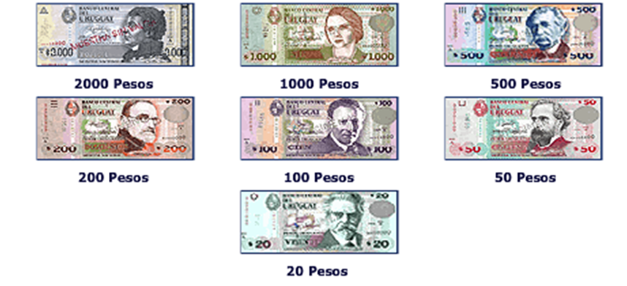

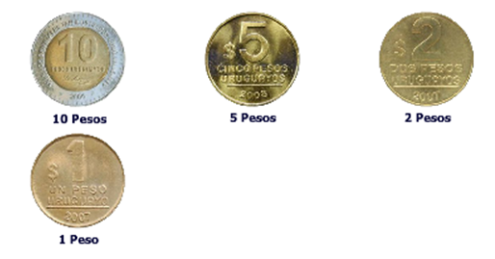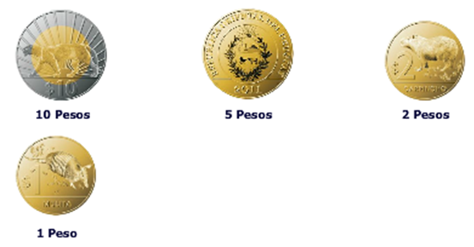

- GENERAL INFORMATION

8.1 General Information about Uruguay:
Government: | Unitary Presidential constitutional Republic
President: | Mr. José Mujica Cordano
Vicepresident: | Cr. Danilo Astori
Area: | 176.215 km2
Total Area: | 313.782 km2
Population: | 3.286.314 (Censo 2011)
Capital: | Montevideo
Language: | Spanish

8.2 Weather:
The meeting will take place in the Uruguayan summer, with temperatures in Montevideo between the 23 º and 30 º C.
For more information:
http://www.meteorologia.gub.uy http://www.accuweather.com/en/uy/montevideo/349269/weather-forecast/349269

8.3 Time Zone:
Uruguay is GMT - 0300 hours.

8.4 Electricity:
AC power voltage in Uruguay is 220 V, 50 Hz.
Find below all outlets used.
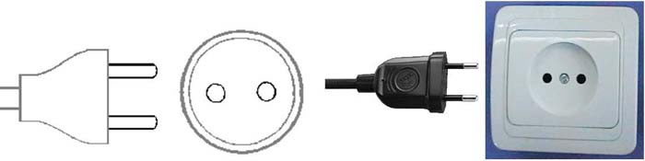
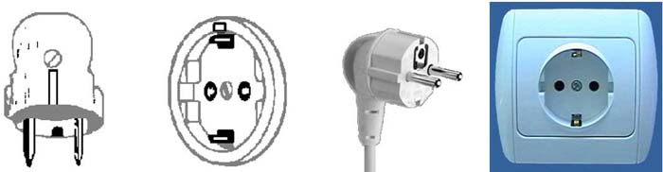
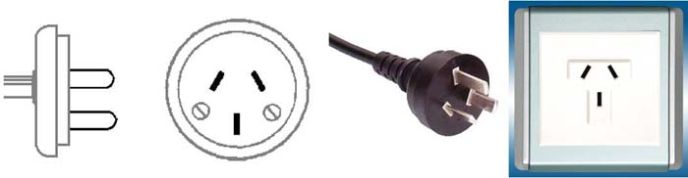
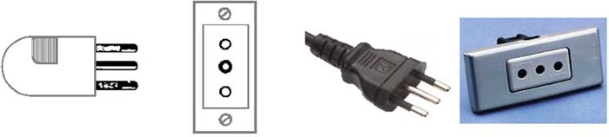

8.5 For additional information please access:

www.turismo.gub.uy/

www.presidencia.gub.uy

Events of ITU and UNESCO in Uruguay
ANNEX 1

Montevideo - Uruguay
(11-14 March, 2014)

HOTEL RESERVATION FORM
Name:
Tel: |  | Country: |  | E-mail:
Selected Hotel:
Selected rate:
Type of room | Double room  Single room |  | Check-in (dd/mm/yy): |  | Check-out (dd/mm/yy):
Travel information:
Place and arrival date:
Airline and flight number:
Place and departure date:
Airline and flight number:

Credit Card Information:
Type of card: Number:
Expiration date: Name (as it is written on the card):
Place:
Date:
Signature:
We kindly ask you to fill this form and send it to the hotel of your choice no later than
25 February 2014 copying the following email address:
secretaria@dinatel.miem.gub.uy.

