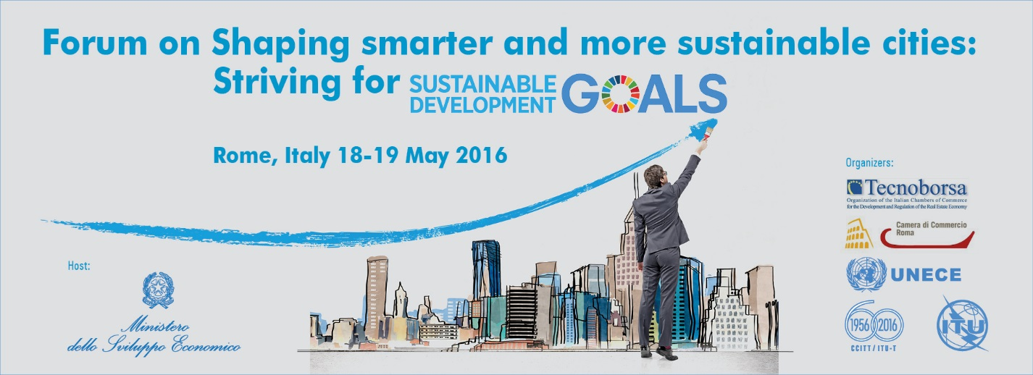
Practical information
Forum on
“Shaping smarter and more sustainable cities: striving for sustainable development goals”
Rome, Italy
18-19 May 2016
- CONFERENCE VENUE
The meeting will take place at the Camera di Commercio di Roma – Temple of Hadrian Hall
  - The address is as follow:

Temple of Hadrian Hall
Camera di Commercio di Roma – Sala del Tempio di Adriano
Piazza di Pietra
00186 Rome
Italy

- HOTEL ACCOMMODATION
  - List of recommended hotels:
- Grand Hotel de la Minerve
www.grandhoteldelaminerve.com

- Albergo del Senato
https://albergodelsenatorome.reserve-online.net/

- Albergo Cesàri
http://www.albergocesari.it/en/

- Colonna Palace Hotel
www.itihotels.it/ita/colonna_palace_hotel/home.htm

- Hotel Nazionale a Montecitorio
www.hotelnazionale.it/
Participants are responsible for meeting the cost of their accommodation.
  - Participants will be responsible for making their own transfers arrangements from their respective hotels to the meeting venue if staying in hotels outside of the list of recommended hotels.

- VISA
  - Citizens from non-EU countries should possess a valid passport to enter Italy. The passport should be valid for at least three months after arrival date in Italy.
  - Citizens from EU and Schengen countries are required to present a valid Passport or Identification Card.
  - There may be visa requirements for citizens of some countries to enter Italy. Where this is the case, visa applications can be made at any Italian Embassy or Consular Office in your country. Upon request, Tecnoborsa will provide participants, who are officially registered in the conference, with an invitation letter in order to facilitate the processing of their visa applications. Applicants should address such requests, together with a scanned copy of their passport (pages with photo, date of issue and expiry date) as well as their occupation/position within their company, to Tecnoborsa.

- REGISTRATION
  - All participants are required to register prior to attending this Forum. Participants are encouraged to complete and submit an online registration which can be accessed from the link below:

http://www.itu.int/online/regsys/ITU-T/misc/edrs.registration.form?_eventid=3000858

Kindly refer to the instructions on the website to complete the registration.

- AIR TRAVEL
  - Rome has two airports:
  - Leonardo da Vinci International Airport (Fiumicino)
Address: Via dell' Aeroporto di Fiumicino, 320, 00054 Fiumicino RM, Italy
  - Rome Ciampino Airport
Address: Via Appia Nuova, 1651, 00040 Ciampino RM, Italy

- LANGUAGE
  - Italian is the official language in Italy, but English is widely understood in major hotels, restaurants, banks and businesses.

The conference will be held in English, Italian and Russian with simultaneous interpretation.

- CLIMATE
  - The climate of Italy is mainly temperate.
Rome enjoys a Mediterranean climate. Spring and autumn are mild to warm; generally the summer ‘season lasts about 6 months, from May to October.
- LOCAL TIME
Rome / CET

- CURRENCY, BANKS AND CREDIT CARDS

The official currency accepted in Italy is EURO. Major foreign currencies may be exchanged to EURO at hotels and foreign exchange banks. Official banking hours can vary slightly, but in general are from 8:30 a.m. to 1:30 p.m., and an hour and a half in the afternoon between 2:30 and 4:40. Banks are generally closed on weekends and holidays. Cash can be easily withdrawn 24/7 from the numerous ATMs spread in the city.

Most hotels, restaurants, car rental agencies, department stores and shops accept major credit cards (American Express, Diners Club, MasterCard, VISA). Usually there is a sticker at the entrance indicating which cards are accepted.
- ELECTRICITY
  - The standard supply is 220 volts, 50 Hz.

  - Please bring the correct adapter for your equipment.

- ABOUT ITALY

The Italian Republic is a country located in south-central Europe. The territory of Italy covers some 301,338 km2 (116,347 sq mi) and is influenced by a temperate seasonal climate. With 60.4 million inhabitants, it is the sixth most populous country in Europe, and the twenty-third most populous in the world.

Italy's capital, Rome, was for centuries the political centre of Western civilization as the capital of the Roman Empire. After its decline, Italy endured numerous invasions by foreign people, from Germanic tribes to Huns. Centuries later, Italy became the birthplace of the Renaissance.
Through much of its post-Roman history, Italy was fragmented into numerous kingdoms and city-states but was unified in 1861, following a tumultuous period in history known as "Il Risorgimento".

Modern Italy is a Democratic Republic. Nowadays, Italy plays a prominent role in European and global, cultural, diplomatic and military affairs.

- ABOUT ROME
Rome, “Caput mundi”, is the capital of Italy with over 2.7 million residents in 1,285.3 km2 (496.3 sq mi). Rome's metropolitan area is the second largest in Italy (after Milan), with some 3.7 million residents. The city is located in the central-western portion of the Italian Peninsula, on the Tiber River within the Lazio region of Italy.

Altitude
Rome is located about at 14m / 49ft above sea level.

Transportation
Public Transportation in Rome consists of: buses, trams, metros and night buses.
More information is available on the following website: http://www.atac.roma.it/
To call for a taxi within Rome: 06 3570, 06 4994, 06 6645, 06 551, or 06 8822.

Health Care
Pharmacy and good medical facilities are largely available in Rome.
Emergency medical services: 118

Useful Emergency Numbers
Police: 113
Carabinieri: 112
Fire Brigade: 115
Traffic Wardens: 0039 06 67691
Guardia di Finanza: 117
Police Headquarters: 0039 06 4686
- HOST COUNTRY CONTACT:
Tecnoborsa
Viale delle Terme di Caracalla, 69/71 - 00153 Roma, Italy
Ms. Lucilla Scelba
Email : l.scelba@tecnoborsa.com
D. Line: +39 06 57300710
Fax: + 06-5730183 2
_____________

