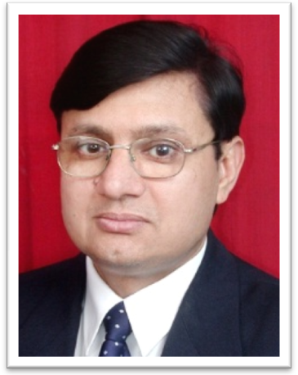
Brief Resume

Dr. R. S. Sharma, FAMS
Senior Deputy Director General & Scientist – G
Indian Council of Medical Research
New Delhi – 110029, India
E-mail: radheyss@gmail.com

Fellow - National Academy of Medical Science, India
Fellow - World Health Organization (WHO)
Fellow - Rockfeller Biotechnology Career Fellow, USA

Significant contribution in the area of EMF research in the following capacity:
- Member Secretary – ICMR Experts committee on EMF research.
- Dr. Sharma is co-ordinating and conducting a hospital based multi-disciplinary cohort study in Delhi & NCR to find out the adverse effects of radiation emitted from cell phone on adult Indian population. This is a largest epidemiological study going on in the Country. Under this study efforts are going on to examine whether use of cell phone is associated with neurological disorders (cognitive behavior, sleep related disorders, depression etc.), reproductive dysfunctions, cardiovascular disorders, Otorhinolaryngology (ENT) disorders and promote cancer if any, in human volunteers.
- Member – Expert Committee for installation of cell phone towers in Delhi, Municipal Corporation of Delhi (MCD), Govt. of Delhi, Delhi.
- Member – Expert Committee to study the health effect of mobile technology, Director General of Health Services, Ministry of Health and Family Welfare, Govt. of India, New Delhi.
- Member – Expert Committee for improving signal strength of mobile connection, AIIMS, New Delhi.
- Member – Expert Committee appointed under the direction of the Hon’ble Prime Minister at Department of Science and Technology (DST), Govt. of India for advising the DST on scientific approach for resolving the issues relating to the likely harmful effects of Telecom Towers and the need for increasing Tele-density as a developmental requirement.
- Member – Inter-Ministerial Committee constituted by the Ministry of Communication and IT, Govt. of India representing both Ministry of Health and Family Welfare and ICMR.
- Member – International Advisory Committee on EMF, World Health Organization (WHO), Geneva.

National Contribution
- As a prominent member of the Inter-Ministerial Committee of Ministry of Communication and IT, Govt. of India played a significant role in
  - reducing exposure limit of Radio Frequency Radiation (RFR) to 1/10th of the existing one, emitted from cell phone tower in the Country.
  - reducing the Specific Absorption Rate (SAR) of cell phone.
  - developed guidelines for safe use of cell phone by the users in the Country.
  - developed guidelines for installation of cell phone towers in the Country.
  - Identified new researchable areas.

Awards:

1. Awarded Late Dr. T C Anand Kumar Oration and Gold Medal - ISSRF-2012

2. Awarded Bharat Jyoti Award by India International Friendship Society, 2010

3. Labhsetwar Award - 2009 for outstanding contribution in the area of population control

4. Dr. Subhash Mukherjee Oration Award – 2007 for outstanding contribution in the area of Assisted Reproductive Technologies

5. ESSEM Founded Award – 1998 for outstanding contribution in the field of Reproductive Physiology.

Current Research Interest: Effect of EMF on Health, Development of Male Contraception, Infertility & Assisted Reproduction
Publications: Published around 125 papers in National & International Journals and edited ten books in the related area.

