Report of ITU and IEEE Photonics Workshop on “Photonics for AI Infrastructure”

Contact: | Matthew Posner  Axonal Networks Inc.  Canada | Tel: +1-4389299257  E-mail: matthew.posner@axonalnetworks.com

Abstract: | This document provides the report of the ITU-T and IEEE Photonics Society Workshop on “Photonics for AI Infrastructure” on 5 July 2026, which occurred during the SG15 plenary meeting in Montréal, QC, Canada. This ITU and IEEE Photonics Society Workshop aimed to provide a discussion platform for stakeholders involved in the evolution of AI infrastructure. The workshop included presentations on the ITU SG15 framework, technical presentations on the themes of “Scale-up,” “Scale-out,” and “Scale-Across,” as well as informal networking opportunities for representatives from industry, academia, and standards organizations. The technical developments align closely with the objectives of ITU-T Study Group 15 and complement the broader goals of the ITU AI for Good initiative by providing sustainable, high-capacity communication infrastructure needed to support future AI systems and services

Introduction

The International Telecommunication Union (ITU) and IEEE Photonics Society Chapter of the IEEE Montreal Section organized a workshop on “Photonics for AI Infrastructure” on 5 July 2026, 13:00-16:30 ET, which was held at Le Centre Sheraton Montreal Hotel, Montreal, QC, Canada. The workshop was held in conjunction with the co-located SG15 plenary meeting of 29 June–10 July 2026. The workshop was attended by approximately 98 people in person and 48 online attendees.

Workshop organisation and objectives
The workshop aimed to foster dialogue, knowledge exchange, and partnerships across industry, academia, and standards organizations. It sought to strengthen collaboration between ITU-T Study Group 15 and the broader photonics research and innovation community by addressing topics of shared interest and strategic importance. Participation in the workshop was open to Members from IEEE, ITU Member States, Sector Members, Associates and Academic Institutions and to any individual from a country that is a member of ITU who wished to participate.
The workshop was organized by a program committee consisting of Matthew Posner (IEEE Photonics Society, Axonal Networks), Glenn Parsons (ITU SG15, Ericsson), Benton Qiu (McGill University), Santiago Bernal (McGill University), Aleksandar Nikic (McGill University), Anabel Alarcon (Exfo), Alex Poungoue (Anyon Systems). The workshop was sponsored by ITU-T and the Centre for Systems, Technologies and Applications for Radiofrequency and Communication (STARaCom), a regroupement stratégique funded by the Fonds de recherche du Québec – Nature et technologies (FRQNT). A networking lunch for program committee and speakers was hosted by IEEE Montreal Section and IEEE Photonics Society.
Key takeaways were:
- AI data centres are driving faster, scalable, more intelligent networks, but today’s network architecture limits growth for increased bandwidth, data rates, and compute.
- The photonics research, development, and innovation community are developing solutions to respond to this growing infrastructure demand.
- These technical developments align closely with the objectives of ITU-T Study Group 15 and complement the broader goals of the ITU AI for Good initiative by providing sustainable, high-capacity communication infrastructure needed to support future AI systems and services.

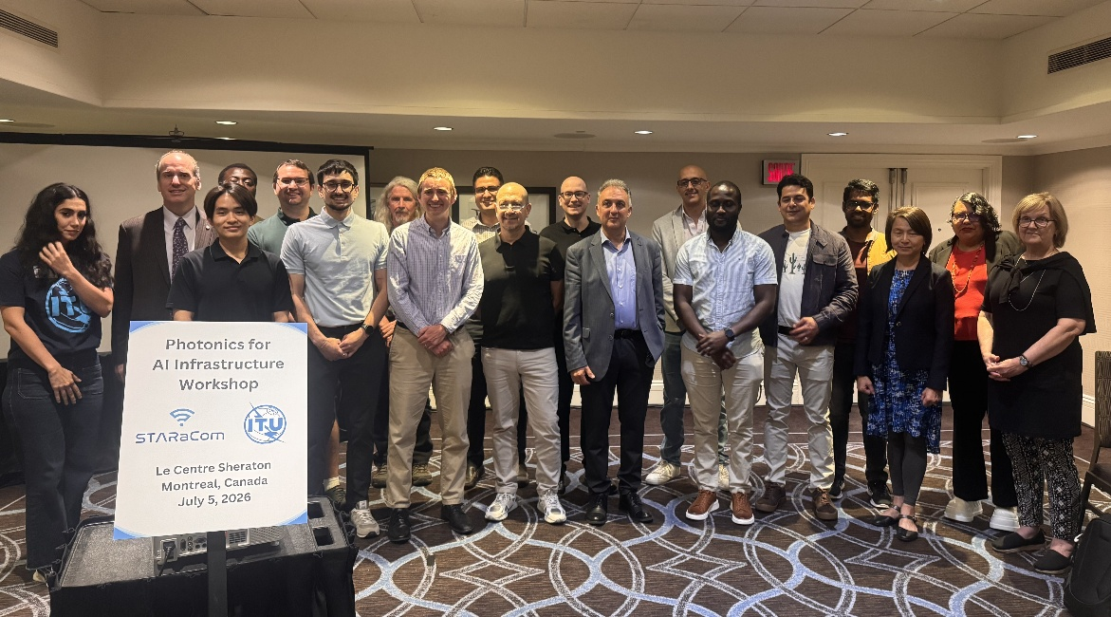
Figure 1: Group photo of speakers, program committee, and partners of the ITU-T and IEEE Photonics Society Workshop “Photonics for AI infrastructure”

Workshop programme
The workshop consisted of brief introductory remarks from Glenn Parsons, Chairman of SG15, and Dr. Posner, Chair of the Workshop, followed by sessions entitled “Building the AI rack” and “Scale Across and Access”. The workshop was moderated by Matthew Posner, Benton Qiu, Aleksander Nikic, members of the program committee. The workshop format allowed for Q&A to take place throughout the sessions, with time for all speakers to engage with the audience. The web page for the workshop is at: ITU and IEEE Photonics Workshop on “Photonics for AI Infrastructure" where the complete presentations and recordings are available.

Session summaries

Opening Speech: ITU-T SG15 Introduction and Update​ – Glenn Parsons
Glenn Parsons is the principal standards advisor with Ericsson Canada. In the opening speech, Glenn Parsons highlighted the role of ITU-T Study Group 15 in developing the standards for optical transport, access and network infrastructure that will underpin the evolution toward intelligent optical networks supporting future AI applications.

Program presentation: Photonics for AI infrastructure – Matthew Posner
Matthew Posner is Chair of the IEEE Photonics Society Chapter Montreal, through which he supports outreach education, career development, and technical networking. It was noted that AI infrastructure is driving a fundamental transition in networking, with photonics becoming an essential enabling technology rather than simply a high-speed communication medium (Fig. 2)
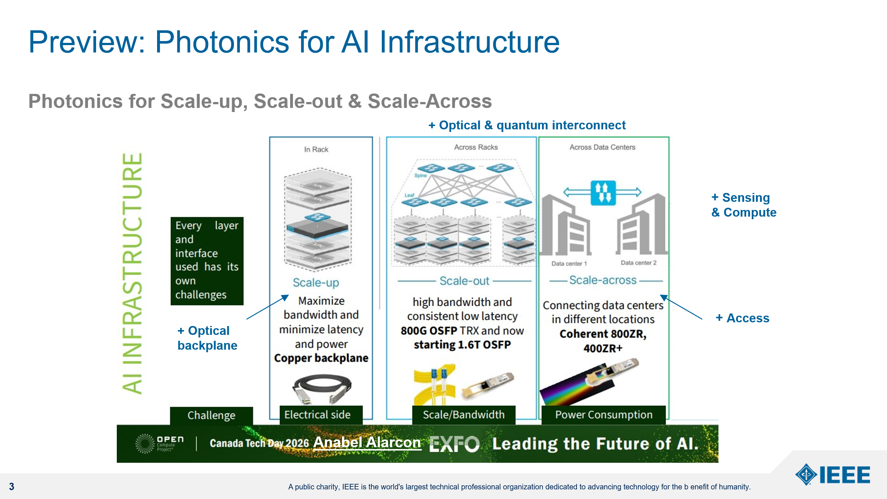
Fig. 2: Photonics technologies spanning AI scale-up, scale-out, scale-across, sensing and compute in networking technologies.

1.6T and Beyond: Innovations in High-Speed Technology – Anabel Alarcon
Anabel Alarcón is a technology and product management professional with Exfo, specializing in high-speed networking and telecommunications. The presentation described
- The evolution from 800G to 1.6T and future 3.2T optical interfaces introduces new challenges in power consumption, cooling, connector technology and system validation across AI infrastructure (Fig. 3)
- Emerging architectures including Co-Packaged Optics (CPO), Near-Packaged Optics and Optical Circuit Switching require new approaches to testing, troubleshooting and interoperability throughout the deployment lifecycle.
- Test and measurement capabilities must evolve alongside optical technologies to ensure reliable deployment of increasingly complex AI networking systems operating at terabit-per-second data rates.
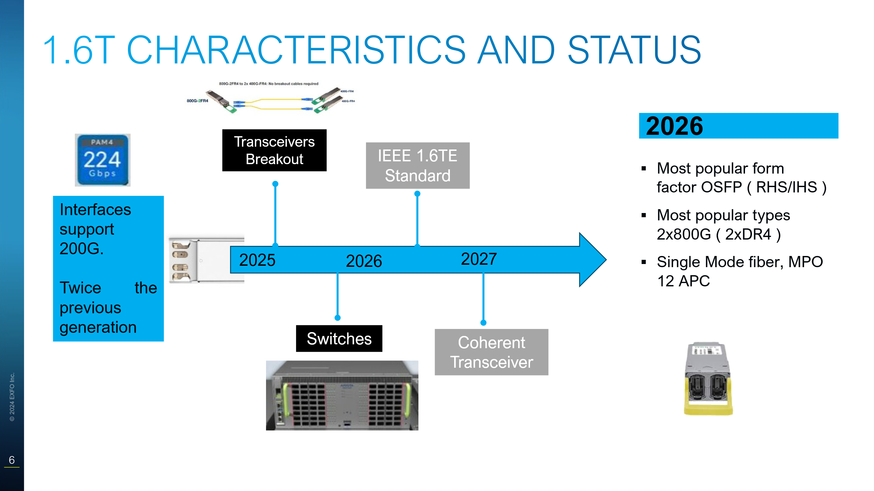
Fig. 3: Roadmap for 1.6T optical transceiver standardization and ecosystem adoption

Architectural Trends in Optical Interconnects for the AI Scale-Up Fabric – Mohammad Alavirad
Mohammad Alavirad is a Senior Principal Research Architect in the Office of the CTO at Dell Technologies, where he leads initiatives in optical networking, Co-Packaged Optics (CPO), Near-Packaged Optics (NPO), and advanced AI infrastructure. The presentation described
- AI scale-up fabrics require a broader range of optical interconnect options, where Linear Pluggable Optics (LPO), Near-Packaged Optics (NPO) and Co-Packaged Optics (CPO) should be viewed as complementary points along a continuous design space rather than competing technologies.
- Early adoption of LPO is expected at the network interface card (NIC), where reducing digital signal processing (DSP) count lowers power consumption, latency and cost while maintaining system reliability through integrated hardware design.
- Future AI clusters will increasingly optimize complete system architectures rather than individual optical modules, requiring closer co-design between servers, switches, optics and packaging technologies (Fig. 4)
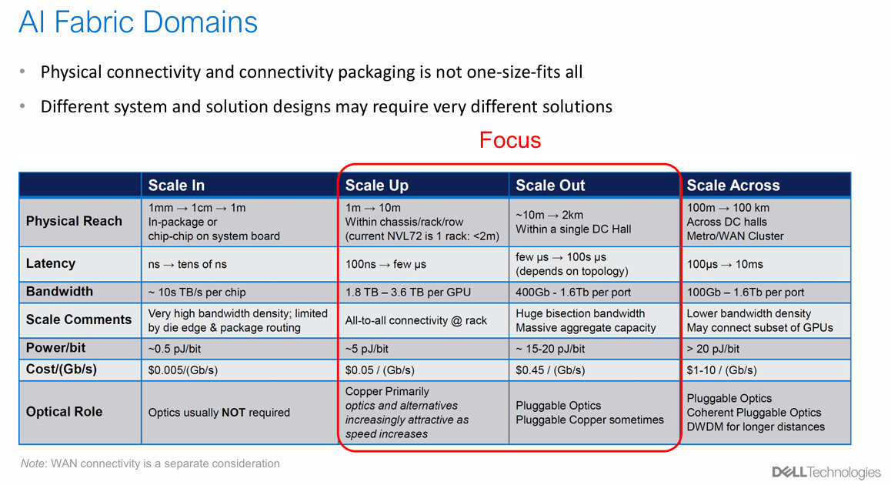
Fig. 4: AI Fabric Domains requirements for connectivity, bandwidth and latency.

Optical Circuit Switch Technology and Applications – Amjad Haddad
Amjad Haddad manages Lumentum’s Wavelength Selective Switching portfolio and has been active in the telecommunications industry since 2007. The presentation described
- Rapid growth in AI cluster bandwidth is significantly outpacing switch ASIC capacity, making network scalability, power consumption and switch radix primary architectural challenges.
- Optical Circuit Switching (OCS) enables passive, protocol-independent, high-radix optical connectivity that reduces electrical packet processing, lowers latency and power consumption, and supports dynamically reconfigurable AI network topologies (Fig. 5).
- MEMS-based OCS technology has reached commercial maturity and is expected to play an increasingly important role in future AI scale-out, scale-across and data centre interconnect architectures.
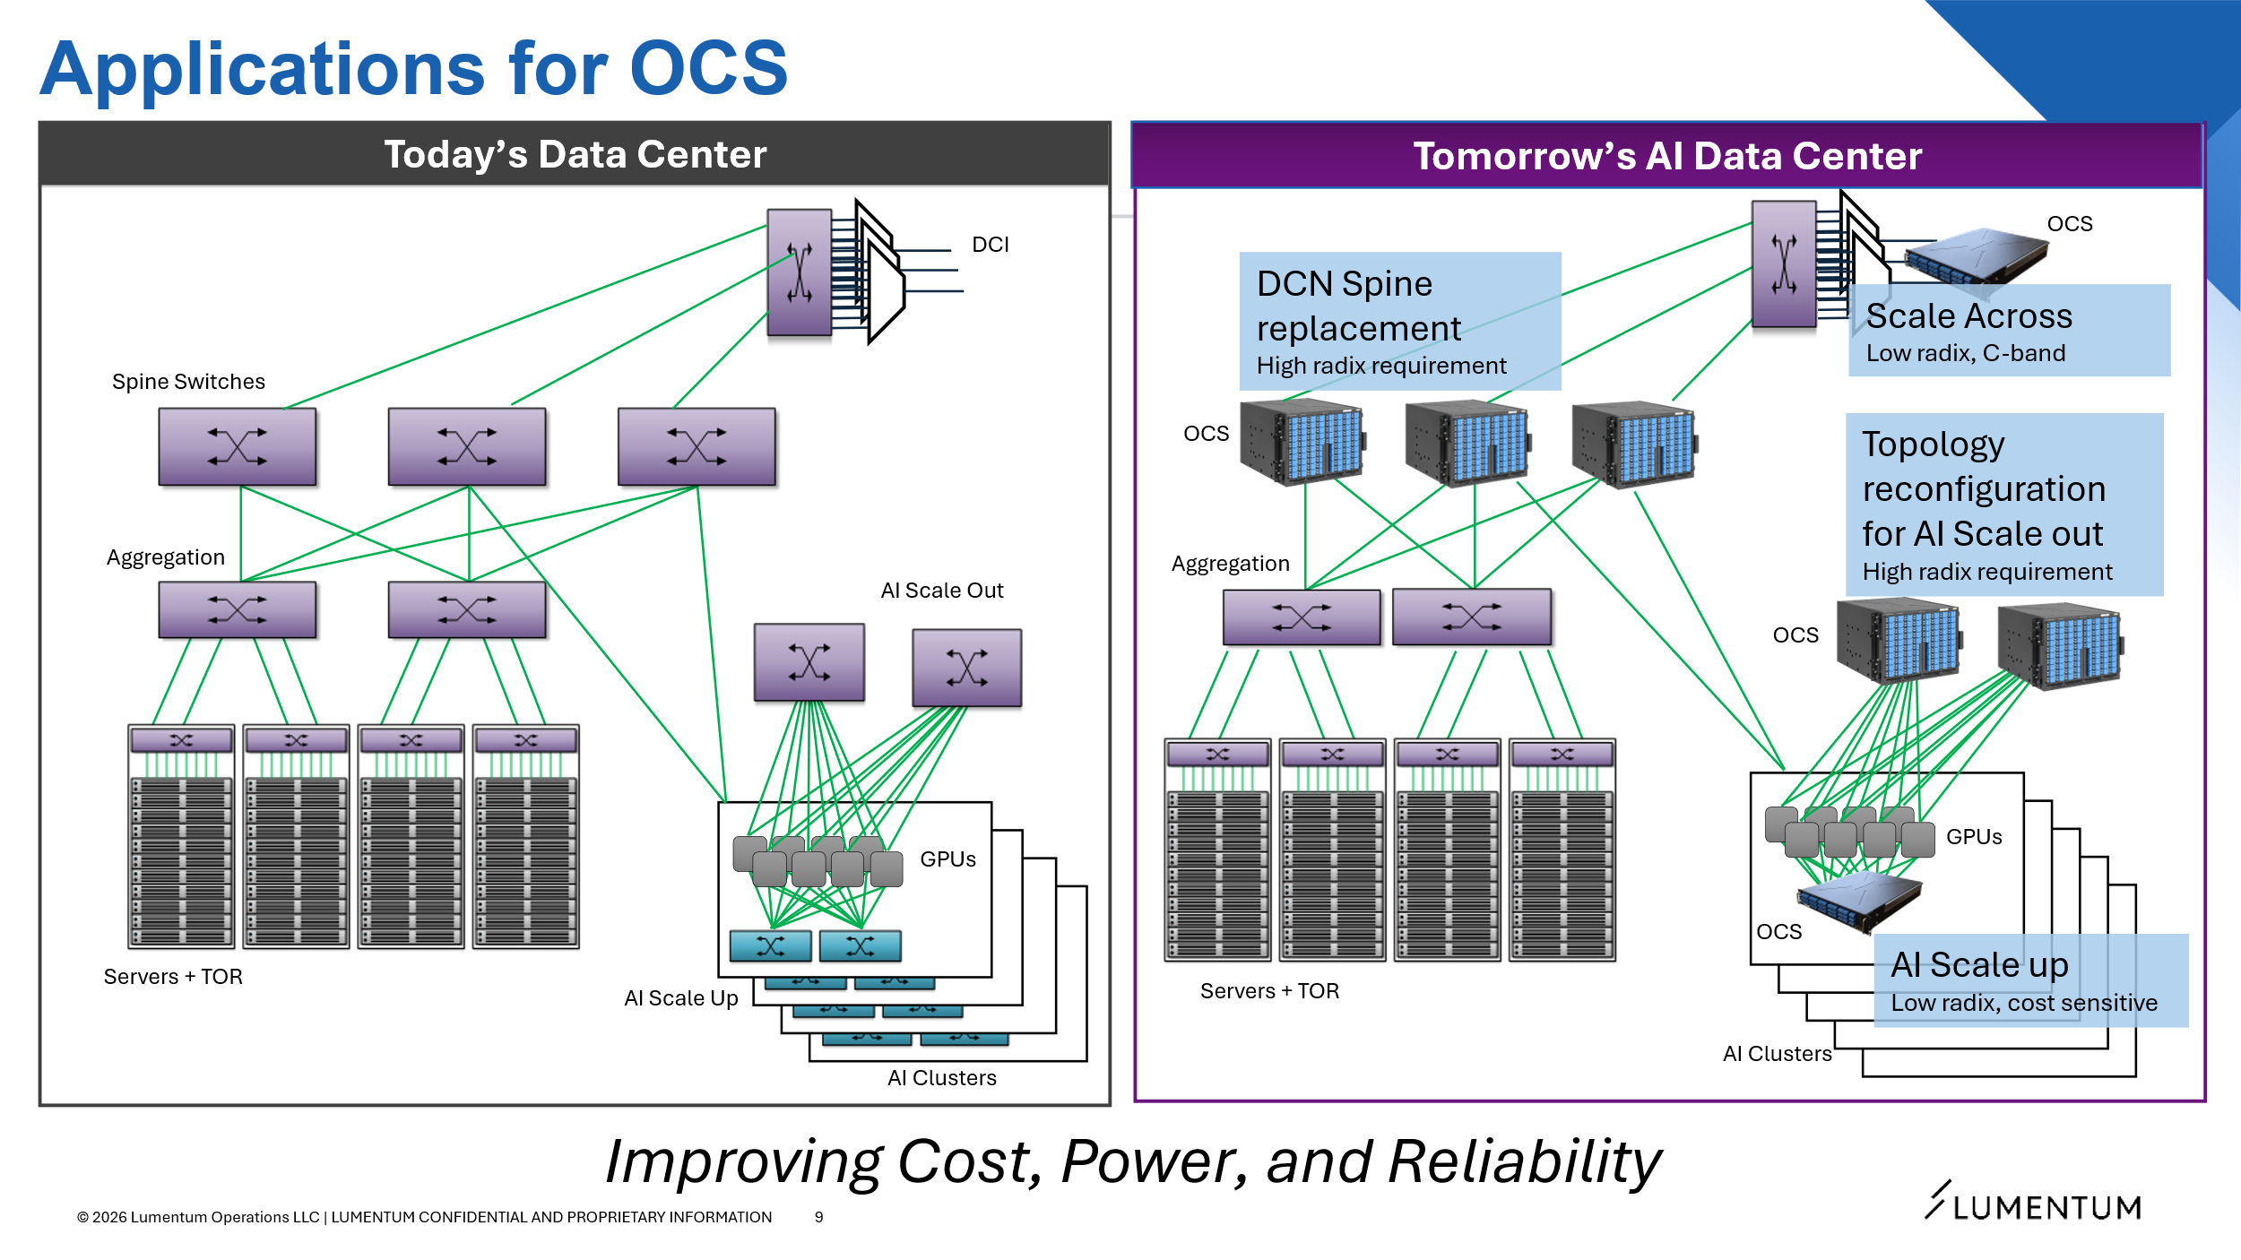
Fig. 5: Applications for Optical Circuit Switch Technology in AI infrastructure.

Digital Photonics for High-Radix Switches in AI Data Centers – José Garcia-Echeverria
José García Echeverría is Chief Technology Officer at Axonal Networks, where he helps drive the development of photonic technologies for next-generation communication and computing systems. The presentation described
- Conventional electronic packet switch architectures face increasing limitations in transistor count, power density and scalability as AI clusters grow towards multi-thousand-radix switching systems.
- A novel packet switch architecture combining distributed switching, spatial-division multiplexing and digital photonic logic to significantly reduce network complexity while enabling significantly higher switch radix than conventional leaf-spine networks (Fig. 6)
- Experimental demonstrations of stabilized silicon photonic microring logic gates and optical switching illustrate the potential for distributed optical processing that minimizes electrical conversions and substantially reduces network power consumption.

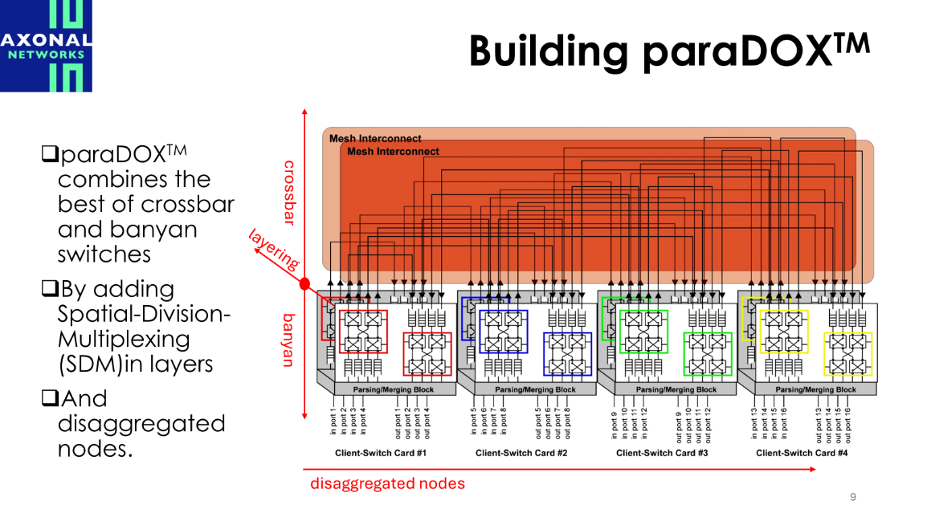

Fig. 6: Distributed photonic switch architecture for scalable high-radix AI networking.

Photonics for AI Infrastructure: Scale Across – David Plant
David V. Plant is a Tier 1 Canada Research Chair in the Department of Electrical and Computer Engineering, McGill University, Montreal, Canada. He researches photonic systems. The presentation described
- Ethernet continues to evolve beyond 1.6T through advances in higher symbol rates, multi-level modulation, digital signal processing and emerging modulator technologies including silicon photonics, thin-film lithium niobate (TFLN) and barium titanate oxide (BTO).
- Experimental demonstrations show that 200–400 Gb/s single-lane IM/DD transmission is becoming feasible through a combination of advanced modulation formats (PAM4/PAM8), probabilistic shaping and nonlinear equalization, enabling multi-terabit optical links without coherent detection (Fig. 7)
- Future scale-across AI networks will depend on continued co-optimization of photonic devices, DSP algorithms and system architectures to maximize bandwidth while maintaining practical power consumption, transmission reach and manufacturing scalability.
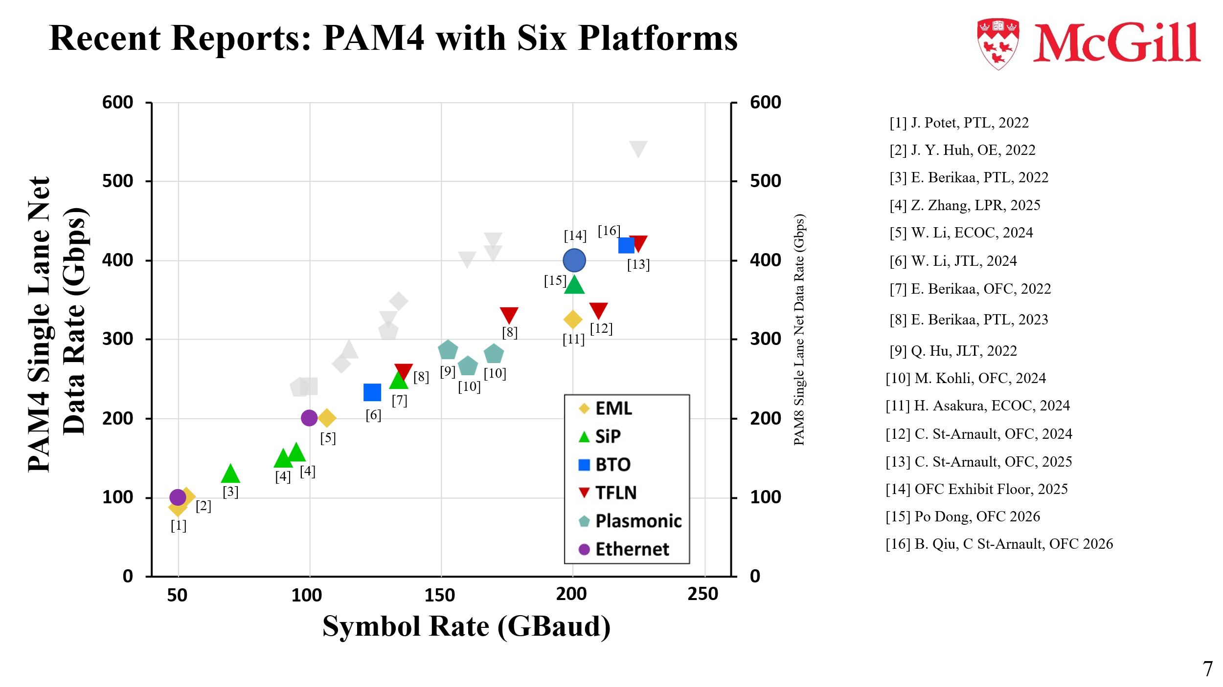
Fig. 7: Research progress toward beyond-400 Gb/s single-lane IM/DD optical transmission.

Optical Interconnects in Radio Access: Use Cases and Enabling Technologies for Future RAN Architectures – Fabio Cavaliere
Fabio Cavaliere is an expert in Photonic Systems and Technologies at Ericsson, and Rapporteur of ITU-T Question 6/15 (Characteristics of optical components, subsystems and systems for optical transport networks). The presentation described
- Increasing bandwidth demands in 6G radio access networks are driving interest in integrated photonic interconnects, where Co-Packaged Optics (CPO) and Near-Packaged Optics (NPO) developed for AI data centres can be adapted to future radio and Access systems (Fig. 8).
- Integrated optical packaging, optical PCBs and external laser architectures offer significant reductions in power consumption, latency and signal integrity challenges while improving long-term reliability for distributed radio infrastructure.
- AI-assisted digital twins and physics-informed machine learning provide a promising approach for optimizing complex high-speed optical links, reducing operational complexity while enabling future intelligent radio transport networks.
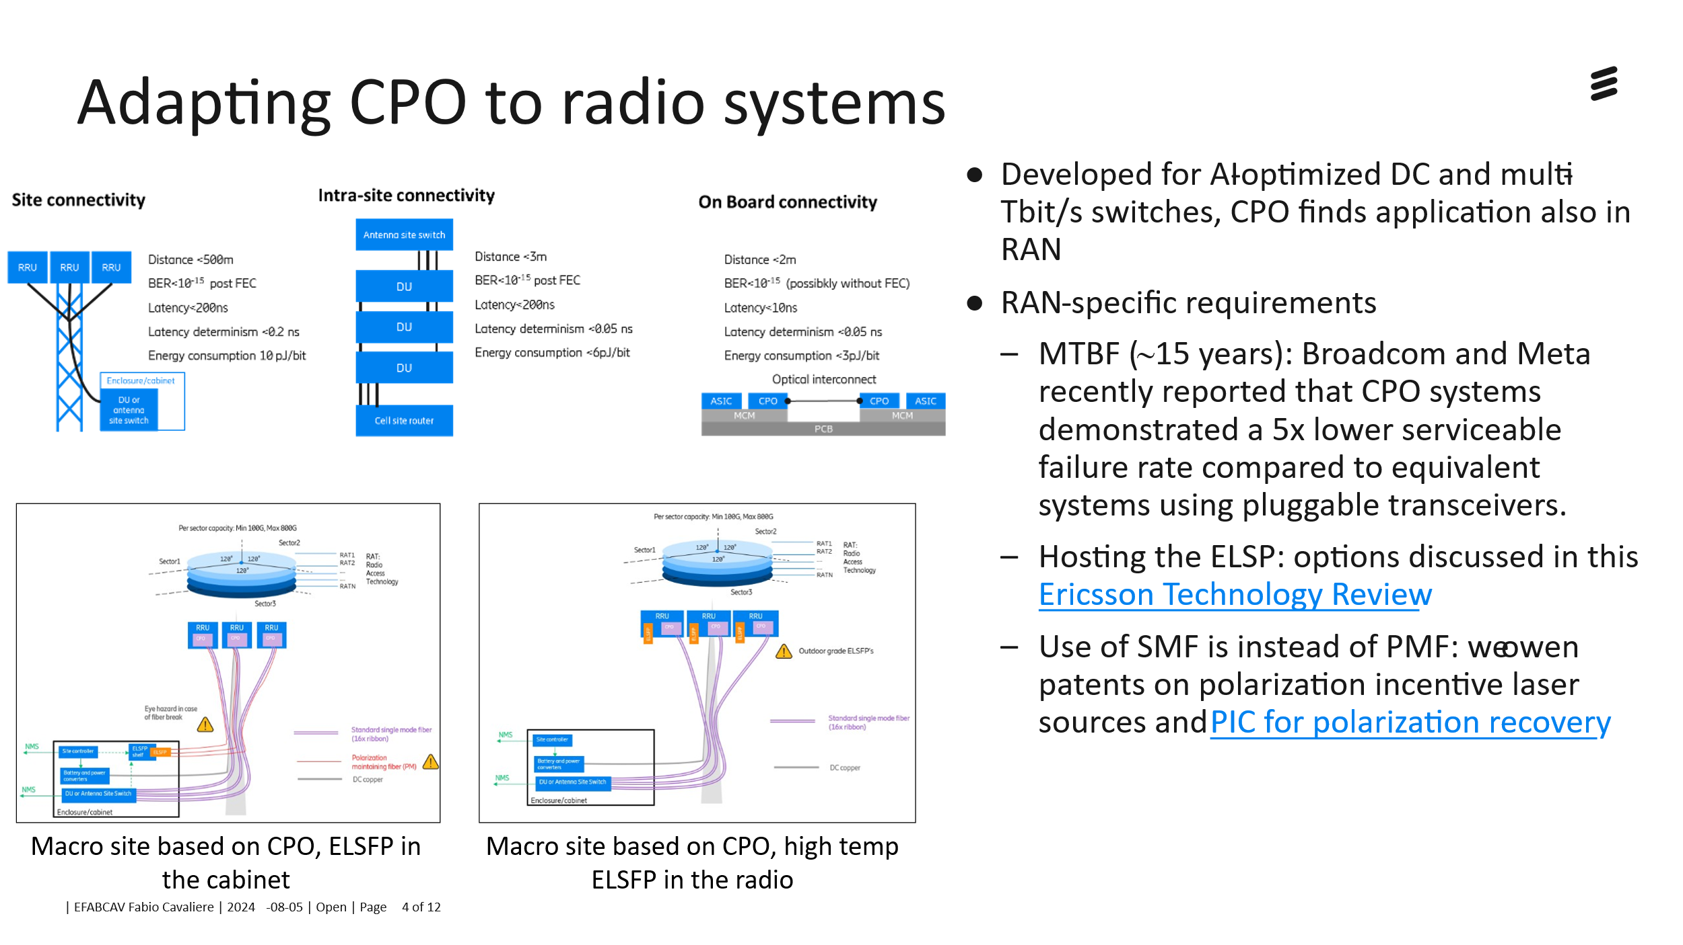
Fig. 8: Adapting co-packaged optics architectures for future radio access networks

Distributed Fibre Optic Sensing for Telecom Networks – Jun Shan Wey
Jun Shan Wey is an Associate Fellow in Technology Standards Planning at Verizon. Her work focuses on optical networking standards ecosystem development, including service as the ITU-T SG15 Q2 Associate Rapporteur, WP1 Coordinator and editor of G.681 Recommendation. The presentation described
- Distributed Fibre Optic Sensing (DFOS) enables existing telecommunications fibre infrastructure to provide continuous monitoring for cable identification, asset mapping, fault detection and infrastructure protection without disrupting communication services.
- Verizon presented operational deployments and field trials demonstrating AI-assisted event classification, high-resolution fault localization and proactive risk monitoring using deployed metropolitan optical networks. Requirements are listed in Fig. 9.
- Continued development of ITU-T standards for DFOS interoperability, performance and deployment is expected to reduce implementation costs and accelerate large-scale adoption of intelligent sensing capabilities across optical transport networks.
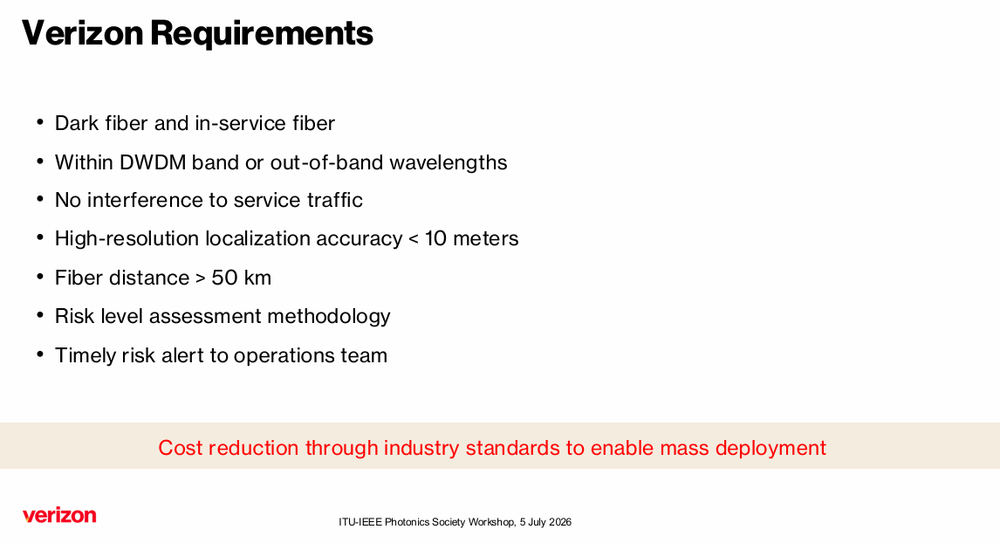
Fig. 9: Verizon deployment requirements for distributed fibre optic sensing in operational telecom networks

Sensing in Fiber Optic Networks: From Communication Infrastructure to Distributed Intelligence – Christine Tremblay
Christine Tremblay is a Full Professor at École de Technologie Supérieure and the Founding Researcher and Head of the Network Technology Lab, a cutting-edge optical network testbed integrating a wide range of fiber-optic transmission technologies, as well as advanced test, modelling, and control systems supporting speeds up to 1600G. The presentation described
- Existing optical communication networks can simultaneously provide distributed sensing capabilities, transforming telecommunications infrastructure into large-scale platforms for environmental monitoring, infrastructure protection and situational awareness.
- Complementary sensing approaches based on dedicated interrogators and coherent communication transceivers enable different levels of spatial resolution, deployment cost and operational awareness, supporting integrated communication and sensing functions (Fig. 10)
- Artificial intelligence will play an increasingly important role in interpreting large volumes of distributed sensing data, enabling autonomous network monitoring and intelligent infrastructure management.
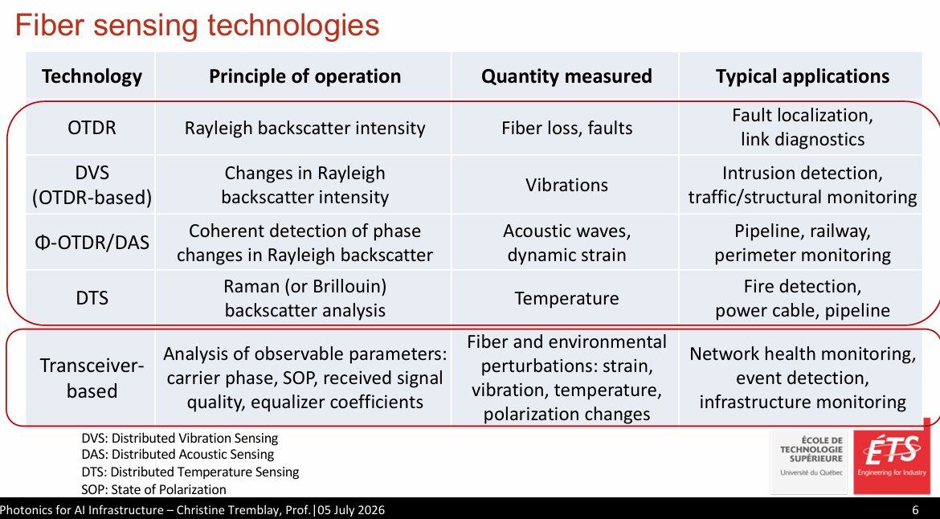
Fig. 10: Comparison of distributed fibre sensing technologies and representative network applications.

Quantum photonic interconnects – Piotr Roztocki
Piotr Roztocki is co-founder and CTO of Ki3 Photonics Technologies, where his work is focused on the development of quantum photonic technologies compatible with standard telecommunications infrastructures. The presentation described
- Scalable quantum computing requires photonic interconnect technologies capable of distributing entanglement while maintaining extremely stringent requirements for timing, phase stability and optical coherence (Fig. 11).
- Integrated hardware modules for entanglement generation, optical synchronization, interferometric stabilization and network orchestration demonstrate how quantum networking can leverage mature telecommunications technologies and standards.
- Future quantum data centres are expected to integrate classical and quantum networking infrastructure within common rack-scale systems, creating new opportunities for photonic standardization and interoperable network management.
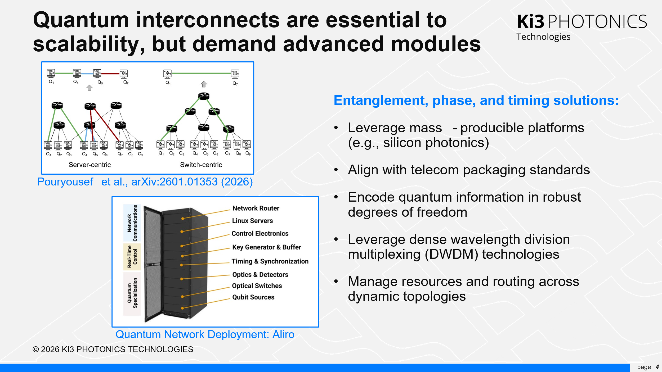
Fig. 11: Key enabling technologies for scalable quantum photonic interconnects

Closing Remarks – Matthew Posner
The workshop demonstrated the growing importance of photonic technologies in enabling next-generation AI infrastructure, spanning scale-up, scale-out, scale-across, optical access, compute and sensing, and quantum networking. Presentations highlighted advances in optical interconnects, high-radix switching, integrated photonics, optical circuit switching, quantum interconnects, and intelligent fibre sensing, while emphasizing the need for continued innovation in performance, energy efficiency and scalability. Collectively, the presentations demonstrated that photonic technologies will play a central role in enabling the scalable, energy-efficient and interoperable communications infrastructure required to support the next generation of AI systems.
These technical developments align closely with the objectives of ITU-T Study Group 15 and complement the broader goals of the ITU AI for Good initiative by providing sustainable, high-capacity communication infrastructure needed to support future AI systems and services. The strong participation from industry, academia and standards organizations demonstrated the importance of international collaboration in accelerating innovation, interoperability and standards development for future AI infrastructure.

