The purpose of the workshop is to solicit input from network operators in particular to address the following points:
Based on contributions to the June 2017 meeting of SG15 we noted that the 3GPP RAN architecture will be extended to allow the function of the 4G eNB to be split between a DU (Distributed Unit) and a CU (Centralized Unit). The DU will communicate directly with the RRU (Remote Radio Unit). Based on these contributions our assumption is that the resultant architecture is as shown below:
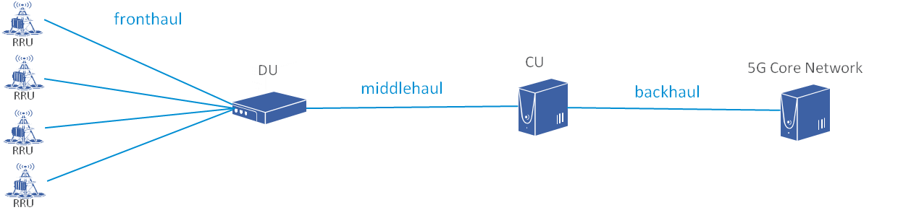
The DU will process PHY level radio protocol and real-time services while the CU will process non-real-time radio protocols.
The purpose of the (simplified) architecture is to identify the interfaces between the entities defined by 3GPP and the transport network. In the absence of any other terminology we are using the following terms:
- Fronthaul: The connection between the RRU and DU
- Middlehaul: The connection between the DU and CU
- Backhaul: The connection between the CU and the 5G core network
The entity relationships are understood as follows:
- One RRU can only communicate with one DU at the same time: A DU can be connected to multiple RRUs,
- One CU can be connected to multiple DUs: One DU can only communicate with one CU at the same time
- So far there is no direct communication between RRUs nor between DUs.
We have requested confirmation of these assumptions from 3GPP RAN.
Question 1: How will these 3GPP entities (RRU, DU, CU) be deployed in your network.
Question 2: For the transport network we would like to understand the characteristics of the interface to fronthaul, middlehaul and backhaul network for each deployment scenario:
- Distance between these entities
- Number of interfaces; interface bit rate; total capacity
- Latency and latency variation and latency symmetry in uplink and downlink
- Network synchronization requirements
- Is there a requirement to dynamically adjust transport capacity?
Question 3: Guidance on the planned use of Network Slicing in particular the characteristics that need to be supported by the fronthaul, middlehaul and backhaul transport network.

Technical Report, TRGS-TN5G, on “Transport network support of IMT-2020/5G”
WP3/15, having responsibility for Optical Transport Networks, has initiated a new work item to produce a Technical Report, TRGS-TN5G, on “Transport network support of IMT-2020/5G”. This Technical Report will describe the high level architecture for a Transport Network to support the requirements of IMT-2020/5G networks with a focus on supporting the radio network specified by 3GPP. This description will include the following:
- A reference model for the IMT-2020/5G transport network (with the terminology clarified)
- A set of deployment scenarios including details on:
  - Transport network topology
  - Interfaces between the IMT-2020/5G entities to the transport network
    - distance between these entities
    - number of interfaces; interface bit rate; total capacity
    - latency requirements
    - synchronization requirements
- Control/Management interfaces
- Support of IMT-2020/5G network slicing (data plane and control plane)
TRGS-TN5G will provide guidance that will allow the other Questions of SG15 to work efficiently in the development of new, revised or amended G series Recommendations that will enable the Transport Network to support IMT 2020/5G.

_______________________

