Title: The 2nd APT/ITU Conformance and Interoperability event

Introduction
The 2nd Conformance and Interoperability (C&I) event was held on 25 and 26 August 2014 jointly by the APT^{*1} and ITU^{*2}. The purpose of this event was to promote activities to deepen the understanding of C&I throughout countries in the Asia-Pacific region, and to improve the capabilities of each APT member nation and resolve their problems. This event featured C&I-themed workshops, NGN/IPTV interoperability testing, and showcases giving demonstrations of NGN E2E service, IPTV, M2M/IoT/e-helath, Speech to Speech translation and Optical access technologies. This article provides a broad description of the 2nd APT/ITU C&I event.

APT/ITU Conformance and Interoperability event
This event was organized by APT and supported by ITU. It included interoperability testing and showcasing events. It was therefore targeted at people from developing countries in the region with the purpose of contributing directly to the resolution of issues in developing countries.
The 2nd APT/ITU C&I event was held at the Imperial Queen’s Park Hotel in Bangkok, and its configuration and schedule were as follows:
- Workshop (AM & PM on 26th August)
- Interoperability testing (25th AM August)
- NGN E2E Service (VoIP, Video conference)
- IPTV(including IPTV-MAFR (Multimedia Application Framework))
- Showcasing (from 25th PM to 27th August)
- NGN E2E Service (VoIP, Video conference)
- IPTV(including IPTV-MAFR (Multimedia Application Framework))
- M2M/IoT/e-health
- Speech to Speech Translation
- FTTH (GPON and GEPON)

The 24th ASTAP general assembly was held on 27 – 29 August, so, this event ran back-to-back with the ASTAP general assembly.

Testing & Showcasing
For Testing & Showcasing, there were six exhibitor companies, and 154 visitors came to listen and observe at the workshops and showcase events. Five technical areas were testing and showcasing in this event.
- NGN End-to-End service
- Purpose
  - Service interoperability Confirmation
Based on ITU-T Q.3402 NGN-UNI
Confirm connectivity of SIP terminal to NGN with using Gateway (New)
  - End-to-End interoperability Confirmation
Based on ITU-T Q.3948 (VoIP service)
Based on ITU-T Q.3949 (Multimedia service)
Based on ITU-T H.264 (HD: 720p) (New)
  - Confirm End-to-End interoperability by Remote Environment via Internet (New)
- Participating organizations
China-soft-Tokyo, NEC, NEIX, NTT, OKI
- Test result and consideration
  - NGN E2E service testing: VoIP (based on ITU-T Q.3948)
Result (VoIP) | 1st event, Sep 2013 | 2nd event, Aug 2014
Audio
OK | 40% | 100%
NG | 60% | 0%

  - NGN E2E service testing: Multimedia (based on ITU-T Q.3949)
Result (VoIP) |  | 1st event, Sep 2013 | 2nd event, Aug 2014
Audio | Video
OK | OK | 13% | 67%
OK | NG | 37% | 33% *1
NG | NG | 50 | 0%
*1: The issue of video profile remains.
  - Remote testing configuration
It was successful to integrate VPN configuration for remote participants. Video noise was found in remote testing. It is possible to consider that this reason is loss band, packet delay by using Internet.
- Showcasing
Smart Visual Station (NC1000-MV) presented by NEC Corporation
IP Video Phone for Smart-Devices on NGN presented by OKI
NGN Network simulator presented by NEIX

- Conclusion
To confirm the almost basic NGN services was successful in this 2nd interoperability event. Interoperability event can identify both issues of current standardized recommendation protocols and issues of participating products. It is important to feedback this event’s result to future recommendation and product’s implementation. Application service (ex. T.38 IP-FAX, Video-conference) testing specifications are now being drafted in ITU-T SG11. We hope to add other NGN E2E service testing on next event. It's important to promote for new members to participate in this event.
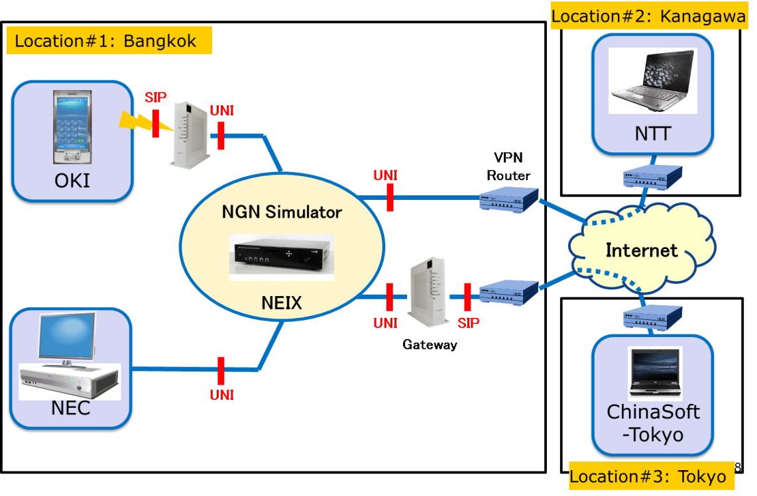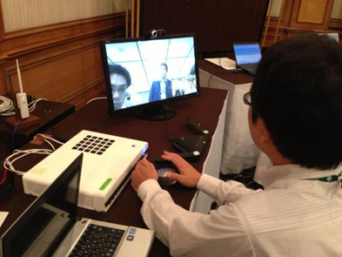

- IPTV/Internet TV
- Purpose
Testing
Confirm conformance on draft of revised H.721 and its test specification between server (OKI) and test terminal.
Showcasing
  - Demonstrate the video comparison between ITU-T H.264 and 265 over IPTV platform
  - Demonstrate the global standard based IPTV STB and head end system.
  - Demonstrate an interactive networking among server, STB/Display and H.810 e-health devices.
  - Demonstrate live transmission from I3GT (ITU IPTV IPv6 Global Testbed) to the venue in Thailand.
- Participating organizations
Mitsubishi Electric, OKI (HTB, INOX and Ateneo de Manila Univ.)
- Showcasing
IPTV STB presented by Mitsubishi Electric
IPTV Head-end presented by OKI
Broadband Wireless for Disaster Operation presented by OKI
- Future directions
More participants, new testing based on the new or popular standards, and more exhibitions will be expected in future events.
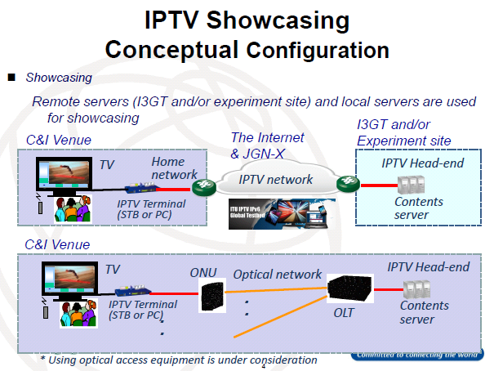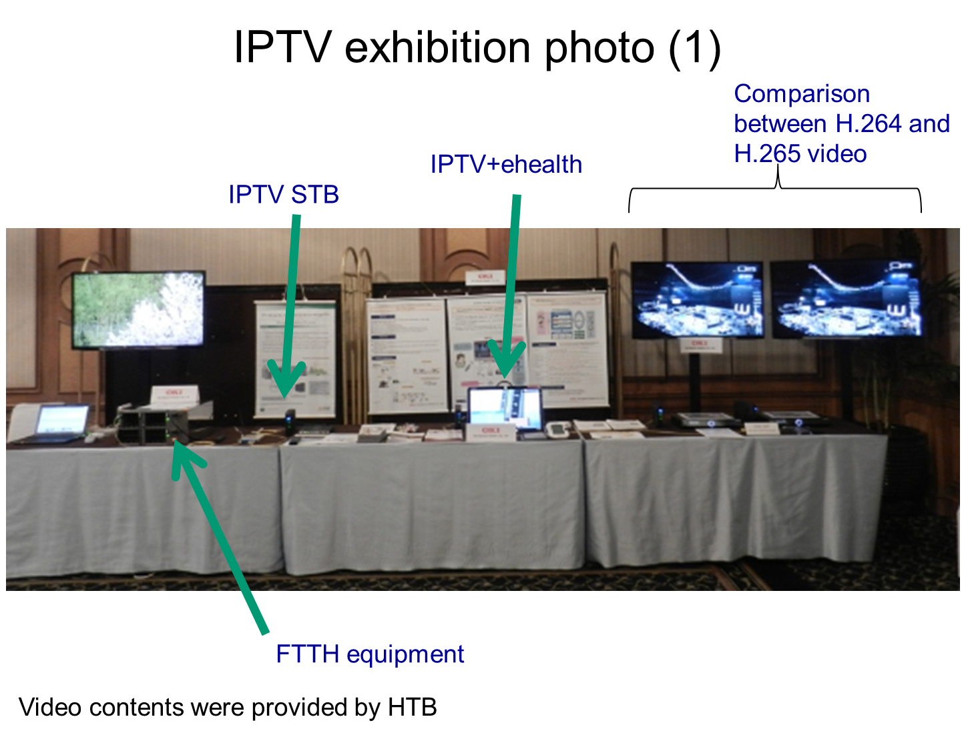

- Optical Access
- Intention of 10G-EPON system interoperability
Ensure operators to deploy 10G-EPON system under multiple vendors’ environment. Any countries’ operators can utilize the highly matured next generation optical access technology for their telecommunication infrastructure.
- Optical access TILC
  - Performs IOP verification under multiple venders’ environment
  - To ensure interoperability of devices for the optical access network
  - Considers and extract issues for conducting conformance and interoperability tests in Japan.
  - Feedbacks the interoperability test results and achievements to related standards.
- Showcase
Demonstration of 10G-EPON system interoperability:
  - 2 ONUs (OKI, MITSUBISHI) are connected to 1 vendor’s OLT and the OLT will be replaced by another OLT.
  - Data transmission is kept when the connected OLT is changed to different vendor’s OLT.
  - Demonstrate the high speed mobile data communication of beyond 1Gbps.
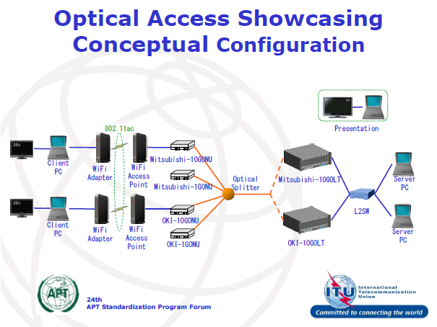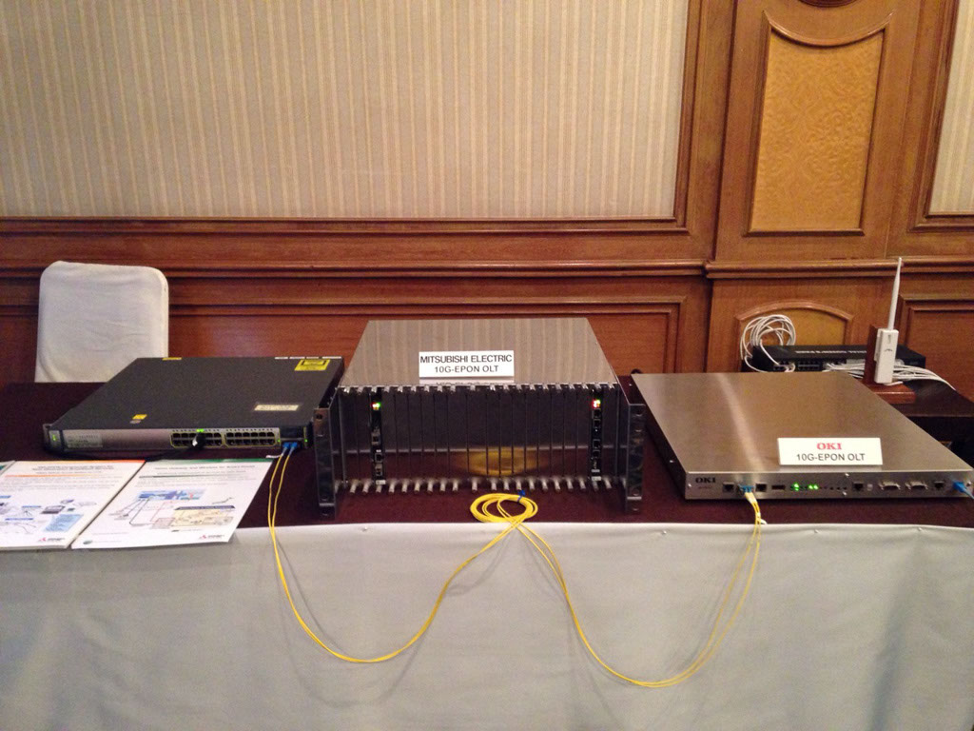

- M2M/IoT/e-Health
- Showcase
BAN portable Health Clinic presented by NICT
Body Area Network (BAN) offers a wired communication or short range radio communication capability for sensors to exchange data with a gateway around a person’s body (From ITU-T Focus Group on M2M service layer: M2M enabled ecosystems: e-health). BAN is not limited to the space around a person, but depends on the distance reachable by cables and radios.
BAN Portable Health Clinic (BAN-PHC) is Health check-up and telemedicine on sites, such as factories in urban areas and villages in rural areas. It provides that continuous use in areas where power supply is unstable, easy to use interfaces to users, such as paramedics, easy network maintenance and ease of carrying.
- Standards around E-Health and Medical BAN
MBAN (Medical Body Area Network) international standards
  - IEEE802.15.6 Narrow Band [US, JP,EU, 400MHz, 800MHz, 900MHz, 2.36GHz, 2 4GH ]
  - IEEE802.15.4j [US, 2.36GHz]
  - IEEE802.15.4n [CN, 200MHz, 400MHz, 600MHz]
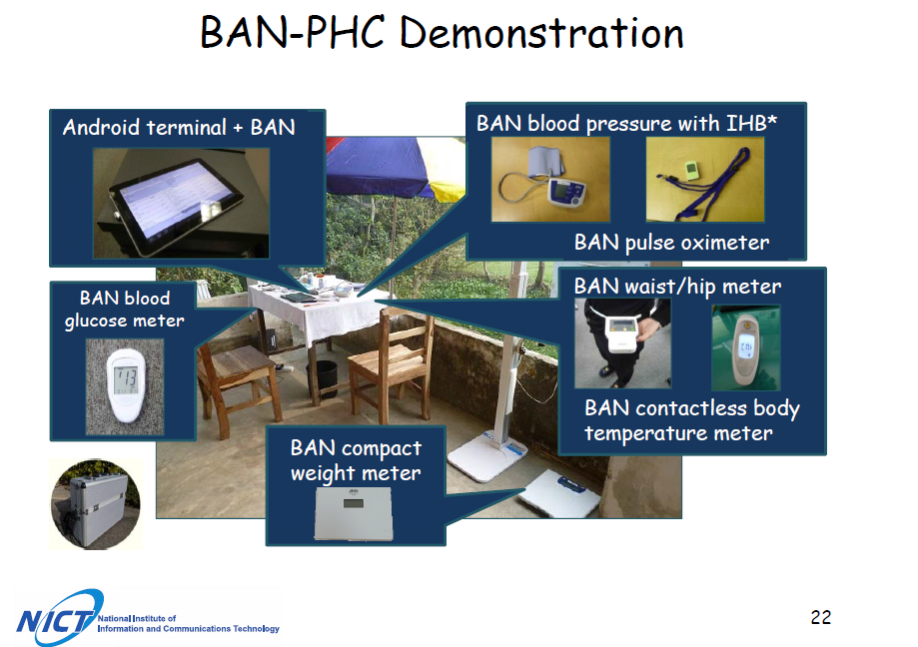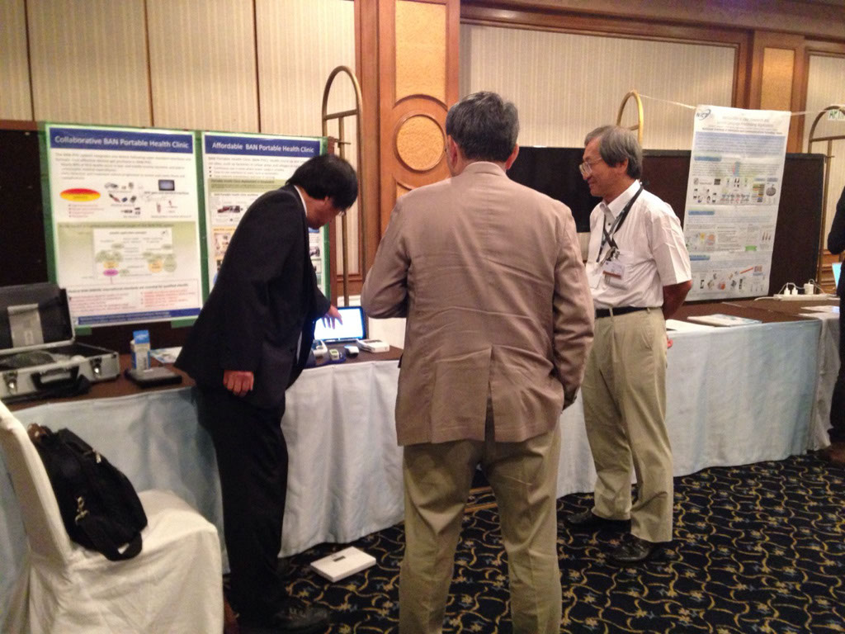

- Language translation
- Showcase
Speech Translation Technologies (VoiceTra 4U) presented by NICT
The Universal Speech Translation Advanced Research Consortium is an international research consortium conducting research and development on a network-based speech-to-speech translation (S2ST) system, with the aim of breaking the language barriers of the world. U-STAR has developed a speech translation app using this network-based S2ST system, "VoiceTra 4U" (for multiple devices), which implements ITU-T standardization protocols, F.745 and H.625.
VoiceTra 4U helps multiple users (up to 5) to communicate in different languages, in real time either face to face or remotely.
The application contributes to overcome the barriers of languages as well as communication modalities. For instance; it helps users to communicate with the visually-impaired via spoken word, or with the hearing-impaired via text input.
- Standards around Language translation
Network-based speech-to-speech translation
  - ITU-T F.745 Functional Requirements for Network-based Speech-to-Speech Translation (S2ST)
  - ITU-T H.625 Architectural Requirements for Network-based S2ST
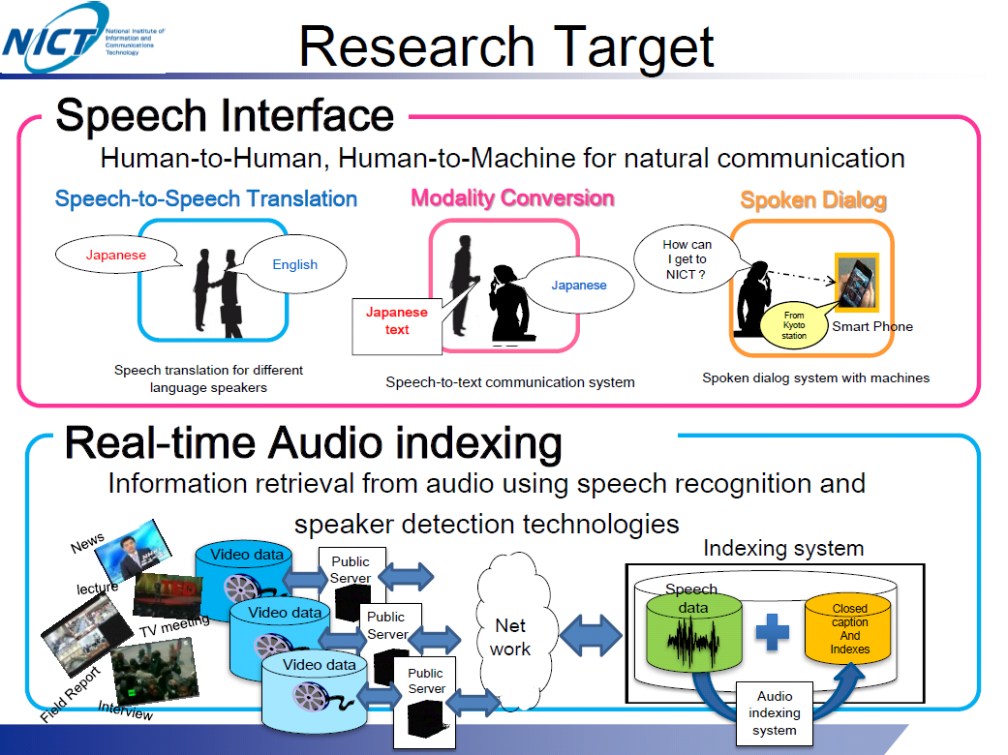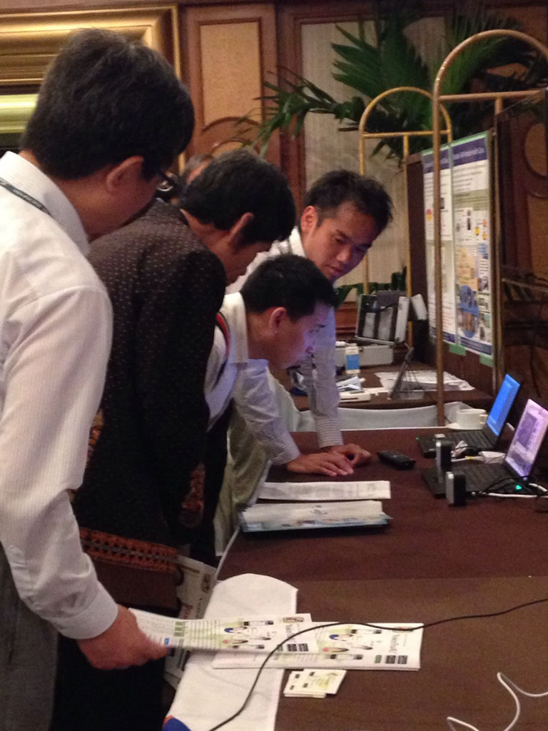

Workshop
At the workshops, there were fifteen presentations from APT member countries, testing and showcasing exhibitors and ITU-T. Panel discussions were held at the end of the workshops to gather suggestions to the ASTAP relating to C&I. Based on these suggestions, we plan to discuss specific implementation method at the next ASTAP general assembly.
Programme of workshop
- AM on 26th August
  - Session 1: Presentations from APT member
    - Conformity Assessment in China and Introduction of China Telecommunication Technology Labs (China)
    - TTC activities on IMS interconnection interface (NTT)
    - VNPT’S IMS and proposals for C&I activities (VNPT)
    - A future direction of packet transport networks (NTT)
    - Content Delivery Network (CDN) and its benefit for Internet-base VDO Streaming (Innovative Extremist Co., Ltd)
  - Session 2: Presentations from exhibitors
    - Report of NGN E2E service testing and showcasing
    - Report of IPTV testing and showcasing
    - Report of U-star showcasing
    - Report of BAN-PHC showcasing
    - Report of Optical access showcasing
- PM on 26th August
  - Session 3: Presentations from SDOs
    - Presentation of ITU Regional Office
    - Presentation of ITU-T
    - Presentation of ITU-T SG13
    - Presentation of ITU-T SG16
    - Presentation of ITU-T SG11
  - Session 4: Panel discussion
    - Discussion on C&I

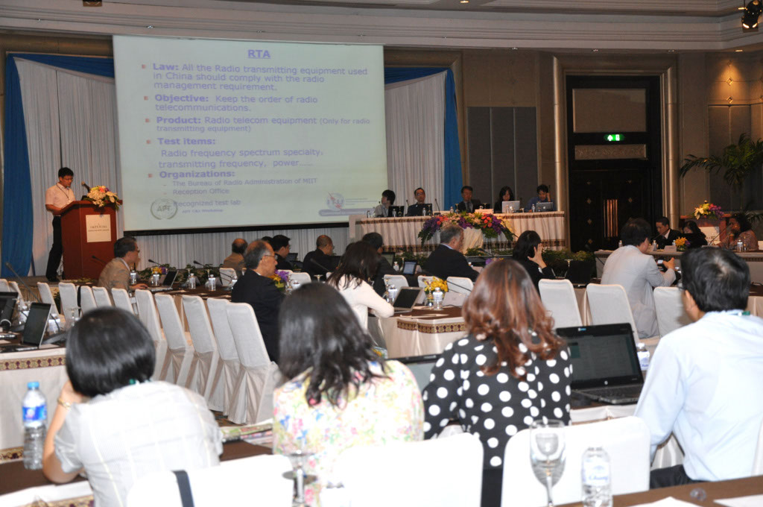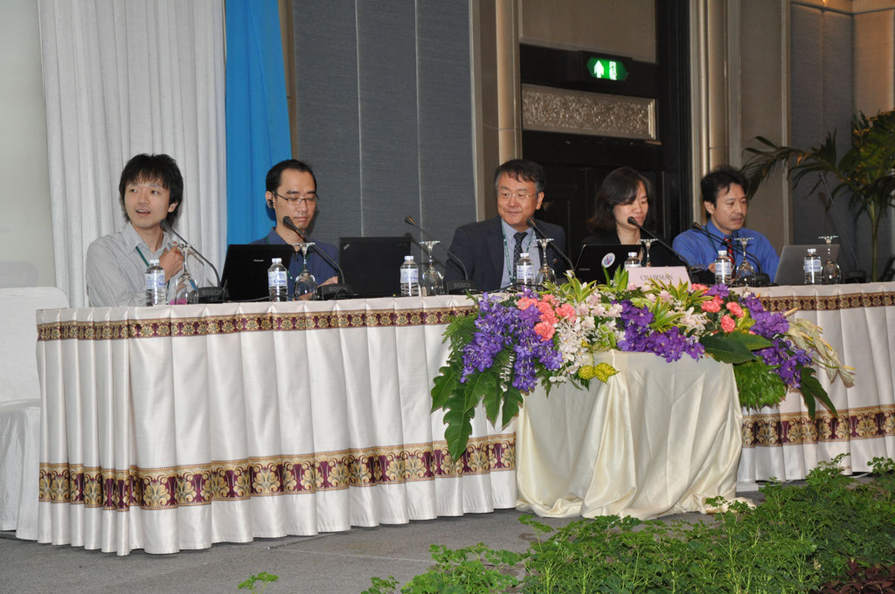

C&I discussions in the ASTAP#24 meeting
The 24th ASTAP general assembly was held on 27 – 29 August. During this meeting, the C&I joint session was held to review the report of the event and discuss the next actions on C&I in ASTAP. In this session, the proposals created in the C&I event workshop were assigned to the relevant WGs/EGs in ASTAP for further actions based on these proposals. It was also proposed to hold the 3rd C&I event and agreed. The proposed topics of the 3rd C&I event was tentatively agreed for further discussion as follows;
- IMS/NGN interworking
- Future Transport Network
- M2M/IoT/e-Health
- Language translation
- FTTH (GPON and GEPON)
- IPTV/internet TV
- NGN E2E service
- SDN/NFV (New)

We will capture the requirements form APT member countries and decide the topics of the 3rd C&I event in the 25th ASTAP general assembly in March 2015. The following work plan was proposed toward 2015.
- To have “APT network operator’s forum” during the 25th ASTAP general assembly in March 2015 in order to identify the issue and requirements of the network operators in APT member countries and take them into consideration to the topics of the 3rd C&I event.
- To create “The Coordination Committee” and assign the chair of it. And then the coordination committee will invite the committee members and discuss the details of the 3rd C&I event.

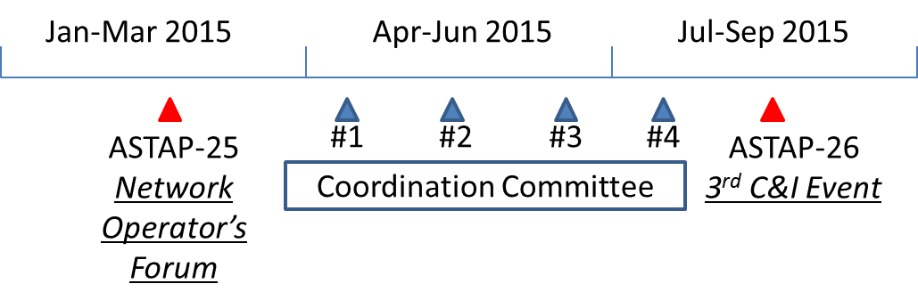

Conclusion
The 2nd APT/ITU C&I event was successfully held in August in Bangkok. This event was highly appreciated from APT member countries and as the consequence of this event, it was decided the 3rd event would be held in 2015. “APT network operator’s forum” is going to be held during the next ASTAP#25 meeting in March 2015 in order to facilitate to exchange information and issues on C&I among the network operators in APT. We would like to invite network operators to join this session and share the information on C&I. These discussions will be taken into consideration to the topics of the 3rd C&I event. The 2nd APT/ITU C&I event became more populated than the 1st event and many members were interested in its activities. It is expected that more exhibitors and presenters actively participate in the 3rd event in 2015.

