Test Report

2nd ITU Test Event: Performance of Mobile Phones as Gateways to Car Hands-free Systems

Geneva 23-25 May 2016

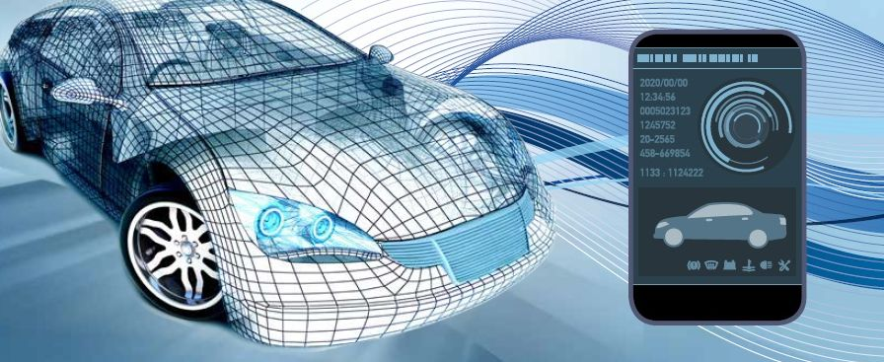
www.itu.int/go/hft-test-event-2

© ITU 2016


Background
In continuation of the 1st Test Event in May 2014, ITU now organized a 2nd Test Event “Performance of mobile phones as gateways to car hands-free systems”.
The test event, held at ITU Headquarters between 23rd and 25th of May 2016, again analysed the behaviour of a representative sample of mobile phones available today and capable of connecting to hands-free systems.
Note: Initially the test event was scheduled from 23-27 May 2016. As all submitted mobile phones have been tested within three days the event was fulfilled from 23 to 25 May 2016
The motivation for these events, to verify the transmission transparency of today’s mobile phones in conjunction with car hands-free systems, was pursued. The results also provide the possibility to compare the performance of the sample of mobile phones to those measured during the 1st Test Event in 2014 and draw conclusions.
The tests were performed by HEAD acoustics GmbH, based on the ‘Chapter 12 tests’ of Recommendations ITU-T P.1100 and ITU-T P.1110, standards for narrow-band and wideband communications involving motor vehicles. The test requirements were adapted and applied to real-world scenarios. The methodology and results will be fed back into an ongoing process to refine the standards.
This report was written by HEAD acoustics which is responsible for the test conduction and the analysis of the test results. Participating companies in the event received the results of all tested mobiles phones from ITU. Test results have been anonymized in this report.
Note: the testing laboratory was selected by ITU according to the results of the call for bids which was announced by ITU in September 2015 (newslog)

Contact persons:
Mr Denis Andreev, denis.andreev@ITU.int, Tel. +41 22 730 5780


Mr Marc Lepage, marc.lepage@head-acoustics.de, Tel. +49 2407 577 105
Mr Frank Kettler, frank.kettler@head-acoustics.de, Tel. +49 2407 577 68

Table of Contents
1. Motivation 1
2. Summary 2
3. Cascaded Algorithms 3
4. Test Description 5
4.1 Test Setup 5
4.2 Tests Implementations and Adaptations for the Test Event 6
4.3 Selection and Designation of Mobile Phones 10
4.4 Result Representation and User Experience 10
5. Analyses Results 13
5.1 Overview - Narrowband 13
5.2 Overview - Wideband 16
5.3 Individual Summary – Narrowband 19
5.4 Individual Summary – Wideband 24
5.5 Cross Connection Tests 29
6. References 33

Motivation
“This issue is very severe. This is not only relevant from speech quality point of view; it should be considered to be addressed by certification.” This was one discussion point among the participants during the tests in Geneva, highlighting the severity of detected issues on specific phones. Car manufacturers and hands-free suppliers expressed their serious concerns, that it is not always possible to tune the hands-free system appropriately, if a mobile phone is as far out of range as some of the tested devices during the 2nd Test Event.
In the typical use case for hands-free communication, the driver uses his mobile phone and links it via wireless communication to the vehicle’s hands-free system. Thus, the mobile phone provides the mobile network access. It acts as an “audio gateway” between the vehicle hands-free system and the mobile network and should provide fully transparent voice transmission in uplink and downlink. The relevant signal processing is performed solely by the vehicle’s hands-free system; mandating that the signal-processing functionality of a mobile phone be disabled while the phone is mounted on a hands-free system.
The wireless connection, typically realized via Bluetooth® today, can be controlled via appropriate AT commands [2]. However, even if the AT command exchange between hands-free system and mobile phone works properly and the mobile phone replies with “ok”, it is not always guaranteed that the mobile phone behaves transparently and only provides gateway functionality. If speech processing algorithms (such as echo cancellation or noise reduction), signal amplification or attenuation or equalizers are not disabled in the mobile phone, the phone may significantly degrade the quality of the whole system.
Corresponding speech quality tests for verification of transparency are described in Chapter 12 (“Verification of the transmission performance of short-range wireless (SRW) transmission enabled phones”) of Recommendations ITU-T P.1100 [4] and ITU-T P.1110 [5]. These tests have been used during the 1st and again during the 2nd test event.
The first test event, hosted by ITU in May 2014 in Geneva [1], showed, that only approximately 30% out of 35 tested mobile phones from 12 different vendors can be regarded as fully transparent, as required. These phones are listed in the “Whitelist” of the best hands-free performers [3]. Reason enough to verify the performance of a number of current mobiles again now in the 2nd ITU Test Event and update the “Whitelist” accordingly.
The 2nd Test Event took place between May 23rd and 25th at ITU-T headquarters in Geneva. 34 tests were carried out on a total number of 18 “state-of-the-art” mobile phones of 12 different phone vendors. Narrowband and wideband test were performed. The devices were selected and provided by 4 participating companies. For all tested devices the SRW transmission was realized using the Bluetooth® wireless technology standard.
The most important conclusions are drawn in Chapter 2 of this report. Chapter 3 gives some background information about the influence of cascaded algorithms. The setup together with a short introduction of the tests itself including adaptations for the Test Event, an overview about the selected mobile phones and the result representation is given in Chapter 4. Chapter 5 analyses the results. References can be found in Chapter 6.

Summary
The most important findings can be summarized as follows:
- 18 different mobiles from 12 different vendors were selected from the participating companies. A total number of 34 tests was conducted in narrowband (NB, 18 tests) and wideband mode (WB, 16 tests). Two devices were not wideband capable.
- All tested mobile phones in NB and WB mode respond with “ok” to the “AT+NREC=0” command, indicating that the internal signal processing (noise reduction, echo cancellation) is disabled.
- Approximately 25 to 30% of the tested phones violate the adapted round trip delay requirement of ≤ 190 ms for NB respectively ≤ 200 ms for WB. The maximum round delay was determined to nearly 300 ms for one phone in NB and WB mode.
- One device tested in NB mode did not disable noise reduction and echo cancellation, although it responded with “ok” to the AT command. One device tested in WB mode did not disable noise reduction. For comparison, approximately 30% of the mobile phones tested in NB mode during the 1st test event did not disable noise reduction and echo cancellation.
- However, other influences on the transmitted signals, such as active volume control on the Bluetooth® link, signal amplification around 10 dB (9 dB and 11 dB in sending direction as highest measured amplification), signal attenuation of 13 dB in downlink (highest attenuation) or active equalizers were detected during the tests. Similar results have been reported already during the 1st test event. Such extreme signal amplification and attenuation motivate the discussion, to include such tests in the certification process for mobile phone as a hands-free system in not capable to cope with it.
- Only 4 out of 18 tested mobile phones (22%) in NB mode and 4 out 16 phones (25%) tested in WB mode can be regarded as fully transparent, as required.
- Cross connection tests in WB Bluetooth® connection in combination with WB and NB network access indicate the expected inband level transparency in both transmission directions for all WB capable devices. Although the limited number of tested devices is far from being exhaustive, these concurrent results may indicate, that the use of WB network connections is more uniquely handled by the level management. The results from the 1st test event indicated at least some devices with strong inband level mismatch.
- Additional tests without sending the “AT+NREC=0” command to the mobile phones (relevant for Bluetooth® headsets communicating with mobile phones also via the hands-free profile), pointed out, that 6 out of 18 NB devices (7 out of 16 WB devices) always disable noise reduction, 11 out of 18 NB devices (11 out of 16 WB devices) always disable echo cancellation, although it is not (!) requested by the accessories. The trigger seems to be the detection of the Bluetooth® connection but not the AT command. This is an important issue e.g. for Bluetooth® headsets without own implemented signal processing. In this case, the mobile phone should keep the algorithms active.

Cascaded Algorithms
According to the Hands-free Profile V1.7 [2], a vehicle mounted hands-free system may request the mobile phone to disable the internal signal processing, such as echo cancellation and noise reduction. This is necessary in order to avoid cascaded algorithms which may significantly impair conversational quality either in receiving direction in the vehicle or in sending direction, i.e. at the far end side.
The block diagram in figure 3.1 indicates the two transmission directions and shows the different components, i.e. mobile network, the mobile phone, which acts as audio gateway between network and hands-free system, the hands-free telephone system, the audio playback system and the hands-free microphone system in the vehicle. Note that the connection between hands-free telephone system and mobile phone is today typically realized via Bluetooth®.
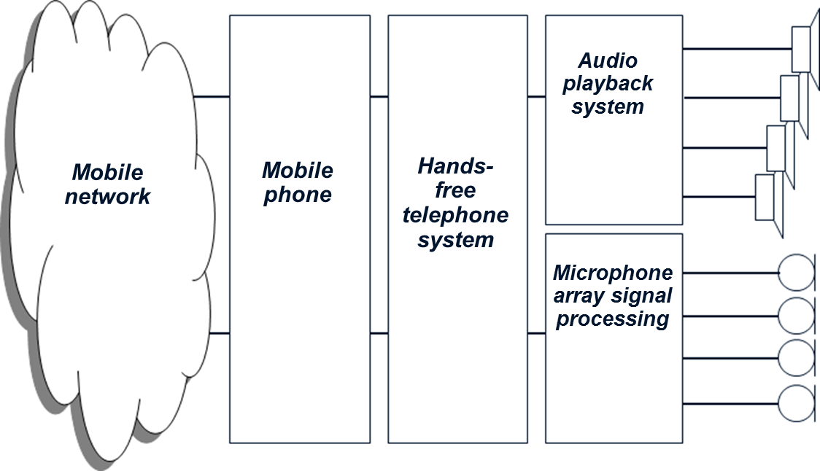  Sending direction | Receiving direction  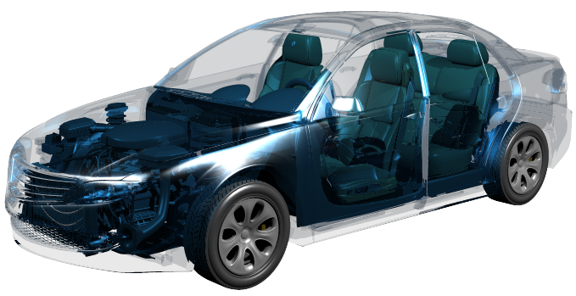
Fig. 3.1: Principle block diagram and definition of transmission directions
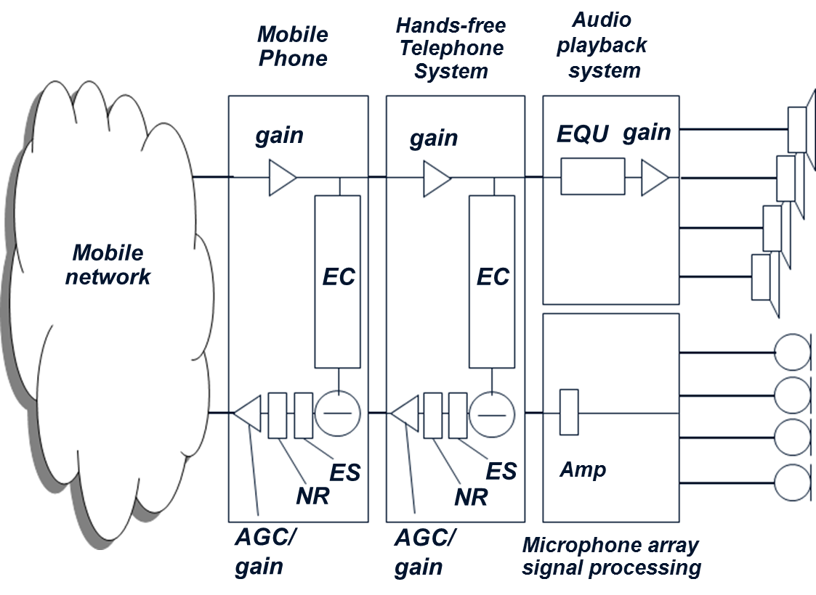 | Figure 3.2 shows the typical signal processing components in this set-up. The hands-free algorithms provide the echo cancellation functionality (“EC”), the additional processing to suppress residual echo components (echo suppression “ES”), noise reduction algorithm (“NR”) and gain adjustment including possible automatic gain control (“AGC”).  Today’s mobile phones provide the same kind of algorithms (see fig. 3.2) which may lead to cascaded signal processing, if they are not bypassed or disabled.
Fig. 3.2: Cascades signal processing
This should, under all circumstances, be avoided. The components in the hands-free telephone system are already optimized on the acoustic environment in each vehicle.
Experience shows that cascaded algorithms lead to degradations in conversational quality:
- Additional echo cancellation and echo suppression significantly hamper the very important double talk performance. The echo suppression unit (“ES” in figure 3.2) typically introduces attenuation in the microphone path under single talk conditions, if only the far end subscriber is talking and his voice is played back via the loudspeakers in the car. In this situation the driver hears the far end talkers’ voice in the car. The implemented signal processing (EC, ES) suppress the echo, which would be audible and annoying for the person speaking at the far end side.
If the driver interacts (both persons talk at the same time, designated as “double talk”) any attenuation in the microphone path, introduced by the echo suppression unit, needs to be quickly removed. Cascaded echo suppression units (in case they are not disabled in the mobile phone) hamper the conversation. Driver’s voice may be significantly attenuated or even partly suppressed (speech gaps in driver’s voice, “chopped” speech), which is very annoying for the far end subscriber.
- On the other hand, cascaded noise reduction algorithms (“NR” in Figure 3.2) degrade speech transmission quality, especially if the driver is talking from the driving car. In this case his voice is transmitted together with background noise from the vehicle. The noise reduction algorithm shall lower the transmitted background noise without impairing driver’s voice. However, due to technical limitations quality degradation occurs. Driver’s voice sounds artificial, unnatural and “metallic” and perhaps disturbed by other artifacts known as “musical tones”. This is audible and annoying for the far end conversational partner. The degradation is even worse, if two cascaded noise reduction algorithms are active in such a connection.
- Other cascaded signal processing like additional gain or automatic gain control introduced by the mobile phone may lead to signal saturation either in receiving direction (in this case the voice sounds distorted in the car) or in the microphone path (distorted driver’s voice audible at the far end side).

4. Test Description
The short range wireless connection was realized as a Bluetooth® connection during the test event, representing the most common use case connecting a mobile phone to a vehicle hands-free system today.

4.1 Test Setup
The principal test setup is described in figure 4.1. The tests are carried out on a mobile phone between two electrical interfaces, i.e. a mobile network simulator on the network side and a Bluetooth® reference interface on the near end side. The Bluetooth® reference interface MFE XI (measurement frontend provided by HEAD acoustics) communicates via the hands-free profile to the mobile phone under test. A narrowband and wideband Bluetooth® connection can be setup depending on the capability of the mobile phone, in particular if the mobile phone supports the wideband Bluetooth® connection using the mSBC codec. Tests in a narrowband Bluetooth® connection use the CVSD speech codec.
On the network side a network simulator (CMW500, Rohde & Schwarz) was used providing the capability of establishing a narrowband or wideband connection to the mobile phone.
In narrowband mode, the AMR codec operated at 12.2 kbit/s was used, the AMR-WB codec at 12.65 kbit/s was used in WB mode.  The Bluetooth® reference interface MFE XI is directly connected to the test system ACQUA. The network simulator is connected via unbalanced analog input and output connectors to the MFE VI.1 to the ACQUA measurement system (see test setup in figure 4.1). The clocks between both frontends, MFE XI and MFE VI.1 are synchronized via a digital AES/EBU connection. | 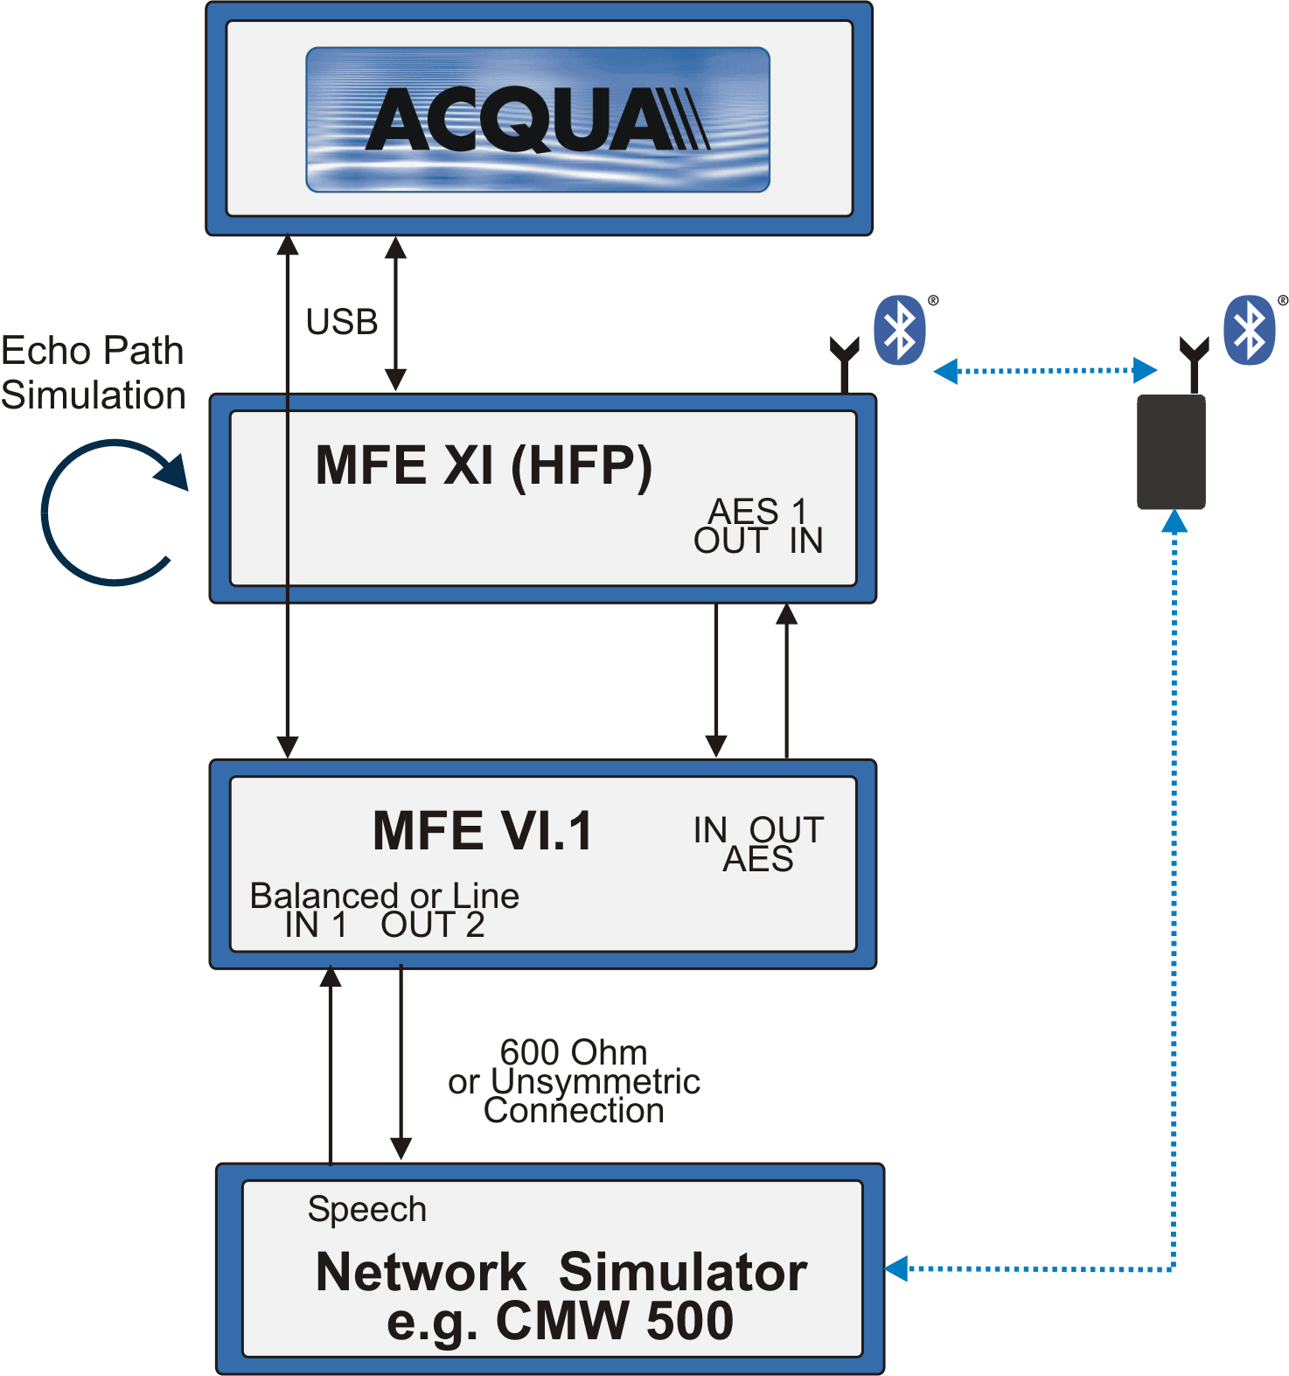
 | Fig. 4.1: Test setup, mobile phone connected to Bluetooth® reference frontend MFE XI and network simulator
Definition of transmission directions:
- Sending direction (see also fig. 3.1): The sending direction (uplink) represents the transmission from the Bluetooth® interface (representing the car hands-free unit) via the mobile phone to the network simulator.
- Receiving direction (see also fig. 3.1): The receiving direction (downlink) is defined as the transmission from the network simulator through the mobile phone to the Bluetooth® interface representing the hands-free unit in a vehicle.
In order to verify the echo performance of the mobile phones in such a simulated Bluetooth® connection, an echo path can be simulated in the MFE XI. This is indicated in figure 4.1. In this case, the downlink signal received via Bluetooth® at the MFE XI is coupled back in sending direction of the Bluetooth® connection with defined echo attenuation. These settings are stored in the appropriate frontends. The test setup guarantees an automatic test run for all devices under all test conditions.
The tests can be separated to verify the performance of the different communication aspects:
- Tests in sending direction covering Junction Loudness Rating tests, frequency response tests, Linearity tests, …
- The corresponding tests in receiving direction also cover these sensitivity tests, i.e. Junction Loudness Rating, frequency response, Linearity tests,…
- Echo performance tests are realized by simulating an echo path on the Bluetooth® side. These tests are implemented in order to verify if the implemented echo cancellation signal processing in the mobile phone is disabled as required.
- Background noise transmission tests are analyzed in sending direction. The main purpose is the verification, whether noise reduction is disabled, as required.
- Double talk performance tests are carried out applying test signals in both directions (receiving and sending direction) simultaneously. The most critical use case, signal attenuation in sending direction caused by the implemented (and possibly active) echo suppression units in the mobile phones, is analyzed.

4.2 Tests Implementations and Adaptations for the Test Event
As the Test Event is also used to verify and potentially improve the latest version of the ITU-T P.1100 and P.1110 Chapter 12 tests, the following test implementations and extension of tests were performed during the event. The main motivation for these test adaptations is to provide realistically achievable quality of service requirements. The tests are based on the latest versions of ITU-T P.1100 and P.1110 dated January 2015 [4], [5].
Section 12.1.1: SRW delay
The current delay measurements as described in Recommendation ITU-T P.1100/1110 distinguish between an access specific delay Tas and the mobile phone implementation dependent delay Trtd.
In narrowband mode the roundtrip delay in TSRWrtd = TSRWs + TSRWr shall be less than 20 ms with two additional notes 1 and 3:
NOTE 1 – The delay TSRWrtd should be minimized.
NOTE 3 – When providing state of the art low delay implementations the delay introduced by the access Tas without channel impairments should not exceed 170 ms.
Thus, the narrowband round trip delay limit was set to TSRWrtd 190 ms.
In wideband mode the round trip delay: T_{SRWrtd} = T_{SRWs} + T_{SRWr} shall be less than 30 ms with two additional notes 1 and 3:
NOTE 1 – The delay T_{SRWrtd} should be minimized.
NOTE 3 – When providing state of the art low delay implementations the delay introduced by the access Tas without channel impairments should not exceed 170 ms.
Thus, the wideband round trip delay limit was set to T_{SRWrtd} 200 ms.
Section 12.2: SRW loudness ratings
The current versions of SRW tests in P.1100 and P.1110 use real speech according to ITU-T P.501 [6] with the requirements of JLR_{SRWsnd} = 0 ± 2 dB and JLR_{SRWrcv} = 0 ± 2 dB.
In addition the test to verify the influence of the mobile phone volume control on the Bluetooth® link was conducted. The mobile phone volume control should not affect the measured JLRSRWrcv.
Section 12.2.4/5: SRW linearity in send and receive direction
For acoustical signal level variation in the range of −30 dB / 0 dB (steps of 10 dB) from the nominal signal level, the measured JLRSRWsnd and JLR_{SRWrcv} shall not deviate more than ±2 dB from the JLRSRWsnd and JLR_{SRWrcv} measured with the nominal signal level. Again, this tests is based on real speech as test signal.
Section 12.3: SRW sensitivity frequency response SND/RCV
The current frequency response test uses real speech as test signal and the following tolerance schemes for narrowband (left) and wideband transmissions (right). The curves are applicable in both directions, sending and receiving:
Narrowband |  |  | Wideband
Frequency [Hz] | Upper Limit | Lower Limit | Frequency [Hz] | Upper Limit | Lower Limit
200 | 0 | -3 | 100 | 0 | -3
2000 | 0 | -3 | 2000 | 0 | -3
3100 | 0 | -4 | 3100 | 0 | -4
3400 | 0 | -4 | 6300 | 0 | -4
4000 | 0 | Not def. | 7000 | 0 | Not def.

Section 12.4.2: SRW noise cancellation test in SND
The test signal used in the current version of ITU-T P.1100 and P.1110 for the measurements is the left channel of the "Medium size car: Noise at constant driving conditions (100 km/h)" according to clause B.4.1 of ITU-T P.501 [6]. The level of the transmitted signal is measured at the electrical reference point. The measured signal level is referred to the test signal level and displayed versus time. The levels are calculated from the time domain using an integration time of 35 ms for NB and 5 ms for WB. The requirement for the attenuation of the transmitted driving noise test signal is ±1 dB for all periods of the test signal.
The test pointed out that both, the time constant and the requirement are not suited to detect an active noise reduction algorithm. The test signal (real driving noise) is too non- stationary to be adequately analysed with such a short time constant. The time constant was temporarily set to 125 ms during the event and the resulting attenuation curves plotted vs time. The limit of ±1 dB is still far too tight as the chipsets typically do not seem to bypass the noise reduction algorithms but keep them in idle mode.
It is possible to distinguish between enabled or disabled noise suppression using these analysis parameters, exemplarily shown by the 3 wideband examples from the event:
NR disabled | NR disabled | NR enabled
However, this analysis setting was used during the event, a proposal for test adaptation (time constant, requirement,…) will be derived after final data analysis.
Section 12.5.1/3: SRW speech quality during single talk SND/RCV
The POLQA algorithm as described in Recommendation ITU-T P.863 [7] is used to determine listening speech quality in both directions. For wideband the requirements are MOS-LQOw ≥ 3.8 in both directions, for narrowband the limits are set to MOS-LQO_{n} ≥ 4.0.
Substitution for Section 12.5.2/4: Speech quality stability SND/RCV
The test procedures for the speech quality stability described in Recommendation ITU-T P.1100 and P.1110 are not realistic to be performed in a laboratory environment since different test positions in a vehicle and different combinations of SRW links cannot accurately and reproducibly be simulated. This test was skipped.

Section 12.5.5: Verification of disabled echo control
The tests in accordance to ITU-T P.1110 and P.1100 use compressed speech as test signal applied with an active speech level of -10 dB_{m0} in receiving direction. The 20 dB artificial echo path is considered on the SRW reference interface side and the analyzed echo loss (TCL_{w} for narrowband and TCL for wideband) is corrected by the previously determined JLR values.
Additional Test: Double talk test in SND
In addition to the echo control test an automatic double talk type test according to ITU-T P.502 Amendment 1 Appendix 3 was informatively performed in SND in order to double check the disabled state of the echo control signal processing.
Additional Test: Repetition of tests with new service level connection and without sending the “AT+NREC=0” command.
In order to verify that the deactivation of the NR and EC signal processing is really triggered by the dedicated AT command “AT+NREC=0” (and not by other indicators, e.g. the detection of a Bluetooth connection), a subset of tests is repeated after setting up a new service level connection and WITHOUT sending the “AT+NREC=0” command. The tests to be repeated are:
- Delay SND/RCV
- JLR SND/RCV
- Sensitivity frequency response SND/RCV
- Noise reduction test in SND
- Verification of disabled echo control
- Automatic double talk test in SND
These tests are of special importance for accessories like headsets using the hands-free profile to connect to mobile phones but relying on the phones’ signal processing.
Additional Tests: Cross connection tests (Recommendation ITU-T P.1110 only)
Codec negotiation mechanisms between the SRW (Bluetooth®) side and the mobile network side of mobile phones are not clearly defined. Thus NB/WB or WB/NB cross-connections are possible which may lead to unwanted level contrasts, as shown in the 1st Test Event results [1].
In order to limit the testing effort and considering the assumption, that in most cases today the head units in vehicles are wideband capable on the Bluetooth® link, interconnection tests are limited to wideband connection on the Bluetooth® side (ITU-T P.1110 test case). The additional test is performed as follows:
- SRW connection in wideband mode and mobile network connection in wideband mode, JLR (JLR_{SRWsnd} and JLR_{SRWrcv}) and frequency response measurements in both direction (test case 12.2 and 12.3.)
- Test repetition in SRW wideband connection and mobile network connection in narrowband mode. Comparison of measured JLR and frequency responses to test 12.2 and 12.3 results.

4.3 Selection and Designation of Mobile Phones
Following the idea from the first Test Event in 2014, the mobile phones were again selected by the participating companies in the event. The participation fee for each company covered eight tests, a company could select eight different mobile phones to be tested in wideband mode or split the test modes between the mobile phones depending on the transmission capability.
The motivation for the choice of mobile phones for each participant depended on individual needs (verification of state-of-the-art phones typically used by customers, verification of reported customer complaints, the suitability of mobile phones for hands-free tuning). Even the intention to make known issues of phones public through the Test Event was mentioned by participants.
In total, 18 devices of twelve different mobile phone vendors have been tested during the event, thus representing a major part of vendors worldwide. Note, that the same number of vendors were also tested during the first event (but not necessarily the same companies). All devices are commercially available. 18 mobile phones were tested in narrowband mode, 16 mobile phones were wideband capable and tested accordingly.
Designation used for the tested devices (example): 1-WB
…tested in wideband mode
Mobile phone No.1…

4.4 Result Representation and User Experience
A two page test report was generated for each test run including a “Quality Pie” chart representation according to Recommendation ITU-T P.505 [8] of the most important results, the designation of the mobile phone including manufacturer, brand name, IMEI and software version, a summary of the most important findings, additional graphs for the sending and receiving frequency responses, the noise reduction performance and the spectral echo attenuation tested with a 20 dB simulated echo path, frequency response curves without sending the “AT+NREC=0” command. In case of wideband, the reports are further extended by the results and curves from the added cross connection tests.
One example for the “Quality Pie” chart according to Recommendation ITU-T P.505 from the test event together with a short description of the selected parameters and requirements is shown in figure 4.2. The “Quality Pie” slices represent the following parameters and requirements (clock wise):
- The “AT+NREC=0” pie slice indicates the reply of the mobile phone on this command from the reference Bluetooth® interface. The pie slice is scaled between “OK” and “Error”.
- The round trip delay slice is scaled in ms (with the 200 ms wideband limit in figure 4.2).
- The pie slice “Vol. Ctrl.” is also digitally scaled between “Not active” and “Active”. It is recommended that the volume control on the mobile phone should not influence the sensitivity of the Bluetooth® connection, independent if the remote volume control feature is supported by the hands-free unit or not. In case the hands-free unit supports this feature, it is expected, that the volume control adjustment on the mobile phone may control the hands-free unit playback volume. However, the mobile phones’ volume control should not influence the sensitivity of the Bluetooth® link itself.
Fig. 4.2: Quality Pie Chart according to Recommendation ITU-T P.505
- The very important verification, if the implemented noise reduction in the mobile phone is still active in the Bluetooth® connection after sending the “AT+NREC=0” command, is indicated by the “NR” pie slice. The slice represents two possible states, the noise reduction being disabled as expected (“off” in the Quality Pie) or being enabled (“on”).
- The verification of the active echo cancellation algorithm in the mobile phone after receiving the “AT+NREC=0” command from the Bluetooth® reference interface is scaled in a similar way. Again two different stages, “off” (as required) or “on” are represented in the corresponding pie slice (“EC”).
- The influence of implemented signal processing on double talk performance is represented by the “DT” pie slice. Again two different stages are possible, the pie slice is scaled between “transparent” (as recommended) or “not transp.”.
- The sending sensitivity expressed by the measured Junction Loudness Rating (“JLR (SND)”) is scaled in dB. The limit, given by the inner red circle, represents an attenuation or amplification of 2 dB (JLR range 0 ± 2 dB).
- The Quality Pie slice “SFR” is also scaled in dB. It represents the violation of the suggested tolerance by the measured sending frequency response (SFR) in dB.
- The “Linearity SND” pie slice indicates the gain adjustment (amplification or attenuation) introduced in sending direction by the mobile phone, when applying different test signal levels. This pie slice is scaled in dB, the inner red circle represents the minimum requirement of ± 2 dB.
- Listening speech quality measured in sending direction using the Recommendation ITU-T P.863 POLQA method is used for scaling of the “MOS-LQO SND” pie slice. The scale directly represents the measured MOS-LQO_{n} or MOS-LQO_{w} scores. The limit represented by the inner red circle is given by the numerical value 3.8 (4.0 in the narrowband case).
- The receiving sensitivity (Junction Loudness Rating (“JLR (RCV)”) is scaled in dB. The inner red circle represents attenuation or amplification of 2 dB (JLR 0 ± 2 dB).
- The Quality Pie slice “RFR” (receiving frequency response) is scaled in dB and indicates the violation of the suggested tolerance by the measured curve.
- The “Linearity RCV” pie slice indicates the gain adjustment (amplification or attenuation) introduced in receiving direction by the mobile phone, when applying different test signal levels. This pie slice is scaled in dB, the inner red circle represents the minimum requirement of ± 2 dB.
- Listening speech quality in receiving direction is given by the “MOS-LQO RCV” pie slice. The limit represented by the inner red circle is given by the numerical value 3.8 (wideband), and 4.0 respectively (narrowband) as described above (see Chapter 4.2).
In addition to these results that were analyzed after sending the AT+NREC=0 command some tests were repeated without sending the command. In this case it is expected that the internal signal processing in the mobile phone is enabled as this control mechanism may be used by the headset industry relying on the signal processing in the mobile phones. The most important results are summarized in a short table in the test report.
Test Report example (wideband tests):
Additional test results without sending the ”AT+NREC=0“ command
Description of analysis parameter displayed in the “Quality Pie” Chart
Summary in ITU-T P.505 “Quality Pie” Chart
DUT information, and identification (incl. IMEI, SW)
Analysis curves and numbers:
SFR, RFR, noise reduction, echo atten.
Cross connection tests (wideband reports only)
SFR, JLR (SND)
RFR, JLR (RCV)

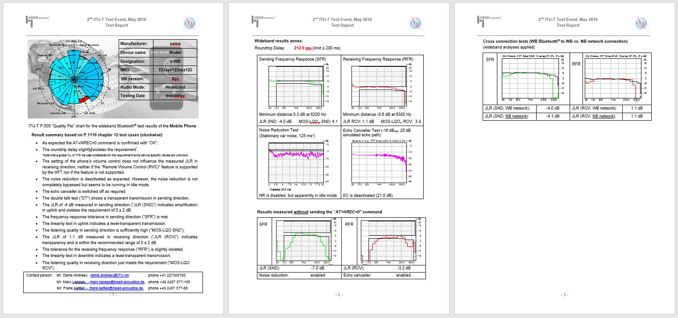

5. Analyses Results

5.1 Overview - Narrowband
The measured delay values in sending direction (uplink, UL), receiving direction (downlink, DL) and the round-trip delay (RT) are analyzed in figure 5.1a to 5.1c. The delay introduced by the test setup (frontend delay, network simulator) is considered and subtracted. Both one-way delays are informative in figure 5.1a and 5.1b. The limit of 190 ms is verified in figure 5.1c for the round trip delay as indicated in chapter 4.2 (red dotted line).
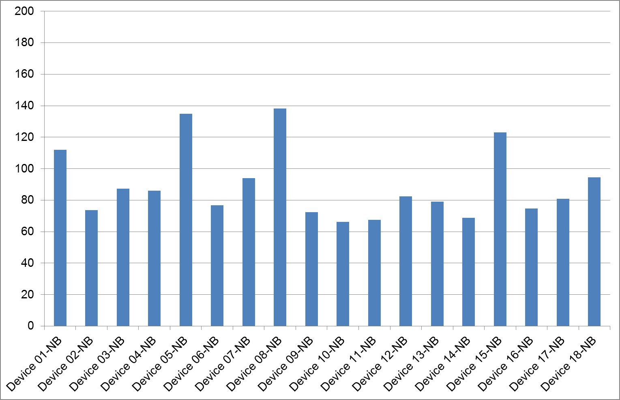 | 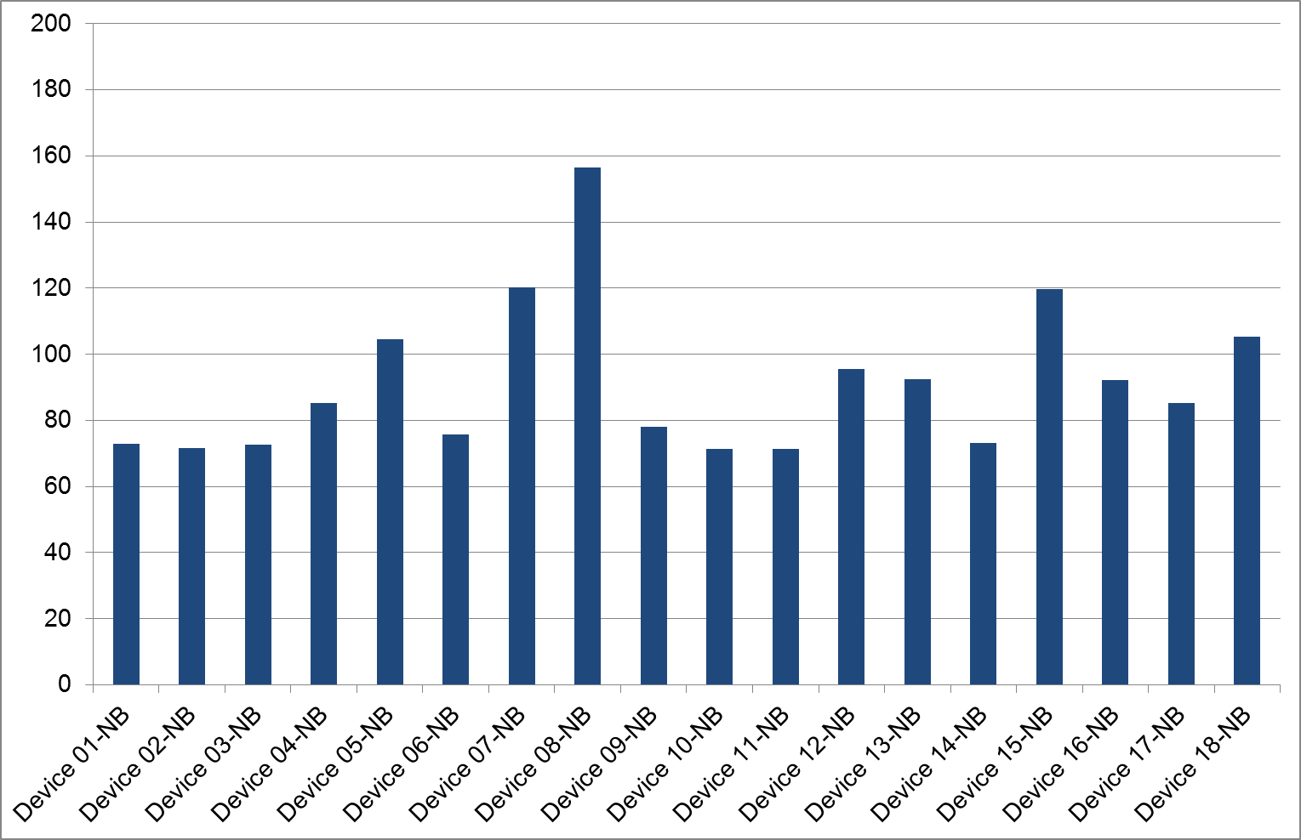
Fig. 5.1a: Sending (uplink) delay T_{AG,UL}, narrowband | Fig. 5.1b: Receiving (downlink) delay T_{AG,DL}, narrowband
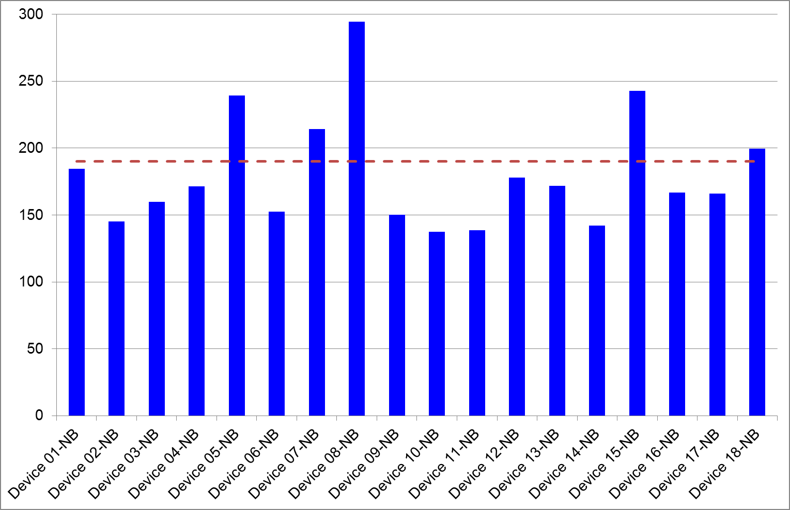
Fig. 5.1c: Round trip delay T_{AG,RT}, narrowband, 18 tested mobile phones
5 out of 18 devices, approximately one quarter of devices, violate the round trip delay requirement of 190 ms in narrowband mode. The maximum violation is caused by the measured result of 295 ms (device 8). Vice versa, the lowest delay was determined to 138 ms (device 10), which is less than half of the delay.
Figure 5.2 analyzes 14 individual parameters in order to provide an overview about the 18 mobile phones tested in narrowband mode. The green segments of each bar represent the number of mobile phones meeting the limits for each specific parameter. Vice versa the red segments indicate the number of limit violations.

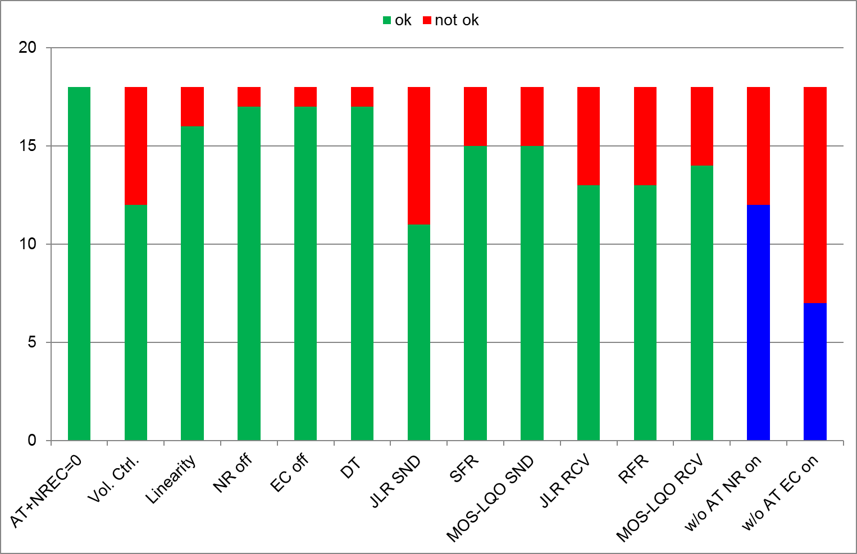

Fig. 5.2: Narrowband test result overview, 18 tested mobile phones

The last two bars on the right-hand side represent the additional tests carried out without sending the AT+NREC=0 command. The bars represent the verification of enabled noise reduction or echo cancellation (“NR on”, “EC on”). It should be noted that, without sending the AT+NREC=0 command, both algorithms are supposed to be enabled.
The following conclusions can be drawn:
- All 18 phones tested in narrowband mode respond with “Ok” to the AT+NREC=0 command. This result was already observed during the 1st Test Event.
- 6 out of 18 devices keep the volume control active on the mobile phone (“Vol. Ctrl.”). The volume control button on the phone directly influences the sensitivity on the Bluetooth® link. This could be observed for 4 out of 27 devices in the 1st Test Event and is, in general, not recommended. In case the hands-free telephone system supports the “Remote Volume Control” feature the head unit allows the mobile phone to send appropriate commands to the head unit in order to remotely adjust the playback volume on the head unit. However, it is not recommended to change the sensitivity on the Bluetooth® link within the mobile phone. This could worsen the signal to noise ratio in the digital transmission. Furthermore, the playback volume in the vehicle during a phone call depends on the volume setting of the phone, which is hard to control without drivers’ distraction.
- Automatic gain control (“Linearity”) either in receiving or sending direction is active in 2 of the 18 tested devices (5 of 27 in the 1st Test Event).
- 6 % of the implementations (1 of 18 devices) keep the noise reduction (“NR”) enabled (9 of 27 in the 1st Test Event), although they responded with “Ok” to the AT command to disable the signal processing.
- 1 out of the 18 devices keep the implemented echo cancellation (“EC”) active (4 of 27 in the 1st Test Event).
- The double talk performance is hampered only by 1 of the 18 devices. This is promising result, although the 18 phones cannot be regarded as representative for the whole market.
- The range of 0 ± 2 dB for the sending sensitivity (“JLR SND”) is violated by 7 devices and met by 11 implementations. It is worth to mention, that the strongest amplification in the sending signal path was more than 12 dB, which most likely leads to distorted drivers voice. A similar amount of phones (8 of 27) did not meet the sensitivity limits in the 1st Test Event (although the limits were slightly different at that time).
- 3 of 18 implementations (11 of 27 in the 1st Test Event) do not meet the adapted tolerance for the sending frequency responds (“SFR”).
- The listening speech quality limit expressed by the MOS-LQO_{N} (“MOS-LQO SND”) is violated by only 3 devices.
- The sensitivity in receiving direction (“JLR RCV”) with a recommended range of 0 ± 2 dB is violated by 5 of the 18 tested implementations (5 of 27 in the 1st Test Event).
- The receiving frequency response is violated by 5 of the 18 test devices (16 of 27 during the 1st Test Event).
- Listening speech quality in receiving direction with the limit of ≥ 4.0 MOS-LQO_{N} is violated by 4 devices.
The two additional test results in figure 5.2 measured without sending the AT command can be summarized as follows:
- 6 out of 18 devices disable the implemented noise reduction, although the AT command is not sent.
- 11 devices disable the implemented echo canceller in the Bluetooth® connection without having received the AT command.
These devices obviously disable the internal signal processing in a Bluetooth® link independent if the AT command is received or not. This is even a slightly higher amount of devices compared to the 1st Test Event (3 of 27 for noise reduction, 7 of 27 for echo cancellation). Bluetooth® headsets without own implemented signal processing may rely on the algorithms in the paired mobile phone. Consequently, echo disturbances and a low communication quality in noisy environment may occur.

5.2 Overview - Wideband
The measured delay values in wideband mode are analyzed in figure 5.3a to 5.3c. Again both one-way delays are informative only and the suggested limit of 200 ms is indicated in figure 5.3c by the red dotted line. Again the delay introduced by the test setup is considered in these analyses.
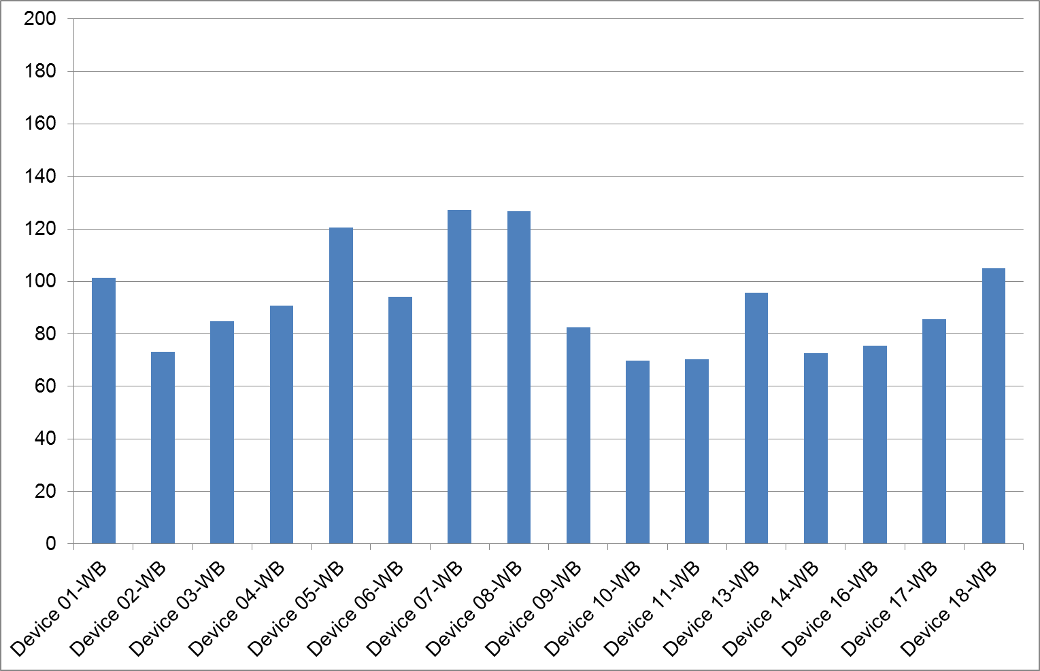 | 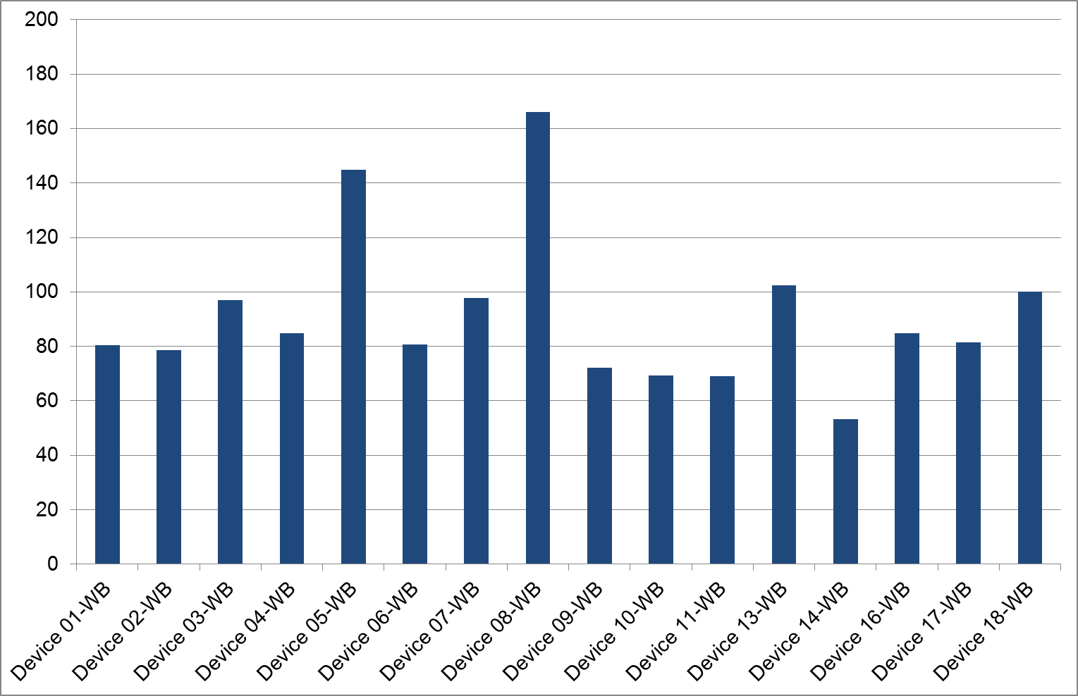
Fig. 5.3a: Sending (uplink) delay T_{AG,UL}, wideband | Fig. 5.3b: Receiving (downlink) delay T_{AG,DL}, wideband
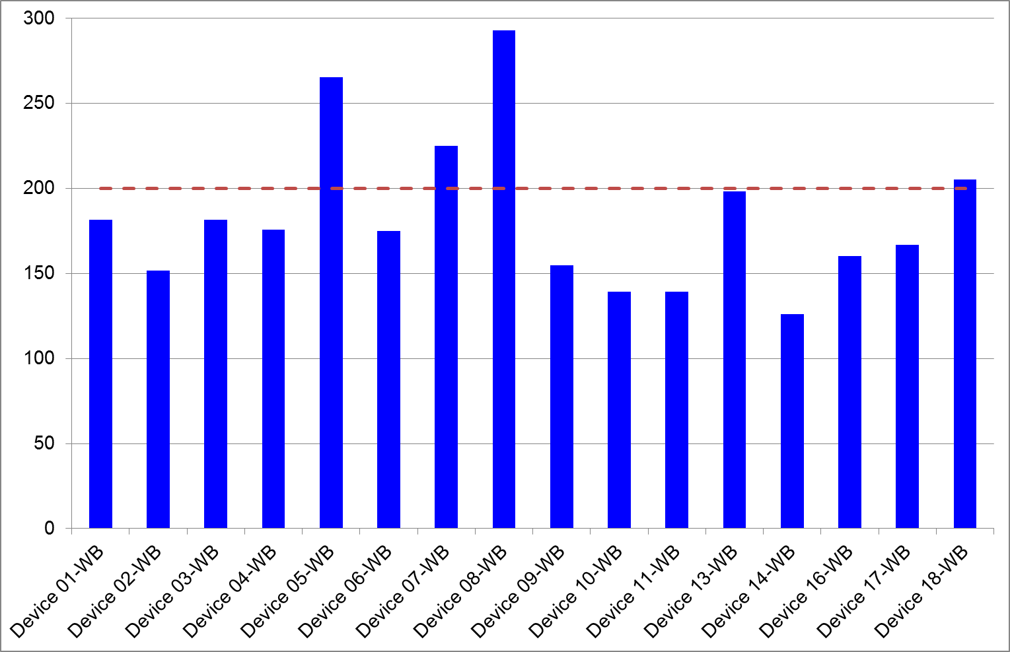
Fig. 5.3c: Round trip delay T_{AG,RT}, wideband, 16 tested mobile phones

The round trip delay limit of 200 ms is violated for 4 of the 16 tested wideband devices. The highest delay was determined to approximately 300 ms for device 8 (see also the high narrowband delay for this device).

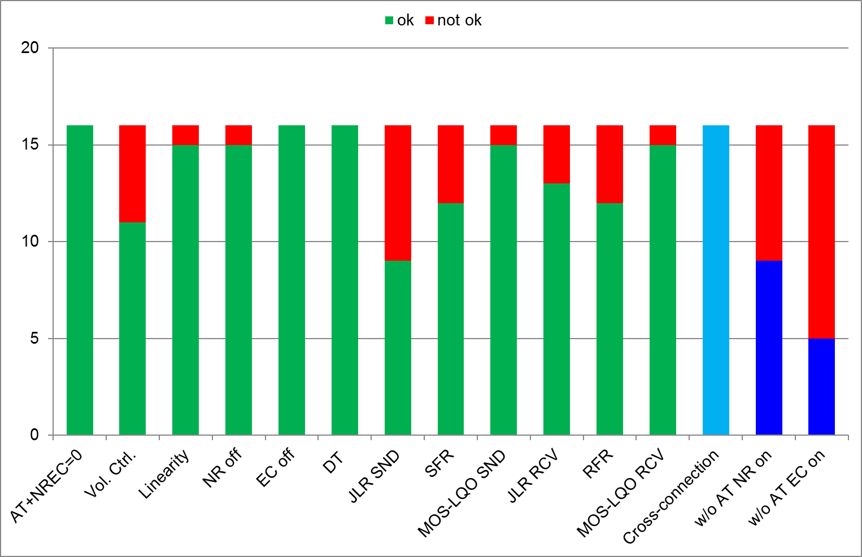
Fig. 5.4: Wideband test result overview, 16 tested mobile phones

The wideband results shown in figure 5.4 can be summarized as follows:
- All 16 wideband devices respond with “Ok” to the AT+NREC=0 command. The same could already be observed during the 1st Test Event.
- 5 devices keep the volume control active (“Vol. Ctrl.”), the other 11 tested devices do not influence the sensitivity on the Bluetooth® link by the volume control. In the 1st Test Event, only one device out of 13 influenced the Bluetooth® link level.
- One of the tested devices showed an automatic gain control (“Linearity”).
- The noise reduction was enabled in one of the 16 tested implementations (“NR”, same as 1 out of 13 in the 1st Test Event).
- The implemented echo cancellation (“EC”) was disabled in all wideband tests and none of the tested mobile phones influenced double talk performance (“DT”). The sending path can be regarded as transparent in all tests (same results as in the 1st Test Event).
- The range of 0 ± 2 dB for the sending sensitivity (“JLR SND”) is violated by 7 devices, 9 implementations showed the expected sensitivity. The result is also comparable to the 1st Test Event: approximately 50% of the tested devices showed unexpected level differences.
- 4 implementations (6 of 13 in the 1st Test Event) violate the tolerance for the sending frequency response (“SFR”).
- One of the mobile phones violates the listening speech quality limit of ≥ 3.8 MOS-LQOw using the P.863 recommended POLQA analysis method, in sending (“MOS-LQO SND”) and in receiving direction (“MOS-LQO RCV”).
- The Junction Loudness Rating range of 0 ± 2 dB in receiving direction (“JLR RCV”) is violated by 3 devices.
- The receiving frequency response is violated by 4 of the 16 tested devices. These results are also comparable to the 1st test Event.
The cross-connection tests can be summarized as follows:
- All tested wideband capable mobile phones showed the expected level transparency in the cross connection tests. The frequency responses mainly differ in the band limitations. Audible level contrasts are not expected e.g. if the mobile network codec dynamically switches from wideband to narrowband mode during an ongoing audio connection.
The test results without sending the AT command can be summarized as follows:
- Approximately 1/2 of the devices disable noise reduction and 2/3 disable echo cancellation, although “AT+NREC=0” has not been sent to the mobile phones. Again this may be critical in conjunction with Bluetooth® enabled headsets without own implemented signal processing. Disabled algorithms in this setup may lead to echo disturbances and a low communication quality, e.g. if the headset is used in noisy environment.

5.3 Individual Summary – Narrowband
Device: 1-NB
Volume control disabled
NR and EC disabled, but NR in “idle mode”, transparent double talk performance
Slightly high uplink sensitivity, transparent in downlink
- Almost transparent device, no speech quality degradation for customers
 | w/o sending “AT+NREC=0” | Noise reduction: enabled Echo canceller: enabled

Device: 2-NB
Volume control disabled
NR and EC disabled, but NR in “idle mode”, transparent double talk performance
All sensitivities within the recommended range
- Transparent device, high speech quality.
 | w/o sending “AT+NREC=0” | Noise reduction: enabled Echo canceller: enabled

Device: 3-NB
Volume control disabled
NR and EC disabled, but NR in “idle mode”, transparent double talk performance
All sensitivities within the recommended range
- Transparent device, high speech quality
 | w/o sending “AT+NREC=0” | Noise reduction: disabled  Echo canceller: disabled

Device: 4-NB
Volume control enabled
NR and EC disabled, but NR in “idle mode”, transparent double talk performance
All sensitivities within the recommended range
- Transparent device, high speech quality
 | w/o sending “AT+NREC=0” | Noise reduction: disabled  Echo canceller: disabled

Device: 5-NB
Volume control enabled, high round trip delay
NR and EC disabled, but NR in “idle mode”, transparent double talk performance
Uplink and downlink sensitivity too high
- May cause speech quality degradations

 | w/o sending “AT+NREC=0” | Noise reduction: enabled Echo canceller: disabled

Device: 6-NB
Volume control disabled
NR and EC disabled, but NR in “idle mode”, transparent double talk performance
Slightly high uplink sensitivity
- Almost transparent device, no speech quality degradation for customers
 | w/o sending “AT+NREC=0” | Noise reduction: enabled Echo canceller: enabled

Device: 7-NB
Volume control disabled, high round trip delay
NR and EC disabled, but NR in “idle mode”, transparent double talk performance
Recommended sensitivities, but frequency responses out of range
- Degraded listening speech quality
 | w/o sending “AT+NREC=0” | Noise reduction: enabled Echo canceller: disabled

Device: 8-NB
Volume control disabled, very high round trip delay
NR and EC disabled, but NR in “idle mode”, transparent double talk performance
Signal amplification in uplink, attenuation in downlink, frequency responses violate tolerances
- Degraded speech quality
 | w/o sending “AT+NREC=0” | Noise reduction: enabled Echo canceller: disabled

Device: 9-NB
Volume control disabled
NR and EC disabled, but NR in “idle mode”, transparent double talk performance
All sensitivities within the recommended range, transparent transmission
- Transparent device, high speech quality
 | w/o sending “AT+NREC=0” | Noise reduction: enabled Echo canceller: enabled

Device: 10-NB
Volume control disabled
NR and EC disabled, but NR in “idle mode”, transparent double talk performance
Uplink sensitivity significantly too high, downlink too low
- Degraded speech quality in downlink

 | w/o sending “AT+NREC=0” | Noise reduction: disabled  Echo canceller: disabled

Device: 11-NB
Volume control disabled
NR and EC disabled, but NR in “idle mode”, transparent double talk performance
All sensitivities are within the recommended range
- Transparent device, high speech quality

 | w/o sending “AT+NREC=0” | Noise reduction: enabled  Echo canceller: enabled

Device: 12-NB
Volume control disabled
NR and EC enabled, degraded double talk performance
All sensitivities are within the recommended range
Frequency responses violated in both directions
- Still acceptable listening speech quality

 | w/o sending “AT+NREC=0” | Noise reduction: enabled  Echo canceller: enabled

Device: 13-NB
Volume control enabled
NR and EC disabled, but NR in “idle mode”, transparent double talk performance
Downlink sensitivity slightly out of range
- high speech quality in uplink, slightly low speech quality in downlink.
 | w/o sending “AT+NREC=0” | Noise reduction: disabled  Echo canceller: disabled

Device: 14-NB
Volume control disabled
NR and EC disabled, but NR in “idle mode”, transparent double talk performance
Uplink sensitivity significantly too high, downlink sensitivity too low
- Degraded speech quality in downlink
 | w/o sending “AT+NREC=0” | Noise reduction: disabled  Echo canceller: disabled

Device: 15-NB
Volume control enabled, high round-trip delay,
NR and EC disabled, but NR in “idle mode”, transparent double talk performance
Level-transparent transmission in uplink and downlink
- Transparent device, high speech quality

 | w/o sending “AT+NREC=0” | Noise reduction: enabled Echo canceller: disabled

Device: 16-NB
Volume control enabled
NR and EC disabled, but NR in “idle mode”, transparent double talk performance
Level-transparent transmission in uplink and downlink
- Transparent device, high speech quality

 | w/o sending “AT+NREC=0” | Noise reduction: enabled  Echo canceller: enabled

Device: 17-NB
Volume control enabled
NR and EC disabled, but NR in “idle mode”, transparent double talk performance
Level-transparent transmission in uplink and downlink
- Transparent device, high speech quality

 | w/o sending “AT+NREC=0” | Noise reduction: disabled  Echo canceller: disabled

Device: 18-NB
Slightly high round-trip delay, volume control disabled
NR and EC disabled, but NR in “idle mode”, transparent double talk performance
Uplink sensitivity too high, receiving frequency slightly out of tolerance
- No speech quality degradation for customers

 | w/o sending “AT+NREC=0” | Noise reduction: enabled  Echo canceller: enabled

5.4 Individual Summary – Wideband
Device: 1-WB
Volume control disabled
NR and EC disabled, but NR in “idle mode”, transparent double talk performance
Transparent device, but slight signal amplification in uplink
- high speech quality both directions

 | w/o sending “AT+NREC=0” | Noise reduction: enabled Echo canceller: enabled

Device: 2-WB
Volume control disabled
NR and EC disabled, but NR in “idle mode”, transparent double talk performance
All sensitivities within the recommended range
- Transparent device, high speech quality

 | w/o sending “AT+NREC=0” | Noise reduction: enabled Echo canceller: enabled

Device: 3-WB
Volume control disabled
NR and EC disabled, but NR in “idle mode”, transparent double talk performance
All sensitivities within the recommended range
- Transparent device, high speech quality

 | w/o sending “AT+NREC=0” | Noise reduction: disabled Echo canceller: disabled

Device: 4-WB
Volume control enabled
NR and EC disabled, but NR in “idle mode”, transparent double talk performance
All sensitivities within the recommended range
- Transparent device, high speech quality

 | w/o sending “AT+NREC=0” | Noise reduction: disabled Echo canceller: disabled

Device: 5-WB
Very high round trip delay, volume control enabled
NR and EC disabled, but NR in “idle mode”, transparent double talk performance
Signal amplification in uplink and downlink
- May lead to speech quality degradation

 | w/o sending “AT+NREC=0” | Noise reduction: enabled Echo canceller: disabled

Device: 6-WB
Volume control disabled
NR and EC disabled, but NR in “idle mode”, transparent double talk performance
Transparent device, but slight signal amplification in uplink
- high speech quality in both directions

 | w/o sending “AT+NREC=0” | Noise reduction: enabled Echo canceller: enabled

Device: 7-WB
High round-trip delay, volume control disabled
NR and EC disabled, but NR in “idle mode”, transparent double talk performance
signal levels transparent in uplink and downlink
Frequency responses and linearity violated in both directions
- Degraded speech quality in both directions.
 | w/o sending “AT+NREC=0” | Noise reduction: enabled Echo canceller: disabled

Device: 8-WB
Very high round trip delay, volume control disabled
EC disabled, but NR enabled, transparent double talk performance, transparent performance in downlink
Transparent sensitivities in both directions
- Degraded speech quality

 | w/o sending “AT+NREC=0” | Noise reduction: enabled Echo canceller: disabled

Device: 9-WB
Volume control disabled
NR and EC disabled, but NR in “idle mode”, transparent double talk performance
All sensitivities are within the recommended range
- Transparent device, high speech quality.

 | w/o sending “AT+NREC=0” | Noise reduction: disabled Echo canceller: disabled

Device: 10-WB
Volume control disabled
NR and EC disabled, but NR in “idle mode”, transparent double talk performance
High signal attenuation in downlink, very high amplification in uplink, slight violation of sending frequency response
- Signal amplification may distort uplink signal.
 | w/o sending “AT+NREC=0” | Noise reduction: disabled Echo canceller: disabled

Device: 11-WB
Volume control disabled
NR and EC disabled, but NR in “idle mode”, transparent double talk performance
All sensitivities within the recommended range
- Transparent device, high speech quality.
 | w/o sending “AT+NREC=0” | Noise reduction: enabled Echo canceller: enabled

Device not wideband capable | Device: 12-WB
Device not wideband capable | w/o sending “AT+NREC=0” | Noise reduction: Echo canceller:

Device: 13-WB
Volume control enabled
NR and EC disabled, but NR in “idle mode”, transparent double talk performance
All sensitivities within the recommended range
- Transparent device, high speech quality in both directions
 | w/o sending “AT+NREC=0” | Noise reduction: disabled Echo canceller: disabled

Device: 14-WB
Volume control disabled
NR and EC disabled, but NR in “idle mode”, transparent double talk performance
Very strong signal amplification in uplink, very strong attenuation in downlink
Slight violation of sending frequency response
- Signal amplification may distort uplink signal
 | w/o sending “AT+NREC=0” | Noise reduction: disabled Echo canceller: disabled

Device not wideband capable | Device: 15-WB
Device not wideband capable | w/o sending “AT+NREC=0” | Noise reduction: Echo canceller:

Device: 16-WB
Volume control enabled
NR and EC disabled, but NR in “idle mode”, transparent double talk performance
transparent transmission in uplink and downlink
- Transparent device, high speech quality in both directions
 | w/o sending “AT+NREC=0” | Noise reduction: enabled Echo canceller: disabled

Device: 17-WB
Volume control enabled
NR and EC disabled, but NR in “idle mode”, transparent double talk performance
Frequency responses in both directions slightly out of tolerance
- No speech quality degradation for customers
 | w/o sending “AT+NREC=0” | Noise reduction: disabled Echo canceller: disabled

Device: 18-WB
Slightly high round-trip delay,
Volume control, NR and EC disabled, but NR in “idle mode”, transparent double talk performance
Signal amplification in uplink, transparent in downlink
- may lead to speech quality degradation
 | w/o sending “AT+NREC=0” | Noise reduction: enabled Echo canceller: enabled

5.5 Cross Connection Tests
The sending and receiving sensitivities and possible level contrasts are analyzed in cross connection scenarios, cascading a Bluetooth® connection in wideband mode (BT WB) with wideband and narrowband network connections. That these tests can only be carried out for wideband Bluetooth® capable phones. It can further be assumed that head units in vehicles today are wideband Bluetooth® capable and connect in wideband mode to the mobile phone.
The following figures compare the wideband sensitivities in sending (SFR) and receiving direction (RFR) to the narrowband network connection. The measured JLR values are given in addition:
- the SFR curves are measured and compared for the wideband connection (wideband Bluetooth® and wideband network, black curve) and the cross connection (wideband Bluetooth® and narrowband network, green curve) in the left hand figures.
- Correspondingly the RFR curves are compared in the right hand figures (wideband Bluetooth® and wideband network, black curve; wideband Bluetooth® and narrow-band network, red curve).
All devices show a more or less constant sensitivity in the narrowband transmission range. No noticeable level offset between the narrowband network connection and the wideband network connection can be observed. Neither the driver (receiving direction) nor the far end subscriber (sending direction) will notice a level contrast, if the network connection switches from wideband to narrowband.
Signal amplification or attenuation on the wideband Bluetooth® link persists during network transition (see device 5-WB, 10-WB and 14-WB).

1-WB |  |  | JLR (SND) | -2.5 dB
1-WB |  |  | JLR_{cross} (SND): | -2.8 dB
1-WB |  |  | JLR (RCV): | -0.3 dB
1-WB |  |  | JLR_{cross} (RCV): | 0.0 dB
2-WB |  |  | JLR (SND) | 0.4 dB
2-WB |  |  | JLR_{cross} (SND): | 0.6 dB
2-WB |  |  | JLR (RCV): | 0.8 dB
2-WB |  |  | JLR_{cross} (RCV): | 0.8 dB

3-WB |  |  | JLR (SND) | 0.4 dB
3-WB |  |  | JLR_{cross} (SND): | 0.6 dB
3-WB |  |  | JLR (RCV): | 0.6 dB
3-WB |  |  | JLR_{cross} (RCV): | 0.7 dB
4-WB |  |  | JLR (SND) | 0.5 dB
4-WB |  |  | JLR_{cross} (SND): | -0.4 dB
4-WB |  |  | JLR (RCV): | 0.7 dB
4-WB |  |  | JLR_{cross} (RCV): | 0.4 dB
5-WB |  |  | JLR (SND) | -5.5 dB
5-WB |  |  | JLR_{cross} (SND): | -5.4 dB
5-WB |  |  | JLR (RCV): | -5.0 dB
5-WB |  |  | JLR_{cross} (RCV): | -5.0 dB
6-WB |  |  | JLR (SND) | -2.6 dB
6-WB |  |  | JLR_{cross} (SND): | -2.7 dB
6-WB |  |  | JLR (RCV): | -0.3 dB
6-WB |  |  | JLR_{cross} (RCV): | 0.1 dB
7-WB |  |  | JLR (SND) | 1.5 dB
7-WB |  |  | JLR_{cross} (SND): | 0.8 dB
7-WB |  |  | JLR (RCV): | -0.1 dB
7-WB |  |  | JLR_{cross} (RCV): | -0.7 dB
8-WB |  |  | JLR (SND) | 1.0 dB
8-WB |  |  | JLR_{cross} (SND): | 1.1 dB
8-WB |  |  | JLR (RCV): | 0.7 dB
8-WB |  |  | JLR_{cross} (RCV): | 1.2 dB

9-WB |  |  | JLR (SND) | 0.5 dB
9-WB |  |  | JLR_{cross} (SND): | 0.5 dB
9-WB |  |  | JLR (RCV): | 0.7 dB
9-WB |  |  | JLR_{cross} (RCV): | 0.8 dB
10-WB |  |  | JLR (SND) | -9.4 dB
10-WB |  |  | JLR_{cross} (SND): | -9.4 dB
10-WB |  |  | JLR (RCV): | 6.7 dB
10-WB |  |  | JLR_{cross} (RCV): | 6.8 dB
11-WB |  |  | JLR (SND) | 0.4 dB
11-WB |  |  | JLR_{cross} (SND): | 0.5 dB
11-WB |  |  | JLR (RCV): | 0.7 dB
11-WB |  |  | JLR_{cross} (RCV): | 0.8 dB
12-WB | Device not wideband capable |  | JLR (SND)
12-WB |  |  | JLR_{cross} (SND):
12-WB |  |  | JLR (RCV):
12-WB |  |  | JLR_{cross} (RCV):
13-WB |  |  | JLR (SND) | 0.5 dB
13-WB |  |  | JLR_{cross} (SND): | 0.6 dB
13-WB |  |  | JLR (RCV): | 0.7 dB
13-WB |  |  | JLR_{cross} (RCV): | 1.4 dB
14-WB |  |  | JLR (SND) | -11.2 dB
14-WB |  |  | JLR_{cross} (SND): | -11.2 dB
14-WB |  |  | JLR (RCV): | 12.7 dB
14-WB |  |  | JLR_{cross} (RCV): | 12.7 dB

15-WB | Device not wideband capable |  | JLR (SND)
15-WB |  |  | JLR_{cross} (SND):
15-WB |  |  | JLR (RCV):
15-WB |  |  | JLR_{cross} (RCV):
16-WB |  |  | JLR (SND) | 2.2 dB
16-WB |  |  | JLR_{cross} (SND): | 2.3 dB
16-WB |  |  | JLR (RCV): | -0.5 dB
16-WB |  |  | JLR_{cross} (RCV): | -0.4 dB
17-WB |  |  | JLR (SND) | 0.5 dB
17-WB |  |  | JLR_{cross} (SND): | 0.6 dB
17-WB |  |  | JLR (RCV): | 0.7 dB
17-WB |  |  | JLR_{cross} (RCV): | 0.8 dB
18-WB |  |  | JLR (SND) | -5.5 dB
18-WB |  |  | JLR_{cross} (SND): | -5.4 dB
18-WB |  |  | JLR (RCV): | 0.7 dB
18-WB |  |  | JLR_{cross} (RCV): | 0.7 dB

6. References

[1] Performance assessment of vehicle-mounted mobile phones in conjunction with Hands-free Terminals according to Recommendations ITU-T P.1100 and ITU-T P.1110; http://www.itu.int/en/ITU-T/C-I/Pages/test_event_Feb14.aspx
[2] Bluetooth® Telephony Working Group: Hands-free Profile 1.7, Bluetooth Profile Specification, Revision V1.7.0, September 18, 2014
[3] Compatibility of mobile phones and vehicle hands-free terminals, http://www.itu.int/en/ITU-T/C-I/Pages/HFT-mobile-tests/HFT_testing.aspx
[4] Recommendation ITU-T P.1100; Narrowband hands-free communication in motor vehicles, 01-2015
[5] Recommendation ITU-T P.1110; Wideband hands-free communication in motor vehicles, 01-2015
[6] Recommendation ITU-T P.501; Test signals for use in telephonometry, 01-2012
[7] Recommendation ITU-T P.863; Perceptual objective listening quality assessment, 09-2014
[8] Recommendation ITU-T P.505; One-view visualization of speech quality measurement results, 11-2005

