**Solutions for the exercises using the BR IFIC DVD**

1. **National extract**

Retrieve all the assignments recorded in the MIFR on behalf of your Administration using the “Quick Query” option.

**Solution:** Click on the “New Query” button in the toolbar, select “Quick Queries” and press OK.

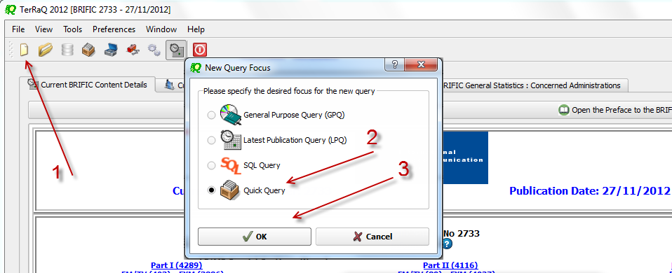

**2769**

**No 2752**

Then select “National Lookup/Extract” and press OK.

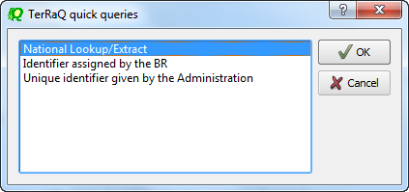

Select your Administration and clear the “Pending Notices (TIP)” check box at the bottom of the screen. Please note that the “Relevant Fragment” should be RR 11 (NTFD_RR).

Press OK to execute the query.

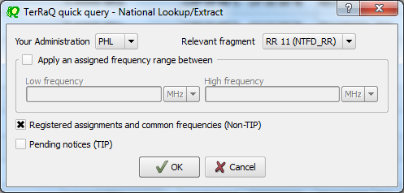

1. **Search for a frequency assignment**

Retrieve the frequency assignment of 948.0 MHz and geographical coordinates 120E5800 14N3600 using the “General Purpose Query”.

**Solution:** Select File->New Query menu, then “General Purpose Query” and press OK.

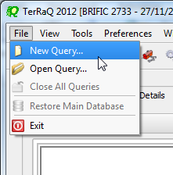 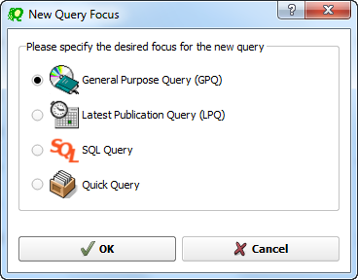

Select “All domains” in Query Settings.

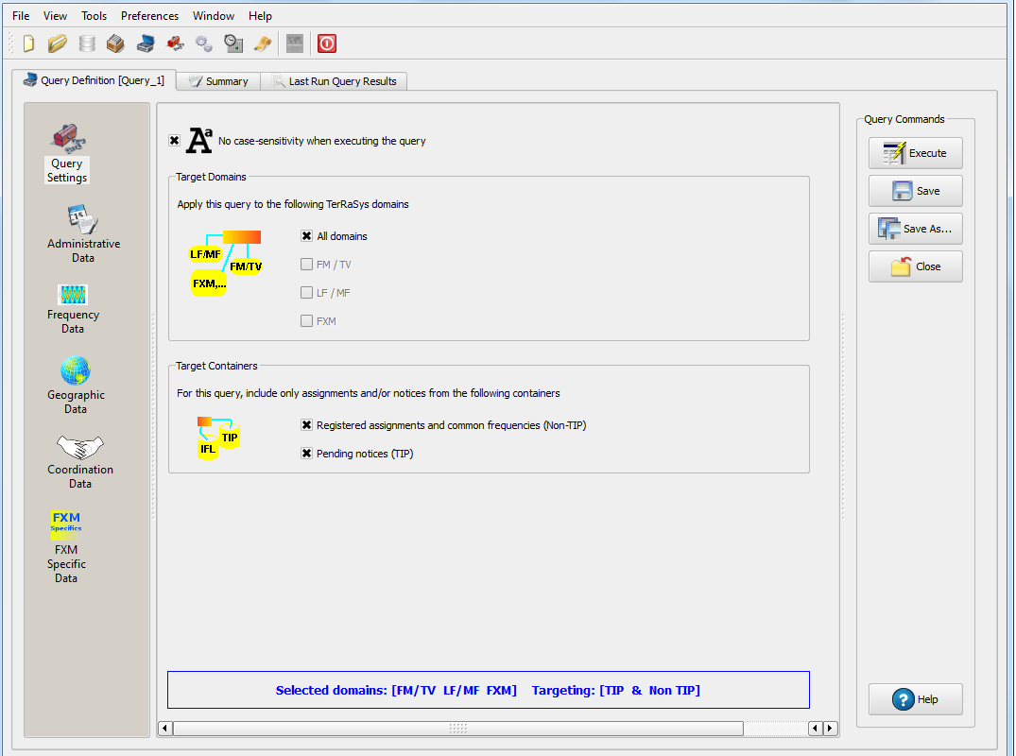

In Assigned Frequency screen under Frequency Data, select f=f1, then enter 948.0 in the frequency box, select “MHz” as the unit and press + button.

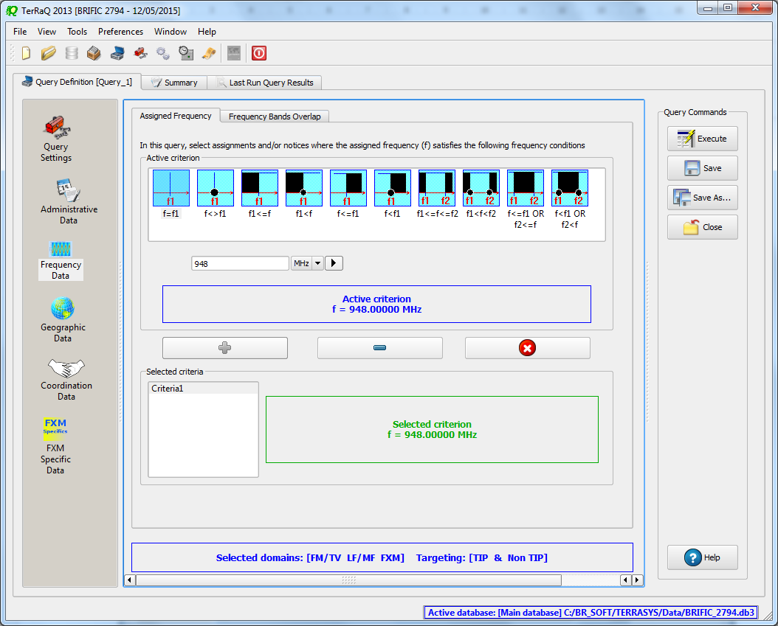

1

2

3

In Geographic Data screen, select “Inside circle”, then enter 120E5800 and 14N3600 in the Longitude and Latitude boxes and enter 1 in the Radius box and press + button.

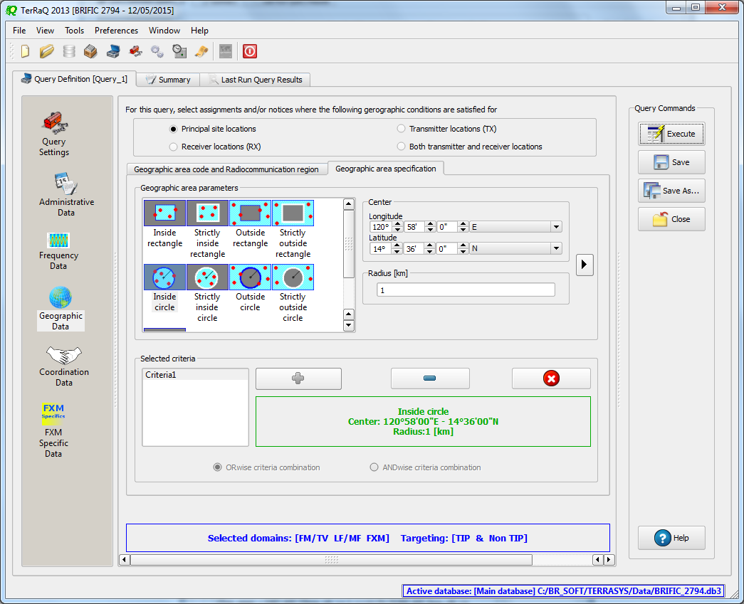

2

1

3

Press Execute button to run the query and in the following screen click on Load button to see the result.

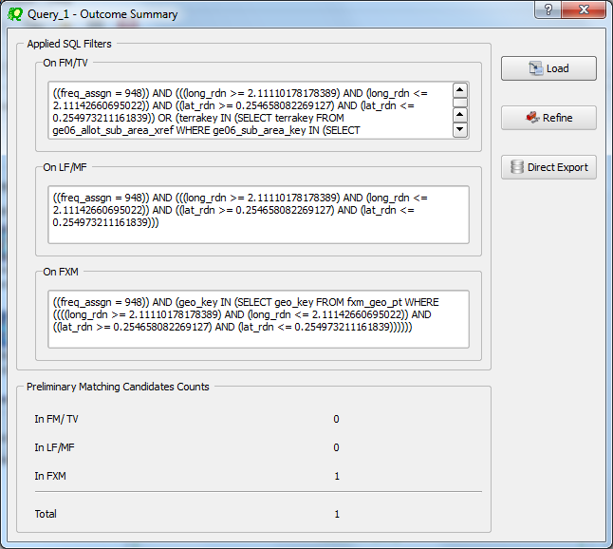

1. **Latest publication query**

Retrieve all the frequency assignments of your Administration published by the Bureau in the latest BR IFIC.

* Indicate those published for acknowledgement of receipt

**Solution:** Create a new LPQ query through the menu item of File->New Query.

 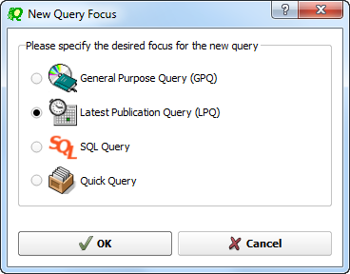

Select all available “Target Domains”.

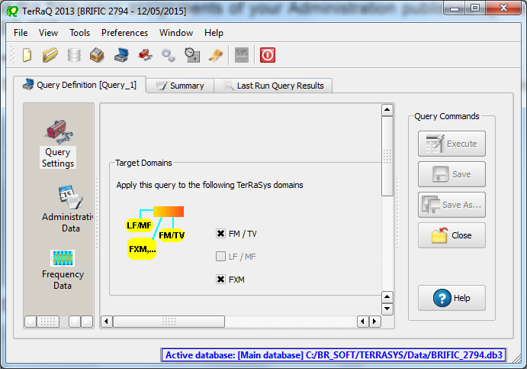

Select your Administration under “Administrative Data”.

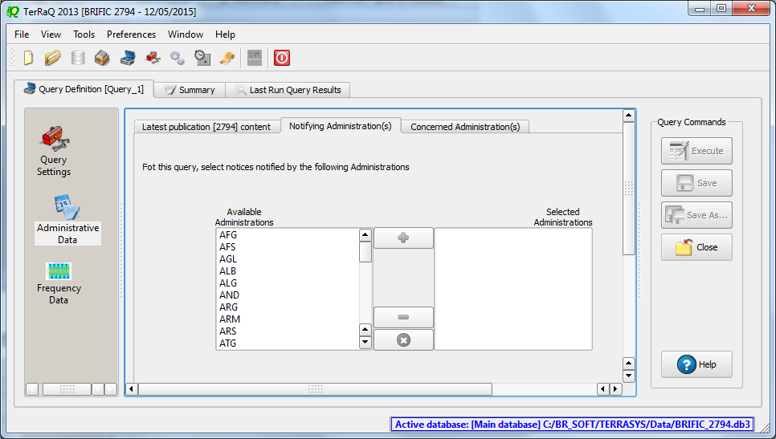

In the “Administrative Data” select only “Part I” in the box of “RR 11” under “FM/TV current publications” and “FXM current publications”. Now press “Execute” to see the result.

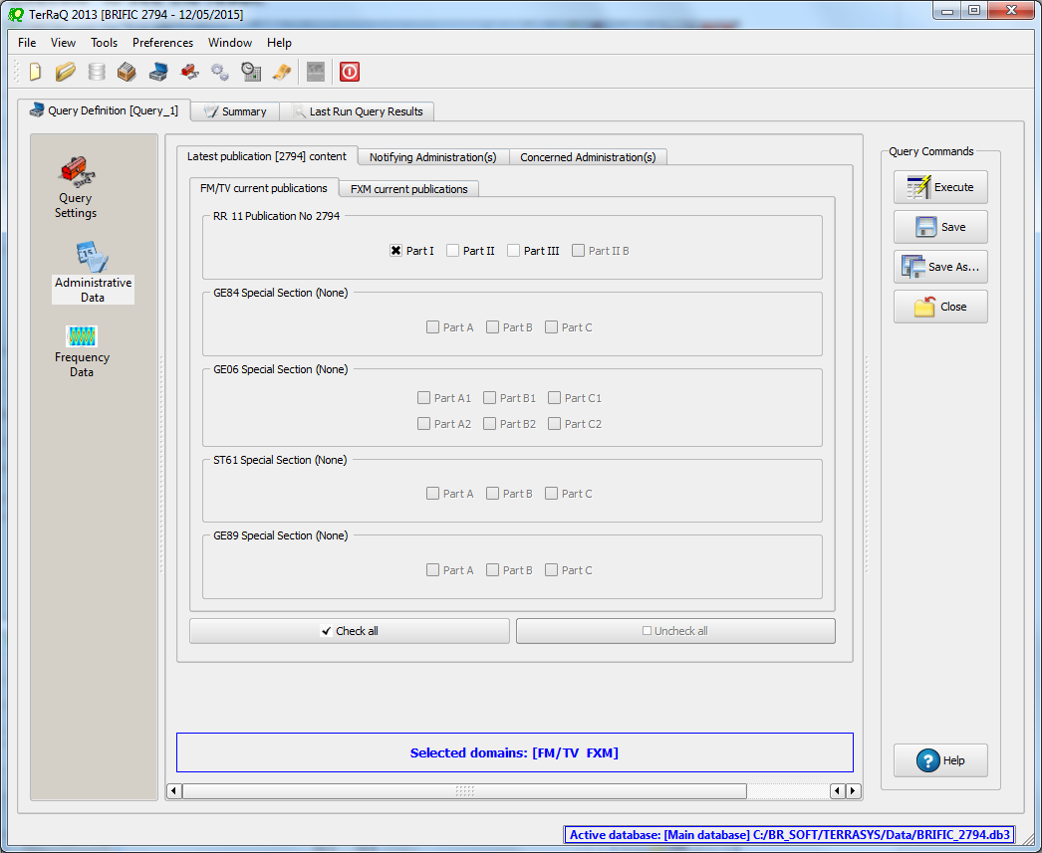

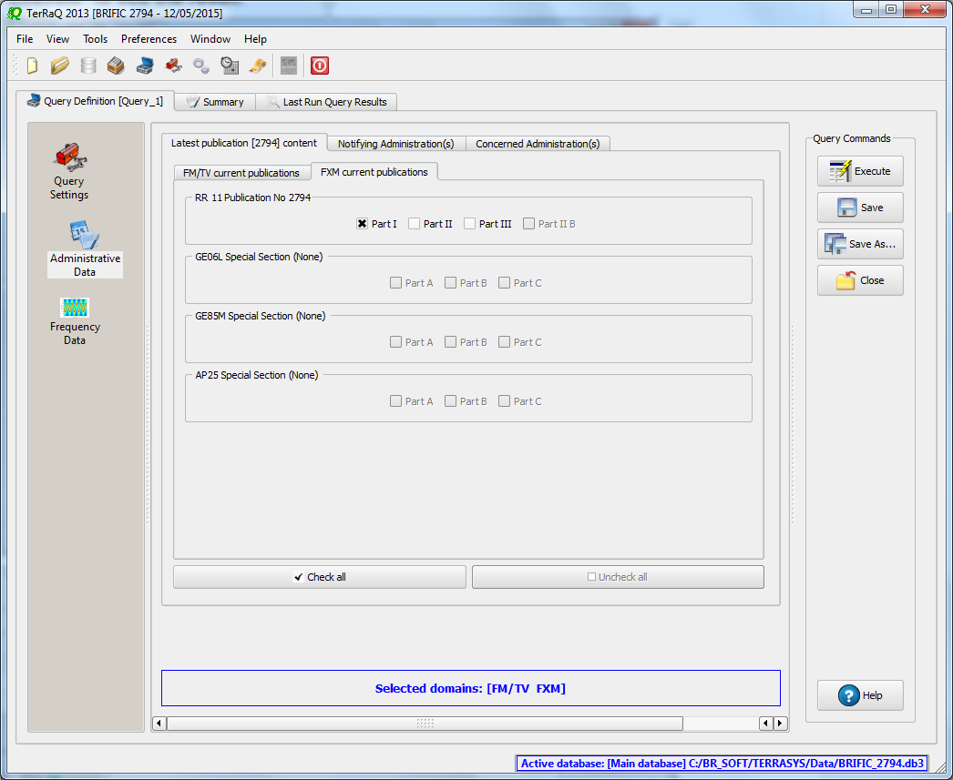

* Indicate those which are going to be recorded in the Master Register.

**Solution:** Create a new LPQ query through the menu item of File->New Query.

 

Select all “Target Domains”.



Select your Administration under “Administrative Data”.



In the “Administrative Data” select only “Part II” in the box of “RR 11” under “FM/TV current publications” and “FXM current publications”. Now press “Execute” to see the result.

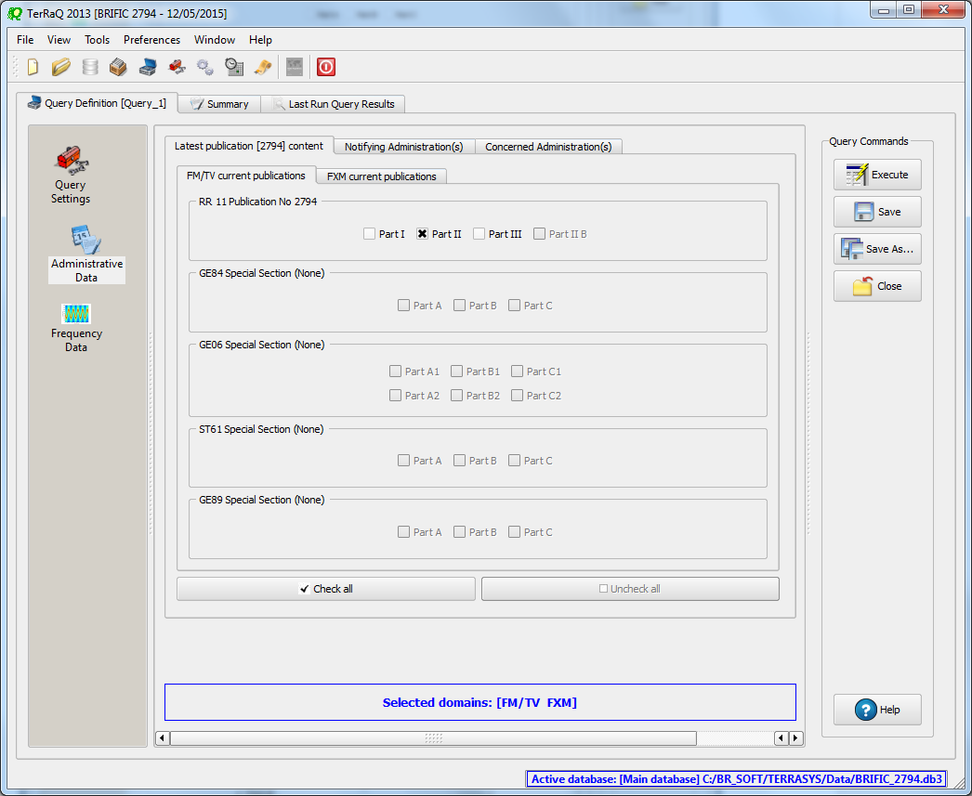

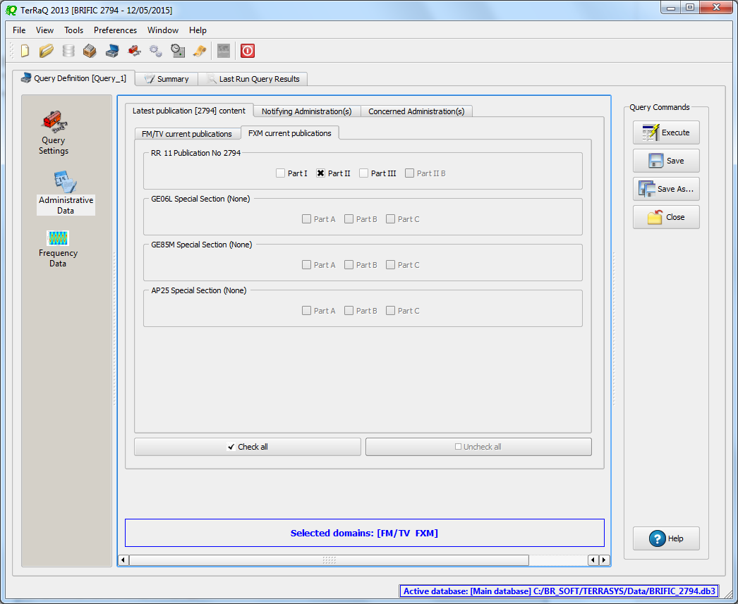

* Indicate those for which the Bureau has formulated an unfavourable finding.

**Solution:** Create a new LPQ query through the menu item of File->New Query.

 

Select all “Target Domains”.



Select your Administration under “Administrative Data”.



Then in the “Administrative Data” select only “Part III” under “FM/TV current publications” and “FXM current publications”. Now press “Execute” to see the result.

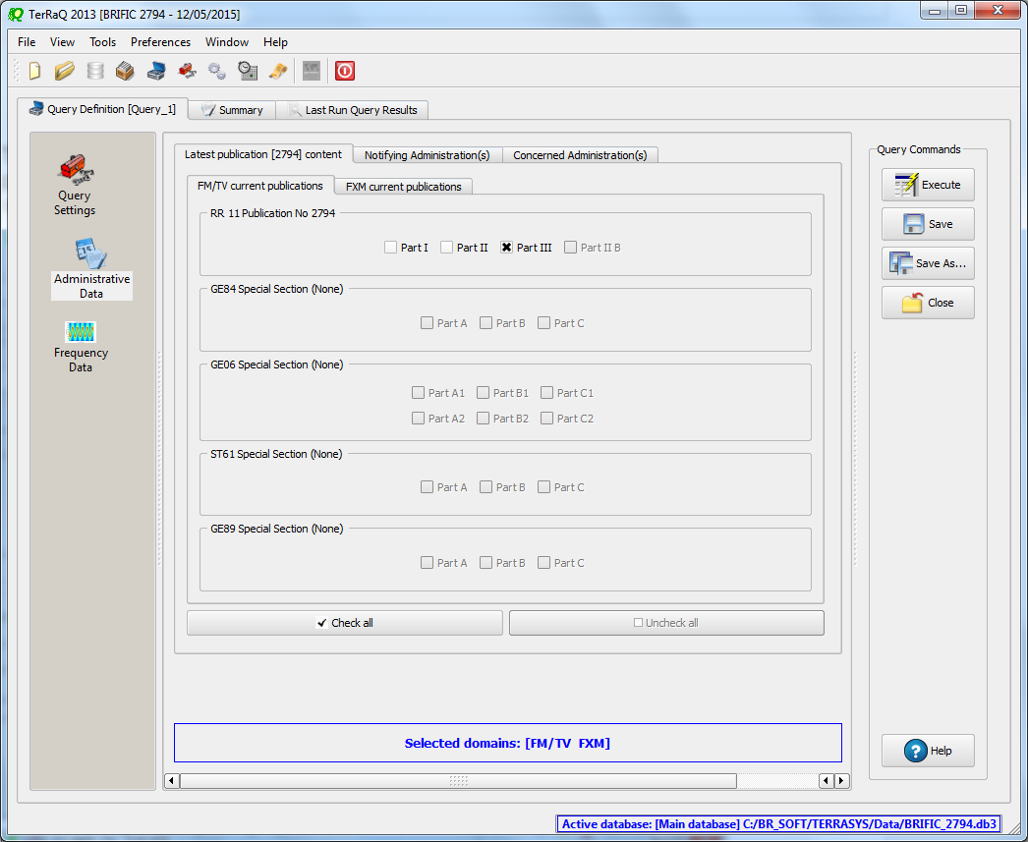

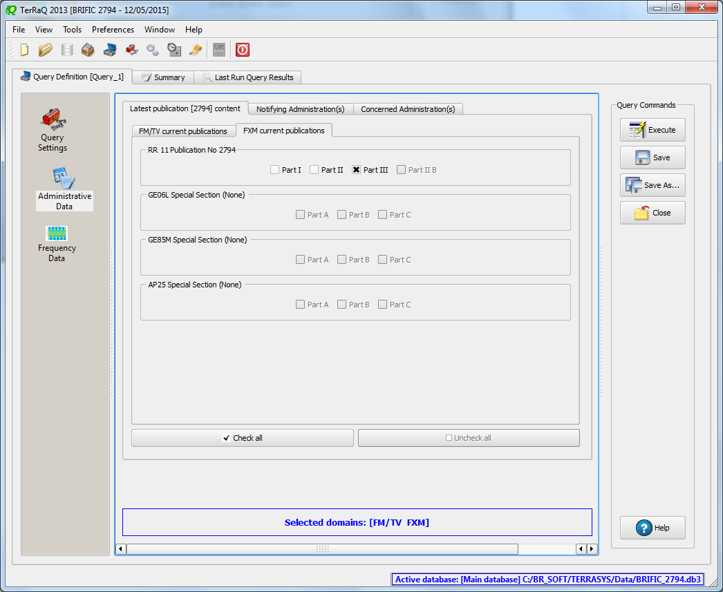

1. **Notification to the BR for registration in the Master Register during year 2014**

Retrieve all the assignments notified by your Administration, for registration in the **Master Register**, during 2014.

**Solution:** Create a new GPQ query through the menu item of File->New Query.

 

Select “All domains” as the target domain and make sure to select both check boxes in the “Target Containers”.

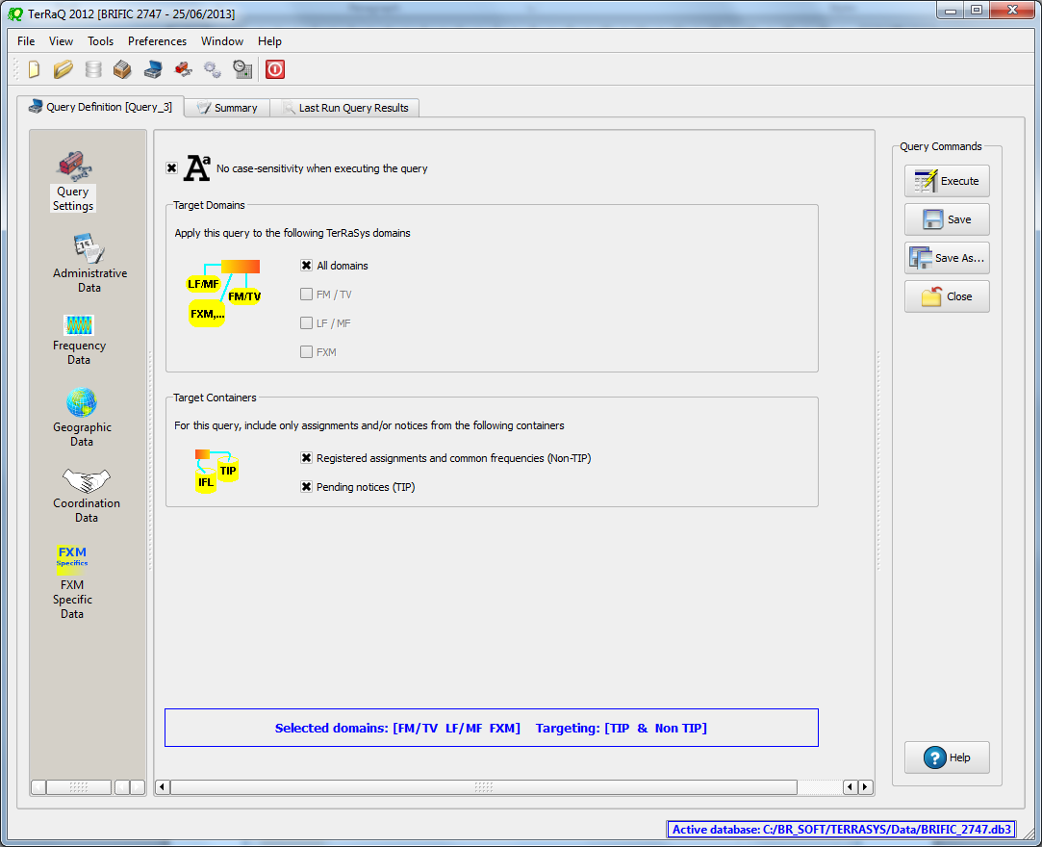

Then under “Administrative Data” and in the “Fragment(s)” page, select “RR 11 (NTFD_RR)”.

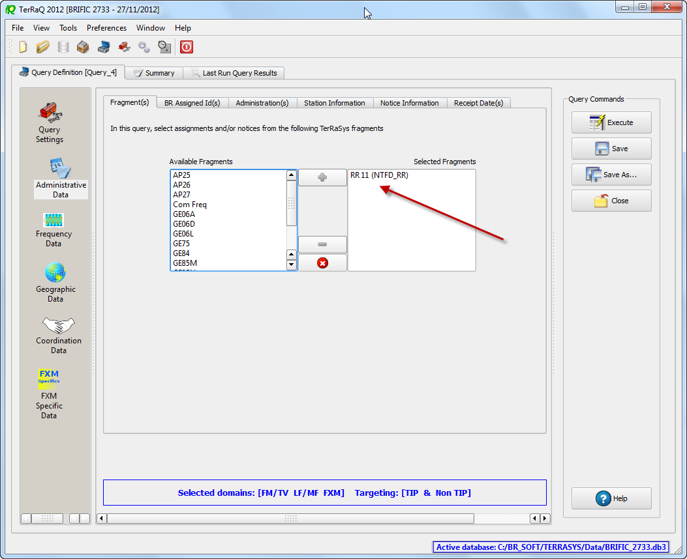

Then in “Administration(s)” page, select your Administration’s code.

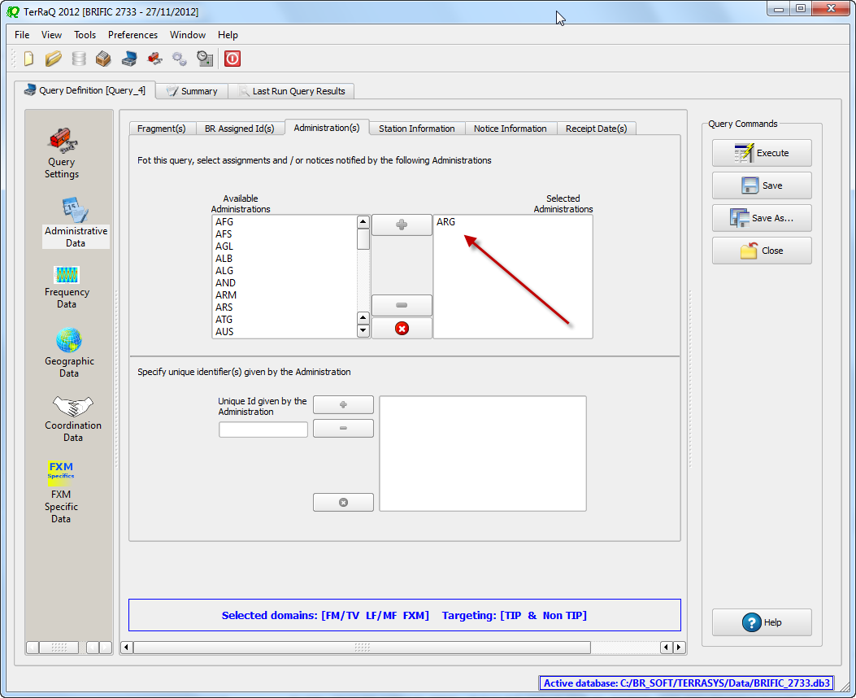

In the “Receipt Date(s)” page, select the check box of “Include only transactions received” then select “After” and enter 01/01/2014 as the date.

Execute the query.

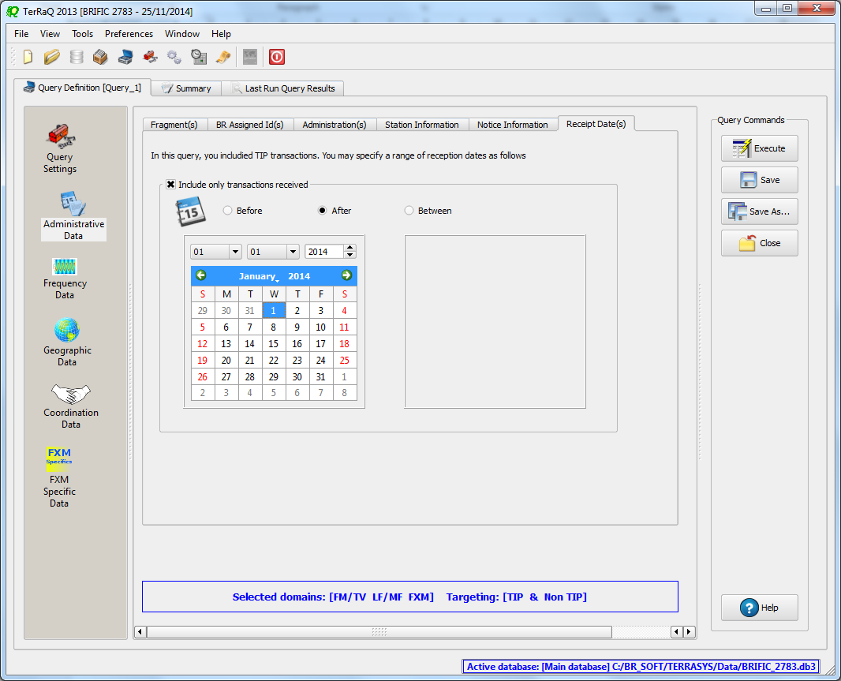

1. **BR IFIC history check**

Retrieve all BR IFICs published in 2013 containing notifications submitted by your Administration.

**Solution:** Click on the “Terrestrial BR IFIC History Browser” button on the toolbar.

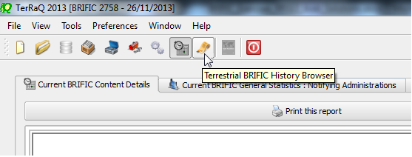

At the top of the screen select the date between 01/01/2013 and 29/12/2013 in the boxes below it and select your Administration as the notifying Administration. It should be noted that you need to click on the day in each date grid to get the date set

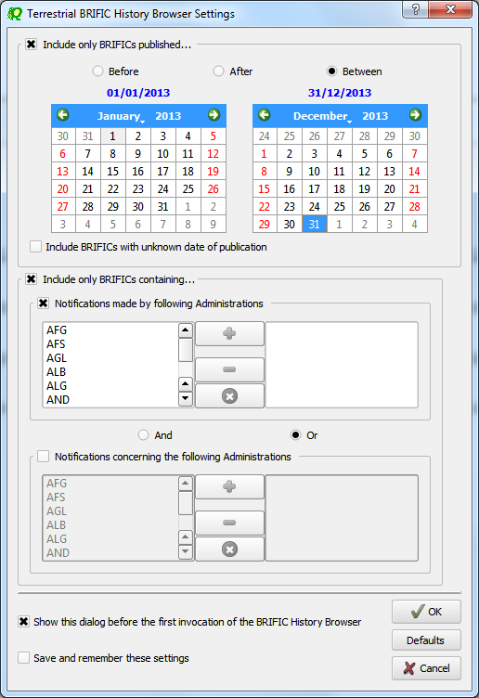

1. **Update Tables 12A/12B of the Preface to the BR IFIC**

Check Tables 12A/12B of the Preface to the BR IFIC (Address Codes and Operating Agencies)

Should there be any changes/suppressions, communicate them to the Bureau.

**Solution:** Open the Preface to the BR IFIC.

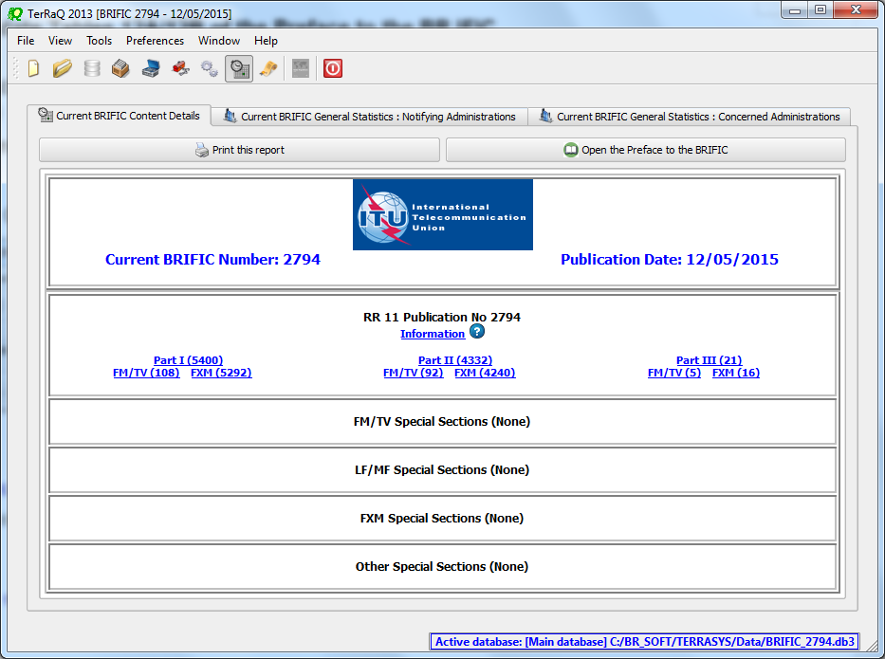

Go to Chapter IV, Section 3 “Address Codes and Operating Agencies” and check the entries under the name of your Administration.

