Monitoring Programme band 406-406.1 MHz (Resolution 205, COSPAS-SARSAT)
There are several Administrations participating in the monitoring programme organized by the Radiocommunication Bureau of the ITU in the band 406-406.1 MHz in application of Resolution 205(Rev.Mob-87). The objective of this programme is to identify and locate unauthorized emissions in the band 406-406.1 MHz that cause harmful interference to the reception of satellite EPIRB signals by the COSPAS-SARSAT system. These Administrations submit reports of their observations to the Radiocommunication Bureau regularly.
Upon receipt of the reports, the Radiocommunication Bureau requests the Administrations responsible for the area where the unauthorized transmitters are located to take immediate action with a view to stopping the emissions.
Through the web page of [Final address of the page] all of the information of those reports received from Administrations can be extracted and displayed as data records and graphical views.

How to retrieve the information?
There are different fields on the screen which combination of them will make the final criteria for information retrieval. Some of them are selective (e.g. Date of observation) and the others which are located in the orange box below, may be entered (e.g. Site ID). Any of the fields in that box may be filled or empty except the ones which are located in the blue box that should be dealt as a group. All of the geographical parameters should be filled or empty. In case some fields are missing or there are some inappropriate data entered/selected, warning messages may show up.
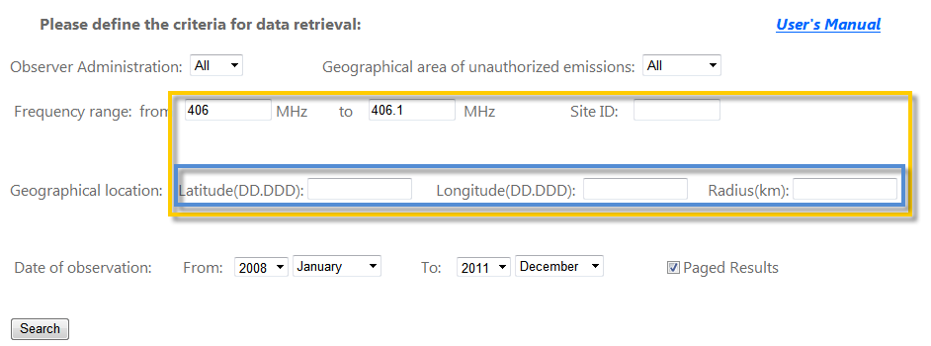
After completion of the creation of the criteria, by pressing Enter key or pushing the Search button, the data will be fetched from the database and displayed in the screen.

How the results are displayed?
If the criterion is defined successfully then the results will be displayed in three different views just under the Search button (See figure below). The description of each part will follow.
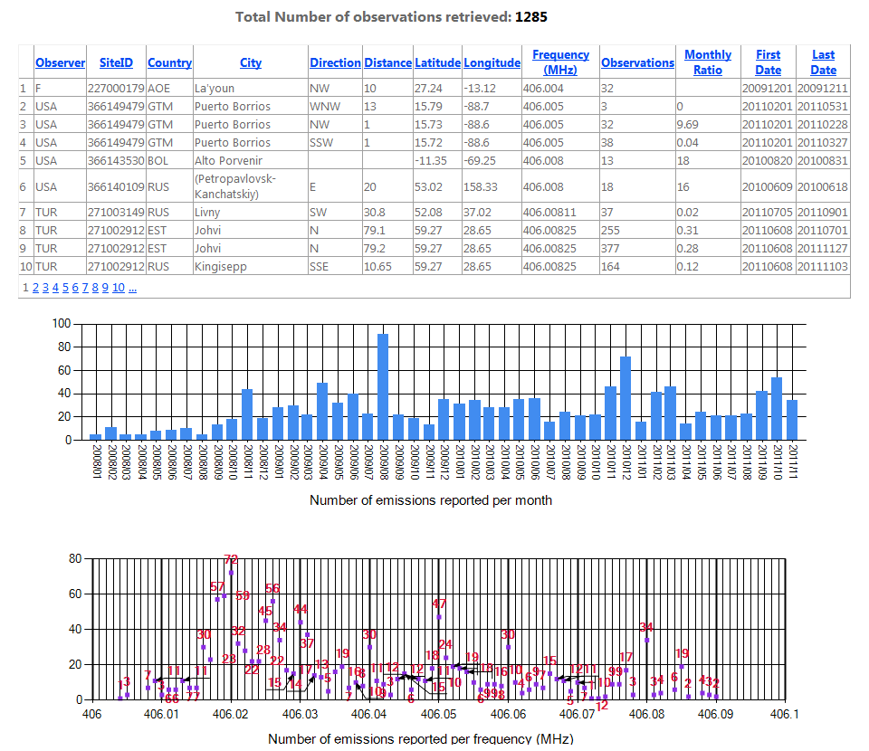

Some brief descriptions about the columns of the result data sheet may be found below:
Observer: The code of the Observer Administration which has detected and reported the emission.
SiteID: The Site ID of the transmitting station.
Country: The code of the Country which is the source of unauthorized emission.
City: The name of the nearest city in the source country of unauthorized emission.
Direction: Direction of receiving signals at the location of the monitoring station from nearest city of transmitter (N=North, NE=North-East, E=East, SE=South-East, S=South, SW=South-West, W=West, NW=North-West)
Distance: Distance between source of emission and the monitoring station in kilo meters.
Latitude: Mean latitude of the source of emission in decimal.
Longitude: Mean longitude of the source of emission in decimal.
Frequency (MHz): Mean detected frequency in MHz
Observations: Total number of observations recorded in the specified period of time.
Monthly Ratio: Monthly detection ratio
First Date: Starting date of observation for this period.
Last Date: End date of observation for this period.

