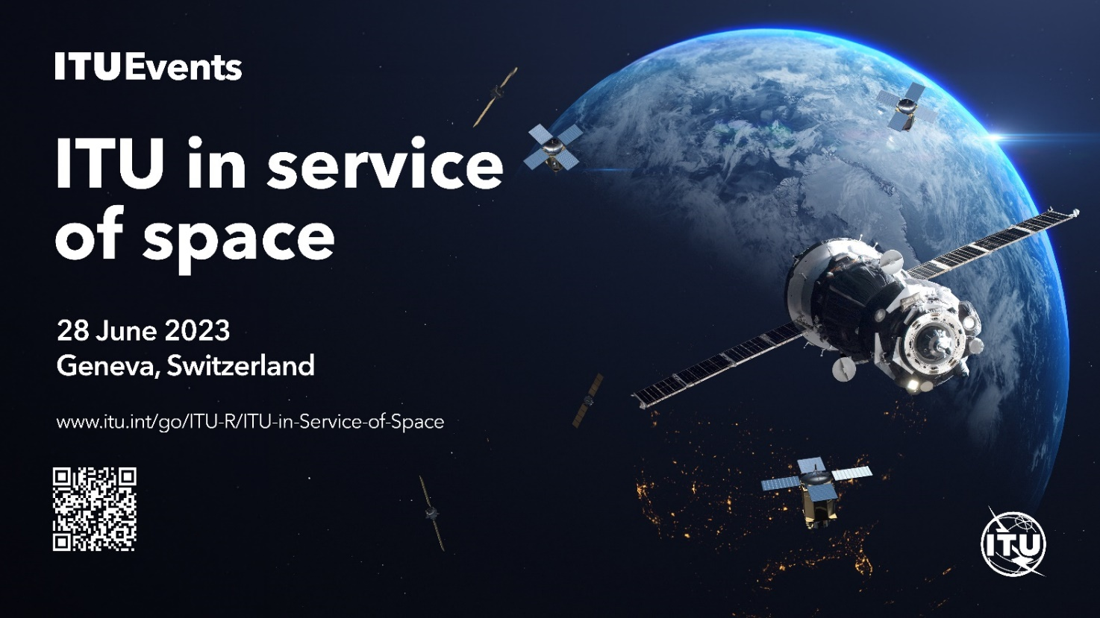
Workshop "ITU in Service of Space"
Geneva, Switzerland,

28 June 2023

Conclusions and proposals of the Workshop
ITU-R Study Group 4 organized a Workshop "ITU in Service of Space" on 28 June 2023, in Geneva, Switzerland.
The purpose of this Workshop was to identify the needs of the satellite industry in developing ITU rules/procedures for regulating the use of the frequency spectrum/satellite orbits, to ensure the development and implementation of new satellite technologies while guaranteeing the equitable access and rational use of GSO and non-GSO orbit/spectrum resources. It provided an opportunity to exchange national experience in regulating the use of the frequency spectrum/satellite orbits and to identify the needs of Administrations in developing recommendations for licensing global satellite systems at the national level. In addition, information on the existing difficulties in the processing of frequency assignment filings for multi-satellite systems was taken into account with the objective of identifying ways to improve the procedures of the Radiocommunication Bureau.
The Workshop was attended by 450 participants, representing 72 Administrations, 24 Recognized Operating Agencies, 17 Scientific or Industrial Organizations, 1 Financial or Development Institution, 3 Other Entities dealing with Telecommunication Matters, 4 Regional and other International Organizations, 2 Intergovernmental Organizations Operating Satellite Systems, 5 Associates, and the Radiocommunication Bureau (BR).
The Workshop consisted of four sessions:
1. Voice of the satellite industry on the improvement of international rules and regulations for the use of the radio frequency spectrum and satellite orbits.
2. National experience in regulating the use of the radio-frequency spectrum and satellite orbits and requests from administrations for recommendations on licensing the use of global services of satellite operators.
3. Activities of the Radiocommunication Bureau to comply with the provisions of the Radio Regulations when processing frequency assignments to satellite networks/systems.
4. Consideration of proposals for the development of rules and regulations for the use of radio frequency spectrum and satellite orbits that meet the requirements of the satellite industry.
During the Workshop, presentations were heard from Echostar, Telesat, SES, Intelsat, SpaceX, representatives of the Administrations of Brazil, UK, France, China and Ghana, representatives of the BR and international experts on the ITU-R activities, Chairman of ITU-R SG 4 and Chairmen of ITU-R Working Parties 4A, 4B and 4C.
• Workshop participants discussed the following issues of regulation of the radio frequency spectrum and satellite orbits:
• The key role of satellite communications in providing global connectivity;
• Sustainability of space activities, including primarily sustainability of access to limited orbital/frequency resources;
• Equitable access to the use of the radio frequency spectrum and satellite orbits;
• Compliance of the existing international rules for the regulation of the radio frequency spectrum and satellite orbits with the modern space industry and the pace of its development;
• Simplifying the preparatory cycle and documentation in preparation for the WRC;
• Ensuring compatibility and guaranteeing the protection of GSO networks and non-GSO systems, while ensuring the safe increase of non-GSO satellites;
• The need to develop coordination criteria and methods of coordination to ensure optimal use of frequency-orbit resource by non-GSO systems;
• Revision of Recommendation ITU-R S.1503 to provide more accurate modeling of modern non-GSO systems and account for cumulative interference from non-GSO systems operating in the shared frequency band;
• Concerns about the widespread use of provision RR No. 4.4 in the notification of frequency assignments for non-GSO satellite systems;
• Requirements and standards for radio interfaces of the satellite component of the 5G/6G ecosystem;
• Features of spectrum regulation at the national level;
• Unauthorized use on the national territory of terminals operating via satellites, including terminals in motion and operating via GSO/non-GSO satellites;
• Activities of the Radiocommunication Bureau in examining the filling of radio frequencies for satellite networks and systems operating in planned and non-planned frequency bands;
• Difficulties encountered in the implementation of national planned allocations (RR Appendices 30/30A and 30B);
• Activities of ITU-R Study Group 4 and its Working Parties;
• and so on…
The workshop participants noted:
1 The satellite industry is going through a phase of rapid growth, transformation and innovation. We are seeing a multitude of new satcom services being launched in different orbital altitudes, and whether it is GEOs, MEOs, LEOs, the trend is to provide more affordable, efficient, reliable and secure connectivity, to help achieve the meaningful connectivity goals.
2 The ecosystem is getting increasingly complex and is evolving at an unprecedented rapid pace. In order to promote investment and foster innovation, it is important to strike the right balance between this rapid evolution and having regulatory frameworks that guarantee access to essential spectrum for all satellite players, in a way that is non-discriminatory and that provides an efficient policy environment in which multiple satellite systems can operate in a sustainable environment. Both non-GSO & GSO are subject to innovation, and the ITU regulations should navigate between regulatory certainty and flexibility, without hindering or limiting technological advances by imposing artificial constraints on them.
3 The Administrations and Sector Members need to strengthen the ITU-R to address these new issues and build the framework and global solutions needed.
4 Space sustainability is an overarching issue that covers many different aspects, from physical access to space, space traffic management, collision avoidance and debris management to the actual use of scarce resources such as radio spectrum and orbits. Best practices for sustainability need to consider the design, pre-launch, launch, early orbit, orbit, operation and satellite disposal phases. The ITU has a specific role to ensure equitable access to these resources, and their efficient use.
5 The topic of space sustainability is broad and being considered at various international fora, including those within the UN system. Still, ITU could take part, or even lead, an inter-agency coordination group so that a comprehensive approach to the topic of space sustainability is ensured.
6 Satellite communications must have access to sufficient, harmonized spectrum in low-, mid- and high- frequency bands. It is critical that spectrum continues to be made available on an internationally harmonized basis. It is viable to progress the ITU regulatory framework to ensure that all needs are covered, without drastic modification that would put at risk the satellite systems in operation or under construction and future investment, without a detrimental impact on the people using all the services now offered by GSO and non-GSO satellites.
7 In dealing with new technologies and applications, including satellite direct to handset, satellite IoT, inter-satellite links (WRC-23 AI 1.17), administrations require regulatory framework and guidance for licensing from the ITU. For administrations, national and regional regulation is complementary to international regulation. At that, stimulus and competition when creating new systems was required without harming national networks and other services, such as radio astronomy which must be protected.
8 Key role of administrations in sharing knowledge with their national operators was also stated as well as a need to assist national operators in building their initial filings in order to avoid their generic descriptions. A number of ITU guidelines were named as helpful in this respect, including Circular Letter CR/420 and Recommendations ITU-R SA.2155-0 and ITU-R SA.2156-0. At that, a timely update of the ITU satellite regulatory framework handbooks was required to keep up with the innovation and technological developments. ITU was also expected to continue assisting administrations of developing countries on issues related to the handling of the BR correspondence and the consequences of missing correspondence or not responding in a timely manner in terms of losing protection of their orbit/frequency resources. A lack, within ITU, of monitoring and interference resolving mechanism for satellite services was also mentioned.
9 The issue of equitable access to orbit/frequency resources and the need to ensure fair and safe use of spectrum in sovereign countries were named among those areas which needed a real action from ITU, though there was no immediately suggested solution and the issue was supposed to be elaborated on by the ITU-R, and SG 4 in particular. The “first come first served” approach was named as inadequate for developing countries who had less developed capacities in space programmers and would like to see a portion of radio-frequency spectrum in LEO to be guaranteed for their future projects on a plan-like basis.
10 The topic of the notifying administration was identified among those causing concern. This includes cases where operators are using multiple filings from different administrations for the same system which makes it unclear which administration is responsible in case of interference. There is also a risk of circumventing national legislations (“forum shopping”). Support to the BR’s proposal to modify RR No. 19.1.1 was shown to ensure that “all transmissions shall be capable of being identified”, without exception for space systems (§ 3.1.7 of the draft report of the BR Director to WRC-23). A strict enforcement of the “one transmission – one flag” principle was suggested. Operators using multiple filings from different administrations are requested to clarify under which administration they operate for each transmission (a pair of space station/frequency).
11 The need for a better understanding of non-GSO interference mitigation capabilities and accurate calculation of non-GSO interference potential, including with modifications to non-GSO systems taken into account, were specifically mentioned. Improved rules on non-GSO would also include those related to orbital tolerances (WRC-23 AI 7A), post-milestone reporting (WRC-23 AI 7B), aggregate interference to GSO (WRC-23 AI 7J), Recommendation ITU-R S.1503.
12 WRC-23 and following Conferences need to continue to give high priority to the matter of equitable access to satellite orbits, taking into account the special needs of developing countries and the geographical situation of particular countries.
13 In order to ensure continuous ubiquitous coverage by satellite systems, it is necessary to harmonize the global satellite spectrum.
14 The active deployment of modern non-GSO constellations requires the study of new methods for modeling non-GSO systems.
15 Results of this Workshop can be used by administrations and regional organizations in their professional activities, in particular in preparation for RA-23 and WRC-23.
Conclusions, proposals and suggestions based on the results of the Workshop
NOTE. The views, ideas, proposal and suggestions presented by some Workshop participants are not representative of all administrations and the entire satellite industry. The bullets below may be further discussed at RA-23 and WRC-23.
1 The RA may discuss and approve a new Resolution, to instruct SG 4, with the assistance of SG 7, to develop recommendations and/or reports to deal with the rational and compatible use of radio−frequency spectrum and associated orbit resources in non-GSO orbits with a long−term sustainability vision;
2 The ITU-R, based on inputs from the Administrations, Sector Members, relevant Associates and Academia, needs:
• to establish mechanisms to improve access to space for all and ensure that all countries can benefit socio−economically from space science and technology applications and space−based data, information and products, thereby supporting the achievement of the Sustainable Development Goals (SDGs).
• to establish incentives and competition by creating new systems without harming national networks;
• to evaluate and consider to create an environment with many international bodies which deal with the Space Sustainability issue, such as UNOOSA (United Nations Office for Outer Space Affairs), COPUOS (Committee on the Peaceful Uses of Outer Space), IADC (Inter-Agency Space Debris Coordination Committee), IAA (International Academy of Astronautics), IAU (International Astronomical Union, national space agencies as Roscosmos, NASA, AEB, CNSA, ISRO, etc.
3 Study a new regulatory regime, that goes beyond compliance with epfd limits and an examination based on the methodology included in Recommendation ITU-R S.1503, with which GSO networks and non-GSO systems should comply and could co-exist, taking into account their modern features in a harmful interference-free environment;
4. Ensure that already deployed and/or planned GSO networks will still be adequately protected in any such new regime;
5 GSO protection is vital (Single Entry limits are important, but what really defines the GSO protection is the aggregate interference, we should put efforts into that and on Recommendation ITU-R S.1503). Go beyond the modelling of an envelope of non-GSO systems – if real non-GSO operations and characteristics are not taken into account, the ITU will risk that its regulations will drive the design of future systems, while it should be the other way around;
6 ITU should go in the direction of maximizing the flexibility in the use of the allocations (Examples of this are: WRC-23 AIs 1.15 and 1.16 addressing ESIMs in the FSS, 1.17 addressing ISL in the FSS, 1.19 addressing FSS in an existing BSS allocation, AI 7 on regulatory improvements. It will result in a more efficient and more effective use of the spectrum);
7 A proper balance needs to be found between maintaining the planned allocations of bands and maximizing the use of those bands (otherwise, other larger industries hungry for spectrum will follow);
8 Within the ITU process, an expanded coordination and cooperation between countries was expected in order to establish procedures and regulations that allow for a more uniform treatment in terms of rights and obligations. A need for a regional and sub-regional approach to settling regulatory matters was also mentioned among the important issues, which would be increasingly helpful in dealing with matters of cross-boundary character;
9 A guidance was requested on how to cope with the increased use of RR No. 4.4 for satellite communication networks not subject to coordination, including a clarification on whether RR No. 4.4 should be only available to non-commercial systems. It is necessary to clarify that the use by administrations of the provision RR No. 4.4 is not the RIGHT of the administration, but an EXCEPTION FROM THE RULES, e.g. used on a temporary basis due to circumstances;
10 Reducing the time between World Radiocommunication Conferences and holding Conferences on specific urgent issues;
11 Creation of a voluntary group of experts to develop proposals to simplify the procedures for coordination and notification of frequency assignments to satellite systems/networks, taking into account the different purposes and complexity of the systems/networks being notified;
12 Adoption by the Radiocommunication Assembly (Resolution ITU-R 2) of a decision to simplify the preparatory cycle and documentation in preparation for the WRC, taking into account the need to maintain the CPM in the current format, including the possibility of deleting CPM-2;
13 There is a need for stricter regulation of the use of low-orbit constellations precisely from the point of view of the challenges of near-Earth space debris and the establishment of stricter rules in the ITU when submitting a filing for non-GSO systems to the BR;
14 Need for possible actions at WRC-23 and for urgent studies on compatibility and conditions for reuse of frequency bands allocated to the mobile service by non-GSO satellite systems;
15 Development of requirements and standards for radio interfaces of the satellite component of the 5G/6G ecosystem based on studies conducted within the framework of WP 4B;
16 Modernize the technical parameters of the FSS Plan in RR Appendix 30B to be comparable to those of additional systems taking into account two important features: Mobility and Broadband Internet Access;
17 To improve the usability of the Plan capacity a new procedure may be established to allow administrations to use their capacity in the Plan and acquire additional capacity, i.e. up to 40 channels in Region 1 and up to 24 channels in Region 3 when a group of named administrations wishes to build a sub-regional system;
18 To study decisions of RRB relating to Resolution 559 (WRC-19) and Article 7 of RR Appendix 30B, once endorsed by WRC-23, in ITU-R WP 4A to identify measures for solving frequency coordination and for reaching agreement under RR No. 23.13 or § 6.6 of Article 6 of RR Appendix 30B that might be incorporated in the Radio Regulations or elements for ITU-R Recommendations;
19 To strictly enforce the “one transmission = one flag” principle. The Radio Regulations is an international treaty which governs the rights and obligations of administrations with respect to each other.
The participants noted the importance and practical significance of discussing the topical issues discussed during the Workshop and expressed their sincere gratitude to the moderators and speakers, the BR Director and ITU-R staff, SG 4 Management and sponsors for the excellent organization, preparation and holding of the first Workshop “ITU in the service of space”.
___________________

