Radiocommunication Study Groups | 
Received: Source: Documents 3L/31(Annex 13), 3L/TEMP/14, 3L/25, 3M/78
Subject: MATLAB code for processing
white Gaussian noise recordings
 | 5 July 2024
 | English only
MATLAB CODE FOR PROCESSING WHITE GAUSSIAN NOISE MEASUREMENTS

1 Summary
This document provides the computer code developed by Ofcom for the processing of radio noise measurements suitable for characterising the white Gaussian noise (WGN) component of man-made noise (MMN), and serves as a user manual for its operation.
The manual describes the WGN data processing methodology (§ 2) and how this has been implemented in the computer code. It explains the structure, inputs, outputs and data format requirements. The code returns a csv file containing the external noise above thermal noise floor (F_{a}) values in the format compatible with the ITU-R Study Group 3 radio noise databank. Each entry in the csv file corresponds to the F_{a} value for a given frequency and timestamp.
In addition, a MATLAB application is also provided with a graphical user interface for running the WGN processing computer code. Please note, this computer code has been developed and tested using the MATLAB, version R2023b.
Disclaimer
• Ofcom’s WGN computer code has been created solely for the purpose of processing radio noise measurement data. In particular, Ofcom’s WGN computer code is designed to apply various corrections to the raw measurements and establish the percentage of the samples to retain that will be representative of the WGN component of man-made radio noise.
• No representation or warranty is given as to the accuracy, completeness or correctness of Ofcom’s WGN computer code and it is provided 'as is'. It is provided without any representation or endorsement made and without warranty of any kind, whether express or implied, including but not limited to the implied warranties of satisfactory quality, fitness for a particular purpose, non-infringement, compatibility, security and accuracy.
• Ofcom does not accept any responsibility for any loss, disruption or damage to your data or your computer system which may occur whilst using Ofcom’s WGN computer code or material derived from Ofcom’s WGN computer code. Ofcom does not warrant that the functions contained in Ofcom’s model will be uninterrupted or error free. Also, Ofcom does not warrant that defects will be corrected, or that Ofcom’s WGN computer code provided is free of viruses.
• In no event will Ofcom be liable for any loss or damage including, without limitation, indirect or consequential loss or damage, or any loss or damages whatsoever arising from use or loss of use of, data or profits arising out of or in connection with the use or otherwise of Ofcom’s WGN computer code. By downloading/using Ofcom’s code, you agree to the above.

2 Methodology for WGN component of MMN based on r.m.s measurements
The WGN component of MMN can be represented by a continuous noise signal exhibiting a flat power spectral density.
The methodology explained in this section requires root mean squared (r.m.s.) power level measurements on a given frequency to quantify WGN component. The recommended practice is to undertake measurements for extended periods of at least few hours in “free” or “predominantly free” bands across several channels in a given frequency band, if possible; with each channel having a resolution bandwidth of less than 200 kHz. This approach helps in the post processing of data to identify and eliminate non-WGN components (e.g., single carrier noise) of MMN, including occupancies by radio services which varies in time and frequency, especially if the measurements are made in partially occupied frequency bands. For measurements undertaken over multiple smaller channels, it is not mandatory to follow this approach.
The requirements for the implementation of WGN methodology include:
1. Radio noise measurements: r.m.s. measurements by using r.m.s./average detector method or post processed r.m.s. levels from raw sampling.
2. Terminated measurements: r.m.s. measurements by using r.m.s./average detector method or post processed r.m.s. levels from raw sampling and replacing the receiving antenna of the monitoring system with a 50-ohms load.
3. Monitoring system gain: The overall gain/loss of the system excluding the antenna factor.
4. Monitoring system noise figure: Overall Noise figure of the monitoring system.
5. Antenna factor: Average antenna factor of the monitoring system antenna over the frequency range of interest.
Table 1 lists the step-by-step procedure to quantify the WGN levels from r.m.s. measurements with the details of each step are provided in the following subsections.
TABLE 1
Data processing steps to quantify WGN levels
Step 1 | Correction applied to raw r.m.s. measurements to compensate for system gain
Step 2 | Correction applied to Step 1 output to compensate for equipment noise  (as per Rec. ITU-R SM.1753-2 § 10.2)
Step 3 | Establish external noise “F_{a}” in “free” spectrum from Step 2 data
Step 4 | Establish external noise “F_{a}” in “partially occupied” spectrum  (as per Rec. ITU-R SM.1753-2 Attachment 2) from Step 3 data

Notations: Bold uppercase and lowercase letters denote matrices and column vectors, respectively; values in linear units are represented using lowercase letters and the uppercase letters are used for the values in decibels (dB); the entry corresponding to the $m$th row and $n$th column of a matrix $A$ is represented by $A_{m,n}$; the superscript ${\left(⋅\right)}^{T}$ is used to represent vector/matrix transpose operation; the $m×n$ matrix of all ones is represented by $1_{m×n}$.
Step 1: Correction for system gain
This correction is required to compensate for the overall system gains and losses. However, the antenna factor is not considered at this stage. The overall gain of the monitoring system is mainly influenced by the LNA gain (if used), and a correction factor must be applied to both the terminated and actual measurements.
Assume that measurements are taken over $n_{c}$ different frequency channels, over $n_{t}$ different time instances or timestamps with the resolution bandwidth of $b_{r}$in $Hz$. The r.m.s. measurement matrix in $dBm$ can be expressed as:
$$\begin{aligned}P^{\left(m\right)}=\left[\begin{matrix}P_{1,1}^{\left(m\right)} & ⋯ & P_{1,n_{c}}^{\left(m\right)} \\ ⋮ & ⋱ & ⋮ \\ P_{n_{t},1}^{\left(m\right)} & ⋯ & P_{n_{t},n_{c}}^{\left(m\right)}\end{matrix}\right]\#\left(1\right)\end{aligned}$$
where $P_{j,i}^{\left(m\right)}$ is the r.m.s. levels measured at time instant $j$ on the $i$th frequency channel in $dBm/Hz$.
Note: $dBm/Hz$ values are calculated from the antenna voltage levels in $dBμV$ using the equation:
$$\begin{aligned}{\left.P_{j,i}^{\left(m\right)}\right|}_{\frac{dBm}{Hz}}={\left.P_{j,i}^{\left(m\right)}\right|}_{dBμV}-107-10\log_{10}{b_{r} }\#\left(2\right)\end{aligned}$$
Similarly, let $P^{(t)}$ be the $n_{t}×n_{c}$matrix of terminated measurements in $dBm/Hz$. For practicality, terminated measurements may be carried out for shorter duration than the actual measurements and $P^{(t)}$ will have far fewer rows than $P^{(m)}$.
The measured and terminated r.m.s. levels corrected for the system gain in $dBm$/$Hz$is given by:
$$\begin{aligned}P^{\left(mc\right)}=P^{\left(m\right)}-G\#\left(3\right)\end{aligned}$$
$$\begin{aligned}P^{\left(tc\right)}=P^{\left(t\right)}-G\#\left(4\right)\end{aligned}$$
where $P^{\left(mc\right)}$ and $P^{\left(tc\right)}$ represent the measured and terminated matrices corrected for system gain. $G$ is the $n_{t}×n_{c}$ matrix of system gains in dB is given by:
$$\begin{aligned}G=\left[\begin{matrix}G_{1} & ⋯ & G_{n_{c}} \\ ⋮ & ⋱ & ⋮ \\ G_{1} & ⋯ & G_{n_{c}}\end{matrix}\right] \#\left(5\right)\end{aligned}$$
where $G_{i}$ is the gain of the system at the $i$th frequency channel and can be established as:
$$\begin{aligned}G_{i}= \sum_{k=1}^{K}{{\tilde{G}}_{k,i}}\#\left(6\right)\end{aligned}$$
where ${\tilde{G}}_{k,i}$ is the gain of the $k$th component in the receiver chain on the $i$th frequency channel and $K$ is the total number of components in the receiver chain.
Step 2: Correction for system noise
System noise or the noise figure of the monitoring system dictates its sensitivity, i.e. its ability to quantify the WGN levels above the thermal noise. The noise factor$n_{f_{i}}$ of the monitoring system on the $i$th frequency channel can be established by using the cascaded equation:
$$\begin{aligned}n_{f_{i}}={\tilde{n}}_{1,i}+\sum_{k=2}^{K}{\frac{{\tilde{n}}_{k,i}-1}{\prod_{j=1}^{i-1}{{\tilde{g}}_{j,i}}}}\#\left(7\right)\end{aligned}$$
where ${\tilde{n}}_{k,i}$ and ${\tilde{g}}_{k,i}$ are the noise factor and gain of the $k$^{th} component of the receiver chain of the monitoring system in linear units on the $i$th channel, respectively.
In cases, where measured r.m.s. levels, $P_{j,i}^{\left(mc\right)}$, are only a few dBs higher than the terminated r.m.s. levels $P_{j,i}^{\left(tc\right)}$, a further correction is applied as recommended in § 10.2 of Recommendation ITU-R SM.1753-2.
First, the measured values $P_{j,i}^{\left(mc\right)}$ are compared with the column average values of $P_{j,i}^{\left(tc\right)}$ (the average of the entries over the multiple $n_{t}$ time instances for each frequency channel $n_{c}$). The averaged entries ${\overline{p}}_{i}^{\left(tc\right)}$are computed in linear unit as:
$$\begin{aligned}{\overline{p}}_{i}^{\left(tc\right)}=\frac{1}{n_{t}}\sum_{k=1}^{n_{t}}{p_{k,i}^{\left(tc\right)}}, {\overline{P}}_{i}^{\left(tc\right)}=10\log_{10}{{\overline{p}}_{i}^{\left(tc\right)}}. \#\left(8\right)\end{aligned}$$
Then, the correction is applied if the difference between $P_{j,i}^{(mc)}$ and ${\overline{P}}_{i}^{\left(tc\right)}$of the$i$^{th} frequency channel is less than $X_{i} dB$. In essence, the correction requires the noise factor of the monitoring system to be linearly subtracted from measured r.m.s. levels as:
$$\begin{aligned}P_{j,i}^{\left(mcx\right)}=\left\{\begin{aligned}P_{j,i}^{\left(mc\right)} if P_{j,i}^{\left(mc\right)}- {\overline{P}}_{i}^{\left(tc\right)}≥X_{i}, \\ 10\log_{10}\left(p_{j,i}^{\left(mc\right)}-\left(\frac{\left(n_{f_{i}}-1\right)}{n_{f_{i}}}\right){\overline{p}}_{i}^{\left(tc\right)}\right) otherwise. \end{aligned}\right.\#\left(9\right)\end{aligned}$$
The coefficient $X_{i}$ can be calculated as:
$$\begin{aligned}X_{i}\left(dB\right)=10\log_{10}\left(\frac{11\left(n_{f_{i}}-1\right)}{n_{f_{i}}}\right)\#\left(10\right)\end{aligned}$$
Step 3: Establishing external noise “F_{a}” in “free” spectrum
The matrix of $F_{a}$ values (external noise above thermal noise in dB) is calculated using equation 10 in Recommendation ITU-R SM.1753-2 as:
$$\begin{aligned}F_{a}=P^{\left(mcx\right)}+B^{\left(1\right)}\#\left(11\right)\end{aligned}$$
where the element in row $j$and column $i$ of the $n_{t}×n_{c}$ matrix $B^{\left(1\right)}$ is:
$$\begin{aligned}B_{j,i}^{\left(1\right)}=α_{i}-20\log_{10}\left(f_{i}\right)+203.8, ∀j\#\left(12\right)\end{aligned}$$
and $α_{i}$ is the average antenna factor at frequency $f_{i}$, in MHz, and assuming an isotropic reference antenna.
Note: All r.m.s. samples are converted to $F_{a}$values and further statistics such as the median hourly, daily and standard deviations can be generated for each frequency channel or for the combined frequency range. However, the statistics will only be representative of WGN component of MMN if the measurements were undertaken on a free or predominantly free frequency or a range of frequencies in a given environment. It is important to undertake additional checks to ensure there are no emission of radio transmitters in the frequency bands considered for measurements. The adjacent channel selectivity of the monitoring system should also be considered to understand the impact of occupancies in bands adjacent to measurement frequencies.
Step 4: Establishing external noise “$F_{a}$” in “partially used” spectrum
Finding free spectrum for radio noise measurements in real world environments is a challenge and it may not be valid to assume the measurement frequency (or range) considered is completely “free” for the whole measurement period in both time and frequency domains. Hence, it is important to remove those samples in $F_{a}$ matrix of step 3 that may not be representative of WGN component of MMN.
It is recommended to remove at least $d_{s}$ $\%$ of the largest magnitude samples from $F_{a}$ matrix for measurements undertaken in partially occupied bands. An appropriate value of $d_{s}$ can be in range of 10-20 % for most of the bands above 400 MHz. It should be noted that largest magnitude samples removal will also eliminate the single carrier noise (SCN). Hence, the WGN data processing methodology is not suitable for characterising the SCN components of radio noise.
Attachment 2 to Recommendation ITU-R SM.1753-2 provides a method for establishing the percentage of $F_{a}$samples that should be kept (i.e. 100-$d_{s}$). This method makes a valid assumption that measurements undertaken in partially occupied frequencies will contain both WGN and non-WGN samples and the resulting sample distribution may not be Gaussian. By removing the non-WGN samples, the mean and median of remaining samples in $F_{a}$ should be the same noting the symmetric properties of the probability density function of the Gaussian distribution.
One drawback of this simple approach is that in some scenarios (e.g. presence of a dominant single noise source) discarding the largest magnitude samples from $F_{a}$ matrix may also remove some WGN samples. Hence, a further correction is applied to the retained samples in $F_{a}$. To calculate this correction factor, the terminated samples $P^{(tc)}$ are used as these generally exhibit a Gaussian distribution.
The methodology implements the overall approach to WGN samples retention and correction by first establishing the difference between the mean and the median of each percentile of all samples in $F_{a}$ and selecting the maximum percentile to retain when the difference between the mean and median is at most 0.15 dB. Alternatively, one may set the lower bound $d_{l}$ on the percentage of data to discard. The percentage of largest magnitude samples discarded from $F_{a}$ in the processing is:
$$\begin{aligned}d=\max\left(d_{s},d_{l}\right) \#\left(13\right)\end{aligned}$$
Then the correction factor is established given that $d\%$ of the largest magnitude samples are discarded, calculate the mean $μ_{t_{1}}$of all the terminated samples in $P^{(tc)}$, and the mean $μ_{t_{2}}$ using the samples in $P^{(tc)}$excluding the highest $d\%$ entries. The correction to apply is the difference of both means i.e. $\left(μ_{t_{1}}-μ_{t_{2}}\right)$.
Let the matrix of measurement samples with the $d\%$ largest magnitude entries removed/blanked be $P_{d}^{(mcx)}$. The corrected $F_{a}$ values are then calculated as:
$$\begin{aligned}F_{a, c}=P_{d}^{\left(mcx\right)}+B^{\left(2\right)}\#\left(14\right)\end{aligned}$$
where the element in row $j$and column $i$ of the $n_{t}×n_{f}$ matrix $B^{\left(2\right)}$ is:
$$\begin{aligned}B_{j,i}^{\left(2\right)}={\left(μ_{t_{1}}-μ_{t_{2}}\right)+α}_{i}-20\log_{10}\left(f_{i}\right)+203.8, ∀j\#\left(15\right)\end{aligned}$$

3 Installation of the code
The zip file “Ofcom_WGN_processing_SourceCode.zip” contains all the files required to run Ofcom’s WGN computer code in MATLAB. Extract these files to a location which MATLAB can access.
Please note that Ofcom’s WGN computer code has only been tested on machines (and virtual machines) running Windows 10 and Windows 11 and MATLAB R2023b. It is advised that the computer code should only be used on machines (or virtual machines) running these operating systems and software version.
The Matlab code requires the following input files:
– A csv file containing the r.m.s. measurements data in $dBμV$;
– A csv file containing the terminated r.m.s. measurements in $dBμV$.

4 Code overview
The code for the processing WGN measurements is written in MATLAB version R2023b. A description of the functions is provided in Table 2.
TABLE 2
List of functions for processing WGN
Function name | Description
analyse_WGN_recordings  example of function call:  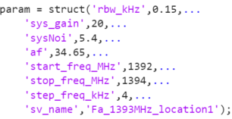  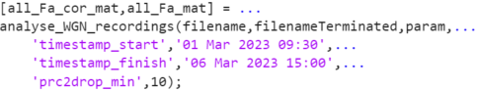 | The main function for processing measurement data  Inputs:  - filename: Path of measurement file  - filenameTerminated: Path of terminated measurement file – measurements with the antenna replaced by a 50-ohms load  - param: A structured array containing the system and configuration parameters (refer to TABLE 3)  - Receiver parameters, e.g., noise figure, system gains and antenna factor,  - Name of file in which Fa values will be stored.  - Optional inputs:  - ‘timestamp_start’ and ‘timestamp_finish’: timestamps of measurements to consider for processing  - ‘prc2drop_min’: the minimum percentage of samples to discard for WGN processing, where the samples discarded are the largest magnitude entries.  Output:  - First output array (e.g, all_Fa_cor_mat): Array containing F_{a} values that have been corrected as described in Step 4 of the methodology.  - Second output array (e.g., all_Fa_mat): Array containing F_{a} values. This is the output from Step 3  - A .csv file containing the processed F_{a} values, saved under the filename specified in the parameter param.sv_name. The entries in the csv file include the values in all_Fa_cor_mat followed by those in all_Fa_mat.
correct_WGN_for_system_noise | Function called from the main functions to correct for the system noise
load_recordings | Function called from the main function to load the measurement files in .csv format.
In the code package, we have also provided a MATLAB app WGN_processing.mlappinstall, which can be used to call the main function and process the measurement data.
To launch the app, open the file WGN_processing.mlappinstall and select ‘Install’.
FIGURE 1
Prompt to install WGN processing app in MATLAB
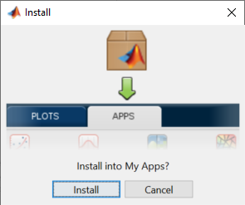
FIGURE 2
Location on installed Matlab app
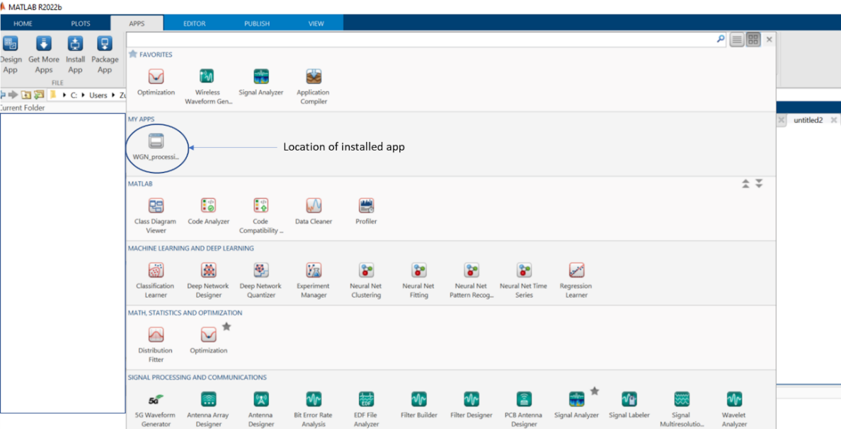

5 Running the code
The function analyse_WGN_recordings is called for processing the measurement data and generate the required F_{a} values. The system and measurement parameters required to process the measurement data are passed to the functions as a structured array with the fields listed in Table 3.
TABLE 3
Variables in structured array param
Fields in structured array | Description
rbw_kHz | Resolution bandwidth in kHz
sys_gain | Gain of the receiver system in dB
sysNoi | System noise of receiver system
af | The antenna factor
start_freq_MHz | Start frequency of measurements in MHz
stop_freq_MHz | End frequency of measurements in MHz
step_freq_kHz | Steps taken between start and end measurement frequencies in kHz
sv_name | Name of file to save the WGN statistics

An example of the function call is given in Figure 3 below.
FIGURE 3
Snippet of code to call main function
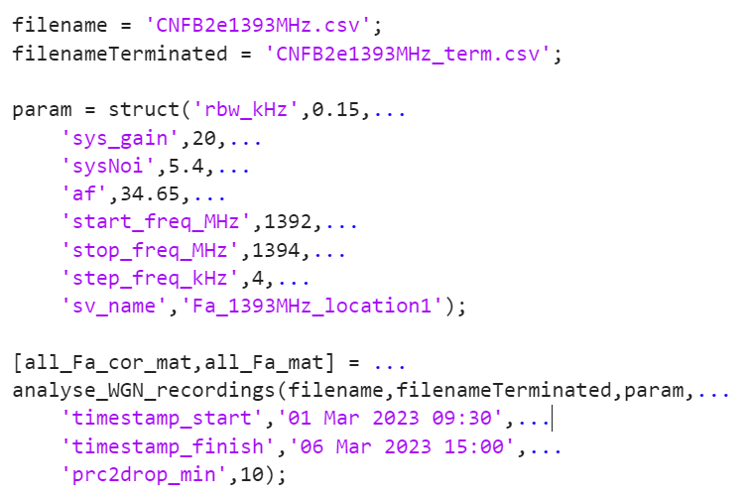
In case a subset of the measurement data needs to be processed, timestamps of the desired measurements can be provided to analyse_WGN_recordings. An example is as follows:
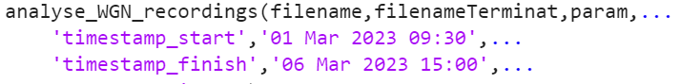
The code also allows the option of specifying the minimum percentage of samples to discard, using the optional input argument 'prc2drop_min'. If this parameter is specified, the actual percentage of samples dropped is the largest of the percentage calculated in Step 4 or the value of 'prc2drop_min'.
Alternatively, the Matlab app can be used to set the input values and generate the results. A screenshot of the app is shown in Figure 4.
FIGURE 4
Screenshot of Matlab app
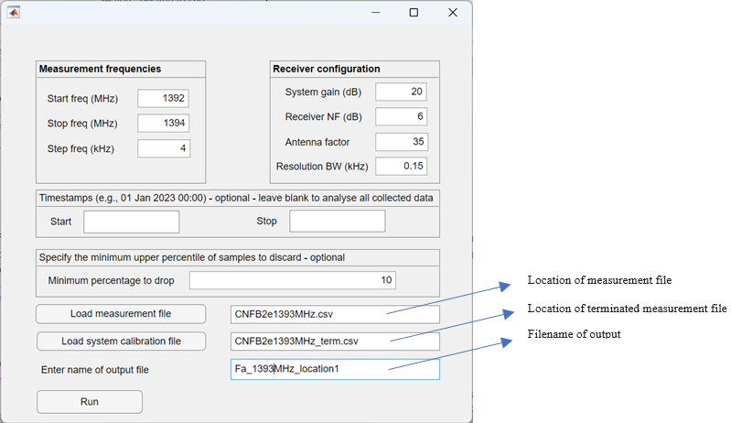

6 Input parameters and format
Ofcom’s WGN processing computer code takes two files as input:
1. a .csv file containing measurement values with that antenna connected; and
2. a .csv file with measurements taken with a terminated 50 ohms load.
We assume that the measurement and terminated measurement files contain values in dBµV and are in .csv format. The column headers in each .csv file contain ‘tag’, ‘timestamp’ and the measurement frequencies in Hz. Each row contains measurements over one frequency sweep, i.e., from the start to the stop frequency in increments specified by the step frequency.
An example of the structure of the measurement file is shown in Figure 5.
FIGURE 5
Structure of measurement file
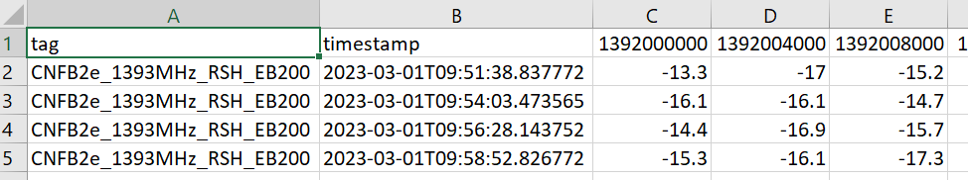

7 Output of results
The function analyse_WGN_recordings returns two arrays, all_Fa_cor_mat and all_Fa_mat which contain the corrected F_{a} values as described in Step 4 of the methodology and the uncorrected Fa values (from Step 3), respectively.
The results of the analysis are also saved to [sv_name]_[date].mat in a folder ‘output_files’; where sv_name is a user specified filename and date is the date when the code was executed.

8 Code validation
We provide two sample data files for measurements taken at 1 393 MHz in one of the Ofcom offices. The file ‘CNFB2e1393MHz.csv’ contains the measurements data over a few days and ‘CNFB2e1393MHz_term.csv’ contains data with the antenna replaced by a 50-ohm load.
The measurement parameters for these recordings are given in Table 4.
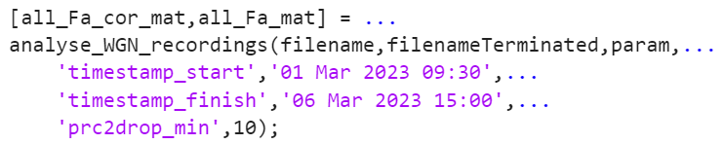
TABLE 4
Parameter values for code validation
Parameter | Values
rbw_kHz | 0.15
sys_gain | 20
sysNoi | 5.4
af | 34.65
start_freq_MHz | 1392
stop_freq_MHz | 1394
step_freq_kHz | 4
sv_name | Fa_1393MHz_location1
Prc2drop_min | 10

Some statistics of the measurement data are displayed in the MATLAB command window as shown in Figure 6.
FIGURE 6
Screenshot of results with validation data
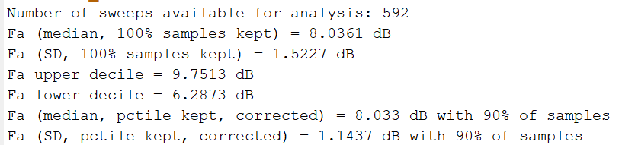
An example of the output file produced using the above input files and parameter values is provided in the csv file ‘Fa_1393MHz_location1_21-Apr-2024.mat.’ below:
Attachment: WGN Processing Code
ATTTACHMENT
WGN processing code submission
The MATLAB functions are provided below in the ‘WGN_processing.zip’ file. An installer package is also submitted in ‘WGN_processing.mlappinstall’.
The associated ITU-R Study Group 3 computer program description proforma document is contained in ‘Proforma_WGN.docx’.

Zip-file containing Matlab functions
Matlab app installer package
ITU-R Study Group 3 computer program description proforma

______________

