 | TOWARDS MOBILE BROADBAND UBIQUITY IN EUROPE | 

International Conference:
„Regulatory activity in electronic communications sector“

29 - 30 September 2014
Budva, Montenegro

Organizers:
Agency for Electronic Communications and Postal Services of Montenegro (EKIP), and
International Telecommunication Union (ITU)

International Conference "Regulatory activity in electronic communications sector“, the twelfth in a row, will take place this year again within the Festival of ICT achievements - INFOFEST 2014. The Conference will be organized by the Agency for Electronic Communications and Postal Services (EKIP) and International Telecommunication Union (ITU).

This year's conference should provide the stakeholders with the opportunity of a high-level dialog on the strategies and policies directed to the development of broadband access in the Region through the discussions about challenges and opportunities that are offered via high-speed networks and services provided over modern infrastructure.

The Conference, which will be focused on the mobile broadband ubiquity, will particularly deal with the following issues:
- Towards Smart Regulation and Policy Fostering Growth of Mobile Broadband Ubiquity,

- Technologies – Trends, Disruptive Innovations, Challenges and Opportunities,
- Market and Consumer Needs and Preferences,
- Consumer Protection Challenges in Mobile Broadband Ubiquity,
- Way Forwards and Necessary Action.

The Conference will be organized within XXI Festival of ICT achievements - INFOFEST 2014, at the "Maestral“ Hotel, at Pržno, Budva municipality.
In addition to the official program, the organizers of the Conference will offer other content, which will contribute to a relaxed working environment in order to achieve the best effect of mutual communication of participants (cocktail and a boat trip around the Bay of Kotor for the participants of the Conference).

The representatives of the European regulatory agencies, ministries, operators of electronic communications, as well as the representatives and experts from international organizations and institutions responsible for policy development and regulation of electronic communications are invited to participate in the Conference and thereby contribute to the success and quality of this year's Conference.

All those who are interested in participation in the Conference in the capacity of panelists or speakers are invited to submit the name of their presentation by 5 September 2014 at the e-mail address conference@ekip.me, whereas their presentations should be submitted by 19 September 2014.

For this Conference documents will not be submitted in paper form. Documents relating to the Conference, including agenda, registration form and practical information for participants will be posted on the website of the International Telecommunication Union (ITU):
http://www.itu.int/en/ITU-D/Regional-Presence/Europe/Pages/Towards-Mobile-Broadband-Ubiquity.aspx, or at the website of the Agency for Electronic Communications and Postal Services (EKIP): http://www.ekip.me/INFOFEST/index.php

The Conference will be held in English and Montenegrin language with simultaneous translation in both languages.

Participants who may need an entry visa for Montenegro should contact the nearest embassy or consulate of Montenegro for assistance well in advance. A list of embassies and consulates of Montenegro in the world can be found on the website of the Ministry of Foreign Affairs and European Integration: http://www.mvpei.gov.me/rubrike/misije/Ambasade-i-konzulati-CG-u-svijetu/

With the sincere hope that you will accept our invitation to participate in the Conference, we look forward to meeting you and spending time together at Pržno, Miločer, in the beautiful Mediterranean setting.

TIME AND VENUE OF THE CONFERENCE

The Conference will be held:
- on Monday, 29 September 2014, 09:30 – 17:00, and
- on Tuesday, 30 September 2014, 09:30 – 13:00.

The venue of the Conference will be the Maestral Hotel, Pržno, Budva.
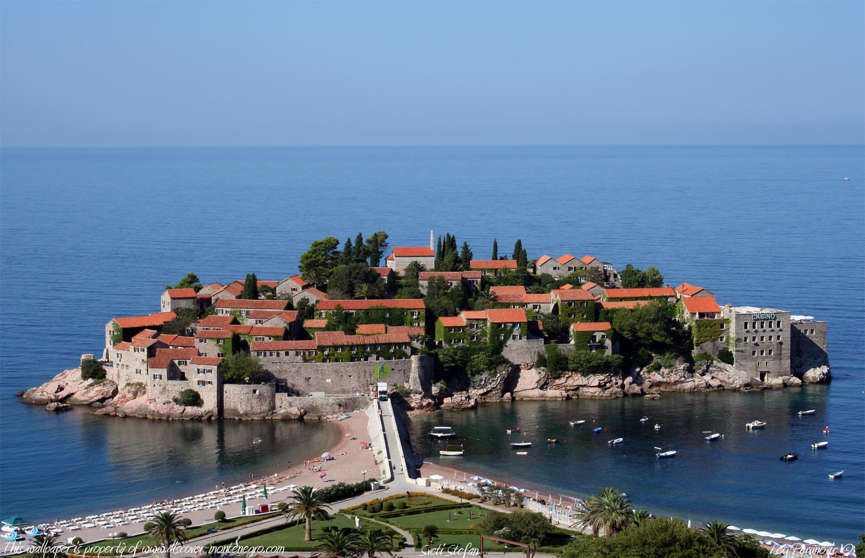
Pržno is situated in the best part of Budva Bay, and is surrounded by the hills of Paštrovići and a beautiful Miločer park. Plenty of trees and other tropical vegetation enrich the air with beautiful fragrance. At Pržno one can feel the atmosphere of an authentic fishing village with traditional ways of fishing. Pržno is a health resort because Miločer park is full of pine trees, and only 20 minutes’ walk through a cedar forest can bring one to the pearl of the Adriatic - the famous resort of Sveti Stefan.

Pržno is connected with Budva by a mini-bus line. During the tourist season, mini-buses run every 15 minutes and otherwise every 30 minutes.

The climate is mild and sunny throughout the tourist season from May till the end of October. The average number of sunny days in a year is 240, and the season lasts for 180 days. The sea is dark blue with transparency of 38 to 56 meters.

Distance from Pržno:
Budva: 7 km
Tivat airport: 32 km
Podgorica: 51 km
Podgorica airport: 40 km
Cetinje: 25 km
Bar 29 km
Kotor: 31 km
Miločer: 0.5 km
Sveti Stefan: 1 km

CONDITIONS FOR PARTICIPATION AND APPLICATION FORM

The Conference will be held within the Festival of ICT achievements - Infofest 2014. In addition to participation in the Conference, all registered participants can attend the program content of the Infofest. More information on Infofest 2014 may be found at www.infofest.com.

Conditions for participation in the Conference and application form can be found in the Appendix to this Invitation letter.

Opening Ceremony of the Infofest 2014 will be held at the Maestral Hotel, on Sunday, 28 September 2014, at 20:00.

CONTACT

To contact the Conference organizers you can use the following information:

Agency for Electronic Communications and Postal Services of Montenegro
Tel: +382 20 406 700
Fax: +382 20 406 702
E-mail: conference@ekip.me
Address: Bulevar Džordža Vašingtona 56, II sprat, 81000 Podgorica, Montenegro
Contact person: Mr Boris Jevric
Related website: http://www.ekip.me/eng/Infofesteng/index.php

or

International Telecommunication Union
Tel.: +41 22 730 6065
Fax : +41 22 730 6453
E-mail : EURregion@itu.int
Address : Place des Nations, 1211 Geneve 20, Switzerland
Contact person : Mr Jaroslaw Ponder
Related Website: http://www.itu.int/en/ITU-D/Regional-Presence/Europe/

