Telecommunication
Development Bureau (BDT)
Ref. | BDT/EUR/DM-005 |  | Geneva, 29 January 2015
 |  |  | To Administrations of ITU Member States, Regulators, Broadcasting Authorities and Enterprises of the Europe Region
Subject: | Smart Accessibility on Connected TV workshop, 18 March 2015, Barcelona, Spain.
Dear Sir/Madam,
I have pleasure to inform you of the forthcoming workshop on Smart Accessibility on Connected TV, to be held in Barcelona, Spain, on 18 March 2015.
The workshop is organized by the Autonomous University of Barcelona in partnership with the International Telecommunication Union and European Commission. It will be held within the framework of the ITU European Regional Initiative on “Ensuring access to telecommunications/ICTs, in particular for persons with disabilities”, adopted by WTDC-14, Dubai.
Ensuring that the entire European population has access to television services is one of the targets set by world leaders in the World Summit on the Information Society. Television is important for enhancing national identity, providing an outlet for domestic media content and getting news and information to the public, which is especially critical in times of emergencies. Television programs are also a principal source of news and information for illiterate segments of the population, some of whom are persons with disabilities. Migration from analogue to digital TV represents an ideal opportunity for ITU members to take the necessary steps to ensure TV is accessible.
The meeting will provide a basis for the exchange of best practices in the field of accessibility services, highlight recommendations of the model ICT accessibility policy report, as well as practical solutions for broadcasters in providing access services for persons with disabilities. International standards for connected TV, as well as legal, policy and regulatory aspects will be presented and discussed.
Participants are requested to kindly complete the registration form available on the event’s webpage, and send it by e-mail to pilar.orero@uab.cat with copy to eurregion@itu.int before 8 March 2015.
This workshop will be conducted in English only and the meeting will be paperless. The Preliminary Agenda is attached for ease of reference. Documents related to the event, including Agenda, Registration Form, and Practical Information for participants will be posted on the ITU website at: https://www.itu.int/en/ITU-D/Regional-Presence/Europe/Pages/Smart-Accessibility-on-Connected-TV.aspx

Although there is no participation fee for this meeting, please note that all expenses concerning travel, accommodation and insurance of your experts should be covered by your Administration / Organization / Company.
Mr Jaroslaw Ponder, Coordinator for Europe Region, ITU is at your disposal should you have any questions or need clarifications concerning the workshop (email: eurregion@itu.int, phone: +41 22 730 6065).

Yours faithfully,
[Original signed]

Brahima Sanou
Director

Annex 1: Preliminary Draft Agenda

ANNEX 1
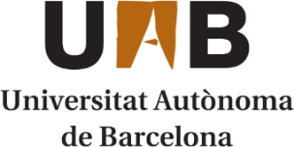 | 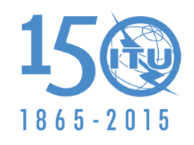 | 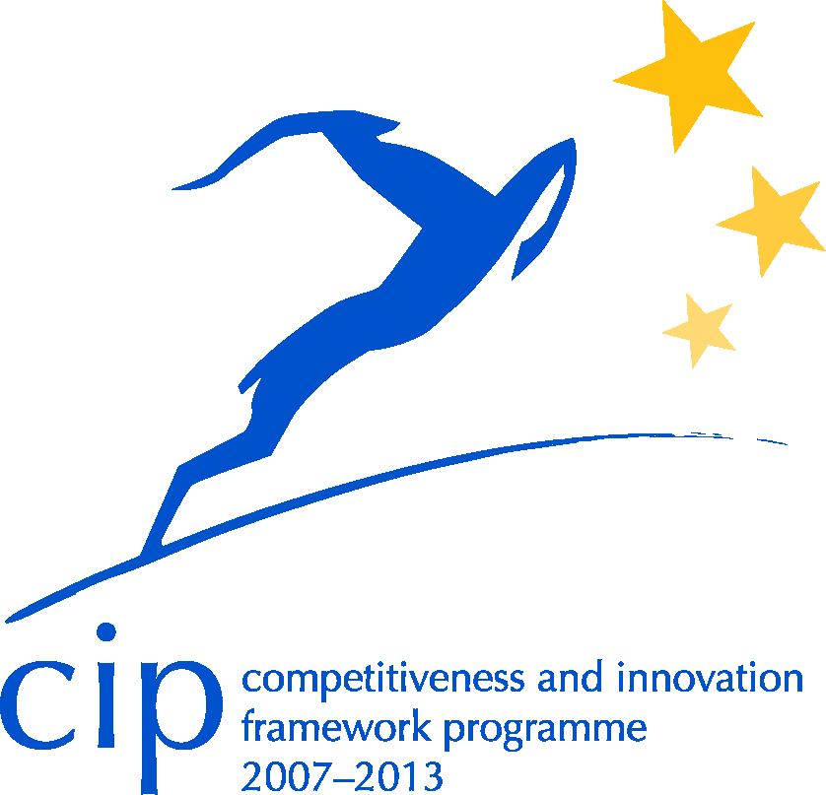

Regional workshop organized by the Universitat Autònoma de Barcelona, in collaboration with the International Telecommunication Union and the European Commission
Smart Accessibility on Connected TV
D’Investigadors Residence Hall, Barcelona, Spain
18 March 2015
Draft agenda
08:30 – 09:00 | - Registration
09:00 – 09:45 | - Welcome Addresses  - Jaroslaw Ponder, Coordinator for Europe, ITU Telecommunication Development Bureau  - Harald Trettenbrein, Deputy Head of Unit, Directorate-General for Communications Networks, Content and Technology. Unit G1 Converging Media & Content. European Commission.  - Pilar Orero, Universitat Autònoma de Barcelona
09:45 – 10:15 | - Overview of International Standards  - ITU Telecommunication Standardization Bureau
10:15 – 10:30 | - Group Photo and Coffee Break
10:30 – 11:30 | - Approaches to connected TV  - Pere Vila, RTVE, Spain  - Annette Wilson, RBB, Germany  - Dae Kim, Netflix
11:30 – 13:00 | - Accessibility Legal, Policy and Regulatory Frameworks  - Susan Schorr, Head of Special Initiatives Division, ITU Telecommunication Development Bureau  - Harald Trettenbrein, Directorate-General for Communications Networks, Content and Technology. Unit G1 Converging Media & Content. European Commission.
13:00 – 14:30 | - Lunch
14:30 – 15:15 | - Manufacturers promoting connected TV accessibility  - Diego Machado, SAMSUNG  - Samuel Fabra, SONY  - LG
15:15 – 16:00 | - Service Developers promoting connected TV accessibility  - Robin Nachtrab-Ribback, Verbavoice, Germany  - Igor Garcia Olaizola, Vicomtech, Spain
16:00 – 17:00 | - Round table: Accessibility on connected TV  - Dani Giribet, TVC, Spain (Moderator)  - Andreas Tai, IRT, Germany  - John Birch, Screen Systems, UK  - Mario Vinagre, RTP, Portugal  - Gion Linder, Swiss Txt, Switzerland
17:00 – 17:30 | - Conclusions and Way Forward

Note: TV3, Generalitat de Catalunya and S·Dos will offer a demo of their secondary screen accessibility services.

