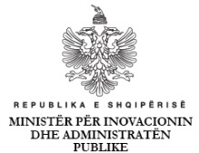


Draft AGENDA

OFFICIAL LAUNCH OF THE ITU COUNTRY REVIEW ON
ICT CENTRIC INNOVATION ECOSYSTEM IN ALBANIA

Albanian School of Public Administration
Street: Blv " Zhan D'Ark", Nr 31, Tiranë , Albania
Friday, 25 November 2016

09.45– 10.00 Registration of Participants
10.00 – 10.10 Opening Speech
H.E. Mrs. Milena Harito, Minister of State for Innovation and Public Administration.
10:10- 11:30 Presentation of the Report
Mr. Jaroslaw Ponder, Coordinator for Europe Region, ITU
Mr. Mohamed Ba, Head of Innovation Division, ITU

11:30- 11:40 Follow-up on Report’s Recommendations
Mrs. Vilma Tomço, Head of Department for Innovation and Good Governance, Minister of State for Innovation and Public Administration

11.40 – 12.00 Draft Innovation Action Plan, as part of Economic Reform Program
12:00 – 12:30 Open Discussuion

