Biography
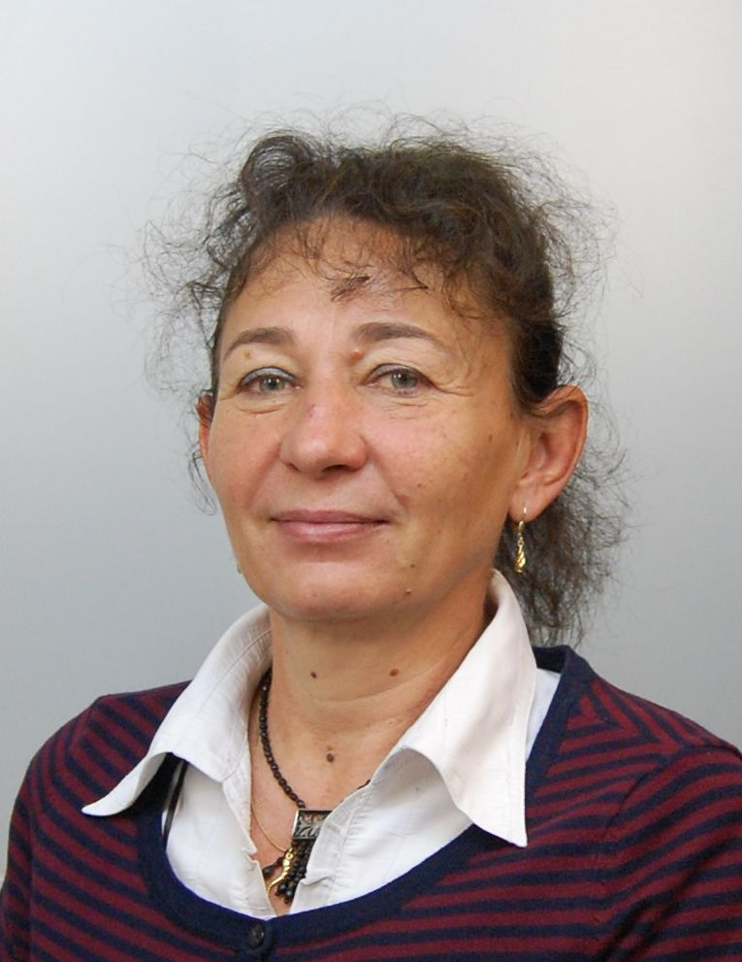

Maria Kissne-Akli
National Media and Infocommunications Authority – Hungary

Maria Kissne-Akli, Head of Frequency Planning and Coordination Unit since 2010. She has a master’s degree in electrical engineering. After graduating at the Technical University of Budapest in 1986 she was a lecturer at the Technical Faculty of National University of Public Service in Budapest. She joined NMHH in 1996 where she dealt with planning and coordination issues in the field of television broadcasting. Her main responsibilities were DVB-T network planning, preparation of the Hungarian GE06 digital plan, participation in international working groups and international conferences (e.g. RRC04/06). From 2007 she worked for the Hungarian network operator, Antenna Hungária. The group lead by her was responsible for network planning tasks related to DVB-T/DVB-H and T-DAB frequency tender and network implementation.

