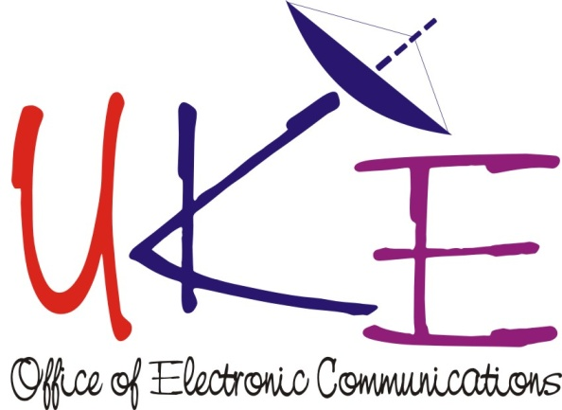

Office of Electronic Communications (Urząd Komunikacji Elektronicznej, UKE, Poland)
EUR5 – Entrepreneurship, innovation and youth
“Girls in New Technologies” Traineeship Contest

National initiative that fits well with the implementation of the European initiatives.
"Girls in New Technologies" is a social initiative of the President of UKE closely connected with the celebrations of the "Women and Girls in ICT Day" established by the International Telecommunication Union (ITU), which also fits in with the implementation of one of the regional initiatives.
The aim of the initiative is to publicise the issue of a low participation of women in the new technology sector: telecommunications and informatics, and to encourage young women to undertake studies and jobs in the ICT industry. Its aim is also to launch a public debate and engage the biggest It and ICT companies sector in supporting employment of women in the field of computing, engineering and innovations.
The Traineeship Contest is one of elements that is organized within this initiative. It is dedicated for female students of technical studies at least in their second year of first degree studies and in uniform master's studies as well as to all female students in their second degree studies. The condition to participate in the Contest is to solve a specific task prepared by each of the partner companies. The awards in this Contest, which are traineeship of least 3 months in a selected partner company, are sponsored by partner companies of the project that promotes the presence of women in the sector of new technologies.
The first edition of the Contest was held in 2013. The second edition finished on the 30th of April 2014. Next editions of the Contest are planned in the following years.
Each edition of the Contest is widely promoted at the technical universities through academic centers for Career Development and students councils. President of UKE, Mrs Magdalena Gaj and Rectors of eight Universities of Technology signed an agreement on cooperation and on cooperative scientific, research and educational actions in the field of telecommunications, IT and engineering. Joint projects included cooperation on the editions of “Girls in New Technologies” Traineeship Contest.

Agreements signed between Universities and the President of UKE in 2013:
Warsaw University of Technology (31st of January 2013)
Wroclaw University of Technology (5th of April 2013)
Military University of Technology in Warsaw (22nd of April 2013)
Agreements signed between Universities and the President of UKE in 2014:
Rzeszow University of Technology (14th of January 2014)
AGH University of Science and Technology (17th of January 2014)
Cracow University of Technology (17th of January 2014)
Gdansk University of Technology (18th of February 2014)
Czestochowa University of Technology (20th of February 2014)
Thanks to the established cooperation, Universities were invited to participate in the Contest “Girls in New Technologies”. They promoted this initiative among their female students.
Contest is also advertised through the official “Girls in New technologies” page on Facebook, in order to communicate with young girls in a modern and direct way. Mrs. Magdalena Gaj, the President of UKE, as ambassador of the idea of employing women in the sector of new technologies encourages the Contest winners to actively participate in promoting the next Contest edition among their friends.
The first edition of the Contest attracted 27 participants. The level of difficulty was high, because only 13 girls fulfilled contest’s requirements. 6 finalists have been awarded with the possibility of paid internship. Finalists have become ambassadors of the contest and got involved in the promotion of its second edition.
Second edition of the Contest attracted 40 applicants including 23 complying with the requirements of the contest rules and regulations. The Contest Committee, based on obtained results and interviews, selected 7 winners for, who will have their traineeships at the following companies: Cisco Systems Poland, Motorola Solutions Systems Polska, Sygnity S.A., Microsoft, Telewizja Polska.
Two already carried out editions of the contest gave unique opportunity for young female students to get professional work experience in the most respected ICT companies in the county. Some finalists after finishing the period of traineeship were offered a full time employment.
Participation in the third edition of the traineeship contest in 2015 was offered by
10 companies:
Motorola Solutions Systems Poland, CISCO Systems Poland, SAS Institute, Sygnity, Microsoft, Ośrodek TVP Technologie, GFT Poland, AVIVA, GTECH Polska and Huawei.
Each edition of the contest attracts more female students and more business partners willing to engage in the project and employ more young women in their companies.
Magdalena Gaj, the President of UKE, as ambassador of the idea of employing women in the sector of new technologies encourages the contest winners to actively participate in promoting the next contest edition among their friends.

