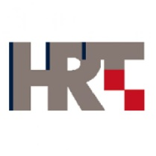

Regional Meeting for Central and Eastern Europe organized by International Telecommunication Union and European Broadcasting Union at the
Kind Invitation of the HRT Academy
eAccessibility in Television Broadcasting in
Central and Eastern Europe

3-4 December 2013

HRT Academy, Zagreb, Croatia

N O M I N A T I O N F O R M

Women candidates are encouraged

(Please print/type clearly)
1. Mr/Ms ___________________________________ _________________________________________
(Surname) (First name)
2. Country ____________________________________________

3. Administration/organization _________________________________________________________________________

4. Title ______________________________________________________________________________________________

5. Tel.:________________________ Fax: _______________________E-Mail: ____________________________________
□ I herewith express my interest in participating in the Regional Experts Group Workshop.

 | Date: |  |  | Signature:
Please fill in and send this Form  no later than 20 November 2013 to: |  |  | ITU: Mr. Jaroslaw Ponder  eurregion@itu.int  Tel: +41 22 730 54 67

