Hellenic Presidency of the Council of the European Union 2014

Safety & Security in Cyber Space:

building up Trust in the EU

6-7 March 2014
Athens, Greece
Venue: Zappeion Megaron

Conference co-organized by

the Ministry of National Defense of the Hellenic Republic,

the Ministry of Administrative Reform & e-Governance of the Hellenic Republic

and the Ministry of Infrastructure, Transport and Networks of the Hellenic Republic

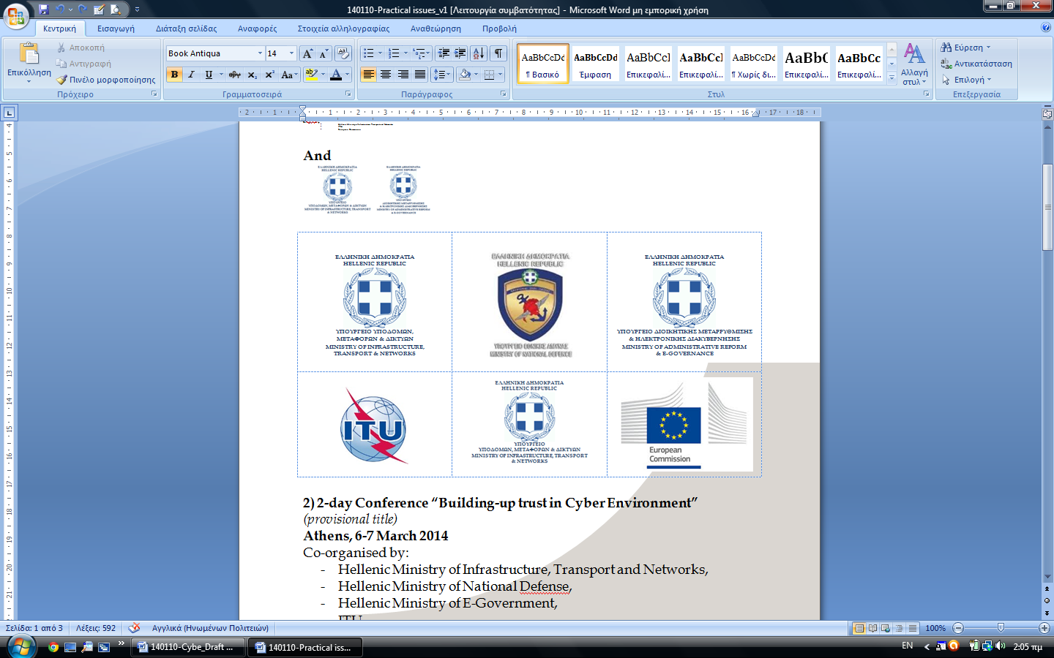 | 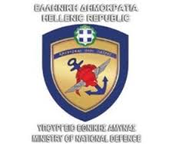

in cooperation with
the International Telecommunication Union

and the European Commission
 | 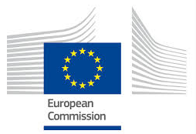

Draft Agenda – v.14
First Day: Thursday, 6 March 2014
[09:00 – 10:00] | Registration
[10:00 – 11:00] | Welcome Addresses  - Mr. Dimitrios Avramopoulos, Minister of National Defense  - Representative, Ministry of Administrative Reform & e-Governance (TBC)  - Mr. Michalis Papadopoulos, Deputy Minister of Infrastructure, Transport and Networks  - Mr. Paul Timmers, Director for Secure and Sustainable Society, Directorate-General for Communications Networks, Content & Technology, European Commission  - Mr. Brahima Sanou, Director, Telecommunication Development Bureau, International Telecommunication Union (video message)  - ESRT (TBC)
[11:00 – 11:30] | Group Photo and Coffee Break
[11:30 – 13:00] | Session 1: Cyber Space and Contemporary Threats  Moderator:  Dr. Sotirios Ioannidis, Principal Researcher, Foundation for Research and Technology - Hellas  Sub-sessions and speakers:  - Prof. Dimitrios Gritzalis, Professor and Director, Information Security and Critical Infrastructure Protection Laboratory, Athens University of Economics and Business  “Know the Self, Know the Enemy: Integrative Security via Proactive Intelligence Gathering and Insider Threat Prediction”  - Mr. Ilias Chantzos, Director of Symantec's Government Relations and Public Affairs programmers for Europe, Middle East and Africa as well as the Asia Pacific and Japan regions  “National and European Cyber Security Strategies. The Emerging Realities”  - Prof. Udo Helmbrecht, Executive Director of ENISA  “The Cyber Security Evolving Threats and the EU Cooperation”  - Mr. Paul Timmers, Director for Secure and Sustainable Society, Directorate-General for Communications Networks, Content & Technology, European Commission  “EU Cybersecurity Strategy. One year on”  - Ms. Rosheen Awotar-Mauree, Cybersecurity Officer, International Telecommunication Union  “Building Global Movement to Address Cyber threats”
[13:00 – 14:30] | Lunch Break
[14:30 – 16:00] | Session 2: Legal Aspects in Cyber Domain  Moderator:  Mr. Ilias Chantzos, Director of Symantec's Government Relations and Public Affairs programmers for Europe, Middle East and Africa as well as the Asia Pacific and Japan regions  Sub-sessions and speakers:  - Mr. Vasilios Makris, Deputy Military Prosecutor, Athens Military Court  “Cyber Defense from the perspective of the Internal Hellenic  Legislation”  - LCL Stinissen, Cooperative Cyber Defense - Centre Of Excellence (Estonia)  “Legal Aspects of Active Cyber Defense”  - LCL Aristides Mourtos, Head of Cyber Crime Unit of the Hellenic Police  “Cyber Crime”  - Mr. Yves Verhoeven, Head of International Relations ANSSI (national agency for security of information systems under the Prime Minister), France  “E-Privacy”  - Dr. Marco Gercke, Director, Cybercrime Institute  “Assisting Countries in Harmonizing Cybersecurity Legislations”
[16:00 – 16:30] | Coffee Break
[16:30 –18:00] | Session 3: Trust and Security  Moderator:  Dr. Ioannis Askoxilakis, Head of FORTHcert, the Computer Emergency Response Team of the Foundation for Research and Technology - Hellas  Sub-sessions and speakers:  - Mr. Andrea Servida, Head of Task Force Legislation Team (eIDAS). Directorate General for Communications Networks, Content and Technology, European Commission  “Electronic Identification”  - Ms. Rosa Barceló, Team Leader - Digital privacy, Directorate General for Communications Networks, Content & Technology, European Commission  “Policy Developments in the Area of Privacy & Data Protection”  - Ms. Cornelia Kutterer, Director EU Affairs Privacy, security, law enforcement, Microsoft Corporate Affairs Europe  “Trustworthy Cloud: The challenges in the balance between law enforcement, security and privacy in view of ongoing legal initiatives such as the draft EU privacy regulation and the NIS directive”  - Mr. Preetam Maloor, Strategy and Policy Advisor, International Telecommunication Union  “International cooperation on Child Online Protection”  - Mr. Ken van Wyck, Member of Steering Committee, FIRST “Cooperation among CIRTs”
Second Day: Friday, 7 March 2014
[09:00 – 9:30] | Registration
[9:30 – 11:00] | Session 4: Cyber Security  Moderator:  Prof. Dimitrios Gritzalis, Professor and Director, Information Security and Critical Infrastructure Protection Laboratory Athens University of Economics and Business  Sub-sessions and speakers:  - Mr. Alexander Schol, European Cyber Crime Centre (EC3)  “EMPACT (European Multidisciplinary Platform Against Criminal Threats): priorities in the field of cybercrime for the next years”  - Prof. Socratis Katsikas, Professor at the Department of Digital Systems of the University of Piraeus  “Cyber Security Governance in Europe”  - Mr. Yves Lagoude, Director of European Affairs and Thales & Member of the Board of Directors of EOS  “The Growth of the European Cyber Security Market and of a EU Cyber Security Industry”  - Dr. Ioannis Askoxilakis, Head of FORTHcert, the Computer Emergency Response Team of the Foundation for Research and Technology - Hellas  “Intelligence-Driven Cyber Security”  - Mr. Tim Crosland, Head of Cyber, Prevention and Information Law National Crime Agency  UK experience in addressing cyberthreats  or  - Commissioner of electronic communications and postal regulations – CYPRUS  Cyprus experience in addressing cyberthreats
[11:00 – 11:30] | Coffee Break
[11:30 – 13:00] | Session 5: Capabilities Development in Cyber Environment  Moderator:  Prof. Nineta Polemi, Assistant Professor at the Department of Informatics of the University of Piraeus  Sub-sessions and speakers:  - Dr. Dimitrios Ptochos (TBC), Director of Strategic Planning Bureau / Prime Minister’s Office  “Capabilities Development” (TBC)  - Mr. Wolfgang Rohering, Cyber Defense Project Officer of the European Defense Agency (EDA)  “Cooperation: a Conditio Sine Qua non for Effective and Efficient Cyber Defense”  - Prof. Christos Douligeris, Professor of the Department of Informatics of the University of Piraeus. Vice President of the Board of Trustees of the Hellenic Computer Society and member of the Executive Committee of the National Council of Electronic Commerce  “Cybersecurity: Recent Trends and Perspectives”  - WG CDR Robert Smeaton, European Union Military Staff (EUMS)  “Something From Nothing - the EUMS and Collective Cyber Defense”  - Mr. Aaron Boyd, Vice President of Strategy, ABI Research  “The Global Cybersecurity Index (GCI): a Mechanism to Assess Country Preparedness”  - Ms. Viola Veiderpass, Senior Expert, Digital Crime Centre, INTERPOL  “The global cybercrime landscape”
[13:00 – 14:30] | Lunch Break
[14:30 – 16:00] | Session 6: Network & Information Security – NIS  Moderator:  Prof. Christos Douligeris, Professor of the Department of Informatics of the University of Piraeus. Vice President of the Board of Trustees of the Hellenic Computer Society and member of the Executive Committee of the National Council of Electronic Commerce  Sub-sessions and speakers:  - Mr. Jan Neutze, Director of Cybersecurity Policy at Microsoft  “The NIS Directive: an opportunity for cybersecurity” or “NIS: The need for Harmonization & Critical Infrastructure Protection”  - Ms. Rosa Barceló, Team Leader Digital Privacy, Directorate General for Communications Networks, Content & Technology, European Commission  “The NIS Directive”  - Prof. Nineta Polemi, Assistant Professor at the Department of Informatics of the University of Piraeus  “Ports’ Critical Information Infrastructures Protection (P-CIIP)”  - Dr. Sotirios Ioannidis, Principal Researcher, Foundation for Research and Technology - Hellas  “The Cost of Cyber-Insecurity”  - Ms. Veronique Pevtschin, Technical Coordinator of the CYSPA and CAPITAL Projects of EOS  “EC Projects Supporting Network Information Security”  - Italian Police (TBC)
[16:00 – 16:30] | Coffee Break
[16.30 - 17.30] | Closing Remarks and Ways Forward  - Ms. Rosa Barceló, Team Leader Digital Privacy, Directorate General for Communications Networks, Content & Technology, European Commission  - Mr. Jaroslaw K. Ponder, Coordinator for Europe Region, International Telecommunication Union  - Representative of Ministry of National Defense, Ministry of Administrative Reform & e-Governance, Ministry of Infrastructure, Transport and Networks
* TBC: To Be Confirmed, TBA: To Be Added, Yellow: EC, Light blue: ITU, Red: Greece, Green: neutral

