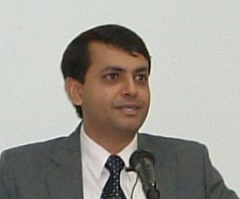

Ashish Narayan

Mr. Ashish Narayan is Advisor in the ITU Regional Office for Asia and the Pacific. His work primarily involves implementing human capacity building initiatives undertaken by ITU in the region and is presently the coordinator for the ITU Asia Pacific Centres of Excellence Network. As well as policy & regulatory assistances under ITU’s programs in several Asia-Pacific countries.

Prior to the ITU, Mr. Narayan worked as Deputy Advisor in the Telecom Regulatory Authority of India. During his tenure in the TRAI, he worked on key telecom sector reform issues. He began his career with the Tata Telecom, an equipment manufacturer, before moving to the Indian Government Service. He has also worked with the Indian public service broadcaster in the area of broadcast engineering.

Mr. Narayan holds an MBA Degree in International Business and a Bachelor’s Degree in Electronics and Telecommunication Engineering.

