Annex 3
ITU CENTRES OF EXCELLENCE NETWORK FOR ASIA-PACIFIC REGION
ITU - ICT Faculty training on
Cybersecurity
12-16 May 2018, Tehran, Islamic Republic of Iran

- Introduction
ITU Asia-Pacific Centre of Excellence Program on “Cybersecurity” will be held in Tehran, Islamic Republic of Iran from 12-16 May 2018.

- Venue Information AND WORKING HOURS
- Venue: Ferdowsi International Grand Hotel, No.20, Kooshk e Mesri street, Beginning of Ferdowsi Ave., North of Imam Khomeini square, Tehran, I.R.Iran. Tel.: (+9821) 66727026 – 31, http://www.ferdowsihotel.com/en
- Date : 12-16 May 2018; Time : 08:00 AM Onwards
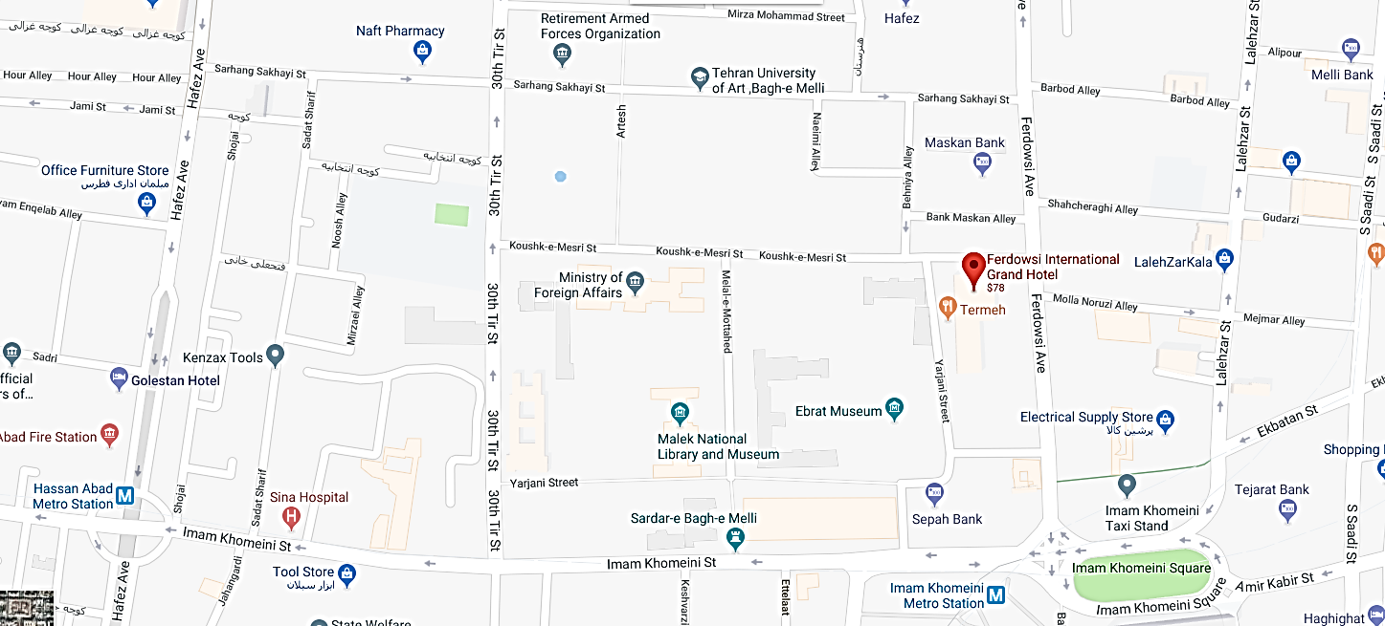

- Coordinators

HOST COORDINATOR  Mr. Hassan Pashaeizad, Director of Research and Information Technology, ICT Faculty  Tel: +98 21 44654800, Fax: +98 21 44658745  E-mail: pashaey@gmail.com;  pashaei@ictfaculty.ir | ITU COORDINATOR  Mr. Sameer Sharma, Senior Adviser,  ITU Regional Office for Asia & the Pacific  Tel: +66 257 500 55, Fax: +66 257 53507  Email: sameer.sharma@itu.int

- Visa Formalities and accommodation
All participants entering Islamic Republic of Iran must possess valid passports (6-month validation) or accepted travel documents and need to check visa requirements before entering the country. All participants of a foreign country who wishes to enter Iran needs to have a valid visa (save for certain exceptions). An Iranian visa allows the visa holder to request the immigration officials’ permission to enter the country. Please check the visa with the nearest I.R. Iran Embassy. Arrival visa can be issued in IKA Airport (Tehran) for participants. For issuing arrival visa participants should insert “IKA Airport” as their visa issuance place in the registration form (Annex2). For more information please visit the website: http://en.mfa.ir
Note: For visa issuance, hotel booking and invitation arrangements please visit: https://1stquest.com and fill out the related forms. Our agency will arrange visa formalities and accommodation for participants.

- LIST OF PROPOSED HOTELS
Hotels below are recommended by host:

Hotels | Distance to Conference Hall | Room | Price
Ferdowsi International Grand Hotel
Address: No.20, Kooshk e Mesri street, Beginning of Ferdowsi Ave., North of Imam Khomeini square, Tehran | - | Single | 143 $
☆☆☆☆ |  | Double | 201 $
Tel: (+9821) 66727026 – 31
Fax: (+9821) 66711449
info@ferdowsihotel.com
Howeyzeh Hotel | Distance to Conference Hall | Room | Price
Address: No.115-Cross Taleghani Ave. & Nejatollahi Av. ,Tehran | 25 minutes | Single | 138 $
☆☆☆☆ |  | Double | 183 $
Tel: (+9821) 88804344-54
Fax: (+9821) 88904823
Hb@kosarhotels.com
Iranshahr Hotel | Distance to Conference Hall | Room | Price
Address: No. 81, South Iranshahr St., Tehran | 15 minutes | Single | 105 $
☆☆☆ |  | Double | 146 $
Tel: (+9821) 88846650
Fax: (+9821) 88821924
Email: info@hotel-iranshahr.com
http://www.hotel-iranshahr.com
Baba Tahir Hotel | Distance to Conference Hall | Room | Price
Address: No 55, Before Somaye Ave, Ghare ney St., Tehran | 15 minutes | Single | 108 $
☆☆☆ |  | Double | 138 $
Tel: (+9821) 88998635-6
Fax: (+9821) 66975709
Hafez hotel | Distance to Conference Hall | Room | Price
Address: No.18, Bank alley, South Ferdowsi, Emam Khomeini Square, Tehran | 5 minutes | Single | 49 $
☆☆☆ |  | Double | 74 $
Tel: +98 21 66705331
Fax: +98 21 66709063
http://www.hafezhotel.net/index.php/en
Golestan Hotel | Distance to Conference Hall | Room | Price
Address: No.14 , Hafez st., Hassan Abad sq. , Tehran | 10 minutes | Single | 48 $
☆☆ |  | Double | 70 $
Tel: +98 21 66760681
Fax: +98 2166725660
http://www.gollestanhotel.com
info@gollestanhotel.com

P

For arranging transportation from hotel to the venue and vice versa please send your hotel booking details as well as your itinerary to us till 30/04/2018.
- If you could not book the hotel directly from the site, our agency can book the hotels for the participants according to the above table rates and they can pay their cost directly in Tehran by cash.
- As international credit cards are not accepted in Iran, all participants are requested to make payments in cash.

Notes
For participants who arrive at Imam Khomeini International Airport, which is located 45 kilometers from the center of Tehran, airport taxis can be easily found from point of entry to hotels.
Local transportation from the recommended hotels to the venue will be provided by the host. Please contact Mr. Hasan Pashaeizad for further details. All participants are requested to make their own travel arrangements from airport.
- Airport Shuttle (Imam Khomeini Airport to Any hotel in Tehran):
Vehicle | Price
Toyota Camry | € 26 per shuttle
Toyota Rav 4 | € 35 per shuttle

- CURRENCY
The currency exchange for Iranian Rial to 1$ USD is currently approximately: 1$=45000 Rials. Government and business offices are open from 8.00 to 16:30, Saturday to Wednesday. Banks are open Saturday to Thursday from 8.00-15 while the department stores open daily from 10.00-20.00. As international credit cards are not accepted, all participants are requested to make payments in cash.
- ELECTRICAL APPLIANCES
The electric current is 220 volt AC throughout the country. The picture shows the type of main power plug used in Tehran so participants can bring the right adaptor for their electrical appliances. This two-wire plug is ungrounded and has two round prongs. It is popularly known as the Europlug which is described in CEE 7/16.

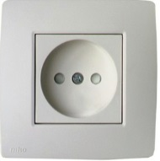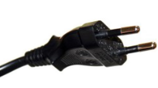

- LANGUAGES
English is spoken in most hotels, shops and restaurants as well as in major tourist destinations and Persian is the country formal language.

- SECURITY
It is safe in Tehran, however to travel at night time alone is sometimes not recommended.

- MEDICAL AND HEALTH
All participants are requested to ensure medical and travel insurance covering the whole period of the training course and overseas travel. Neither ITU nor the ICT Faculty will be able to meet any expenses relating to injury, accident or medical treatment of the participant.
Drinking water from the tap is NOT recommended even though it is clean.

- WEATHER
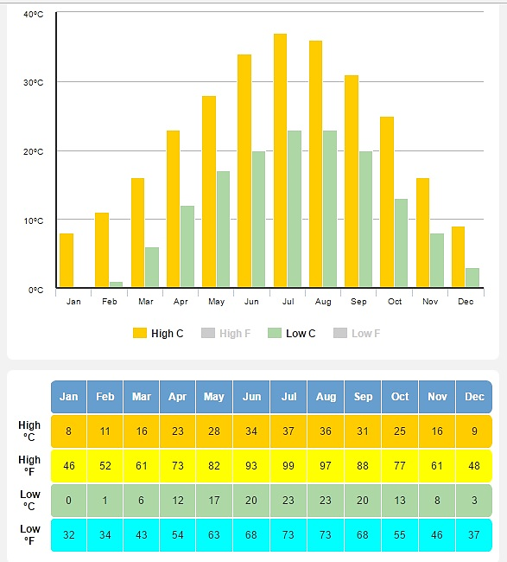
The time in Tehran is 4.5 hours ahead of Greenwich Mean Time (+4.5.00 GMT). In May, the temperature is between 17-28 Centigrade degrees in Tehran, however, the participants are requested to check the weather condition before their trip.
- INTERNET
Internet Access will be provided during training. For staying in the hotel, please contact the reception desk for access.

Have a safe trip

