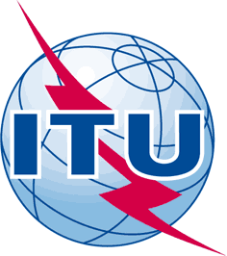 |  | 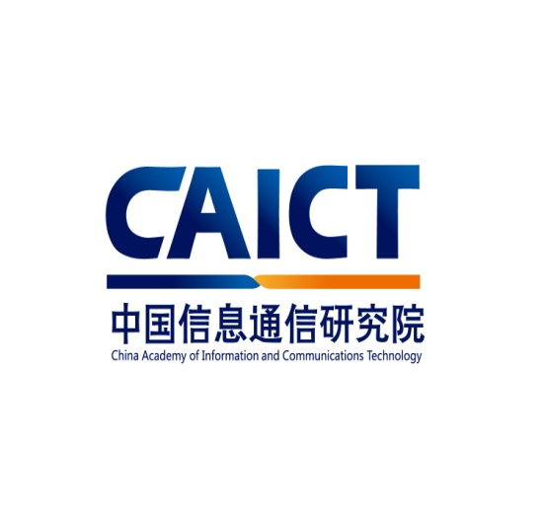
ITU Centres of Excellence Network for Asia-Pacific
China Academy of Information and Communications Technology
Face-to-Face/eLearning Training on
Conformity and Interoperability
Chongqing, China
17-21 October, 2016

COURSE REFERENCE MATERIALS
Course Title | Face to Face Training on "C Conformity and Interoperability about IMS & 4G-LTE " for the Asia-Pacific Region
Course Description | This program has the following objectives:  • To equip participants with an understanding of Strategic of ITU Conformity and Interoperability, Programme, Implementation, Conformity Assessment Principles;  • To equip participants with an understanding of policy, supervision, requirement and conformity assessment and interoperability etc. for new technology.;  • To build knowledge to participants with network development, key technology and standards, service and cases interoperability of IMS;  • To build participants’ knowledge and skills with the strategies, regulations, technical standards, network technology and conformity and interoperability of 4G-LTE.
Course Date | 17-21 OCTOBER, 2016
Course Duration | 1 week

COURSE REFERENCE MATERIALS

- ITU Conformity and Interoperability Portal:

http://www.itu.int/en/ITU-D/Technology/Pages/ConformanceandInteroperability.aspx

http://www.itu.int/en/ITU-T/C-I/Pages/default.aspx

- Concepts and Guidance:

http://www.itu.int/en/ITU-T/C-I/conformity/Pages/default.aspx

- Mandatory Conformity Assessment Schemes:

http://www.itu.int/en/ITU-T/C-I/conformity/Pages/Aschemes.aspx

- Training Activities:

http://www.itu.int/en/ITU-D/Technology/Pages/Events.aspx

- C&I Assessment Studies on Regional basis:

http://www.itu.int/en/ITU-D/Technology/Pages/CI_AssessmentStudyRegional.aspx

- Collaboration agreements

http://www.itu.int/en/ITU-D/Technology/Pages/CICollabAgreements.aspx

- Deliverables and Guidelines:

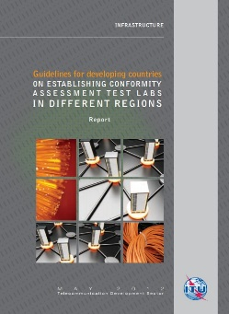 | Guidelines for Developing Countries on establishing conformity assessment test labs in different regions
​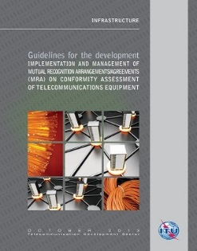 | Guidelines for the development, implementation and management of Mutual Recognition Agreements (MRAs): English version - Spanish version
​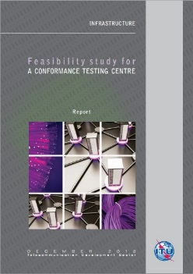 | Feasibility Study for a Conformance Testing Center
​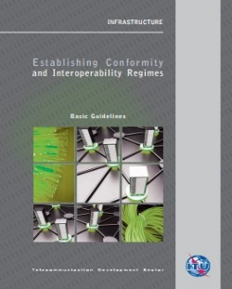 | Establishing Conformity and Interoperability Regimes: Basic Guidelines: Terms of reference - Basic Guidelines​ (English version -Spanish version)
​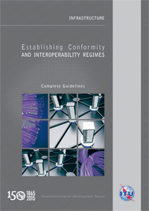 | - ​Establishing Conformity and Interoperability Regimes: Complete Guidelines​ (English version​)

Other Conformance and Interoperability (C&I)-related outcomes from recent ITU-T SG11 meeting (Geneva, 27 June-6 July 2016)
SG11 advanced and updated the standardization work plan for SIP-IMS as 20 new Recommendations were approved on SIP-IMS, TD 1343 (GEN/11). It includes standards of requirements and relevant test specifications of basic call and some supplementary services, which are applied to fixed networks. SG11 collaborate with ETSI TC INT on this subject.
WP4/11 has progressed work on C&I issues. Relevant updates are provided as follows:
– Pilot projects for conformity assessment against ITU-T Recommendations TD 1326 (GEN/11), http://www.itu.int/go/pilot-projects);
– Living list of key technologies which are suitable for C&I Testing (TD 1235 (GEN/11), http://itu.int/go/key-technologies);
– The reference table of standards used for C&I assessment (TD 1255 (GEN/11), http://itu.int/go/reference-table);
– A new Recommendation ITU-T Q.3920 “Terms and definitions to be used in Conformance and Interoperability issues” was consented. It will help to enhance discussions on C&I by providing a common terminology;

