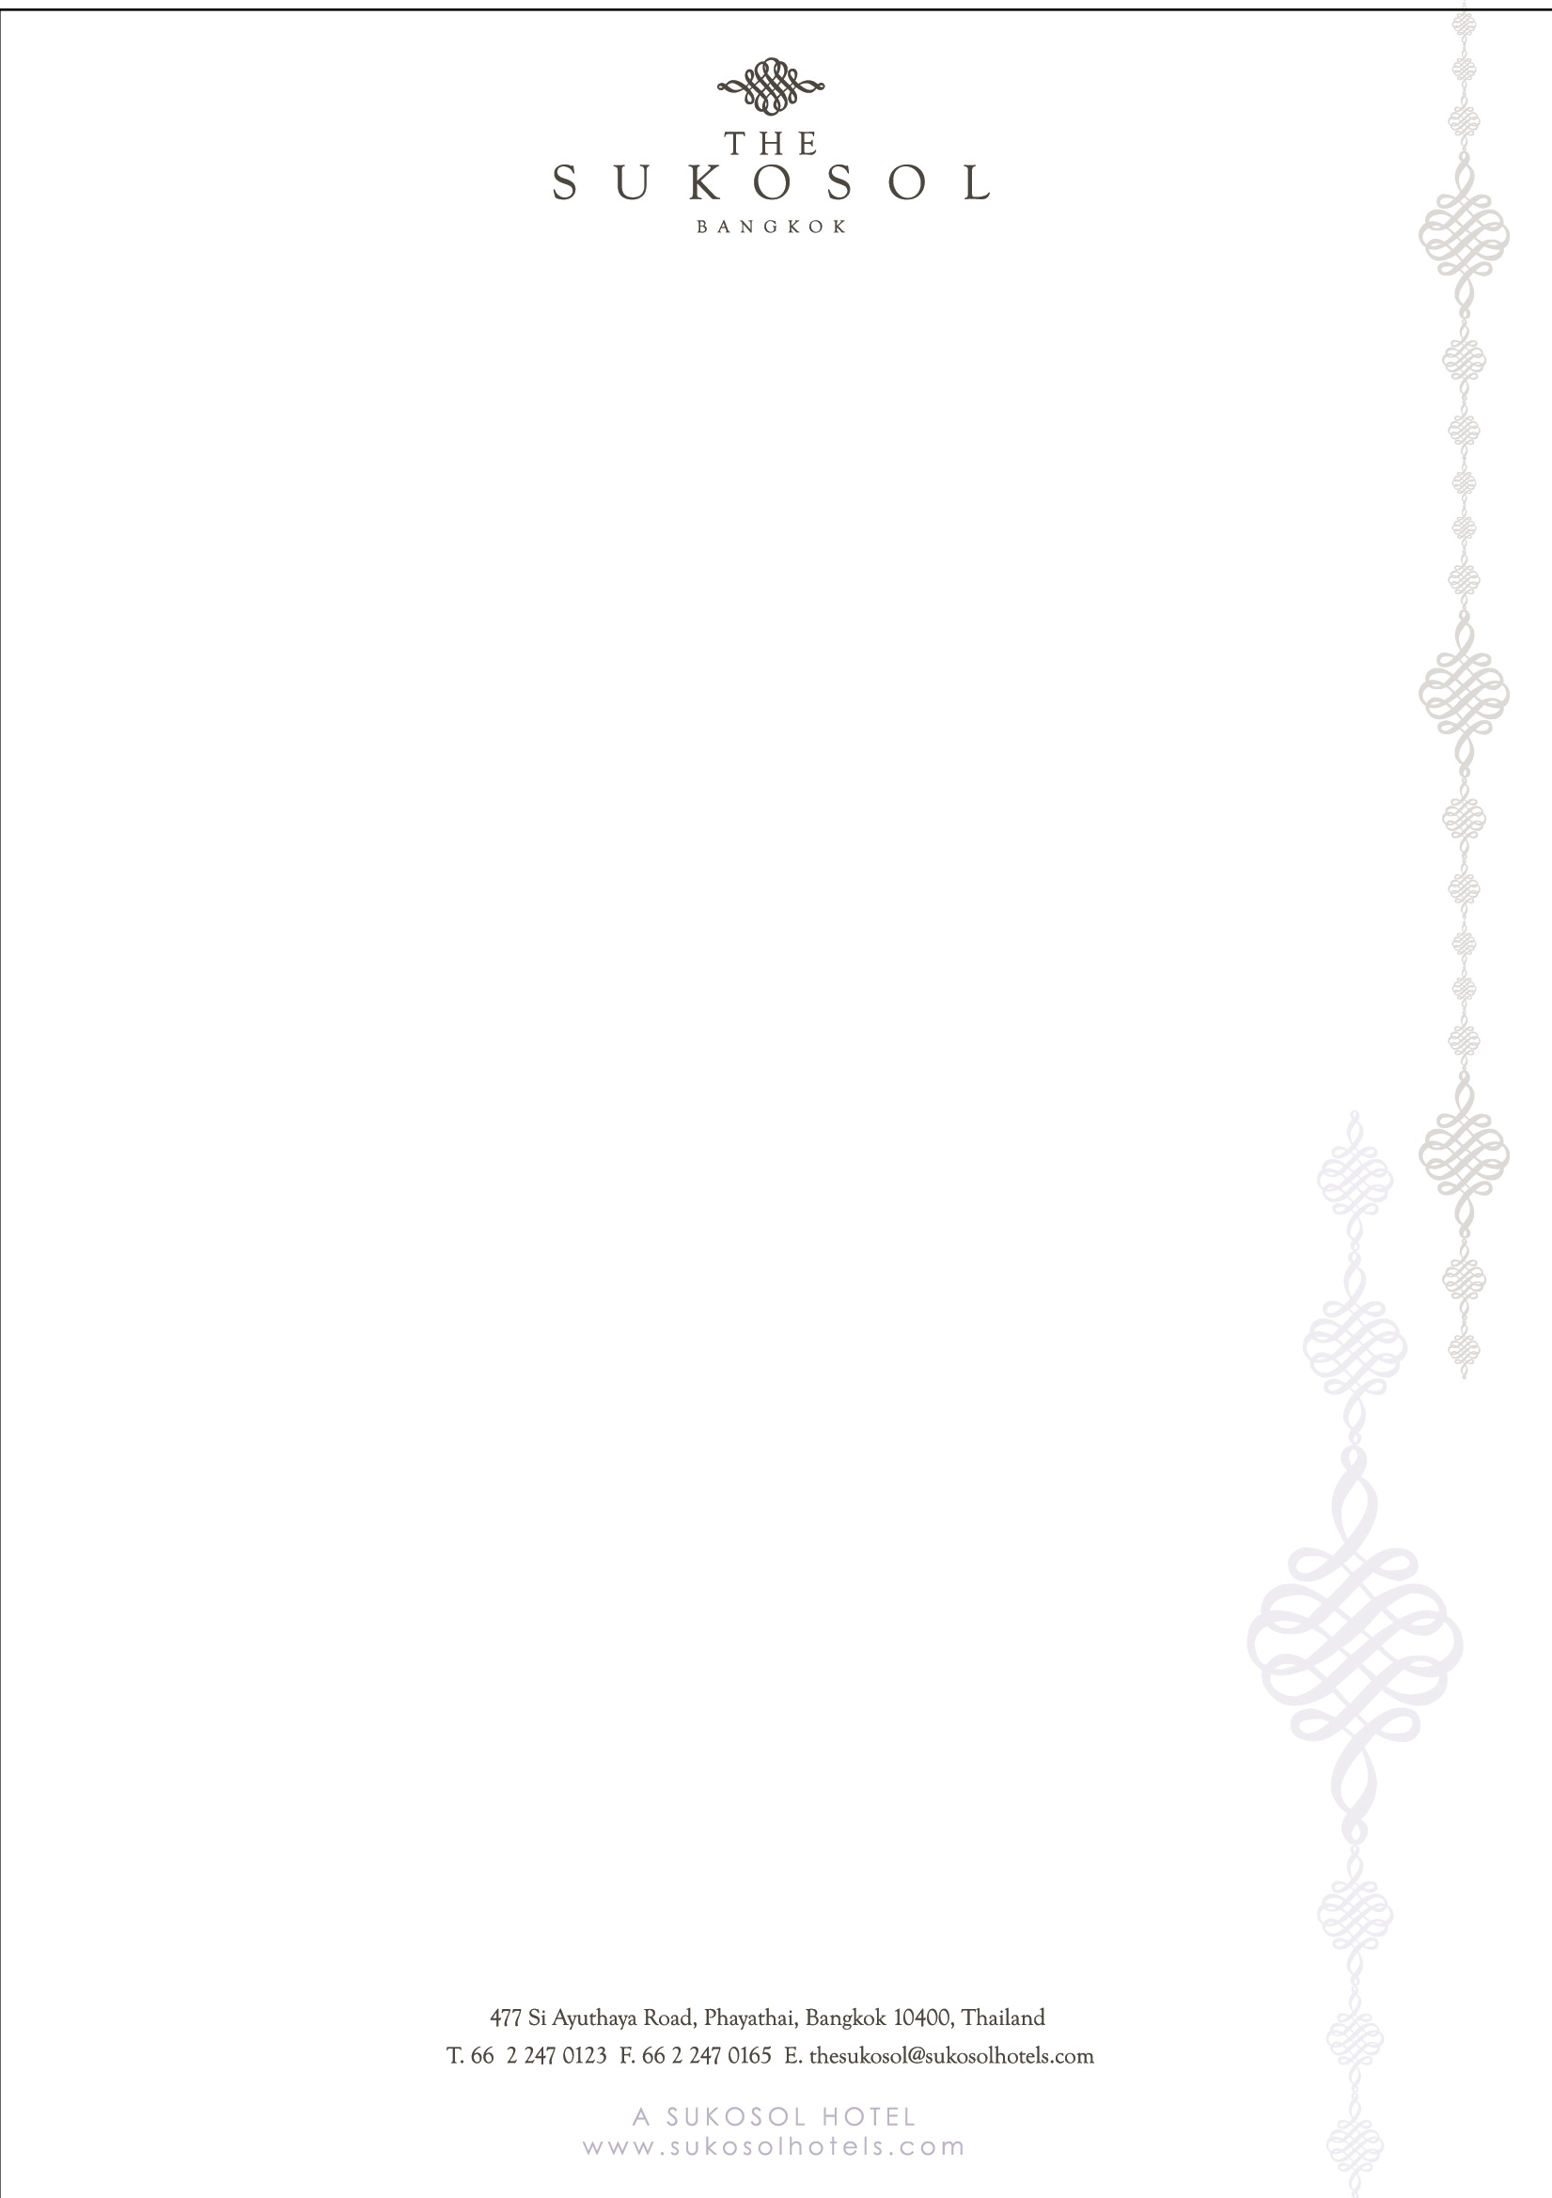

‘Leveraging ICTs for Smart Sustainable Cities’
The Office of National Broadcasting and Telecommunication Commissions (NBTC)

Sep 29 – Oct 2, 2014

Attention: Pak-kawan T. Catering Sales Executive Date: …………………………………………………
Tel. 66 2 247 0123 Ext. 1861 Fax 66 2 247 0160 E-mail: pakkawan.th@sukosolhotels.com

From: ……………………………………… Booked By: ……………………………………………………
(Organization/Company) (Blocked Letters)

Tel : …………………………… Fax : ……………………… E-mail : ……………………………

Guest Name(s): …………………………………………………………………………………………………

Arrival Date: …………………………… Departure Date: ……..……………………………………….

Guaranteed By Credit Card Number # ……………………………… Expiry Date: …………………

Type of Card: ……………………………… Name of Card Holder: ………………………………………

Signature: _______________________________________________________________________

Room Rates: Smoking Room Non-smoking Room

Government Rates *Required for Government I.D. Card
Deluxe Single Baht 2,400 .-nett/room/night (With Breakfast)
Deluxe Twin / Double Baht 2,600 .-nett/room/night (With Breakfast)
Non-Government Rates
Deluxe Single Baht 3,600 .-nett/room/night (With Breakfast)
Deluxe Twin / Double Baht 3,800 .-nett/room/night (With Breakfast)
Account Settlement: Guest(s) will be responsible all expenses for accommodation and will be required to supply the Hotel with a credit card imprint upon check-in to cover charges to individual room account. Full payment is required upon check-out by either cash or credit card.

Remarks: 1. Should the Hotel receive any cancellations of rooms within 48 hours of the arrival date, or “no shows" (guests not arriving for reservations being held), the Hotel reserves the right to charge the amount of the first night's accommodation, which guest agrees to pay for.
2. The reservation will be made only by the completed form and subject to availability.
3. The above special rate is only available to participants that book directly through the organizer, The Sukosol Bangkok.
4. Our Check-In time is 2:00 p.m. (14:00) and our Check-Out time is Noon. (12:00).

*** Please fill in the necessary data for secure the reservation, this booking could be guaranteed by Credit Card and email this form back to hotel. ***

