WORKSHOP ON RESILIENT INFRASTRUCTURE FOR EFFECTIVE EARLY WARNING DISSEMINATION

INFORMATION NOTE

10 – 12 September 2025

Sendai, Japan

**Date and Venue**

The Workshop on resilient infrastructure for effective early warning dissemination will take place at **International Research Institute of Disaster Science (IRIDeS), Tohoku University,** Sendai, Japan from 10 to 12 September, 2025.

**Domestic Transportation**

**1) From/to Sendai Airport:**

Take the Sendai Airport Access Line (JR) to Sendai Station.

Travel time: approx. 25 minutes

Fare: 660 yen (as of August 2025)

Trains run every 20–30 minutes.

**2) From/to Tokyo (Narita/Haneda Airport):**

There are two main options to get between Tokyo and Sendai:

**i) By Shinkansen (Recommended)**

From Tokyo Station, take the Tohoku Shinkansen (Yamabiko or Hayabusa) to Sendai Station.

Travel time: approx. 1.5–2 hours

Fare: around 11,000–13,000 yen (reserved seat)

Trains run frequently throughout the day.

**From Narita or Haneda to Tokyo Station:**

From Narita: Take the Narita Express (approx. 1 hour, 3,070 yen)

From Haneda: Take the Tokyo Monorail + JR Line, or the Keikyu Line (approx. 30–40 minutes, 500–700 yen)

**Access to IRIDeS**

Location: 468-1 Aoba, Aramaki, Aoba-ku, Sendai, Miyagi, Japan 980-8572

URL: <https://maps.app.goo.gl/ebfmZhDvCd557NB26>

**1) By Sendai City Subway:**

Get off at "Aobayama" station on the Tozai Line bound for “Yagiyama Zoological Park” station. (about 9 minutes from Sendai Station)

IRIDeS is about 3-minute walk from the south exit.

**2) By Taxi:**

It takes about 20 minutes from Sendai Station and costs about 1,600 yen, depending on traffic and other conditions.

屋外, 建物, 写真, 座る が含まれている画像

AI 生成コンテンツは誤りを含む可能性があります。

URL: <https://irides.tohoku.ac.jp/eng/access/>

**How to Ride the Sendai Subway**

**How to Buy a Subway Ticket (at Sendai Station):**

Go to the Sendai Subway Tozai Line ticket gate area.

Use a ticket machine (language can be changed to English in the top-right corner).

Select your destination: Aobayama Station.

The fare is 250 yen.

Insert cash or IC card to pay, then take your ticket.

**Lunch Spot near IRIDeS**

There are limited lunch options near IRIDeS.

If you have dietary restrictions or specific preferences, we recommend bringing your own lunch in advance.

**1) Midori Shokudo (J41)**

A typical university cafeteria, often used by students.

Payment: Cash only

URL: <https://maps.app.goo.gl/E47TkiMxMWeXVsKUA>

**2) Buddy's Table (J12)**

Offers a daily set menu with Yoshoku (Japanese-style Western food) dishes.

Payment: Cash only

URL: <https://maps.app.goo.gl/MqNZ59zSYDfGYWhEA>

**3) Kotaro (J12)**

Serves udon noodles and ramen. Located on the 2nd floor above Buddy's Table.

Payment: Cash only

URL: <https://maps.app.goo.gl/uKufx2zv9X7pqpxY9>

**4) Midori Shop** **(J41)**

A small shop inside the university offering snacks, drinks, and light meals.

There is no hot water service.  
Payment: Cash or credit card (credit card accepted only at the leftmost register)

URL: <https://maps.app.goo.gl/oY7ecZCmZY1RkgxG8>

**5) LAWSON (J12)**

A full-featured convenience store offering bento, snacks, drinks, and more.

Payment: Multiple payment options including cash and credit cards

URL: <https://maps.app.goo.gl/Xe9xP7UPRY99YixA8>

ダイアグラム, マップ

AI 生成コンテンツは誤りを含む可能性があります。

URL: <https://irides.tohoku.ac.jp/eng/access/>

**Weather**

The weather information for Sendai during the meeting is as follows:

- Mean Temperature: 21.5°C (70.7°F)

- Maximum Temperature: 25°C (77°F)

- Minimum Temperature: 18°C (64.4°F)

However, due to climate change, the mean maximum temperatures in September could easily exceed 30°C in recent years.

**Currency**

The currency unit in Japan is the Japanese Yen (¥).

The exchange rate fluctuates, but it is approximately ¥140 per 1 US dollar. Major credit cards, including Visa, American Express, Diners Club, Mastercard, and JCB, are widely accepted at hotels, large restaurants, department stores, and select shops.

**Electricity**

The standard electrical voltage in Japan is 100V, and Type A (two flat parallel pins) are used.

If you plan to use laptops, charge mobile phones, cameras, or other devices, please bring an appropriate adapter.

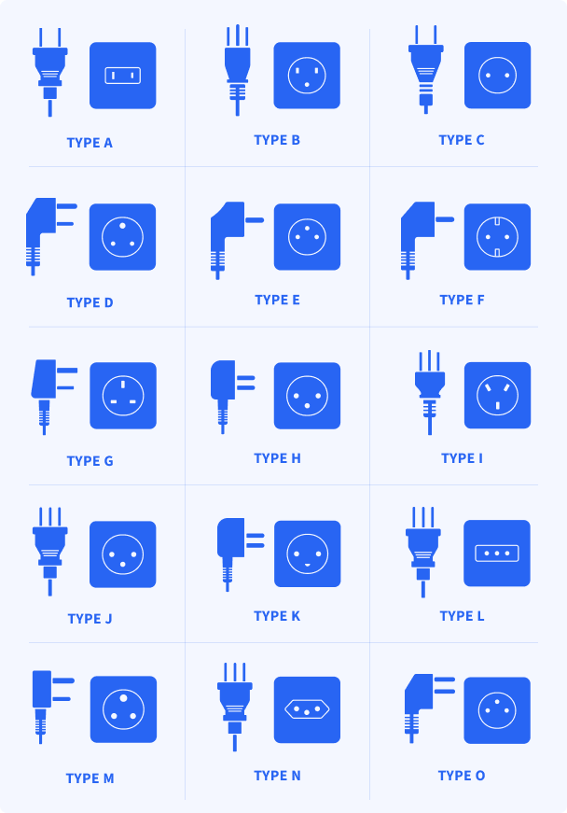

**Local Information**

For additional information and assistance concerning the local and logistic arrangements for the meeting, please contact the Local Organizers as follows:

**i) :**Ms. Yukiko Yano / Co-Researcher, IRIDeS, Tohoku University

Tel: +81-22-752-2098

Mobile Phone: + 81-80-7956-5826

Email: [yukiko.yano.d7@tohoku.ac.jp](mailto:yukiko.yano.d7@tohoku.ac.jp)

**ii) :** Dr. Yuichi Ono / Professor, IRIDeS, Tohoku University

Tel: +81-22-752-2098

Mobile Phone: +81-80-8205-6120

Email: [yuichi.ono.a2@tohoku.ac.jp](mailto:yuichi.ono.a2@tohoku.ac.jp)