**ITU - ITTLLDC Seminar - 2023**

26 – 28 Sep 2023

**UN House meeting room**

Ulaanbaatar, Mongolia

# **INTRODUCTION**

Mongolia is a country located in north-central Asia, with a territory measuring 1.56 million sq km (603,909 sq miles). The national capital, Ulaanbaatar, is in the north-central part of the country.

Welcome to Mongolia and to the ITU - ITTLLDC Seminar – 2023 being organized from 26-28 September 2023 in Ulaanbaatar. This document would provide information on meeting arrangements that you will find useful.

# **VENUE OF THE MEETING**

Seminar will be held in the Conference hall at the UN Building, Ulaanbaatar, Mongolia, located in the city center, 35 minute drive from the Chinggis Khaan Airport, 10 minute walk from the Hotel 9.

|  |
| --- |
| **Entry to UN house is restricted and only those who are registered for the meeting and produce ID with picture would be allowed to enter the UN house building** |

**Registration link is** <https://forms.office.com/e/7N2YXWf9jY>

**Address**: UN House  
United Nations Street-14  
Sukhbaatar district  
Ulaanbaatar 14201  
Mongolia

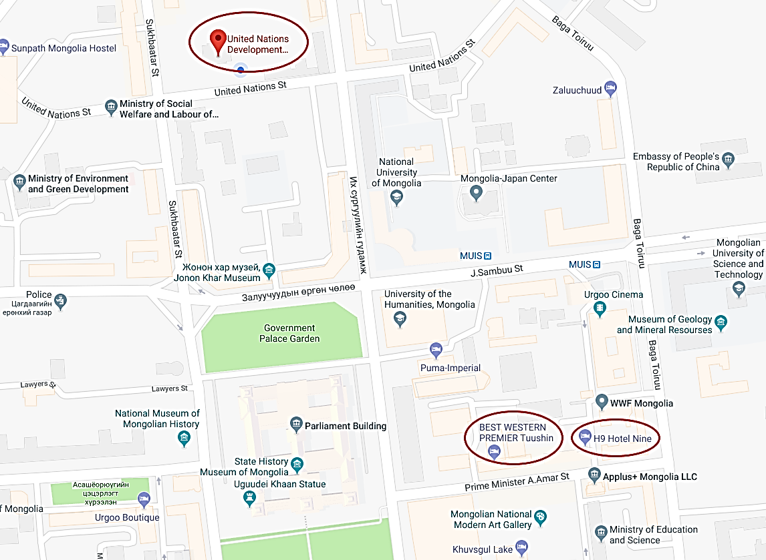

**UN House**

The meeting would run as per the agenda in the venue and break would be provided to undertake lunch at available restaurants outside the UN house at own expense.

# **ACCOMMODATION OPTIONS**

Multiple accommodation options are available near the venue of the meeting including:

* [**Novotel**](https://www.google.com/url?sa=t&rct=j&q=&esrc=s&source=web&cd=&cad=rja&uact=8&ved=2ahUKEwiZ4abj-qGBAxXTT2wGHRo6AjMQFnoECBAQAQ&url=https%3A%2F%2Fall.accor.com%2Fhotel%2FB1D8%2Findex.en.shtml&usg=AOvVaw2RDpKYvHPpyqOftlR8A1M0&opi=89978449)
* [**Hotel 9**](http://hotelnine.mn/)
* [**Bluesky hotel**](https://www.google.com/url?sa=t&rct=j&q=&esrc=s&source=web&cd=&cad=rja&uact=8&ved=2ahUKEwiyv9KU-6GBAxW-ZmwGHRlMDTQQFnoECBEQAQ&url=https%3A%2F%2Fhotelbluesky.mn%2F&usg=AOvVaw0bRyIQQHc-CD0hd26vAG5y&opi=89978449)

Local partners can assist in booking hotel for international participants. Note that the fellowship award by ITU for relevant includes the expenses of hotel accommodation. Hence fellowship awardess from ITU woud be required to settle bill of accommodation by their own.

# **VISA**

International participants requiring Mongolian visas are requested o contact event focal point for further information.

# **ARRIVALS/DEPARTURES AND TRANSPORTATION**

The staff of CRC will greet Members at the Chinggis Khaan International Airport with the sign.

Transport will be provided for international participants from airport to hotel and from the hotel to the venue of the UN House.

All international participants are required to provide their itineraries to Communications Regulatory Commission of Mongolia [**fr@crc.gov.mn**](mailto:fr@crc.gov.mn) copying focal point from ITU.

# **INSURANCE**

Participants are expected to make their own arrangements for accident, illness, and luggage insurance, if so desired.

# **WEATHER**

In last week of September , the average high in Ulaanbaatar is 16 degrees Celsius and the average low is about 1 degree celsius.

# **Required Clothing:**

Warm clothes are advised for September especially for chilly mornings and nights. Wherever you go, take a sweater for cool evenings, the difference between maxima and minima can vary greatly.

# **FOREIGN EXCHANGE**

The local currency is called Mongolian Tugrik. Currency can be freely converted at banks, hotels, international airport or exchange kiosks. The exchange rate fluctuates and is currently around US$1 = 3,4752 Tugriks ([www.xe.com](http://www.xe.com), 11 September, 2023).

# **CUSTOMS FORMALITIES**

* Upon their arrival in Mongolia, visitors may be required to complete a customs declaration form. The form may need to be completed in duplicate, with one officially cleared copy to be retained by the traveler until the departure from the territory.
* Declare to customs when carrying cash in the value equivalent to 15 million MNT (US$6.000) or more.

# **CONFERENCE SERVICES**

The Meeting will be conducted in English. During the meeting, the tea/coffee break will be provided (kindly sposored by CRC).

# **ELECTRICITY**

Electricity in Mongolia is 220 volt/50 hz. Outlets in Mongolia generally accept different types of plugs.

# **COUNTRY INFORMATION**

## Mongolia

### Capital: Ulan Bator or Ulaanbaatar

* **Population** 3.348 million (2021)
* **Area** 1.56 million sq km (603,909 sq miles)
* **Major language** Mongolian
* **Major religion** Buddhism
* **Currency** Togrog or Tugrik (MNT)

Mongolia is the world's second largest [landlocked country](https://en.wikipedia.org/wiki/Landlocked_country), and the [nineteenth largest](https://en.wikipedia.org/wiki/List_of_countries_and_outlying_territories_by_land_area) in the world, with an area of 1,565,000 square kilometer. Mongolia is located between [Russia](https://www.britannica.com/place/Russia) to the north and [China](https://www.britannica.com/place/China) to the south. Its remarkable variety of scenery consists largely of upland steppes, semi-deserts, and deserts, although in the west and north forested high mountain ranges alternate with lake-dotted basins. Mongolia is largely a plateau, with an average elevation of about 5,180 feet (1,580 meters) above [sea level](https://www.britannica.com/science/sea-level). The highest peaks are in the Mongolian Altai Mountains (Mongol Altain Nuruu) in the southwest, a branch of the [Altai Mountains](https://www.britannica.com/place/Altai-Mountains) system.

<https://www.discovermongolia.mn/about-mongolia/>

|  |  |
| --- | --- |
| **ITU**  Mr Syed Aamir Riaz  [Aamir.riaz@itu.int](mailto:Aamir.riaz@itu.int)  **CRC**  Mr chuluunbat tsendsuren [chuluunbat@crc.gov.mn](mailto:chuluunbat@crc.gov.mn) | **ITT for LLDCs for urgent matters:**  Mr. DULGUUN Damdin-Od  Executive Director, International Think Tank for LLDCs  Tel: +976-351971  [thinktank@land-locked.org](mailto:thinktank@land-locked.org) |

***We hope you enjoy your stay in Ulaanbaatar, Mongolia.***