Training Report

Last Mile Connectivity (LMC) training for Asia and the Pacific
Virtual
Oct 6 and 7, 2022

Training Course Structure
The course provided an empowering learning environment for Participants from ASP through a combination of lectures and hands-on exercises to assist efforts to extend affordable and sustainable connectivity service to under-connected localities.
The training shared knowledge on data-led identification of the unconnected areas in order to prioritize limited CAPEX for sustainable technical, financial and regulatory solutions to ensure affordability and accessibility to relevant connectivity services.
The event also provided an opportunity to have interactive technical discussion so that participants can learn from real life examples of planning last mile connectivity solutions and thereby upgrade their skills to implement the best practices in their relevant countries.
Agenda of the training is attached in Annex-A while other details of the event are available at event webpage https://www.itu.int/en/ITU-D/Regional-Presence/AsiaPacific/Pages/Events/2022/LMCASP22/main.aspx

Training methodology
The training was of advanced level delivered in English only. Participants were expected to have
- Advanced knowledge on telecom issues and challenges in designing/planning an ICT network infrastructure.
- Basic understanding or working experience on Geographic Information Systems (GIS)

The virtual training was conducted through introductory presentation of ITU LMC toolkit followed by Instructor-led presentations and exercises on bandwidth calculation, LMC, MMC (Middle Mile Connectivity) planning using infrastructure data and GIS based mapping for planning.

Duration of training course
The training sessions were spread over 2 days on 6 and 7 Oct 2022. Course materials. Data sets, exercises and other relevant presentations were made available to participants before-hand through the event webpage.

Participation
Training received a good response from the region with 181 registered participants for the training. Total 130 unique users connected to zoom link on Day 1 (atleast 100 attended for more than 60 mins) while 70 unique users connected to zoom link on Day 2 (atleast 51 attended for more than 60 mins). The participants ranged from Mid to senior level technical experts involved in ICT policy and decision making, regulators, Universal Service Organizations, private sector representatives, development partners, special interest groups, experts, and academics.

List of registered participants is in Annex-A and group photo after the introduction session on Day 1 is as follows.

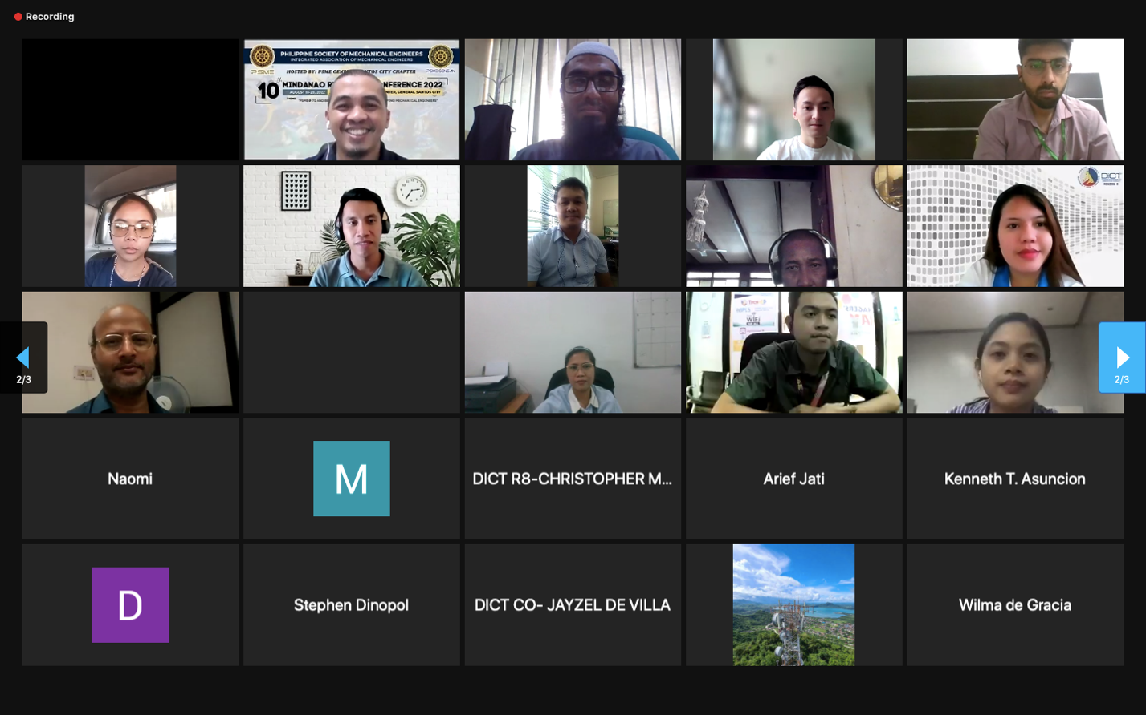
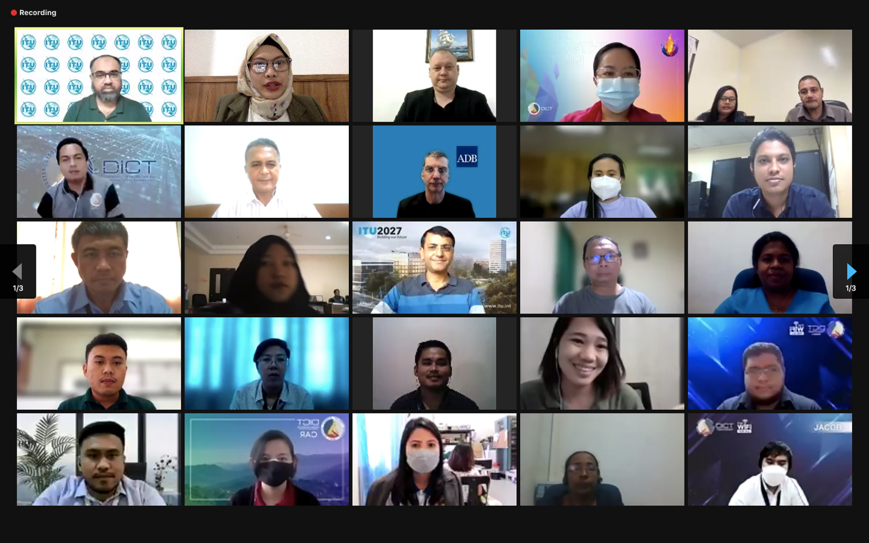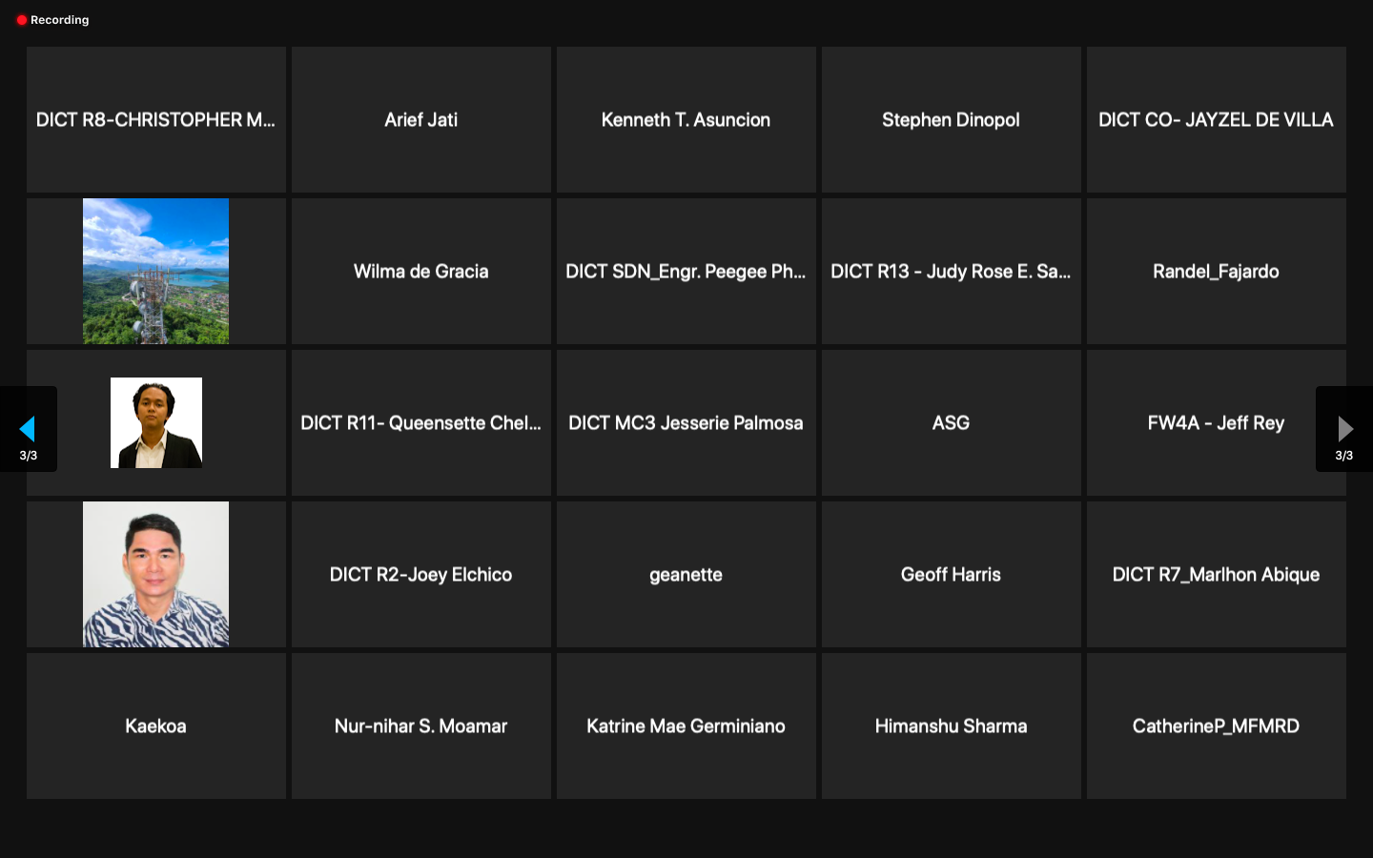

Overall training outcome
The training course was able to achieve its targeted objectives. The participants were provided in-depth overview of the tools available with ITU for specific connectivity requirements. On multiple requests, recording of training sessions were provided to registered participants.

Participants’ feedback
The training received excellent feedback from all participants (see chart 1). In summary, the topic and program were considered to be highly relevant and delivered by very knowledgeable experts in a way that aided participation and learning. Participants pointed out the requirement of F2F training for more knowledge transfer and in-depth understanding of the tool.
The summary of feedback can be accessed at https://forms.office.com/Pages/AnalysisPage.aspx?AnalyzerToken=gJYT2hWC5shhHUBtrnYA3dju3M2nb7DG&id=12TkI-YEh0uRPCS9iSGf05AwGsQJk9NEucyHMoqA-JVUNDI1QjMzVllBOUlRWVo5VFFJMjJWRlhTTy4u

Key suggestion by participants in feedback

- More time allocation especially on QGIS
- Detailed manual of QGIS software
- More hands-on practice. and divide the larger projects in smaller sized practice.
- Conduct of this training need to be effective by steps mode provided
- The need to have people out of Asia also present to have a global perspective
- More trainings on Broadband traffic planning
- Internet of Things
- Tools that can be useful for the LMC solution deployment using satellite communications specifically.
- satellite
- Presentations on the topic of O-RAN.

Recommendations
Similar National trainings may be arranged in F2F format based on requests.

XXX
Annex-A

List of Registered Participants

Zoom meeting attendance report Day 1

Zoom meeting attendance report Day 2

Agenda

