

 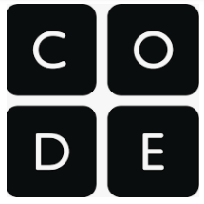

**Bangladesh ICT for Girls - Hour of Code Challenge**

* **Why learn how to code**
* **ICT for Girls Day Bangladesh**
* **ICT for Girls Logo Design Challenge**
* **Coding resources**

[**Why learn how to code?**](https://codeorg.medium.com/cs-helps-students-outperform-in-school-college-and-workplace-66dd64a69536):

"I think it's very important to get more women into computing. My slogan is: Computing is too important to be left to men."

— Karen Spärck Jones, Professor of Computers and Information at Cambridge Computer Laboratory.

“Everyone...should learn how to program, because it teaches you how to think.”   
- Steve Jobs, co-founder of Apple

At first thought, coding seems like a very narrow skillset, but research shows vast benefits from learning computer science and coding skills at a young age. Beyond learning digital literacy, children who learn computer science and coding tend to excel in problem-solving, creativity, math, spatial and reasoning skills, and more.These skills are transferable and are beneficial throughout the lifecycle; from learning to read and write, to improved exam scores, to college or university attendance, and to meaningful careers both in and out of the tech industry.

As the world moves more towards technology, it is important to equip **all** children and youth with the right skills to excel in both life and the workforce. Girls in particular lack opportunities for acquiring skills in the field of technology. We need to strive for higher female participation in areas which are usually the domain of men, such as ICT and engineering – areas where job growth is the highest in this region. Increased representation of girls and women in the tech sector also has huge benefits in terms of developing gender-responsive technologies and innovation, and for opening up more paths for women’s participation in the field.

In order to create more opportunities, we must also break the barrier of the digital gender divide where girls are far less likely to own digital devices, have access to the internet or technology, and in turn have fewer opportunities to gain crucial digital literacy skills. Through programmes such as *Hour of Code*, we can work to include young girls in coding and computer science skills based initiatives to break these boundaries and increase female participation in the field of technology.

Learn more about the benefits of coding [here](https://codeorg.medium.com/cs-helps-students-outperform-in-school-college-and-workplace-66dd64a69536)!

**International Girls in ICT Day - Celebrated in Bangladesh**

International Girls in ICT Day is being celebrated in Bangladesh in 2021 on 29 June. It provides an opportunity for girls and young women to see and be exposed to the benefit of ICT in enabling their career and aspiration. Girls in Tech Day Bangladesh 2021 aims to encourage girls and young women to pursue studying STEM and to enhance the level of digital skills and raise awareness on meaningful and safe use of ICT. To date, over 377,000 girls and young women have taken part in more than 11,400 celebrations of International Girls in ICT Day in 171 countries worldwide. UNICEF Bangladesh and Regional Office for South Asia are joining partners to celebrate International Girls in ICT Day in Bangladesh.

The event is a collaboration with the ITU Asia and the Pacific Regional Office, the Alliance of Affordable Internet initiative of the World Wide Web Foundation, in partnership with the Government of Bangladesh: The Department of Information and Communications Technology Bangladesh, the Ministry of Post and Telecommunication Bangladesh, Ministry of Post and Telecommunication of Bangladesh, the Bangladesh Telecommunication Regulatory Commission, the Aspire to Innovate (a2i) the Bangladesh government’s flagship digital transformation program, jointly implemented by the ICT Ministry and Cabinet Office with technical support from the United Nations Development Programme (UNDP))

in collaboration with Facebook Bangladesh.

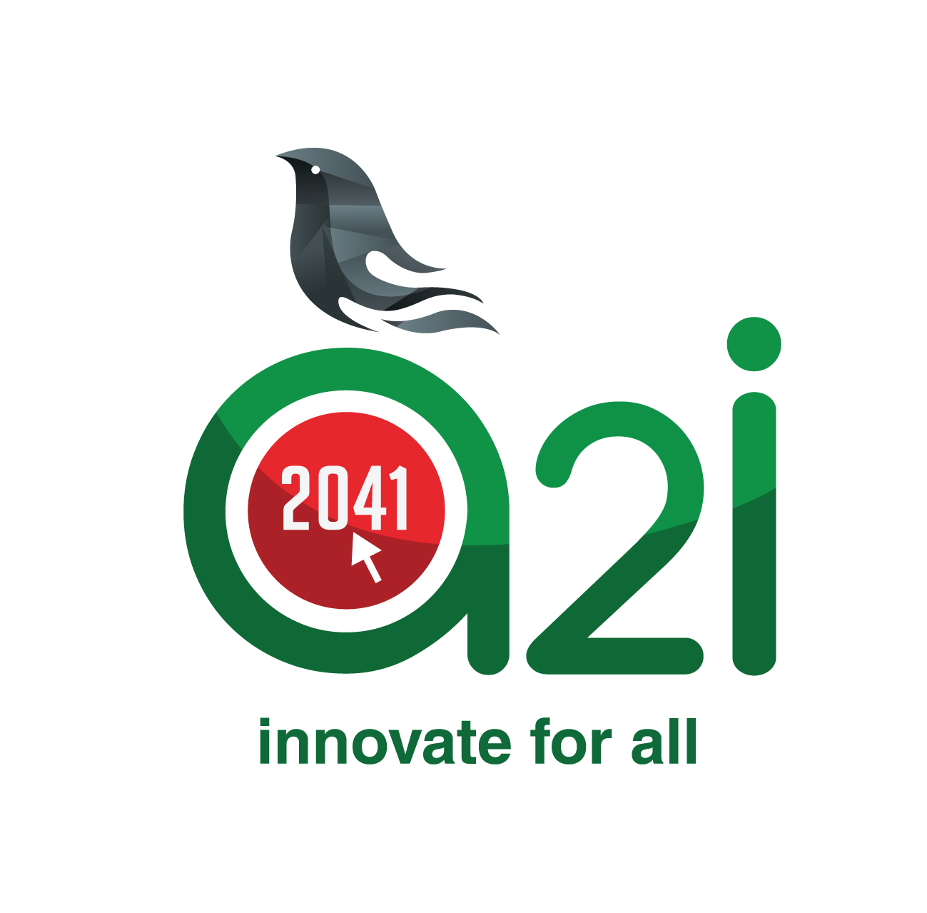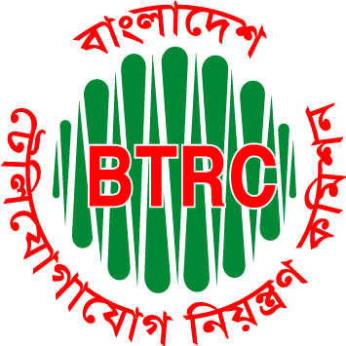





**ICT for Girls Logo Design Challenge**

As part of the International Girls in ICT Day in Bangladesh, UNICEF is organising an *ICT for Girls Logo Design Challeng*e, which will be used to raise awareness around the gender digital divide and the gender gap in ICT jobs. Its purpose is also to encourage as many girls and young women to develop ICT skills. The challenge is to code a logo design on ICT for Girls and share it on your social media pages tagging #UNICEFROSA and #ICTforGirls. Some of the logos may even get featured on UNICEF and partner social media pages to help raise awareness on this important topic!

You can use the following coding apps below to design your logo. If this is your first time coding, you may wish to try some introductory coding activities first.

**Coding Activities:**

Below are some key coding resources recommended by code.org. Please note that their inclusion does not imply endorsement by or affiliation with UNICEF.

|  |  |  |
| --- | --- | --- |
| **Activity** | **Age/level** | **Runs on smartphones?** |
| **Coding Games** | | |
| [Dance Party](https://code.org/dance) | Ages 4 - 21 | Yes |
| [AI for Oceans](https://code.org/oceans) | All ages | Yes |
| [Code with Google](https://edu.google.com/code-with-google/) | Ages 9-14 | Yes |
| **Design an ICT for Girls Logo Challenge**   * Design an ICT for Girls logo and share it on your social media with the #UNICEFROSA! | | |
| [Design Your Own Logo](https://www.codesters.com/curriculum/hour-of-code-2019/Code+Your+Company+Logo/) (Codesters) | All ages | Yes |
| [Create your own Google logo](https://csfirst.withgoogle.com/c/cs-first/en/create-your-own-google-logo/create-your-own-google-logo/create-your-own-google-logo.html) (Google CS First) - Uses [Scratch](https://scratch.mit.edu/) | 8+ | Yes |
| **Create your own website:** | | |
| [5 Minute Website](https://codejika.com/learn/5-minute-website) (CodeJIKA.com) |  | Yes |
| [Making Webpages](https://www.khanacademy.org/computing/hour-of-code/hour-of-html/v/making-webpages-intro) (Khan Academy) |  |  |
| [Build a Digital Postcard with HTML and CSS](https://www.codeavengers.com/html-css/101) (Code Avengers) | 5+ | yes |
| [Master the Web with Muffin the Cat](https://htmlacademy.org/courses/intro-to-web-development/html-and-css?utm_source=hourofcode&utm_medium=ref&utm_campaign=hoc2020) (HTML Academy) |  |  |
| **Related resources (coding and computer science):** | | |
| [Beyond K-12 resources page](https://code.org/student/beyondk12)   * lists resources students can use to learn specific programming languages that they might be interested in | Various age categories | Depending on the resource selected |
| [Computer Science Beyond High School](https://code.org/student/hsgrads)   * focused specifically on recommendations for students who want to become web developers or software engineers | High school + | Depending on the resource selected |
| [code.org 3rd Party Professional Development and Curricula](https://code.org/educate/curriculum/3rd-party) | All ages | Depending on the resource selected |
| [Google CS First Curriculum](https://csfirst.withgoogle.com/login-student) | 9-14 | Yes |
| [Code.org CS for Good initiative](https://code.org/csforgood) | Ages 4+ | Depending on the resource selected |

**Hour of Code Challenge**

[**Code.org**](https://studio.code.org/home) **- Hour of Code Tutorials**

* The [Hour of Code](https://hourofcode.com) is a global campaign to encourage students, teachers, and parents to **try a one-hour introduction** **to computer science** with the goal of showing that anybody can learn the basics. We've created a series of fun and engaging self-guided tutorials that can be used to participate in the Hour of Code.
* You can find the full list of Code.org-created Hour of Code tutorials [on our website](https://code.org/hourofcode/overview).
* As a nonprofit organization, all code.org resources are [free to use and openly licensed](https://code.org/commitment) under a Creative Commons license.
* See more Hour of Code resources [here](https://hourofcode.com/us/promote/resources) including the two following resources:
  + [Malala Yousafzai](https://downloads.code.org/posters/poster_malala.pdf) and [Satya Nadella](https://downloads.code.org/posters/poster_satya.pdf)
* [**Computer Science Fundamentals**](https://code.org/educate/curriculum/elementary-school)
  + CS Fundamentals is aimed at primary education, but also has options that are appropriate for secondary students.
  + It has courses for pre-readers (courses [A](https://studio.code.org/s/coursea) and [B](https://studio.code.org/s/courseb)) and for students in higher grades (courses [C](https://studio.code.org/s/coursec), [D](https://studio.code.org/s/coursed), [E](https://studio.code.org/s/coursee), and [F](https://studio.code.org/s/coursef)). These six courses are designed to be used by students in their classroom and have a length of 10 to 25 hours each, but they can also be self-guided.
  + There are also two express versions: [CSF Express for pre-readers](https://studio.code.org/s/pre-express) for students between 4 and 8 years, and [CSF Express](https://studio.code.org/s/express) for students between 9 anue to a generous donation from amazon, the 2017 version of CS Fundamentals has been fully translated into Hindi.
    - * [Course A](https://studio.code.org/s/coursea-2017/lang/hi?no_redirect=true)
      * [Course B](https://studio.code.org/s/courseb-2017/lang/hi?no_redirect=true)
      * [Course C](https://studio.code.org/s/coursec-2017/lang/hi?no_redirect=true)
      * [Course D](https://studio.code.org/s/coursed-2017/lang/hi?no_redirect=true)
      * [Course E](https://studio.code.org/s/coursee-2017/lang/hi?no_redirect=true)
      * [Course F](https://studio.code.org/s/coursef-2017/lang/hi?no_redirect=true)
      * [CSF Express Pre-reader](https://studio.code.org/s/pre-express-2017/lang/hi?no_redirect=true)
      * [CSF Express](https://studio.code.org/s/express-2017/lang/hi?no_redirect=true)
      * [Teacher-facing Lesson Plans](https://curriculum.code.org/hi-in/csf-1718/)
  + **Video Series**
    - Code.org also has a growing library of [educational videos](https://code.org/educate/resources/videos) available for re-use by educators worldwide, online or in classrooms.
    - Three main series that we recommend:
      * How AI Works
      * How Computers Work
      * What is the Internet?
  + The CSF Express course is a great option for secondary students.
  + Every student-facing lesson has a [corresponding teacher-facing lesson plan](https://curriculum.code.org/csf-20/) to help teachers know how to deliver the content in a classroom.