INFORMATION FOR PARTICIPANTS

1. Meetings

The 4th Asia-Pacific Regional Forum on Smart Sustainable Cities is organised by the International Telecommunication Union (ITU) and hosted by the Ministry of Information and Communications of Viet Nam (MIC). The Forum will be held on 4-6 July 2018 in Thanh Hoa city, Viet Nam. More details of this event are on http://itu.int/go/ssceg2018.

2. Venue
The forum will be held at FLC Luxury Hotel Sam Son, Thanh Hoa city, Viet Nam.
Address: Ho Xuan Huong road, Sam Son, Thanh Hoa, Viet Nam

Tel: +84 (0) 237 878 8888
Email: info@flcsamson.com.vn
Website: http://flcsamson.com.vn/en/home.html

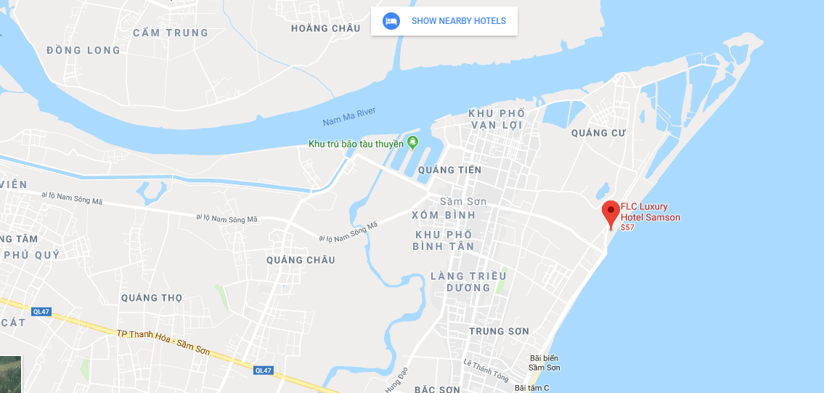

3. Visa and Immigration Requirements

Visas are required for nationals of certain countries to enter Viet Nam for the duration of the meeting and those who need visas are advised to apply at the Viet Nam Embassies or Consulates General or Consular Offices.

If participant requires a visa, please fill in the “Visa Support Request” section in the online form (https://goo.gl/forms/xnX8TR7iibJjxKjw1) and send it as soon as possible to allow sufficient time to process the visa request. After filling in the online form for visa support, the scanned copy of passport must be sent to the contact point in order to get a Visa Approval Letter.

Visas are exempted for the citizens of the countries which have signed a bilateral or unilateral visa exemption agreement with Viet Nam. The countries are listed at http://lanhsuViet Nam.gov.vn/default.aspx. For information on entry visas to Viet Nam, participants are kindly requested to check the web page of the Ministry of Foreign Affairs at https://visa.mofa.gov.vn/Homepage.aspx.

Tourist visas may be valid for 14 up to 30 days. Tourist visa can only be obtained in Viet Namese Embassies and Consulates abroad.
A business visa will require a Visa Approval Letter (Visa Reference Number) which will be sent directly from Vietnamese Immigration Department to the relevant Viet Namese consulate or embassy. It takes at least 3 weeks to process the internal Visa Approval Letter (Visa Reference Number).
Contact point for visa support letter:
Ministry of Information and Communications
Mr. Pham Duc Manh
Official Department of International Cooperation – Ministry of Information and Communications (MIC)
Tel: (+844)39430202
Mobile: +84982352010
Email: pdmanh@mic.gov.vn

4. Recommended Hotel for the Event

FLC Luxury Hotel Samson in Sam Son beach is the recommended hotel for the event. It is a modern hotels and resorts in Thanh Hoa.
Kindly note that accommodations are at the expense of the participant.
Participants are kindly requested to complete their Hotel Reservation Form on https://goo.gl/forms/xnX8TR7iibJjxKjw1 at the latest on 3rd June 2018.
Rooms and prices will not be guaranteed if the reservation is made after the due date. Hotel booking confirmation will be sent to participants after successful reservations.

Main venue |  | FLC Luxury Hotel Sam Son
Detailed Information |  | Address: Ho Xuan Huong Street, Quang Cu, Sam Son City, Thanh Hoa Province, Viet Nam.  Tel: 0237 8788 888  Mail: info@flcsamson.com.vn
Star rating/ Distance |  | - 5-star  - Meeting Venue Hotel
Checkin time – Checkout time |  | 14:00- 12:00
Room rate/ Room type | Deluxe Single | 3.100.000 VND (~ 138 USD)
Room rate/ Room type | Deluxe Double/ Twin | 3.100.000 VND (~ 138 USD)
Complimentary |  | - Daily Buffet for breakfast.  - Fitness center  - Complimentary in-house Tea/Coffee making facilities  - Complimentary two bottle of mineral water daily in bathroom  - Complimentary Wifi internet in guest room

Alternative hotel |  | Van Chai Village
Detailed Information |  | Address: Quang Cu, Sam Son City, Thanh Hoa Province, Viet Nam  Tel: (84).0373.793333  Fax: (84).037.793927  E-mail: frontoffice@vanchai-vn.com  Website: www.vanchai-vn.com
Star Rating/ Distance |  | - 4 star hotel  - 200 meters from FLC Luxury Hotel Sam Son
Checkin time- Checkout time |  | 14:00- 12:00
Room rate/ Room type (Days on week)  From Sunday to Thursday | Single | 1.8500.000 VND ( ~ 82 USD)
Room rate/ Room type (Days on week)  From Sunday to Thursday | Double/Twin | 1.8500.000 VND ( ~ 82 USD)
Room rate/Room type (On weakend)  From Friday to Sunday | Single | 2.500.000 VND ( ~ 111 USD)
Room rate/Room type (On weakend)  From Friday to Sunday | Double/Twin | 2.500.000 VND ( ~ 111 USD)
Complimentary |  | - Daily Buffet for breakfast.  - Complimentary in-house Tea/Coffee making facilities  - Complimentary two bottle of mineral water daily in bathroom  - Complimentary Wifi internet in guest room

Alternative hotel |  | Dragon Sea
Detailed Information |  | Address: No. 43, Ho Xuan Huong Street, Trưong Son District, Sam Son City, Thanh Hoa province, Viet Nam  Tel: +84 2373.826.666 / +842373.821.028  Fax: +84 2373.822.678  Website: http://www.dragonseahotel.vn/
Star Rating/ Distance |  | - 4 star hotel  - 2.8 km from FLC Luxury Hotel Sam Son (5 minutes by taxi)
Checkin time- Checkout time |  | 14:00- 12:00
Room rate/ Room type (Days on week)  From Sunday to Thursday | Single | 1.750.000 VND ( ~78 USD)
Room rate/ Room type (Days on week)  From Sunday to Thursday | Twin | 1.750.000 VND ( ~78 USD)
Room rate/  Room type (On weekend)  Fom Friday to Sunday | Single | 2.700.000 VND ( ~ 120 USD)
Room rate/  Room type (On weekend)  Fom Friday to Sunday | Twin | 2.700.000 VND ( ~ 120 USD)
Complimentary |  | - Daily Buffet for breakfast.  - Complimentary in-house Tea/Coffee making facilities  - Complimentary two bottle of mineral water daily in bathroom  - Complimentary Wifi internet in guest room

Hotel Reservation Cancellation policy

- No charge for Cancellation/Amendment made 25 days before arrival date
- 50% total room charge if booking cancel 24 days to 10 days before arrival date
- 70% total room charge if booking cancel 9 days to 7 days before arrival date
- 100% total room charge if booking cancel less than 7 days before arrival date
- 100% total room charge if booking No Show
- Rates are non-commissionable and room types are subject to availability
- Early check-in or late check-out is subject to room availability

Bao Anh Hotel
Ad: 109 Ho Xuan Huong – Sam Son - Thanh Hoa
Phone: (84). 02378922222

http://baoanhhotel.vn/

 | Bao Anh Hotel | Rate per room per night |  |  | Remark
 | Bao Anh Hotel | Weekday | Weekend | Festival | Remark
 | Deluxe City View | 1,000,000 | 1,500,000 | x
Remark
  - Room rate is applied for Single or Double/ Twin room
  - Above rate is include daily breakfast at the hotel
  - Hotel check in 14.00 and check out at 12.00
  - Early check in or later check out is subject to room availability.
Booking condition
Expect booking/ rooming list at list 45days before arrive date

5. Transport from and to Airport
Noi Bai International Airport, 30km from Ha Noi capital, is the biggest airport in northern Viet Nam with various international and domestic routes.
There are direct flights from more than 25 cities and 83 lines from 47 airports to Ha Noi by 45 international airlines including Viet Nam Airlines, Singapore Airlines, AirAsia, Cathay Pacific, Hong Kong Airlines, Thai Airways, Air France, Tiger Airways, China Airlines, Japan Airlines, Korean Air and many others.
More information about Noi Bai International Airport including flight status can be found at: http://www.noibaiairport.vn/.
Transportation to and from Noi Bai airport will be supported and arranged by the host (MIC). It takes around 4 hours (distance: 200km) from Noi Bai Airport to the meeting venue (FLC Luxury Hotel Sam Son, Thanh Hoa) by Shuttle bus or Taxi.
Notice: Please kindly provide your Flight information for us to arrange transportation from Noi Bai Airport to your Hotel, follow the form in the link: https://goo.gl/forms/xnX8TR7iibJjxKjw1. Deadline for registration of shuttle bus is 3rd June 2018.

6. Weather and food

July is in the middle of summer in the north of Viet Nam, including Thanh Hoa province. The average temperature during July varies from 27 to 35 degrees Celsius and it is usually hot and sunny.

A wide range of both Eastern and Western food choice is available in FLC Hotel ’s restaurant. There are many local restaurants outside the meeting venue which usually offer fresh seafood. For more information, please refer to Viet Nam National Administration of Tourism’s official website.
7. Currency & Credit Cards

The local currency of Viet Nam is Dong (VND). One United States Dollar (USD) is approximately equal to VND 22.500 to 23.000, as of March 2017.
For money changing, banks and money changers are conveniently located all over the city, at the airport, as well as at the hotels. Most banks are open from 08.00 a.m. to 04.00 p.m., Monday to Friday. All common credit cards such as VISA, MASTER, AMEX, etc. are welcome.
Under Vietnamese law, any person who brings or takes an aggregate amount of foreign currency exceeding VND 15.000.000 or USD 5.000 or its equivalent into or out of the Socialist Republic of Viet Nam shall declare the amount of foreign currency to a Customs Officer. Amounts under USD 5,000 or its equivalent to be deposited in credit institutions and branches of foreign banks must also be declared on arrival. Failure to make such a declaration or making any false declaration to a Customs Officer is a criminal offence

8. Taxes

Usually the displayed prices have sales tax already included.

9. Language
The Forum will be conducted in English. English is spoken in the recommended hotels.

10. Local Time
The Viet Nam time zone is GMT +7.

11. Communications
The country code of Viet Nam is +84. The biggest mobile operators in Viet Nam are: Vinaphone, Mobifone and Viettel. Mobile SIM cards are available for purchase at the airport.

12. Electricity & Power Plug
The mains voltage in Viet Nam is 220 Volts, 50 Hz AC throughout the country. The power plugs used are of the 2-pin flat or circular.
Wall Plug   | Extended Socket  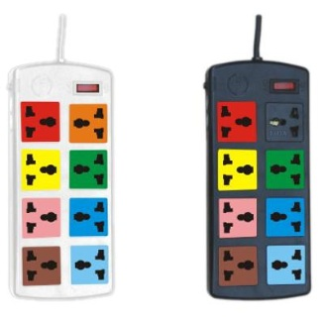

13. About Thanh Hoa

Thanh Hoa is one of the biggest provinces in Viet Nam, located 150km from Ha Noi and 1,560 km from Ho Chi Minh City. This position gives Thanh Hoa a crucial role in the Northern economic region of Viet Nam.
Located 16km from Thanh Hoa City, Sam Son Beach attracts lot of visitors to relax and bath. Beside the beach, Sam Son offers scenic spots such as Trong Mai Rocks, Doc Cuoc Temple and Mount Co Tien.
Tourists also like to discover Ben En National Park in Nhu Thanh, Nhu Xuan districts. The park is a complex of tropical forests, hills, mountains, rivers, springs, and Muc Lake. With natural landscapes and diversified flora and fauna, Ben En is suitable to eco-tourism, sightseeing, and scientific studies.
Thanh Hoa is famous for historical vestiges Ho Dynasty Citadel and Lam Kinh Remains. Lam Kinh is the birthplace of national hero Le Loi and the starting point of the Lam Son revolutionary insurrection. UNESCO recognized the citadel of Ho Dynasty as the World Cultural Heritage Sites.
14. Contacts
For inquiries and information on local arrangements, please contact:

Organization: | Department of International Cooperation  Ministry of Information and Communications
Name: | Ms. Nguyen Thi Khanh Thuan
Position: | Official
Email: | ntkthuan@mic.gov.vn or | thuan115@yahoo.com
Contact Details: | Mobile phone: +84 904255353/  Fixed phone: +84 2438229377

