**Speaker Profile – Caiyong Hao**

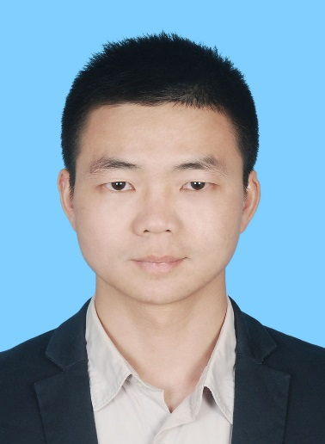

Seiner Engineer

Shenzhen Station of SRMC

Shenzhen, China

Telephone: +86 13631585721

Email: hao.c.y@srrc.org.cn

**Biography**

Mr. Hao got master’s degree from Hunan University in 2010 and studied electrical engineering as an academic visitor at Imperial College London in the UK in 2014. From 2010 he worked in Shenzhen Station of State Radio Monitoring Center, was responsible for satellite monitoring and improved the performance of satellite interference geolocation system greatly. Now he is focus on new technologies research in satellite monitoring.